BAI21113 Software Engineering Assignment
Restaurant Operations Task Tracker
Reflective Report: Agile SDLC, GitHub Collaboration, and Iterative Development
Project | Restaurant Operations Task Tracker
Methodology | Scrum with two short iterations
Team Members | TAN LE PIN and DHINESH
Final Milestone | v1.0-final-submission

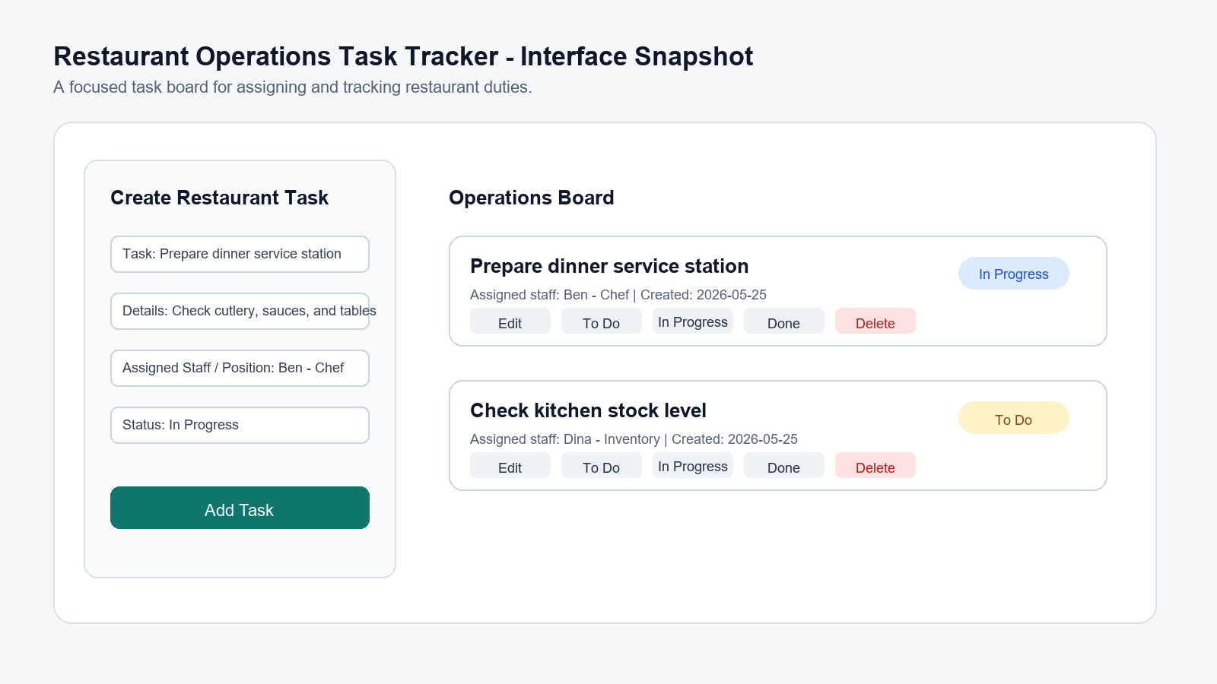
Figure 1. Interface concept for the restaurant operations task tracker.

1. Introduction
This reflective report explains how the Restaurant Operations Task Tracker was planned, developed, improved, and documented for the BAI21113 Software Engineering assignment. The application is a lightweight web-based task tracker for small restaurant teams. It helps users create restaurant operation tasks, assign them to staff or positions, update task status, filter tasks by progress, and keep task data after refreshing the browser through localStorage.
The project began as a general task tracker, but it was refined into a restaurant operations scenario to make the system more realistic. This refinement did not change the main interaction flow. The same core features remained: create, view, edit, delete, assign, filter, and save tasks. The difference is that the final version uses clearer restaurant wording, such as restaurant task, assigned staff or position, and operations board. This makes the system easier to understand as an internal restaurant management tool rather than a generic to-do list.
The assignment did not require a fully complete enterprise system. Therefore, the team focused on the core task management workflow and used two short iterations to demonstrate iterative and incremental development. The final submission also includes GitHub evidence through branches, commits, pull requests, and version tags.

2. Iterative and Incremental Development
The project applied iterative development by building a working version first, reviewing what was missing, and improving the application in the next iteration. It applied incremental development because each stage added useful functionality on top of the previous version. The team did not attempt to build a complete system at once. Instead, the first iteration delivered a minimum viable task tracker, while the second iteration extended it with task management improvements.
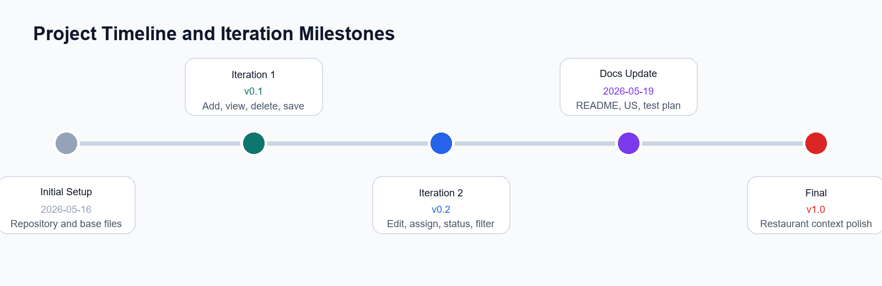
Figure 2. Project timeline and iteration milestones based on repository tags and commits.
Iteration 1 focused on the minimum viable version. The goal was to make the application functional enough for users to create a task, view the task list, delete a task, and keep data in browser localStorage. This was important because it gave the team a stable foundation before adding more advanced features. The completed Iteration 1 work was marked with the tag v0.1-iteration1.
Iteration 2 improved the first working version by adding editing, staff assignment, task status, filtering, validation, and a better user interface. These additions made the application more useful for restaurant operations because staff responsibilities and task progress became clearer. The completed Iteration 2 work was marked with the tag v0.2-iteration2. The final submission was later marked with v1.0-final-submission to show the delivered assignment version.

3. Feature Evolution
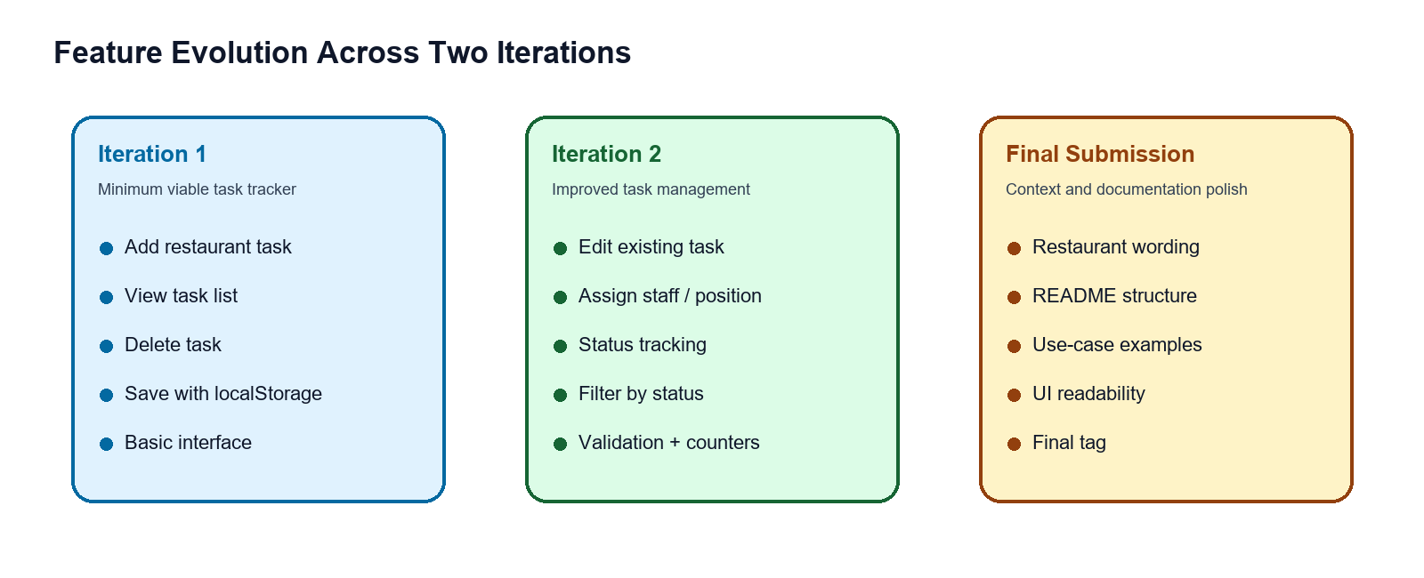
Figure 3. Feature evolution from MVP to final submission polish.
The feature evolution shows how the system grew from a basic list into a more complete restaurant task tracker. In Iteration 1, the core value was simple task recording. Users could create tasks and see them in the task list. The delete function also allowed users to remove tasks that were no longer needed. LocalStorage helped prevent task data from disappearing after a page refresh.
In Iteration 2, the team improved usability and task tracking. The edit function allowed existing task details to be corrected. The assigned staff or position field clarified responsibility. The status options To Do, In Progress, and Done helped users understand task progress. The filter function made the task list easier to scan when many tasks existed. Validation prevented empty task titles, and the counters provided a quick summary of task status.
The final submission polish focused on consistency rather than a new development cycle. The wording and examples were aligned with the restaurant context, and the README was improved to explain the project scope, Scrum process, user stories, GitHub workflow, and future enhancements more clearly.

4. GitHub Collaboration and Version Control
GitHub was used to manage collaboration and provide development evidence. The team used branches to separate feature work, commits to record progress, pull requests to support review, and tags to mark iteration milestones. This helped the project show a clear history from the first working version to the improved version and final submission.
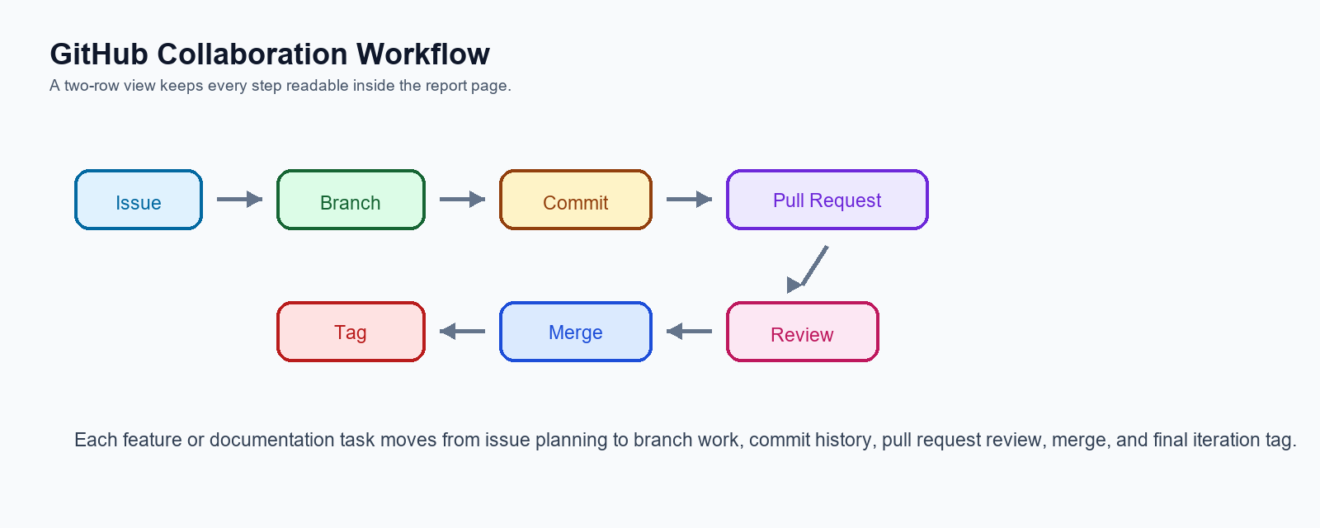
Figure 4. GitHub workflow used to connect planning, implementation, review, and release tags.
The workflow followed the sequence Issue -> Branch -> Commit -> Pull Request -> Review -> Merge -> Tag. This process made the development work more traceable. For example, a feature could be planned as an issue, implemented in a feature branch, committed with a meaningful message, reviewed through a pull request, merged into main, and then included in an iteration tag.
The project used feature branches such as feature/iteration1-basic-task-tracker and feature/iteration2-task-improvements. Documentation work was also separated into documentation branches. This branching strategy made the repository easier to understand because each branch had a specific purpose. The tags v0.1-iteration1, v0.2-iteration2, and v1.0-final-submission helped show the progress of the project across milestones.
Using GitHub also helped the team understand that collaboration is not only about writing code at the same time. It also includes documenting decisions, reviewing changes before merging, keeping commit messages meaningful, and making sure the final repository can explain the development process to someone who was not involved in the project. This was important for the assignment because the rubric gives significant marks for collaboration evidence, not only for the final working web page.

5. Scrum Practices Followed
Scrum was selected because the assignment required an Agile SDLC approach with short iterations. The team treated the two development cycles as short sprints. Each sprint had a clear goal, selected user stories, implemented features, and a review outcome. The product backlog was represented by the user stories, while the iteration plan divided those stories into Iteration 1 and Iteration 2.
Sprint planning was applied when the team decided which features belonged in each iteration. Iteration 1 included the minimum viable features: create, view, delete, and save tasks. Iteration 2 included improvement features: edit, assign staff, change status, filter tasks, and validation. Sprint review was applied by checking whether the completed increment worked as expected. Retrospective thinking was applied when the team identified that the final version should be more clearly connected to a restaurant operations scenario.
Although the team was small, Scrum helped organize the work. It provided a structure for dividing tasks, reviewing progress, and demonstrating improvement. GitHub Issues and the project board supported this process by making the work visible and trackable.
The team also learned that a sprint does not need to deliver a large number of features to be valuable. A small but working increment is easier to test, explain, and improve. This is why Iteration 1 focused on the basic task tracker instead of attempting every possible feature. Iteration 2 then added the features that had the most direct value for task management.

6. Individual Contributions
Team Member | Contribution
TAN LE PIN | Set up GitHub repository, implemented the core application, developed Iteration 1 and Iteration 2 features, managed tags, supported pull request merging, and coordinated final submission polish.
DHINESH | Prepared documentation including README, user stories, test plan, and iteration plan. Supported GitHub collaboration evidence and helped align documentation with the restaurant operations scenario.

The distribution of work allowed the technical implementation and documentation to progress together. Coding work was necessary to deliver the application, while documentation was necessary to explain the Agile process, testing, user stories, and collaboration evidence required by the assignment rubric.

7. Challenges and Improvements
One challenge was keeping the project realistic without making it too large. The assignment brief included examples such as user registration and login, but it also stated that a fully complete system was not required. The team therefore focused on the core task tracking workflow instead of building a full authentication system or database. This kept the project aligned with the assignment scope.
Another challenge was documentation consistency. Early versions described the system more generally as a task tracker, while the final project used a restaurant operations context. The README, user stories, test plan, and iteration plan needed to describe the same product clearly. Improving this consistency made the project easier to understand and helped the final submission look more complete.
A third challenge was balancing usability with simplicity. The system needed to be easy to run directly in the browser, so the team used vanilla JavaScript and localStorage. This made the system lightweight, but it also means the application is not a real multi-user production system. Future versions could add authentication, roles, due dates, priority, and a cloud database.
The final reflection is that software engineering quality is not only measured by the number of features. It is also measured by whether the project scope is clear, whether the implementation matches the documentation, whether the testing covers important behaviours, and whether the repository provides enough evidence for another person to understand how the system evolved.

8. Future Enhancements
- Add manager and staff login with role-based permissions.
- Add restaurant task categories such as Kitchen, Service, Cleaning, Inventory, and Cashier.
- Add due date and priority fields to support urgent restaurant tasks.
- Add search by staff name, position, or task keyword.
- Add a dashboard summary for total, pending, in-progress, completed, and overdue tasks.
- Move from localStorage to a database so multiple devices can share the same task data.

9. Conclusion
Overall, the Restaurant Operations Task Tracker demonstrates the required software engineering concepts for the assignment. Iteration 1 delivered a working minimum viable task tracker. Iteration 2 improved the system with editing, staff assignment, status tracking, filtering, validation, and a clearer interface. The final submission refined the project into a restaurant operations context and improved the supporting documentation.
The project also demonstrates GitHub collaboration through branches, commits, pull requests, and version tags. Scrum practices were applied in a lightweight but meaningful way through backlog planning, sprint goals, review, and reflection. While the system is not a complete enterprise application, it is a functional and stable demonstration of Agile SDLC, iterative and incremental development, and collaborative software engineering practice.
End of Reflective Report

