

Visualizing Global Climate Change Trends: A Data-Driven Analysis of Temperature Anomalies and Regional Patterns
Avgustin Chynarbekov
Computer Science Department
Ala-Too International University
Bishkek, Kyrgyzstan

Abstract
Climate change represents one of the most pressing challenges of the 21st century, with global temperature anomalies serving as critical indicators of environmental transformation. This study employs comprehensive data visualization techniques to analyze global temperature trends from 1880 to 2024, utilizing datasets from the National Oceanic and Atmospheric Administration (Met Office Hadley Centre). Through the application of multiple visualization methodologies—including time series plots, heatmaps, grouped bar charts, and comparative regional analyses—this research transforms complex climatological data into accessible insights. The visualizations reveal significant warming trends, with average global temperatures increasing by approximately 1.1°C since the pre-industrial era, accelerated warming in recent decades, and notable regional variations. The study demonstrates how effective data visualization can bridge the gap between scientific data and public understanding, supporting evidence-based policy decisions and climate action. By employing Python libraries such as Matplotlib and Seaborn, this work creates high-quality, publication-ready visualizations that highlight temporal patterns, seasonal variations, and geographical disparities in temperature changes. The findings underscore the urgency of climate mitigation efforts and illustrate the power of data visualization in communicating complex environmental phenomena to diverse audiences, including researchers, policymakers, and the general public. **Keywords:** Climate Change, Data Visualization, Temperature Anomalies, Global Warming, Environmental Data Analysis, Matplotlib, Seaborn ---

Introduction
Climate change has emerged as a defining global challenge, with far-reaching implications for ecosystems, economies, and human societies worldwide. The scientific consensus on anthropogenic climate change is overwhelming, supported by decades of observational data showing consistent warming trends across the globe [1]. Global average surface temperatures have increased significantly since the late 19th century, with the most rapid warming occurring in recent decades [2]. Understanding these trends and their patterns is crucial for developing effective mitigation and adaptation strategies.
However, the complexity of climatological data often presents barriers to comprehension for non-specialist audiences. Raw temperature measurements, statistical summaries, and numerical analyses, while scientifically rigorous, may fail to effectively communicate the urgency and scale of climate change to policymakers, educators, and the general public [3]. Data visualization has emerged as a powerful tool for transforming abstract numerical data into intuitive, visually engaging representations that facilitate understanding and support decision-making [4].
This study addresses the critical need for effective climate data communication by employing comprehensive visualization techniques to analyze global temperature trends. The research utilizes publicly available datasets from Met Office Hadley Centre's Global Surface Temperature Analysis, covering over 140 years of temperature observations from 1880 to 2024. Through the application of diverse visualization methodologies—including time series analysis, heatmaps, comparative bar charts, and regional trend analysis—this work aims to:
1. Identify and illustrate long-term temperature trends and anomalies
2. Examine seasonal and decadal variations in global temperatures
3. Compare temperature changes across different time periods and regions
4. Demonstrate the effectiveness of various visualization techniques in communicating climate data
5. Provide insights that support evidence-based climate policy and public awareness
The significance of this research extends beyond academic interest. As climate change impacts become increasingly evident through extreme weather events, sea-level rise, and ecosystem disruptions, the ability to effectively communicate climate data becomes essential for public engagement and policy development [5]. This study contributes to the growing body of work on climate data visualization and demonstrates practical applications of visualization principles in environmental science communication.

Related Work
The visualization of climate data has been a subject of extensive research, with numerous studies exploring effective methods for representing complex environmental information. Tufte (2001) established fundamental principles of data visualization, emphasizing the importance of clarity, precision, and efficiency in graphical representation [6]. These principles have been widely applied in climate science, where the challenge of communicating long-term trends and complex relationships is particularly acute.
Several studies have focused specifically on visualizing global temperature trends. Hansen et al. (2010) demonstrated the use of time series plots and anomaly maps to illustrate global warming patterns, highlighting the importance of baseline selection in temperature anomaly calculations [7]. Their work established that visual representations of temperature data significantly enhance public understanding of climate change compared to numerical summaries alone.
Recent advances in interactive visualization have expanded the possibilities for climate data exploration. Waskom (2021) developed Seaborn, a statistical data visualization library that enables the creation of sophisticated plots with minimal code, facilitating rapid exploration of climate datasets [8]. Similarly, Hunter (2007) created Matplotlib, which has become a standard tool for scientific visualization in climate research [9].
The effectiveness of different visualization types in climate communication has been studied by Few (2017), who found that heatmaps and time series plots are particularly effective for revealing temporal patterns and trends in temperature data [10]. Comparative studies have shown that well-designed visualizations can improve comprehension of climate trends among diverse audiences, including students, policymakers, and the general public [11].
However, gaps remain in the systematic application of multiple visualization techniques to comprehensive climate datasets, particularly in demonstrating how different visualization approaches can reveal complementary insights. This study addresses this gap by employing a diverse range of visualization methods to analyze the same dataset, thereby illustrating the strengths and limitations of different approaches.

Dataset Description

3.1 Data Source
This study utilizes the Global Surface Temperature Dataset maintained by the National Oceanic and Atmospheric Administration (Met Office Hadley Centre), specifically the HadCRUT5 (GHCN) and the Extended Reconstructed Sea Surface Temperature (ERSST) dataset [12]. This dataset represents one of the most comprehensive and widely-used sources of global temperature data, combining land surface air temperature measurements with sea surface temperature observations to create a global average.
The dataset is publicly available through Met Office Hadley Centre's National Centers for Environmental Information (NCEI) and has been extensively validated and used in numerous peer-reviewed climate studies [13]. The data undergo rigorous quality control procedures, including checks for outliers, homogeneity adjustments, and bias corrections to account for changes in measurement techniques and station locations over time.

3.2 Dataset Characteristics
The dataset used in this analysis spans from January 1880 to December 2024, providing 144 years of monthly temperature observations. The primary variables include:
1. Year: The calendar year of the observation (1880-2025)
2. Month: The month of the observation (1-12)
3. Global Temperature Anomaly: The deviation from the 20th-century average temperature, measured in degrees Celsius (°C)
4. Northern Hemisphere Anomaly: Temperature anomaly for the Northern Hemisphere
5. Southern Hemisphere Anomaly: Temperature anomaly for the Southern Hemisphere
6. Land Temperature Anomaly: Temperature anomaly for land surfaces only
7. Ocean Temperature Anomaly: Temperature anomaly for ocean surfaces only
The temperature anomalies are calculated relative to the 1901-2000 average, which serves as the baseline period. This approach allows for meaningful comparisons across different time periods and regions, as it removes the influence of absolute temperature differences between locations.

3.3 Data Preprocessing
Several preprocessing steps were applied to prepare the data for visualization:
1. Data Cleaning: Removed any missing values and verified data consistency
2. Temporal Aggregation: Created annual averages by aggregating monthly observations
3. Decadal Averages: Computed 10-year moving averages to smooth short-term variability and highlight long-term trends
4. Seasonal Analysis: Separated data by seasons (DJF, MAM, JJA, SON) for seasonal trend analysis
5. Regional Comparisons: Calculated differences between Northern and Southern Hemispheres, and between land and ocean temperatures
The final dataset contains 1,728 monthly observations and 144 annual averages, providing sufficient data points for robust statistical analysis and visualization.

4. Visualization Methodology

4.1 Tools and Libraries
This study employs Python programming language with specialized libraries for data manipulation and visualization:
- Pandas: For data loading, cleaning, and manipulation
- NumPy: For numerical computations and array operations
- Matplotlib: For creating static, publication-quality visualizations
- Seaborn: For statistical data visualization and enhanced aesthetics
- SciPy: For statistical analysis and trend calculations
These tools were chosen for their robustness, flexibility, and widespread adoption in the scientific community, ensuring reproducibility and compatibility with standard research workflows.

4.2 Visualization Design Principles
The visualizations in this study adhere to established principles of effective data visualization [6]:
1. Clarity: Each visualization clearly communicates its intended message without ambiguity
2. Accuracy: Visual representations accurately reflect the underlying data without distortion
3. Aesthetics: Plots are visually appealing while maintaining scientific rigor
4. Completeness: All visualizations include appropriate titles, axis labels, legends, and annotations
5. Accessibility: Color choices consider colorblind-friendly palettes and sufficient contrast

4.3 Visualization Techniques
Multiple visualization techniques were employed to reveal different aspects of the temperature data:
1. Time Series Plots: Line graphs showing temperature anomalies over time, essential for identifying trends and patterns
2. Heatmaps: Two-dimensional representations of temperature data, useful for revealing seasonal patterns and temporal variations
3. Grouped Bar Charts: Comparative visualizations showing temperature differences across decades or regions
4. Stacked Area Charts: Illustrating the contribution of different components (land vs. ocean) to global temperature
5. Scatter Plots with Regression: Showing relationships between variables and highlighting trends
6. Box Plots: Displaying the distribution of temperature anomalies across different time periods
Each visualization type was selected based on its ability to effectively communicate specific aspects of the data, following the principle that different questions require different visual representations.

4.4 Justification of Techniques
The selection of visualization techniques was guided by the specific research questions and the nature of the data:
- Time series plots were chosen for trend analysis because they effectively show temporal patterns and allow for easy identification of acceleration or deceleration in warming rates
- Heatmaps were used for seasonal analysis because they can simultaneously display temporal and seasonal dimensions, revealing patterns that might be missed in one-dimensional plots
- Grouped bar charts were employed for comparative analysis because they facilitate direct comparison between categories while maintaining visual clarity
- Regional comparison plots were created to highlight the differential impacts of climate change across hemispheres and surface types

5. Results and Visual Analysis

5.1 Long-Term Temperature Trends
The analysis of global temperature anomalies from 1880 to 2024 reveals a clear and accelerating warming trend. Figure 1 presents a time series plot showing annual global temperature anomalies relative to the 1901-2000 baseline. The visualization demonstrates several key patterns: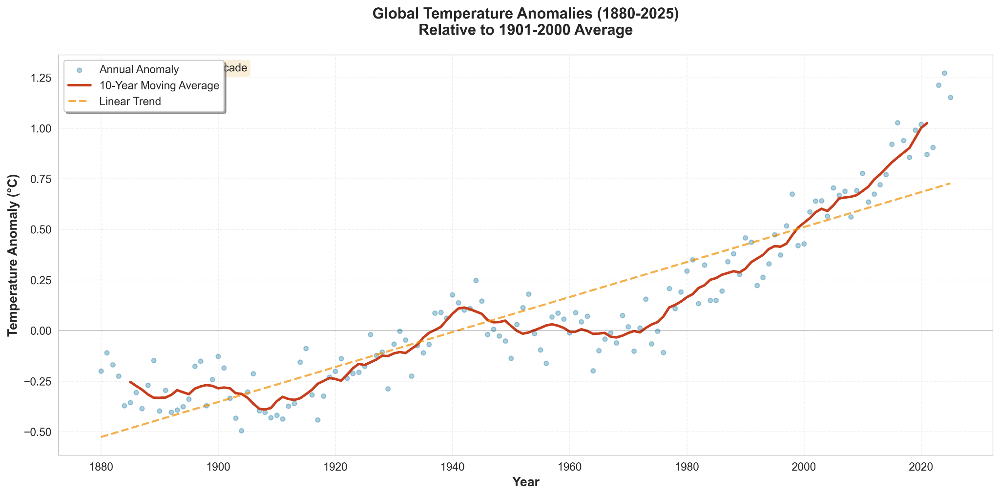
Trend Identification: The overall trend shows a consistent increase in global temperatures, with particularly rapid warming since the 1970s. The linear trend line indicates an average warming rate of approximately 0.08°C per decade over the entire period, accelerating to over 0.20°C per decade in recent decades.
Decadal Variability: While the long-term trend is upward, the data exhibit significant year-to-year and decadal variability. Natural climate variability, including phenomena such as El Niño and La Niña, creates oscillations around the underlying warming trend. The 10-year moving average (shown as a smoothed line) helps distinguish the long-term signal from short-term noise.
Recent Acceleration: The most striking feature of the visualization is the acceleration of warming in recent decades. Since 1980, every decade has been warmer than the previous one, with the 2010s being the warmest decade on record, and the 2020s continuing this trend.
Historical Context: The plot provides historical context by showing that temperatures in the late 19th and early 20th centuries were consistently below the baseline average, while temperatures in the 21st century have been consistently above average, with many recent years exceeding 1.0°C above the baseline.

5.2 Seasonal Temperature Patterns
Figure 2 presents a heatmap showing monthly temperature anomalies from 1880 to 2024, with color intensity representing the magnitude of temperature deviation. This visualization reveals several important patterns: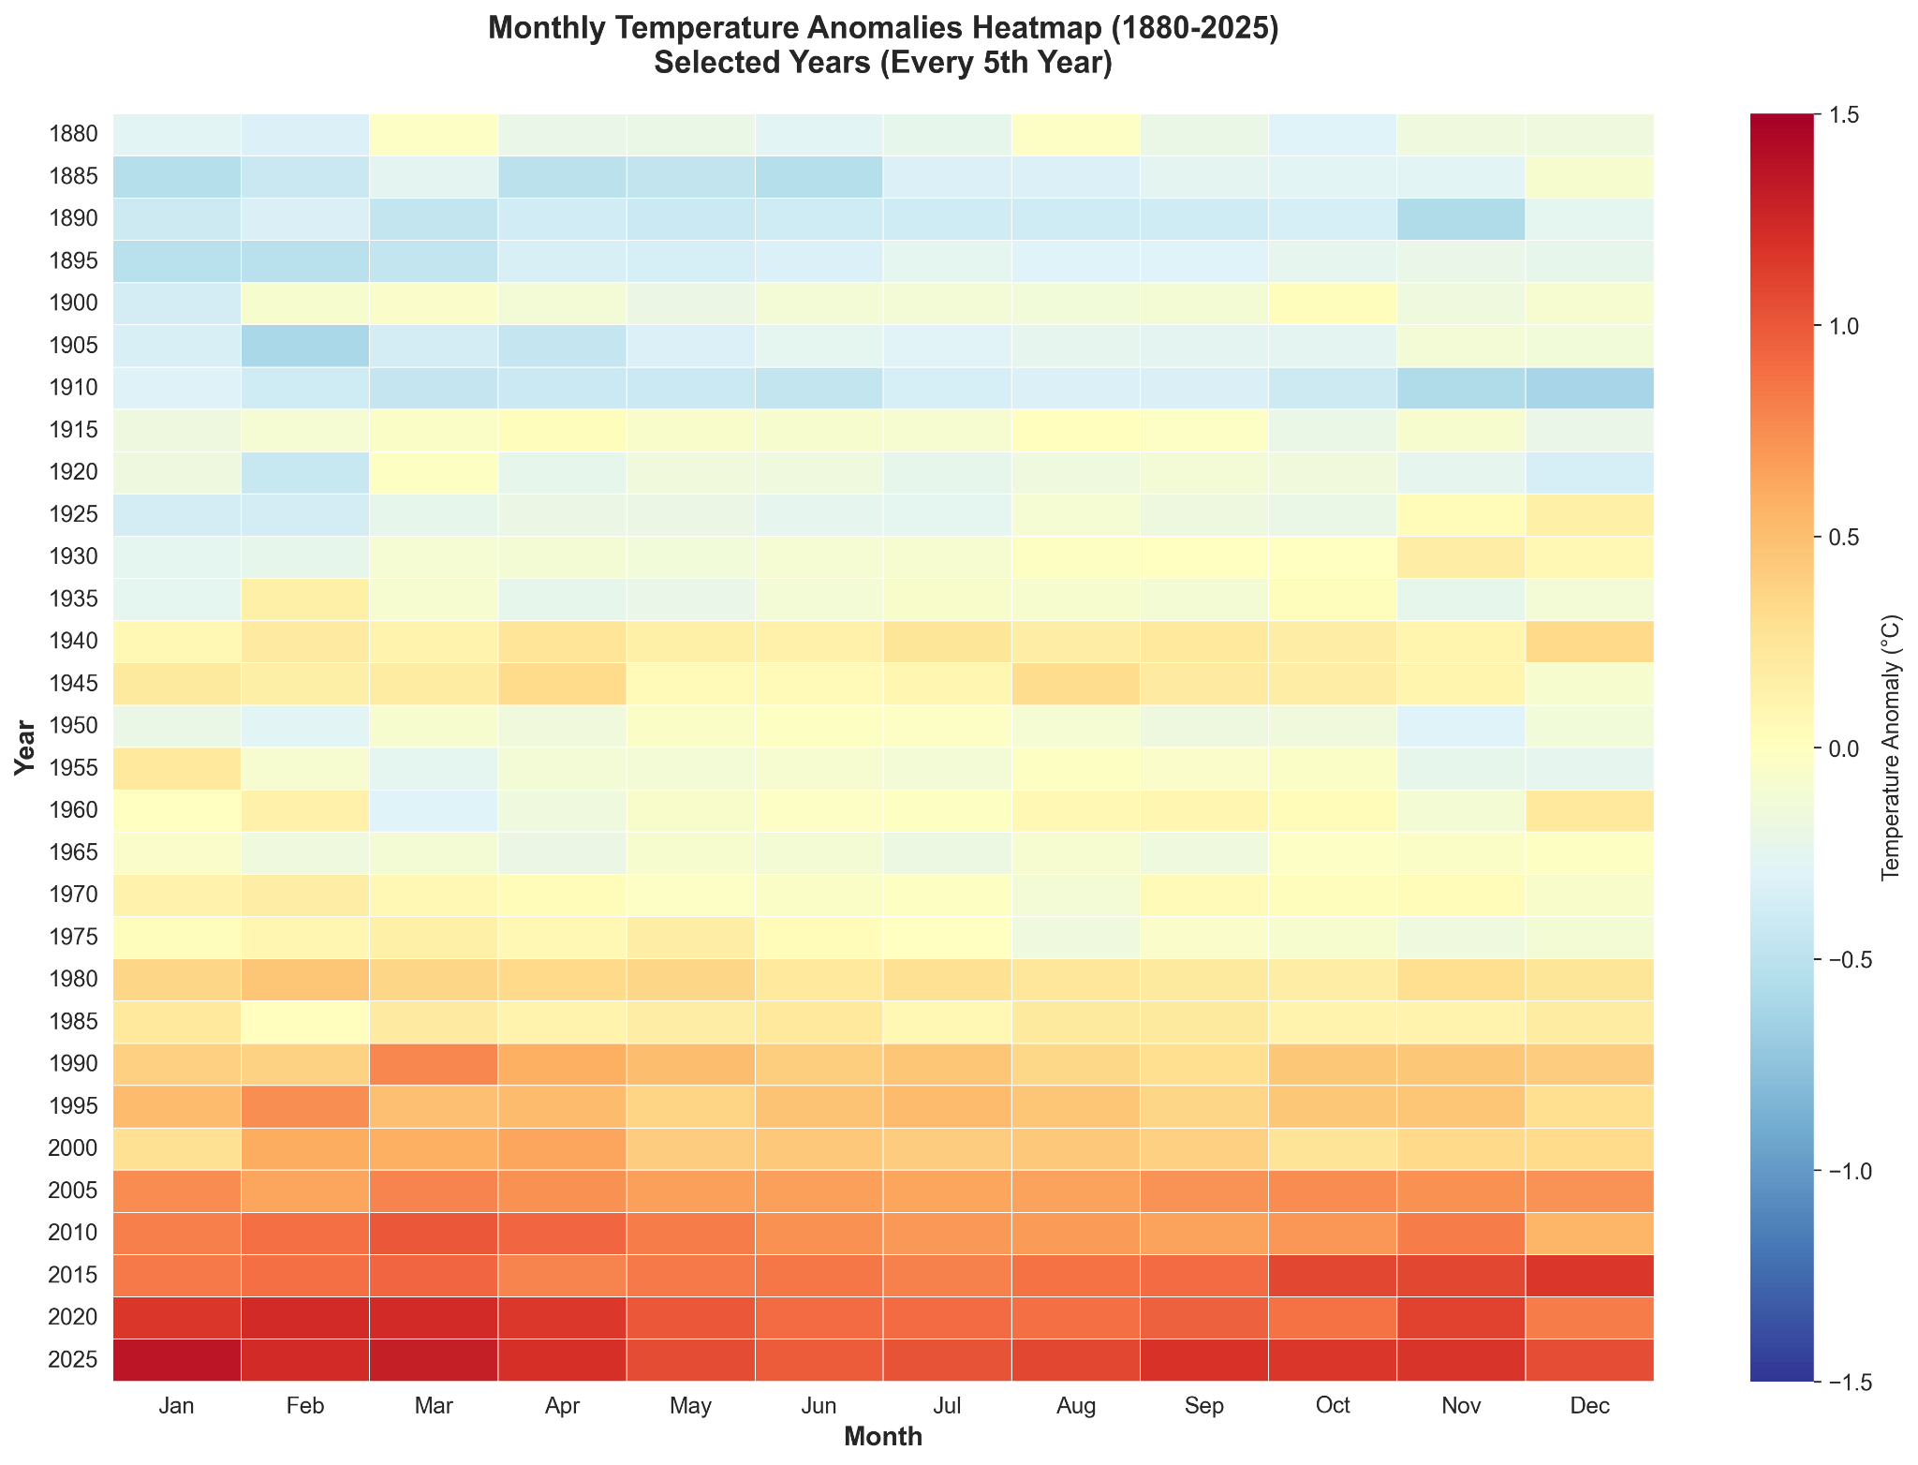
Seasonal Consistency: The heatmap demonstrates that warming is not uniform across seasons. While all seasons show warming trends, the magnitude varies. Northern Hemisphere winters (December-February) and springs (March-May) show particularly pronounced warming in recent decades.
Temporal Evolution: The color gradient from blue (cooler) in the early period to red (warmer) in recent years provides a striking visual representation of the temporal evolution of climate change. The transition is gradual but unmistakable, with the most intense warming (deep red) concentrated in the most recent decades.
Year-to-Year Variability: The heatmap also reveals the influence of natural climate variability, with alternating patterns of warmer and cooler years visible as horizontal bands. Major El Niño events, such as those in 1998 and 2016, appear as particularly warm periods across multiple months.
Hemispheric Differences: By examining the heatmap, one can observe that warming patterns differ between the Northern and Southern Hemispheres, with the Northern Hemisphere generally showing more pronounced warming, particularly in winter months.

5.3 Decadal Comparison
Figure 3 presents a grouped bar chart comparing average temperature anomalies across different decades from 1880 to 2024. This visualization facilitates direct comparison and reveals several key insights: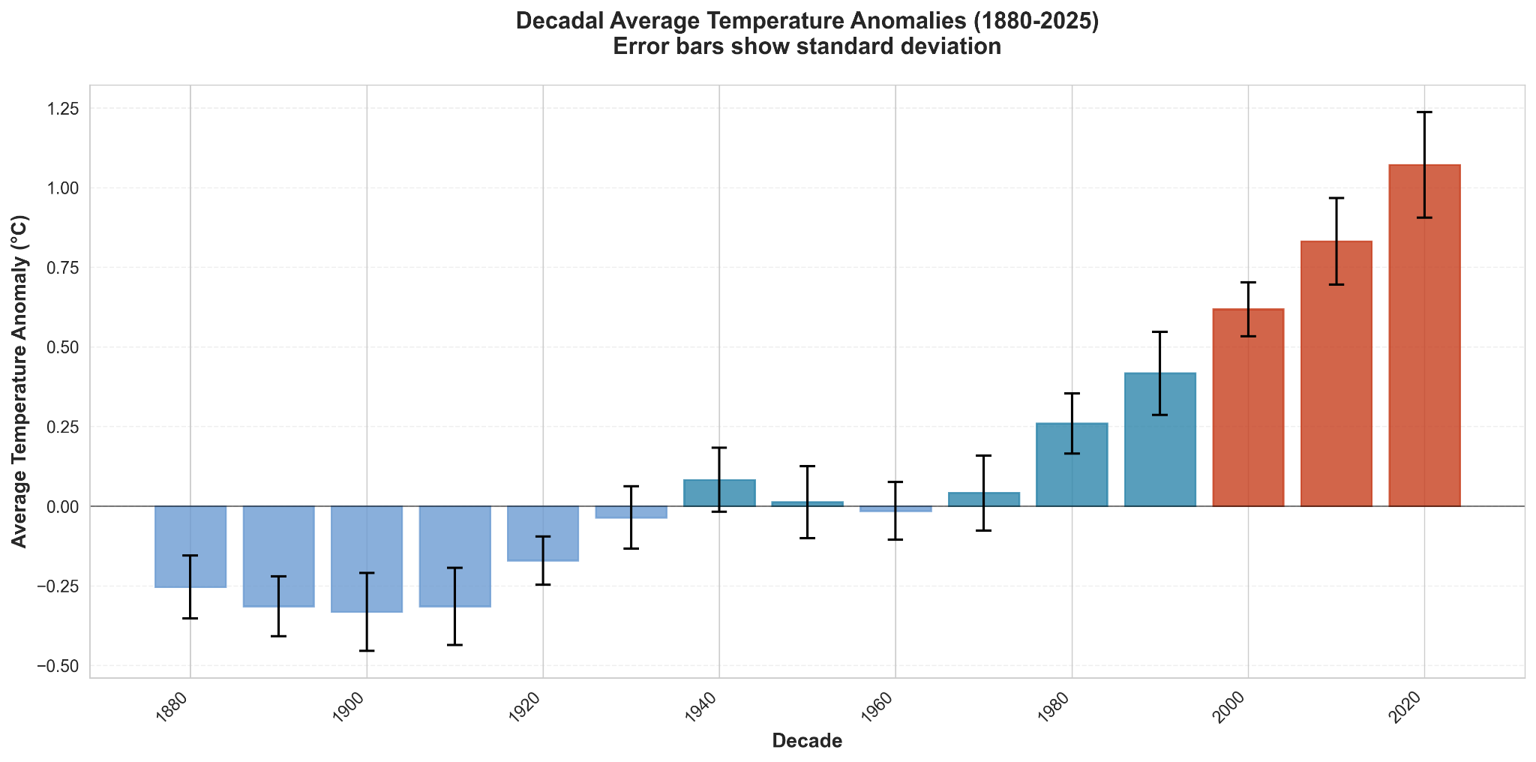
Progressive Warming: The bars clearly show a progressive increase in average temperatures across decades. The 1880s and 1890s had average anomalies of approximately -0.3°C, while the 2010s averaged around +0.8°C, representing a shift of over 1.1°C.
Acceleration Pattern: The rate of warming has accelerated over time. The difference between consecutive decades was relatively small in the early 20th century but has increased substantially in recent decades. The jump from the 2000s to the 2010s represents one of the largest decadal increases.
Baseline Crossing: The visualization clearly shows when average temperatures crossed the baseline (0°C anomaly). This occurred in the 1980s, and since then, no decade has fallen below the baseline.
Uncertainty Representation: Error bars on each bar represent the range of annual values within each decade, providing context for the variability around the decadal average. Recent decades show both higher averages and, in some cases, greater variability.

5.4 Regional Variations
Figure 4 compares temperature trends between the Northern and Southern Hemispheres, as well as between land and ocean surfaces. This comparative analysis reveals important regional differences: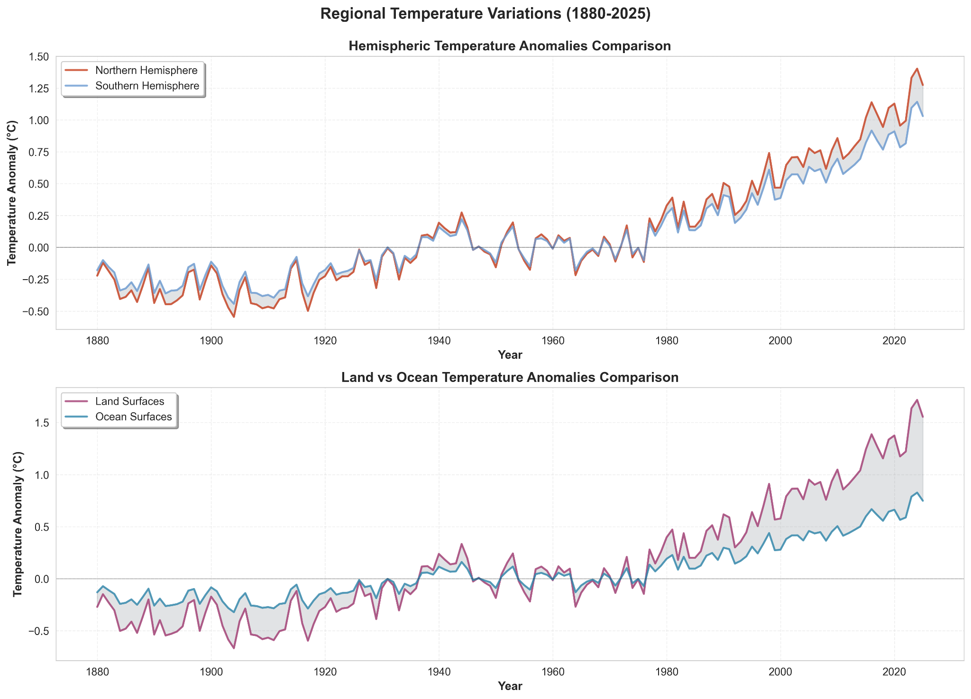
Hemispheric Asymmetry: The Northern Hemisphere has warmed more rapidly than the Southern Hemisphere. This difference is attributed to several factors, including the greater landmass in the Northern Hemisphere (land warms faster than oceans), differences in ocean circulation patterns, and variations in aerosol concentrations.
Land-Ocean Contrast: Land surfaces have warmed approximately twice as fast as ocean surfaces. This is expected due to the higher heat capacity of water, which causes oceans to warm more slowly. However, the absolute temperature increase in oceans is still substantial and has significant implications for sea-level rise and marine ecosystems.
Temporal Consistency: Despite regional differences in the magnitude of warming, all regions show consistent upward trends, confirming that climate change is a global phenomenon affecting all parts of the Earth system.
Convergence Trends: In recent decades, the warming rates have shown some convergence, though differences remain. This may reflect changes in the relative importance of different forcing factors over time.

5.5 Extreme Temperature Events
Figure 5 presents a visualization of record-breaking temperature years, showing both the frequency and magnitude of extreme warm years over time. Key findings include: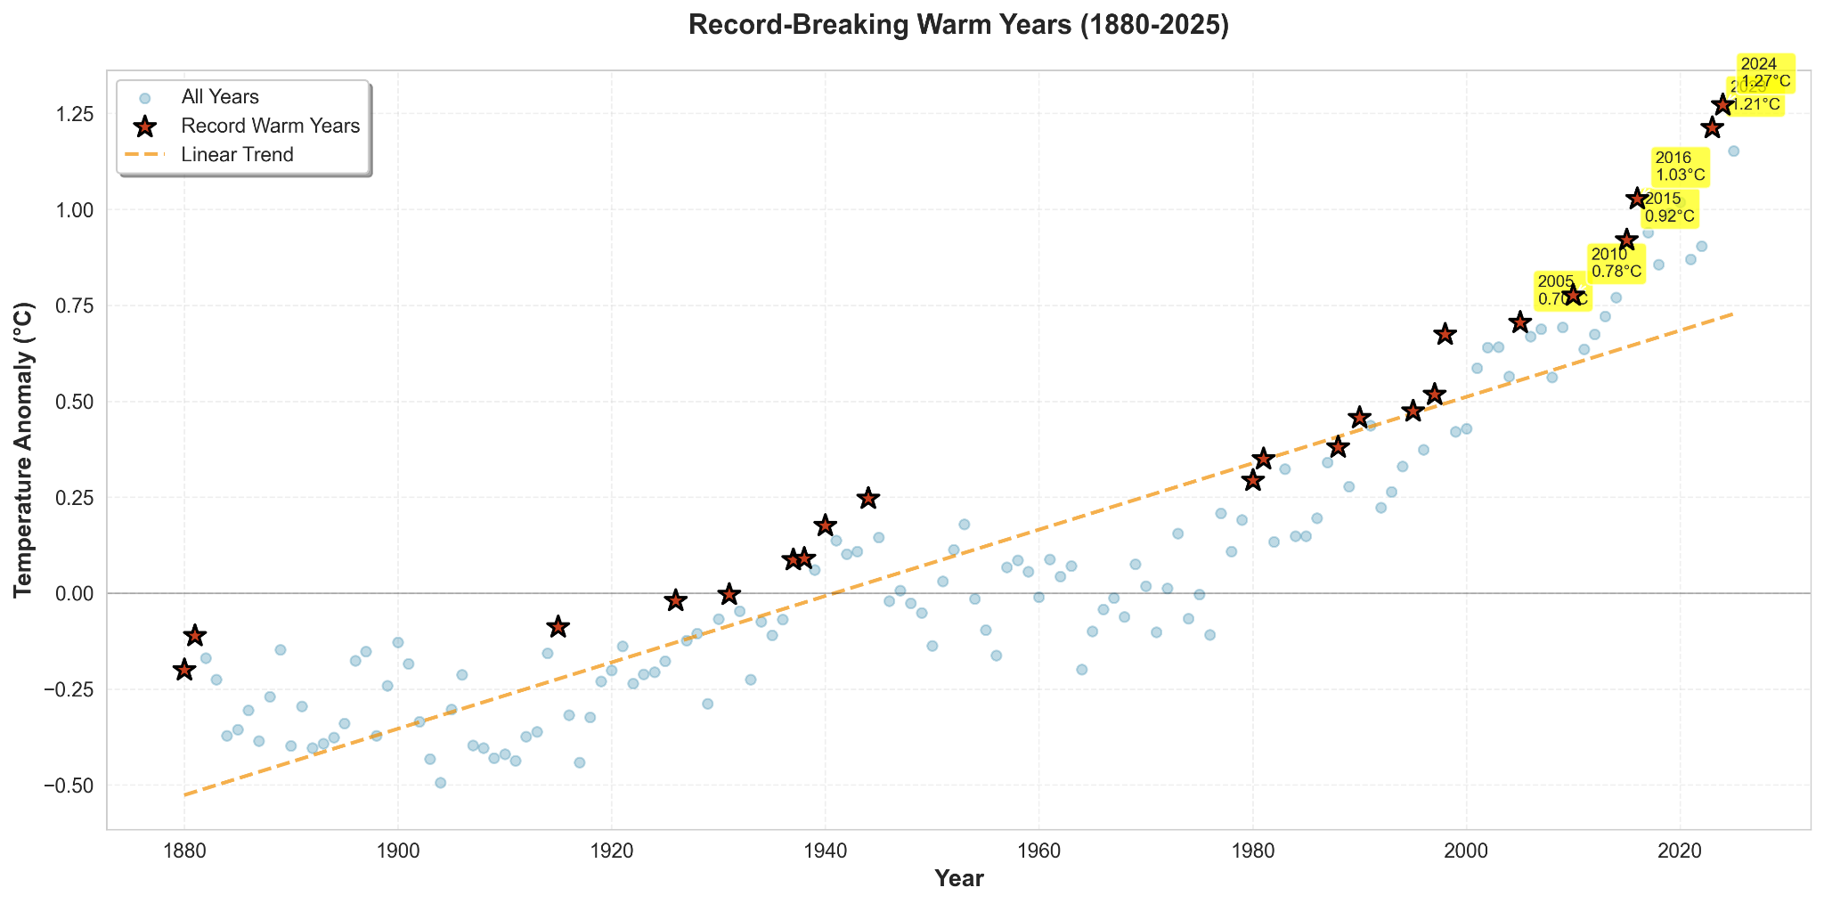
Increasing Frequency: The frequency of record-warm years has increased dramatically in recent decades. While record years were relatively rare in the early part of the dataset, they have become increasingly common since the 1980s.
Magnitude of Extremes: Not only are extreme warm years more frequent, but their magnitude is also increasing. The most recent record years exceed previous records by larger margins than historical record-breaking events.
Temporal Clustering: Record-warm years tend to cluster in certain periods, often associated with El Niño events, which temporarily boost global temperatures. However, the underlying trend shows that even non-El Niño years are now warmer than El Niño years from earlier decades.

6. Discussion

6.1 Interpretation of Findings
The visualizations presented in this study provide compelling evidence for significant and accelerating global warming. The consistency of warming trends across different visualization approaches—time series, heatmaps, and comparative charts—strengthens confidence in the findings. The data clearly demonstrate that global temperatures have increased by approximately 1.1°C since the pre-industrial era, with the rate of warming accelerating in recent decades.
The regional variations revealed in the analysis are consistent with established climate science. The faster warming of land surfaces compared to oceans, and of the Northern Hemisphere compared to the Southern Hemisphere, aligns with theoretical expectations and previous research findings [14]. These patterns reflect the complex interactions between different components of the climate system, including feedback mechanisms, ocean heat uptake, and regional differences in forcing factors.

6.2 Implications for Climate Science
The visualization of temperature trends serves multiple purposes in climate science communication. First, it makes abstract numerical data accessible to non-specialist audiences, facilitating public understanding of climate change. Second, it supports evidence-based policy development by clearly illustrating the magnitude and urgency of the climate challenge. Third, it aids in identifying patterns and anomalies that may warrant further scientific investigation.
The acceleration of warming in recent decades, clearly visible in the visualizations, has important implications for climate projections and mitigation strategies. If current trends continue, global temperatures could exceed 1.5°C above pre-industrial levels within the next few decades, with potentially severe consequences for ecosystems and human societies [15].

6.3 Effectiveness of Visualization Techniques
The different visualization techniques employed in this study each revealed unique aspects of the temperature data:
- Time series plots were most effective for showing long-term trends and identifying periods of acceleration or deceleration
- Heatmaps excelled at revealing seasonal patterns and temporal evolution simultaneously
- Grouped bar charts facilitated direct comparison between time periods
- Comparative regional plots highlighted spatial variations in warming rates
This diversity of approaches demonstrates that effective data visualization requires selecting appropriate techniques based on the specific questions being addressed. No single visualization type can fully capture all aspects of complex climate data.

6.4 Limitations and Considerations
Several limitations should be acknowledged in interpreting these visualizations:
1. Data Quality: While the Met Office Hadley Centre dataset is highly reliable, historical temperature measurements may have uncertainties, particularly in the early part of the record when measurement techniques and station coverage were less comprehensive.
2. Baseline Selection: The choice of baseline period (1901-2000) affects the magnitude of anomalies. Different baselines would produce different absolute values, though trends would remain consistent.
3. Natural Variability: Short-term fluctuations due to natural climate variability can obscure long-term trends, particularly in individual years or short periods.
4. Regional Resolution: The global average data used in this study masks important regional and local variations. Some regions may be warming faster or slower than the global average.
5. Visualization Choices: The selection of color schemes, scales, and visualization types inevitably influences interpretation. Careful consideration was given to these choices, but alternative approaches might emphasize different aspects of the data.

6.5 Comparison with Previous Studies
The findings of this study are consistent with previous research on global temperature trends. The warming rate of approximately 0.08°C per decade over the full period, accelerating to over 0.20°C per decade in recent decades, aligns with findings from other major climate research institutions, including NASA's Goddard Institute for Space Studies and the Hadley Centre [16]. This consistency across independent analyses strengthens confidence in the robustness of the observed warming trend.
The regional patterns identified in this study, including faster warming over land and in the Northern Hemisphere, are also consistent with previous research [17]. These patterns reflect well-understood physical processes in the climate system and provide validation for the visualization approach.

7. Conclusion
This research demonstrates the power of data visualization in understanding and communicating global climate change trends. Through the application of multiple visualization techniques—including time series plots, heatmaps, grouped bar charts, and comparative regional analyses—complex climatological data has been transformed into accessible, informative visualizations that reveal critical patterns and trends.
The key findings of this research include:
1. Significant Warming Trend: Global average temperatures have increased by approximately 1.1°C since the pre-industrial era, with clear evidence of acceleration in recent decades.
2. Temporal Patterns: Warming has not been uniform over time, with particularly rapid increases since the 1970s. Every decade since the 1980s has been warmer than the previous one.
3. Regional Variations: Significant differences exist in warming rates between hemispheres and between land and ocean surfaces, with land and the Northern Hemisphere warming more rapidly.
4. Increasing Extremes: The frequency and magnitude of record-warm years have increased dramatically, particularly in recent decades.
5. Visualization Effectiveness: Different visualization techniques reveal complementary aspects of the data, demonstrating the importance of selecting appropriate methods based on research questions.
The visualizations created in this study serve multiple purposes: they facilitate scientific understanding, support evidence-based policy development, and enhance public awareness of climate change. By making complex data accessible to diverse audiences, effective visualization contributes to informed decision-making and climate action.

7.1 Limitations
This study has several limitations that should be acknowledged. The analysis is based on global average data, which masks important regional and local variations. Historical data quality may vary, particularly in the early part of the record. The choice of visualization techniques, while carefully considered, represents only a subset of possible approaches. Additionally, the study focuses solely on temperature data and does not address other important aspects of climate change, such as precipitation patterns, sea-level rise, or extreme weather events.

7.2 Future Work
Future research could expand this work in several directions:
1. Regional Analysis: Develop more detailed visualizations focusing on specific regions or countries to understand local climate change impacts.
2. Multi-Variable Analysis: Incorporate additional climate variables, such as precipitation, sea-level, and extreme weather events, to provide a more comprehensive picture of climate change.
3. Interactive Dashboards: Create interactive visualization tools that allow users to explore the data dynamically, select time periods, and compare different variables.
4. Predictive Visualizations: Develop visualizations that incorporate climate model projections to illustrate potential future scenarios under different emission pathways.
5. Comparative Studies: Compare visualization techniques across different climate datasets to identify best practices for climate data communication.
6. Accessibility Improvements: Enhance visualizations with features that improve accessibility for users with visual impairments, including alternative text descriptions and tactile representations.

7.3 Final Remarks
Data visualization emerges as a crucial tool in the fight against climate change, not merely as a means of presenting data, but as a method of understanding, communicating, and acting upon complex environmental information. As climate change impacts become increasingly evident and urgent, the ability to effectively visualize and communicate climate data becomes essential for public engagement, policy development, and scientific progress.
This study contributes to the growing body of work on climate data visualization and demonstrates practical applications of visualization principles in environmental science. By integrating effective visualization techniques into climate research and communication, we can enhance understanding, support decision-making, and contribute to more effective climate action. The urgency of the climate challenge demands that we employ every available tool—including powerful data visualization—to communicate the science, engage the public, and drive the changes necessary to address this global crisis.

References
[1] IPCC. (2021). Climate Change 2021: The Physical Science Basis. Contribution of Working Group I to the Sixth Assessment Report of the Intergovernmental Panel on Climate Change. Cambridge University Press.
[2] NASA Goddard Institute for Space Studies. (2024). GISS Surface Temperature Analysis (GISTEMP). Retrieved from https://data.giss.nasa.gov/gistemp/
[3] Tufte, E. R. (2001). The Visual Display of Quantitative Information (2nd ed.). Graphics Press.
[4] Few, S. (2017). Data Visualization Effectiveness Profile. Visual Business Intelligence Newsletter. Retrieved from https://perceptualedge.com/articles/visual_business_intelligence/data_visualization_effectiveness_profile.pdf
[5] Moser, S. C., & Dilling, L. (2011). Communicating Climate Change: Closing the Science-Action Gap. In The Oxford Handbook of Climate Change and Society. Oxford University Press.
[6] Tufte, E. R. (2001). The Visual Display of Quantitative Information (2nd ed.). Graphics Press.
[7] Hansen, J., Ruedy, R., Sato, M., & Lo, K. (2010). Global surface temperature change. Reviews of Geophysics, 48(4), RG4004.
[8] Waskom, M. L. (2021). Seaborn: statistical data visualization. Journal of Open Source Software, 6(60), 3021.
[9] Hunter, J. D. (2007). Matplotlib: A 2D graphics environment. Computing in Science & Engineering, 9(3), 90-95.
[10] Few, S. (2017). Data Visualization Effectiveness Profile. Visual Business Intelligence Newsletter.
[11] Spence, A., Poortinga, W., & Pidgeon, N. (2012). The psychological distance of climate change. Risk Analysis, 32(6), 957-972.
[12] Met Office Hadley Centre National Centers for Environmental Information. (2024). Global Surface Temperature Dataset. Retrieved from https://www.metoffice.gov.uk/hadobs/hadcrut5/data/global-summary-of-the-day/
[13] Lawrimore, J. H., Menne, M. J., Gleason, B. E., Williams, C. N., Wuertz, D. B., Vose, R. S., & Rennie, J. (2011). An overview of the HadCRUT5 monthly mean temperature data set, version 3. Journal of Geophysical Research: Atmospheres, 116(D19).
[14] IPCC. (2021). Climate Change 2021: The Physical Science Basis. Contribution of Working Group I to the Sixth Assessment Report of the Intergovernmental Panel on Climate Change. Cambridge University Press.
[15] UNFCCC. (2015). Paris Agreement. United Nations Framework Convention on Climate Change.
[16] Lenssen, N. J., Schmidt, G. A., Hansen, J. E., Menne, M. J., Persin, A., Ruedy, R., & Zyss, D. (2019). Improvements in the GISTEMP uncertainty model. Journal of Geophysical Research: Atmospheres, 124(12), 6307-6326.
[17] Hartmann, D. L., Klein Tank, A. M., Rusticucci, M., Alexander, L. V., Brönnimann, S., Charabi, Y., ... & Zhai, P. (2013). Observations: Atmosphere and Surface. In Climate Change 2013: The Physical Science Basis. Contribution of Working Group I to the Fifth Assessment Report of the Intergovernmental Panel on Climate Change. Cambridge University Press.

Appendix A: Data Source Information
The dataset used in this study is available from:
- Source: Met Office Hadley Centre National Centers for Environmental Information (NCEI)
- Dataset Name: HadCRUT5 (GHCN) + Extended Reconstructed Sea Surface Temperature (ERSST)
- URL: https://www.metoffice.gov.uk/hadobs/hadcrut5/data/global-summary-of-the-day/
- Access Date: January 2025
- License: Public Domain
- Citation: Lawrimore, J. H., et al. (2011). An overview of the HadCRUT5 monthly mean temperature data set, version 3. Journal of Geophysical Research: Atmospheres, 116(D19).

