**Part 1**

This payroll program is a culmination of everything you have learned in this course. It includes Sequence, Selection, Iteration, Functions, Manipulators, Functions, Arrays, Files, and Strings.

Determine an appropriate project and file name to use.

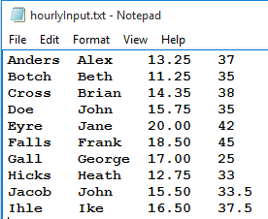

You should set up parallel arrays to hold the data (array names such as Lname, Fname, Payrate, Hours would be appropriate). Using the data you read in, you will need to compute gross pay, taxes, and net pay for each employee and store this data in parallel arrays as well.

You should test to see if the input file opens properly. If not, give a message for the user to locate the correct file and try again.

**Calculating Gross Pay**

You should set up a function that will calculate gross pay. It should be a value-returning function that returns the gross pay amount to main and be stored in a parallel array. It should have parameters for hours worked and pay rate.

NOTE: Recall that gross pay is calculated by multiplying the hours worked by the pay rate. However, if a person works over 40 hours, then they earn 1.5 times their pay rate for any hours worked over 40.

**Calculating Taxes**

You should set up constants for the tax rates as follows:

* Federal Tax = .09
* State Tax = .05
* FICA Tax = .062

You should set up a function that will calculate taxes. It should be a value-returning function that returns the total tax amount to main and be stored in a parallel array. It will have one parameter: gross pay. Since you set up the tax rates as constants (and they are therefore global), you can simply use them in calculations inside this function.

**Calculating Net Pay**

To calculate net pay, take each person’s gross pay and subtract their total tax amount. Their net pay should also be stored in a parallel array. (NOTE: You may use a function for this if you’d like, but it’s not required.)

**Output**

Once you have performed all of the necessary calculations, then you should print a report to an output file. It should be formatted in columns similar to what is shown below. Decimals should be limited to 2 decimal places.

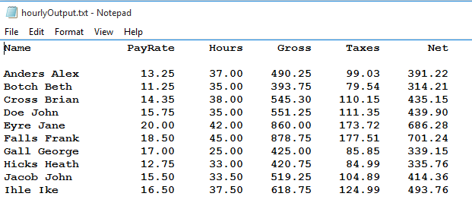

**Part 2**

Make sure that you have completed Part 1 successfully before attempting Part 2! Your output should look similar to the following.



**Add a Menuc**

Create the following menu:

* Run payroll report
* View payroll statistics
* View overtime employees
* Exit the program

Each menu option is explained below . . .

**Run Payroll Report**

This should print everything you did in Part 1. A message should print to the screen should tell the user that the payroll report ran successfully (since nothing prints to the screen).

**View Payroll Statistics**

This option should print out an appropriate title and totals for Gross Pay, Taxes, and Net Pay to the screen with appropriate labels for the user.

Something like this:

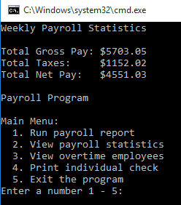

**View Overtime Employees**

This option should print to the screen an appropriate title and the names of employees who worked overtime, along with the number hours they worked.

Something like this:

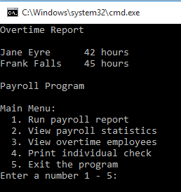

**Exit the Program**

Issue an exit message to the user that thanks them for using the program when they choose to exit.