Africa Scientifique Programme: Post-Workshop Science Communication Project Report

Name & Surname:
Date:

1. Project Activity Title
Maths Is NOT The Enemy! When Parents Change Beliefs, Children Gain Confidence

2. Introduction [objective(s), delivery date(s), target audience, platform(s), tools, formats, language, geographical locations (city, town, country) etc.

The objective of this science communication project was to communicate the importance of positive beliefs and attitudes towards mathematics, particularly among parents and grandparents of school-going children. The project was informed by Bayesian thinking, which provides a useful framework for understanding how beliefs can be updated when individuals are exposed to new evidence and experiences.

The central message of the project was that beliefs such as “maths is too hard,” “maths is only for smart people,” and “I am not good at mathematics” are not necessarily fixed. Through positive experiences, encouragement, regular practice and appropriate support, these beliefs can be updated towards a more constructive belief: “I can learn mathematics.”

The activity was delivered on 7 August 2026 at the Cape Peninsula University of Technology (CPUT) across different locations on campus. Rather than communicating with the conventional audience of school learners, I intentionally selected security guards and cleaning staff who were parents and grandparents of children currently attending primary and high school. This was influenced by the Africa Scientifique mentoring process, particularly the encouragement to think differently about the target audience and not simply communicate science to the most obvious audience.

The activity was delivered at different locations, including the campus gates, administration building, Seratec and the sports hall. I also shared the project with a doctor involved in leading a STEM club. In total, I had approximately 12 direct engagements with individuals across these settings.

The primary format was a science communication poster, supported by verbal explanation and informal discussion. I first introduced myself and the purpose of the project before explaining the problem of negative mathematical beliefs. I then used the poster to explain the transition from an old belief, such as “maths is too hard,” to a new belief, “I can learn maths,” through evidence, encouragement and positive experiences.

Because many of the people I engaged with were older adults, I adapted my communication style and used my mother tongue where appropriate(IsiXhosa), while simplifying the scientific concepts and connecting them to everyday experiences. I also shared aspects of my own journey with mathematics, including experiences from primary and high school, the fear I experienced around tests, the encouragement I received from my teachers and parents, and how those experiences contributed to where I am today.

The geographical location of the project was Cape Town, Western Cape, South Africa, specifically across the CPUT campus.

3. Outcomes of the Project Activity (impact on the audience, public engagement strategies used, delivery mechanism, special/unique aspects of the project activity)

The project generated meaningful engagement because the audience could relate directly to the issue being discussed. Most of the parents and grandparents I engaged with expressed concern about children who perceive mathematics as difficult or who do not take the subject seriously.

One grandfather explained that children often say that they hate mathematics and that mathematics is hard. This created an opportunity to move from simply identifying the problem to discussing practical ways that parents and grandparents could support their children.

A major outcome of the project was therefore increased awareness among parents and grandparents of the influence they can have on children's beliefs about mathematics. I emphasised that the language adults use around mathematics can contribute to either negative or positive beliefs. Parents were encouraged to praise effort and progress rather than only focusing on marks and perfection.

The discussions also focused on practical support mechanisms. I encouraged parents and grandparents to:

Encourage children to practise mathematics regularly.

Engage with mathematics teachers and ask for assistance when children are struggling.

Use online educational resources, including YouTube.

Make use of appropriate educational applications and digital resources.

Use emerging technologies, including AI tools, as supplementary learning resources.

Connect mathematics to everyday activities and situations.

Monitor children's use of technology and encourage productive educational activities.

Reinforce the belief that mathematics is a skill that can be developed through practice.

I also referred some parents to tutoring resources and programmes that I knew could potentially provide additional support.

An important aspect of the project was the use of my personal story as evidence. Rather than communicating Bayesian thinking only as an abstract mathematical or statistical concept, I showed how beliefs can change through lived experiences. I explained that I had also experienced fear and uncertainty around mathematics when I was younger, but through encouragement, teaching and perseverance, my relationship with mathematics changed. I connected this journey to my current position as a graduate, an intern and a postgraduate student continuing to develop academically.

This made the communication more relatable and helped demonstrate that success in mathematics is not necessarily determined by an individual being naturally “smart” at mathematics.

Another unique aspect of the project was the choice of audience and delivery mechanism. Initially, I considered that communicating the project to adults would require a conventional group setting. However, I realised that the security and cleaning staff could not easily be gathered into one room because of their work schedules and responsibilities. The only periods when many of them were together were around the beginning and end of their shifts, when they were preparing to work or go home.

I therefore had to adapt and communicate the project one person or small group at a time across different locations on campus. This required flexibility, confidence and the ability to think on my feet.

The project also created opportunities for continued engagement. Some participants asked for further assistance and exchanged contact details with me so that I could share additional information and resources with them.

4. M&E (feedback/evaluation/social media analytics) Report

No formal quantitative M&E survey or structured feedback instrument was administered during the project. The evaluation was therefore primarily based on qualitative observations, direct engagement and informal feedback from participants.
Approximately 12 individuals were directly engaged with across the different campus locations. The participants included security guards and cleaning staff who were parents, grandparents or relatives of school-going children, as well as one member of the university community involved in STEM education.
The qualitative feedback was generally positive. Participants showed interest in the topic and actively engaged in discussions about the challenges their children experience with mathematics. Several participants asked practical questions about how they could support children who struggle with mathematics.
One particularly meaningful response came from a grandfather who described how children often say that mathematics is hard and asked what he could do to help them. This demonstrated that the project had moved beyond passive communication and had created an opportunity for participants to think about their own role in changing children's attitudes towards mathematics.
Another parent discussed her first child who is currently attending university and how she hoped to encourage her younger child to take education seriously. This allowed me to discuss the importance of positive role modelling within families and how older siblings can also influence younger children.
Participants also expressed appreciation for the opportunity to have the conversation and, in some cases, requested additional assistance and resources. I provided my contact details to some participants so that further information could be shared when required.
Although there were no formal social media analytics associated with the project, the poster itself served as the primary communication resource and was used to structure the discussions.
For future activities, I would improve the M&E component by developing a short pre- and post-engagement questionnaire. This could measure changes in participants' understanding of mathematics beliefs, their confidence in supporting children and their intention to use specific strategies after the engagement.

5. Summary and Reflections (achievements, challenges, lessons learnt, recommendations and future plans)

The main achievement of this project was that I completed and delivered a science communication activity that had been personally meaningful to me for a long time. The project allowed me to communicate an issue that I have experienced personally while also applying scientific thinking to a real-world problem.

One of the most important achievements was successfully communicating a technical concept such as Bayesian thinking to an audience that did not necessarily have a background in mathematics or statistics. I learned that effective science communication is not about simplifying the science to the point where the science disappears. Rather, it is about finding ways to preserve the important scientific idea while explaining it through language, examples and experiences that the audience can understand.

A major challenge was identifying an appropriate way to reach the target audience. I initially realised that the participants could not simply be gathered into a classroom or meeting room. Their work schedules made this impractical. I therefore had to change my delivery mechanism and approach participants individually or in small groups across campus.

Another challenge was communicating scientific concepts to adults using my mother tongue. Although speaking in my mother tongue helped create familiarity and connection, I realised that scientific language is often developed and used in English through academic and professional environments. Translating complex ideas into an accessible conversational language required additional thought.

The project also taught me the importance of audience-centred communication. The same scientific message cannot necessarily be delivered in the same way to a researcher, a university student, a parent, a school learner or a member of the general public.

One of my greatest lessons was that science communication requires authenticity. Because this topic was connected to my own experiences with mathematics, I was able to communicate it with genuine conviction. I believe that the personal connection gave the project greater meaning and made the conversations more natural.

My recommendation for future science communication projects is that researchers should spend sufficient time understanding their intended audience before deciding on the communication format.

Going forward, I would like to continue communicating mathematical and statistical ideas in ways that connect with everyday life, particularly through public engagement.

6. Personal Reflections (how has delivering/sharing your science communication project activity transformed you as an emerging researcher with regard to your future plans in undertaking Science Communication/Public Engagement activities, self-confidence and ability to speak in public?)

Delivering this project transformed my understanding of myself as an emerging researcher. Before the project, I understood science communication largely as an opportunity to present research findings or explain scientific concepts. Through this experience, I realised that science communication is also about building relationships, listening to communities and creating opportunities for people to see how science relates to their own lives.
The project increased my confidence in speaking to people outside my immediate academic environment. I had to approach people I did not know, introduce myself, explain my project and sustain conversations with adults from different backgrounds. This required me to project my voice, communicate confidently and demonstrate that I understood the subject I was discussing.
One of the most important lessons I learned was the importance of carrying the project in my heart. Because the issue of mathematics beliefs is connected to my own educational journey, I was genuinely passionate about the message. I realised that when a researcher believes deeply in the relevance of a project, this comes through in the way they communicate.
The experience also strengthened my ability to translate technical concepts into accessible language. As a mathematical science student, I am accustomed to working with technical terminology, mathematical models and statistical concepts. However, communicating with parents and grandparents reminded me that understanding the science myself is only the first step. I must also be able to communicate that understanding to people who do not share my academic background.
The project also strengthened my sense of responsibility as a researcher. It would have been easy to complete the project superficially by producing the poster and taking photographs with participants. However, I felt strongly that the purpose of the programme was to genuinely communicate science. I therefore chose to approach people, have meaningful conversations and deliver the project properly. I now see myself as a woman of integrity (doing the right thing when no one sees you)…
This experience has strengthened my desire to incorporate science communication and public engagement into my future career as a researcher and data professional. I would like to become better at communicating mathematical, statistical and data-driven insights to both technical and non-technical audiences.
Most importantly, the project reminded me that research should not remain confined to academic spaces. Scientific knowledge becomes more valuable when it can be understood, discussed and used by the communities it is intended to serve.

7. Media and Resources Attachments/Links (activity photos, videos, posters, blogs, M&E surveys, social media snapshots etc.)

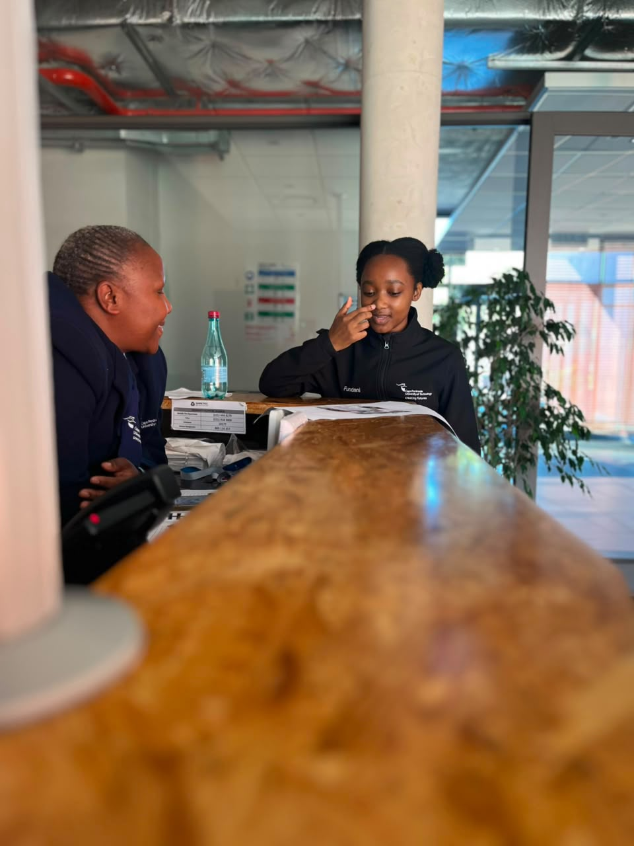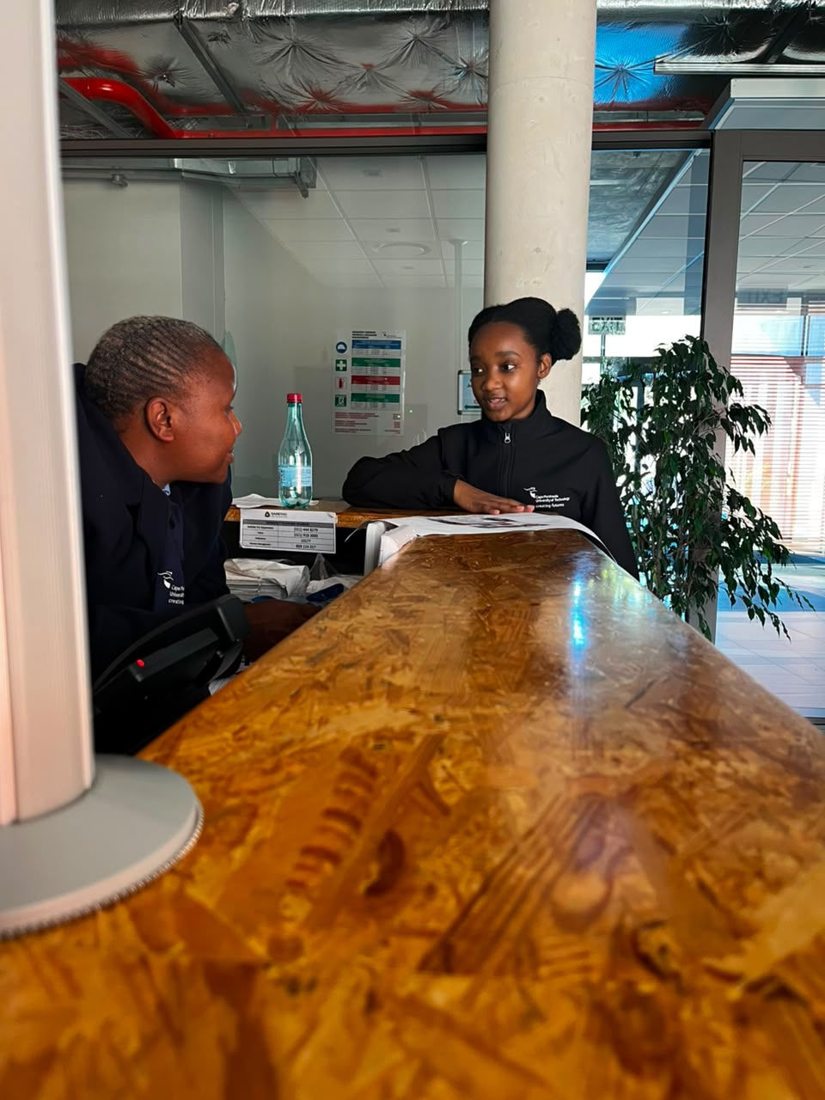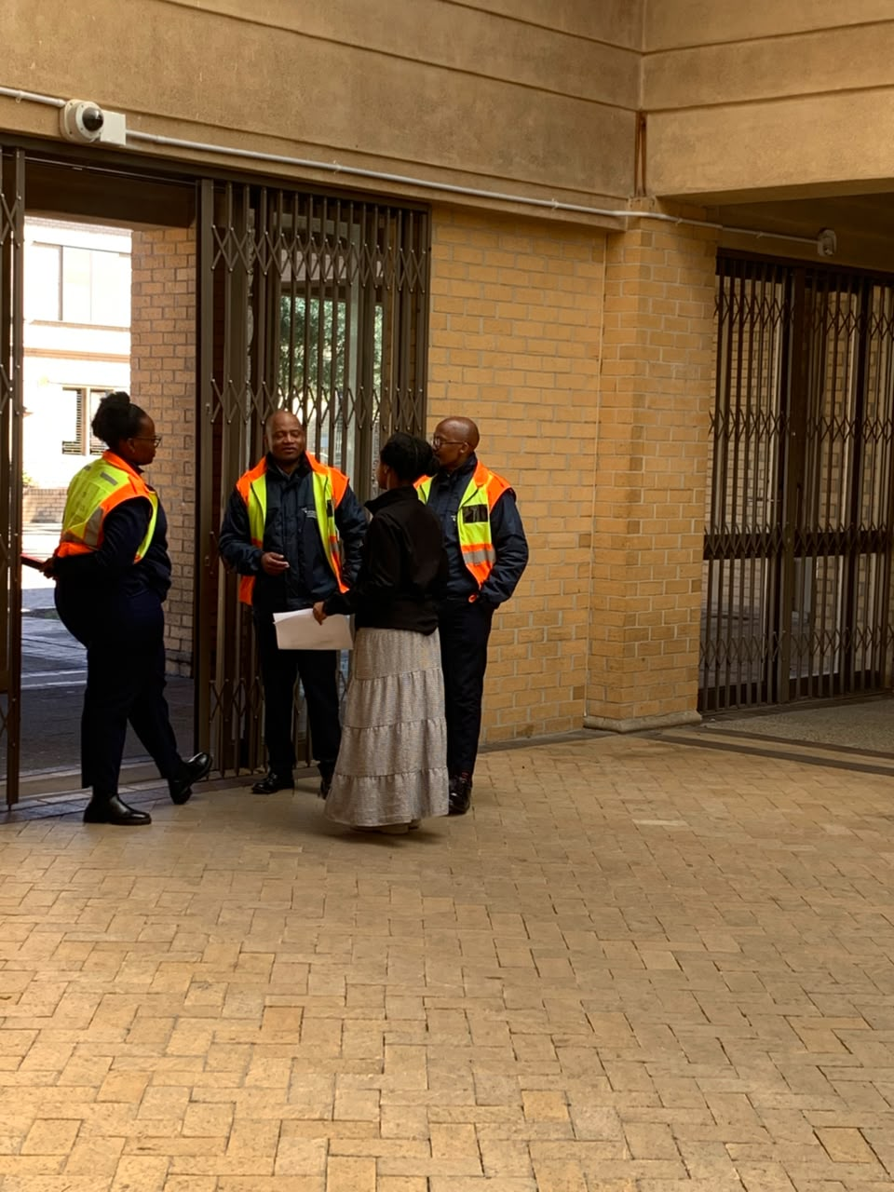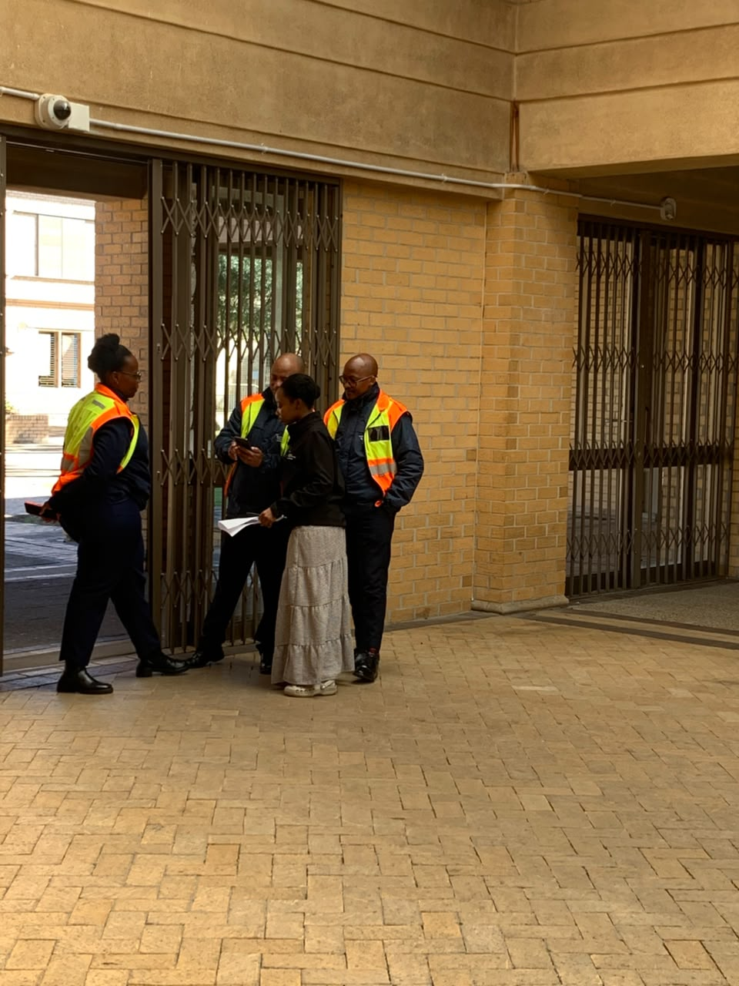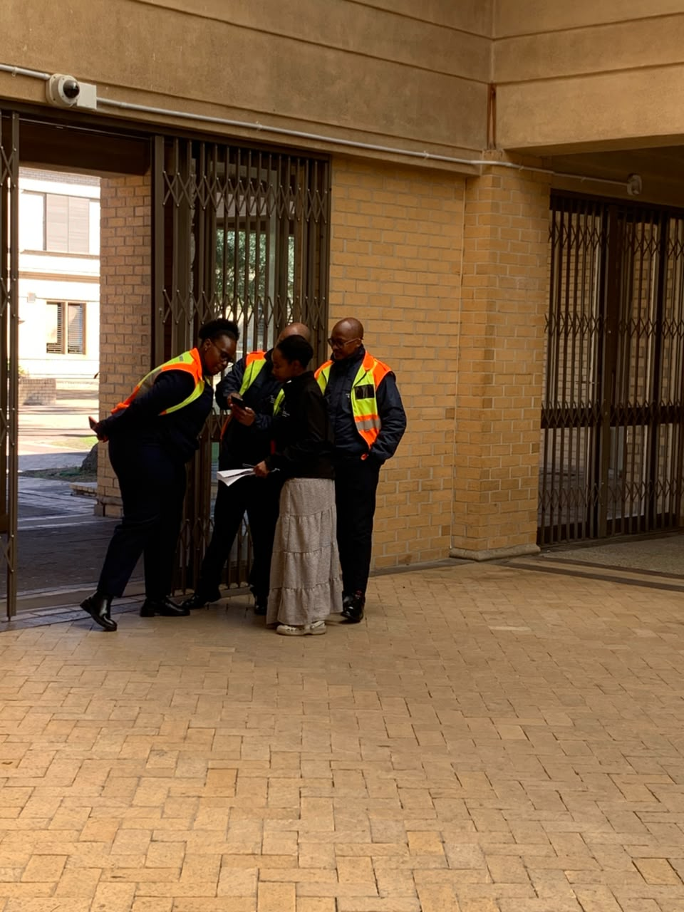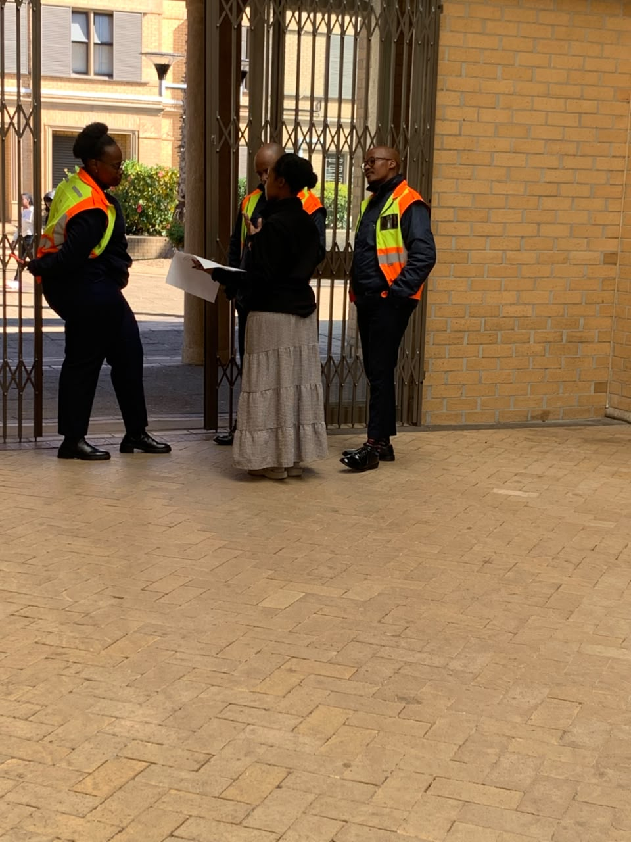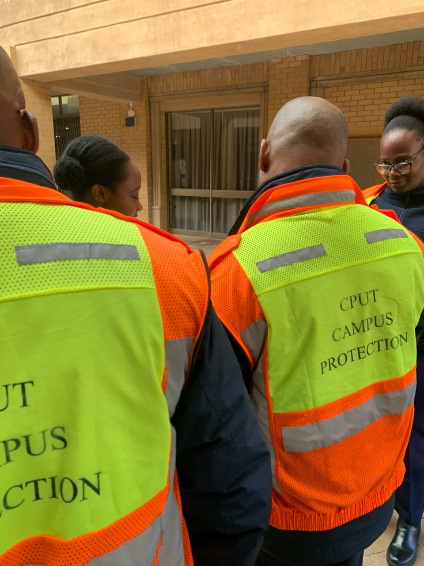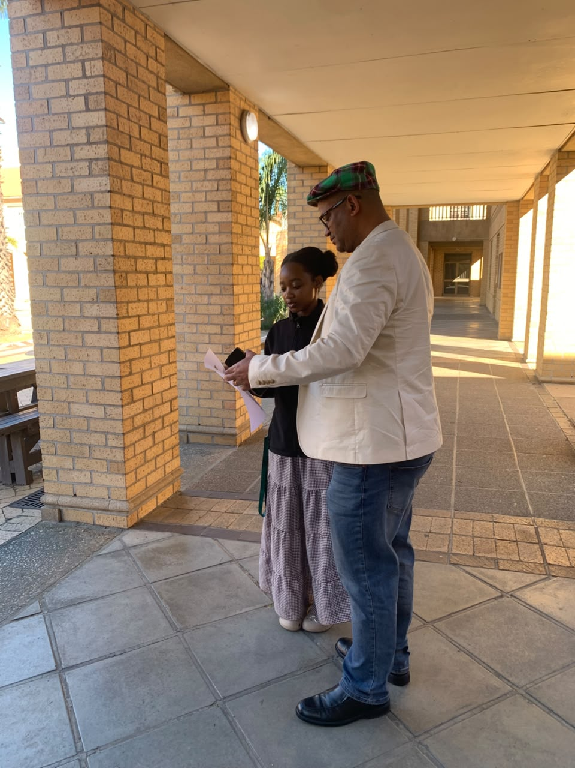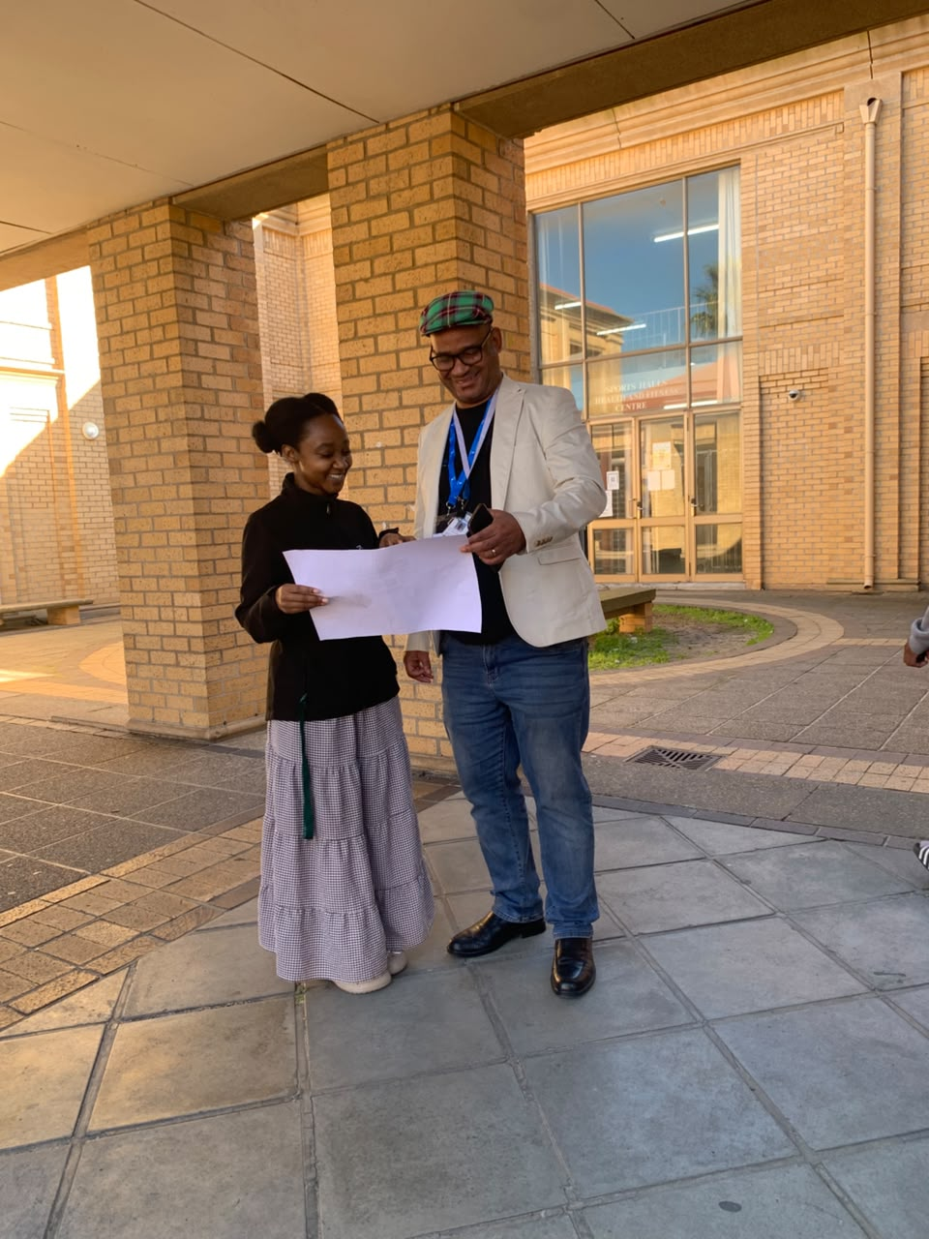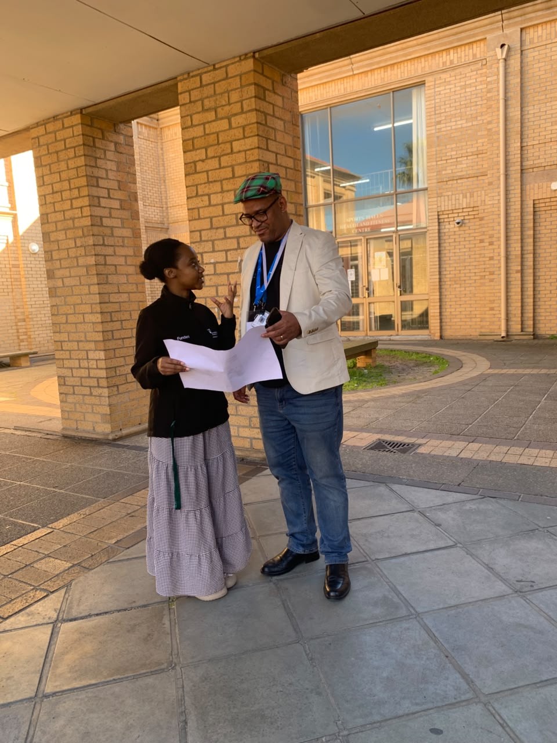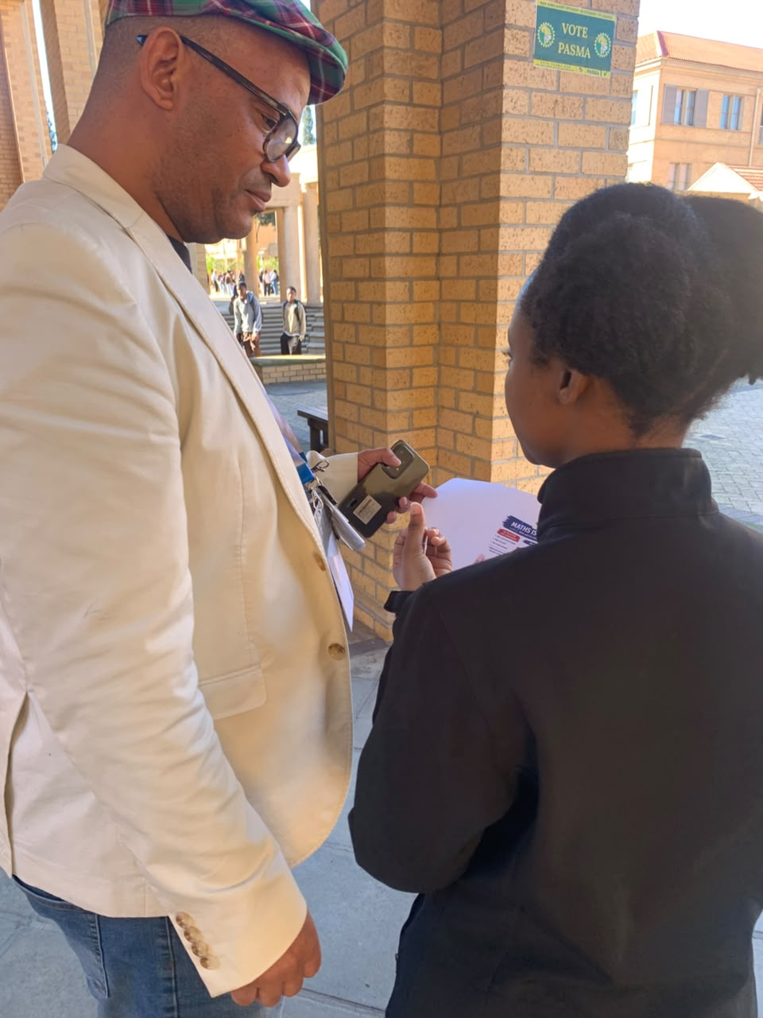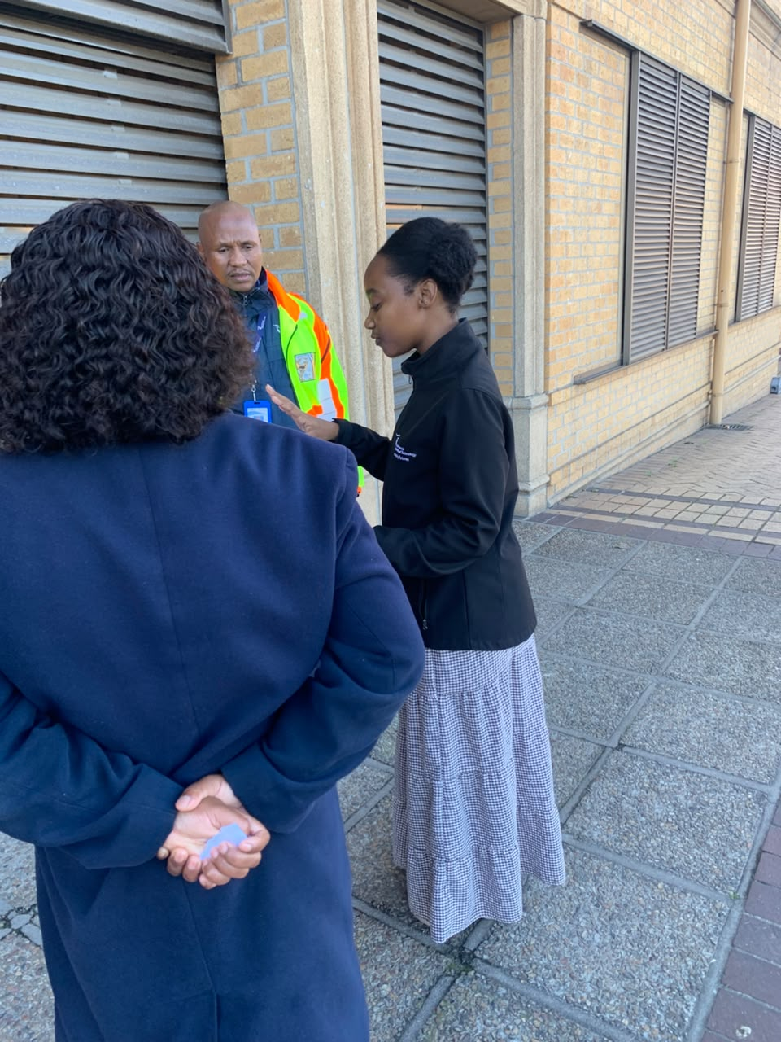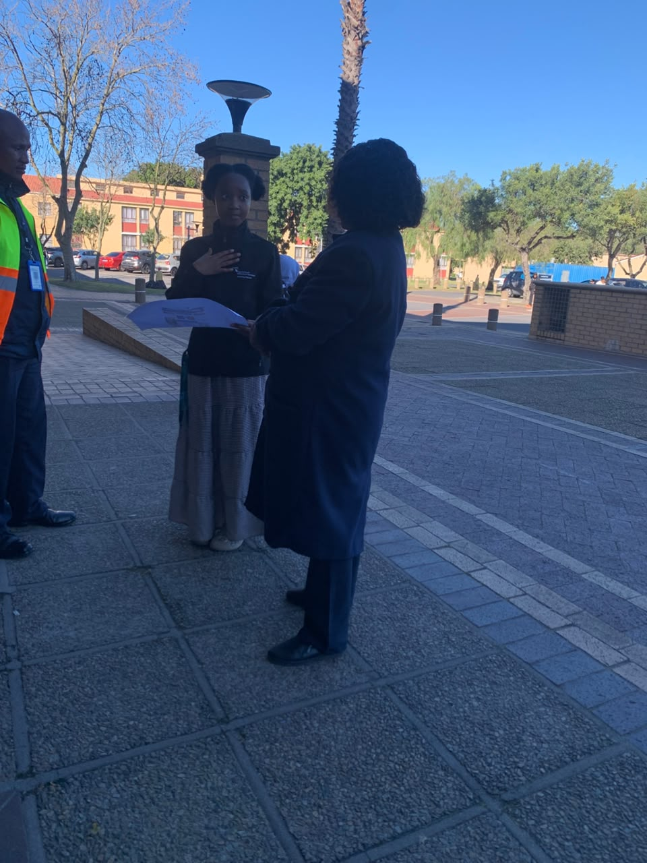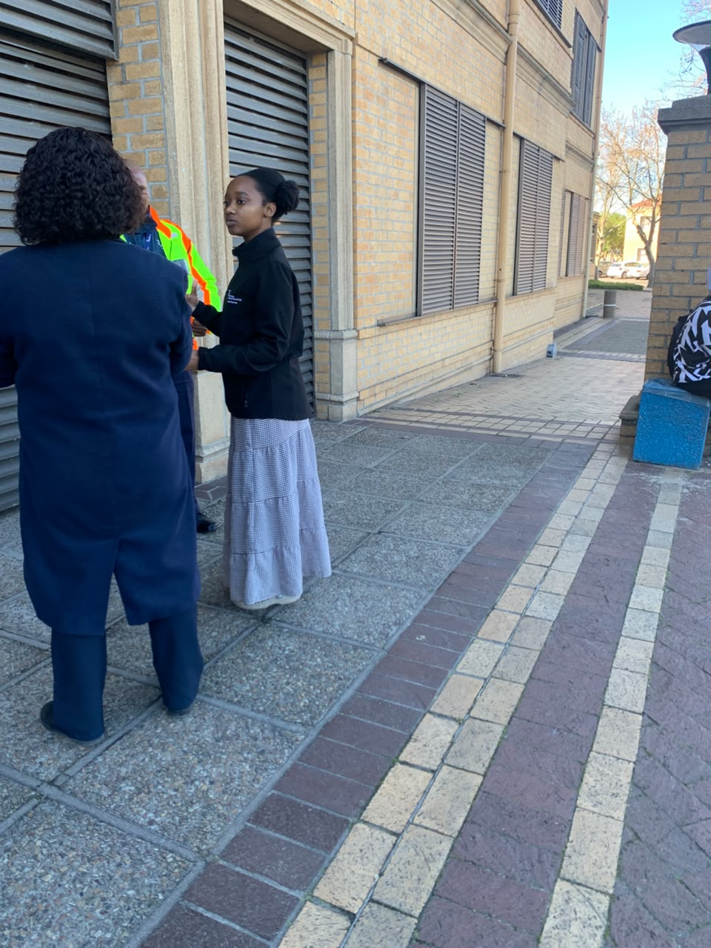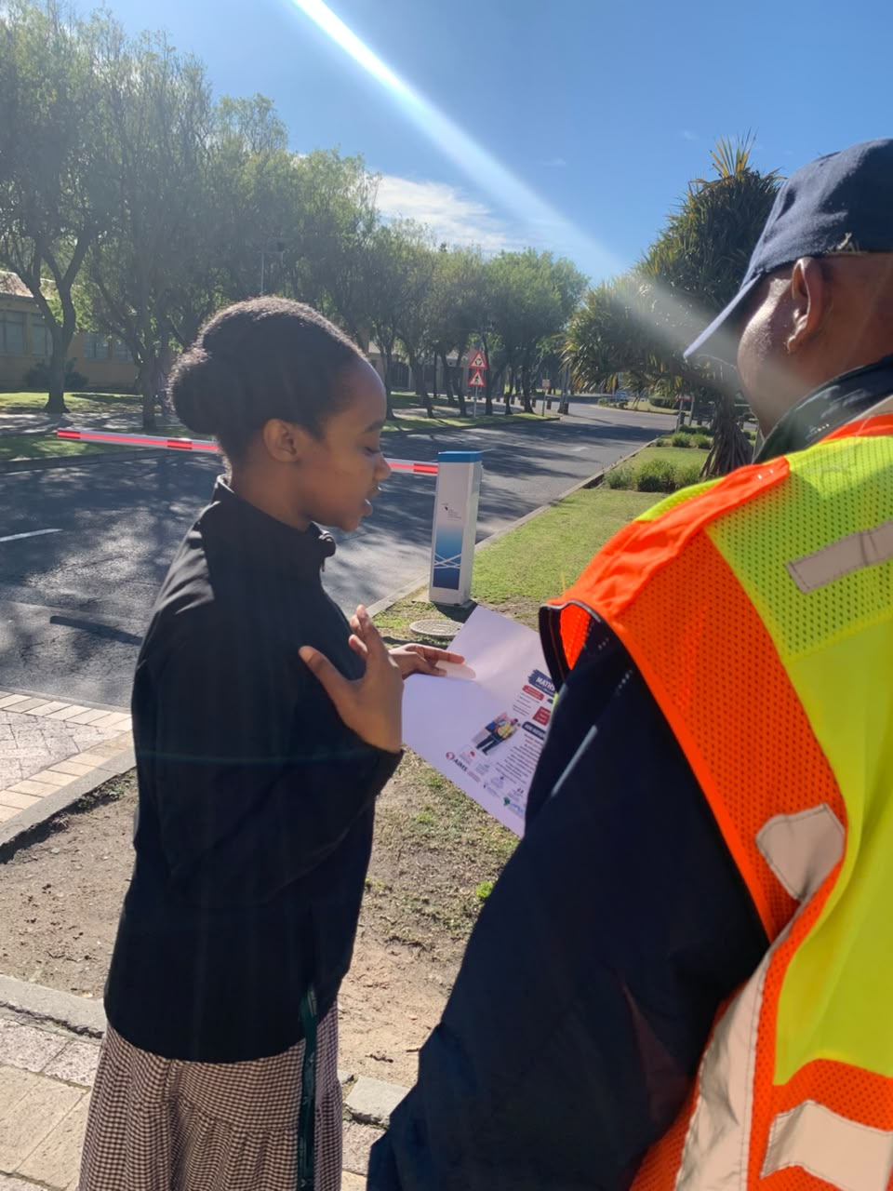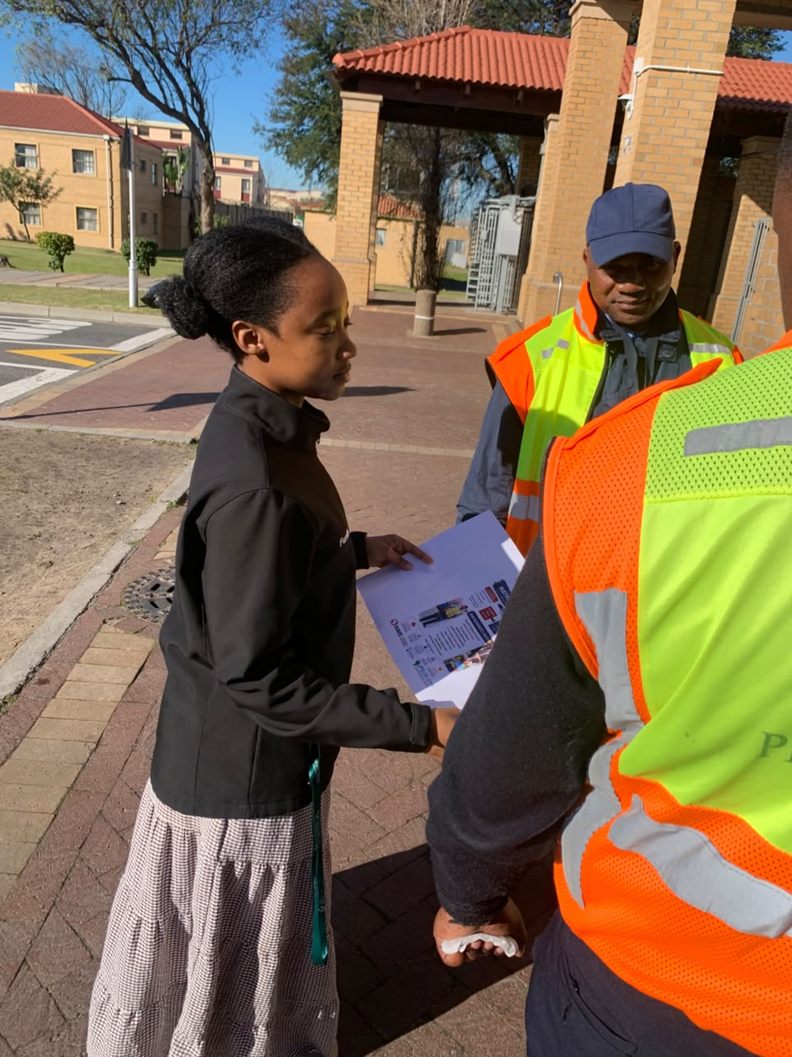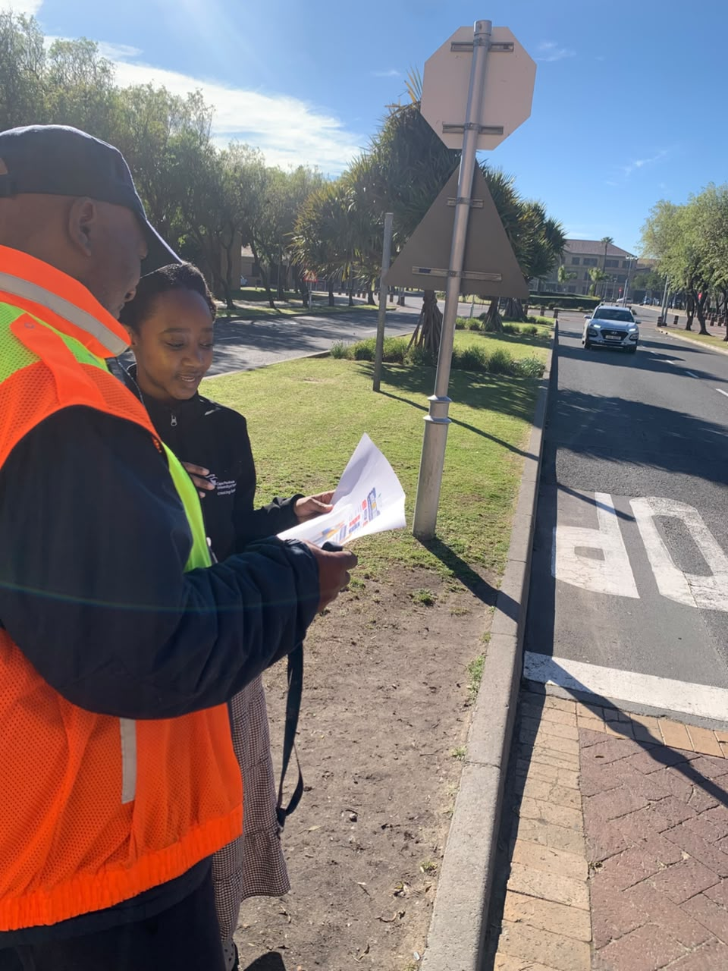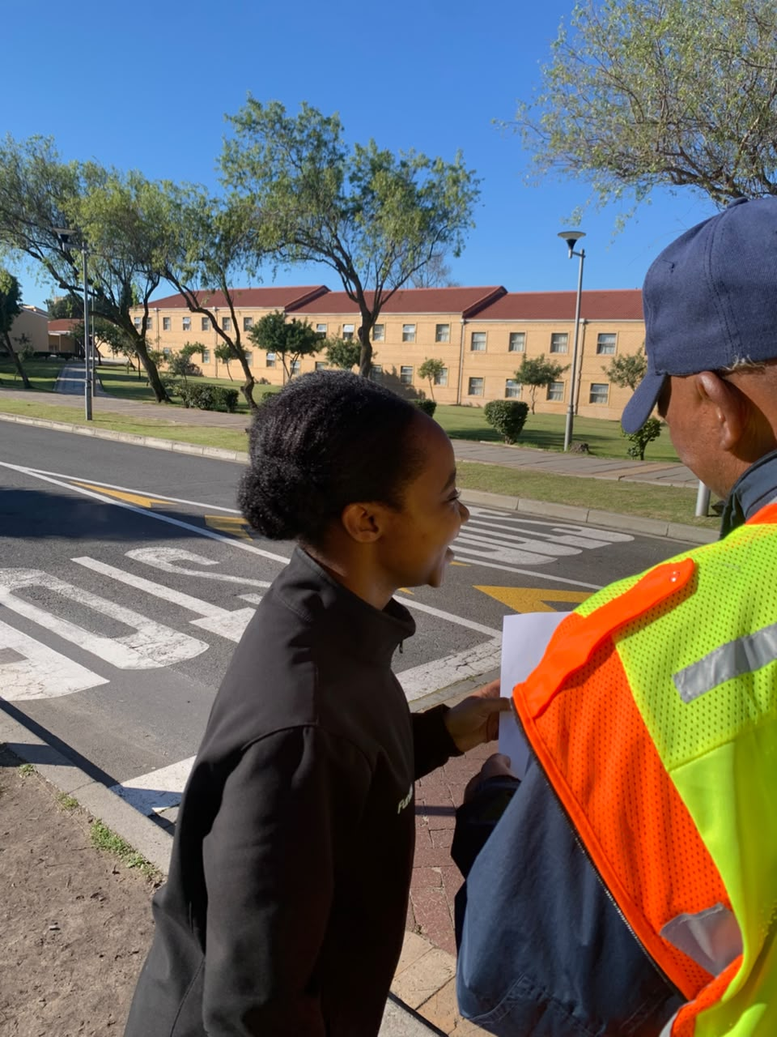

8. You have participated in the Africa Scientifique 3-day workshop and undertaken the six-month post-Workshop activity. On reflection, what insights from the workshop have had a long-lasting impact on you?
The most significant lesson I took from the Africa Scientifique workshop and the subsequent mentoring process was the importance of starting a project and actually seeing it through to completion.
Throughout the process, the coordinators and mentors, including the Africa Scientifique and AIMS team, consistently encouraged us to complete our projects. Seeing other participants who had completed their projects also provided motivation and accountability.
This was particularly meaningful to me because there were several points during the six-month period when I was tempted to abandon the project. I was balancing full-time work, academic responsibilities and personal commitments. Completing the project therefore required discipline and intentionality.
The workshop also changed how I think about science communication audiences. I initially thought more conventionally about who might be appropriate to receive a mathematics communication project. However, the mentoring process challenged me to think beyond the obvious audience. The encouragement to communicate with people other than learners led me to identify parents and grandparents as an important audience because they have a direct influence on children's beliefs and attitudes.
Another long-lasting insight was the importance of projecting my voice and communicating with confidence. I learned that researchers must be willing to speak clearly and confidently about their work. Knowing the science is not enough; researchers must also be able to communicate why their work matters.
The workshop also reinforced the importance of integrity in research and science communication. I learned that completing the activity authentically is more important than simply producing evidence that an activity took place. It would have been possible to take photographs with participants without genuinely communicating the science. However, I understood that the real purpose of the programme was engagement and dissemination.
This experience strengthened my belief that integrity takes you a long way. The project became meaningful because I genuinely delivered the message rather than simply completing a requirement.
Finally, I learned that science communication is most powerful when the researcher has a genuine connection to the issue. This project had been in my heart long before the Africa Scientifique programme. The programme helped me transform that personal concern into a structured and meaningful science communication activity.

9. What aspects of the Post-Workshop Mentoring phase over these six months have you found most useful, beneficial and impactful?

The most useful aspect of the six-month mentoring phase was the continued accountability and encouragement to complete the project. The regular encouragement from the coordinators and mentors helped me remain committed even when balancing the project with work and academic responsibilities became difficult.
The mentoring also helped me think more creatively about my target audience and communication approach. In particular, the encouragement from the mentors to avoid always communicating with learners challenged me to identify an audience that could influence the problem indirectly. This led me to focus on parents and grandparents.
Another valuable aspect was seeing examples of other participants who had completed their projects. These examples helped demonstrate that the projects were achievable and encouraged me to move from planning to implementation.
The mentoring process also strengthened my understanding of how to package a scientific message. I learned that a science communication project needs a clear message, an identifiable audience and a communication method that is appropriate for that audience. The Africa Scientifique programme helped me move from an idea that existed in my heart to a project that could be communicated visually and verbally.
The mentoring also helped me develop confidence in presenting my ideas. I became more conscious of my voice, how I explain concepts and how I interact with an audience.
Most importantly, the mentoring phase reinforced the value of finishing what I start. The completion of this project is significant to me because it required me to persist despite competing responsibilities. I am grateful for the collaboration between Africa Scientifique, AIMS, CPUT and the other participating institutions that created an opportunity for emerging researchers to take ideas that matter to them and bring them into real communities.
The experience has encouraged me to continue developing as a researcher who not only produces knowledge, but also communicates that knowledge with integrity, confidence and purpose.

