ISJ107V · Integrated Software Project · Assignment 3
FireSight
Project Documentation and UML Design
An Integrated Drone Command Platform for Municipal Fire and Rescue Services
Emerging technology: AI / Machine Learning (CNN thermal-image analysis)
Student | Smangele Manaka
Student number | 218503322
Module | ISJ107V (S2 2026), Assessment weighting 20%, 50 marks
Version / date | 1.0 · 30 September 2026
Submission | Through EC (individual)

How to read the results. The system was built as a prototype and tested by simulation. Every number in this document was measured on that prototype. Where a requirement is only partly met, or not met, or was not tested, the document says so.

Contents
Question 1: Final Project Baseline 3
1.1 Project identity and executive summary 3
1.2 Final aim, objectives, scope and approved changes 3
1.3 Document control 5
Question 2: Requirements and Traceability 7
2.1 Final prioritised requirements 7
2.2 Requirements traceability matrix 7
2.3 How the emerging-technology requirements are satisfied 8
Question 3: Final Design as Implemented 10
3.1 System architecture 10
3.2 Use-case diagram and detailed use case 11
3.3 Class diagram 12
3.4 Sequence diagram: thermal-frame analysis 13
3.5 Activity diagram: end-to-end incident workflow 13
3.6 Component and deployment diagrams 16
Question 4: Implementation Documentation 19
4.1 Technology stack, structure, modules and interface 19
4.2 Database 24
4.3 Main API interface 26
4.4 Installation, configuration and deployment 28
Question 5: Evaluation and Responsible Use 29
5.1 Test summary 29
5.2 Quantitative evaluation 30
5.3 User guide for the main workflow 31
5.4 Limitations, risks, ethics, maintenance and future work 32
References 33

Question 1: Final Project Baseline

1.1 Project identity and executive summary
Project title | FireSight: An Integrated Drone Command Platform for Municipal Fire and Rescue Services
System purpose | Give incident commanders real-time aerial intelligence during a fire: automatic drone dispatch from a CAD alert, live telemetry, AI analysis of thermal imagery, a GIS map with hotspots and a fire-spread forecast, firefighter position tracking, a command message channel, and an automatic post-incident report.
Intended users | Incident commanders, drone operators, field crew and system administrators of a municipal fire and rescue department (City of Tshwane is the reference municipality).
Emerging technology | Artificial Intelligence / Machine Learning: a Convolutional Neural Network (PyTorch) that classifies each thermal frame as No Fire, Fire or Critical, followed by OpenCV hotspot segmentation and georeferencing onto the GIS map.
Delivered artefact | A working software prototype (FastAPI backend, browser command dashboard, AI engine, Hardware Abstraction Layer with a drone and fire simulator). It is exercised end to end by simulation. No physical drone, live CAD feed, Azure environment or mobile app was used or built.

Executive summary. FireSight addresses the problems recorded in Assignment 1: crews arrive at a fire without an aerial view, dispatch is manual and slow, communication is fragmented, fire spread is not predicted and incident learning is weak. The implemented solution turns a CAD alert into a drone dispatch in milliseconds, streams drone telemetry to a command dashboard at 10 Hz, classifies thermal frames at 10 frames per second in about 2 ms each, plots georeferenced hotspots and a wind-driven spread polygon on a map, lets commanders message all units, and generates an incident report on closure.
The central design decision from Assignment 2 was kept: a Hardware Abstraction Layer (HAL) so that the whole platform runs on simulated drone data and a real drone SDK can later be swapped in without changing the dashboard, AI engine or reporting. The prototype was verified with 23 automated tests (all passing, 87.4% line coverage) and by driving the real dashboard in a browser. Several requirements are only partly met or not met; Section 2.2 states each result plainly.

1.2 Final aim, objectives, scope and approved changes

Aim
Through an integrated command platform for municipal fire and rescue services, reduce the time to start assessing a priority-1 fire from the current manual baseline of about 10 minutes to under 4 minutes, and give commanders live, AI-assisted situational awareness, so that fire-related deaths and property damage can be reduced. (Assignment 1 and 2 stated "a 40% reduction … from 10 minutes to under 4 minutes". Under 4 minutes is a reduction of at least 60%, so the wording is corrected here.)

Measurable objectives and outcome
# | Objective (SMART) | Result in the delivered prototype | Status
O1 | Drone dispatch initiation for priority-1 calls under 4 minutes (target 30 s, FR-01). | CAD alert to drone en_route measured at 0.001 s on the server and 68.1 ms for the full HTTP round trip, in simulation. The 10-minute baseline is a human process and is not directly comparable; real-world drone launch time is not included. | Delivered
O2 | Command dashboard with thermal imaging, GIS mapping and spread prediction, used by 80% of commanders in active events. | Dashboard delivered with live telemetry, AI panel, hotspot overlay, spread polygon, chat and report. The 80% adoption figure needs pilot users and was not measured (Section 5.1, UAT). | Partly delivered
O3 | GPS tracking and communication for 100% of ground crews, halving relay time. | Crew location and messaging work through the REST API and dashboard. The React Native mobile app was not built, and relay-time reduction was not measured. | Partly delivered

Scope
Scope item (Assignment 2) | Delivered as
Command dashboard | Delivered (HTML/JS + Leaflet, not React)
Automated drone dispatch | Delivered (nearest idle drone, battery of at least 30%, queueing when none free)
AI thermal analysis | Delivered (CNN trained on synthetic frames, not FLAME)
GIS fire-spread prediction | Partly delivered (heuristic; terrain data not used)
Firefighter GPS tracking | Partly delivered (API and dashboard; no mobile app)
Post-incident reporting | Delivered (JSON report with worst thermal frame and timeline; no PDF export)
Hardware Abstraction Layer for simulation | Delivered (SimulatedDrone adapter; DJI adapter is an unimplemented stub)
Out of scope: drone procurement, SACAA permits, replacing the CAD system | Unchanged

Changes since Assignment 2
Lecturer approval must be confirmed. Assignment 3 asks for approved changes. The changes below were made by the developer because of time and environment limits. None is recorded as approved by the lecturer, so confirm or obtain approval before submitting, or state them as deviations.

ID | Change | Justification
C1 | Dashboard built in plain HTML/JavaScript with Leaflet instead of React 18 + TypeScript. | Smallest build that still delivers every dashboard function in the time available. UI logic is about 140 lines and can be ported to React.
C2 | Native WebSocket used instead of Socket.IO. | FastAPI supports WebSocket natively, removes the python-socketio dependency, and matches the wording of FR-02 and FR-07.
C3 | React Native mobile app not built. Crew GPS and messaging use REST endpoints. | Time. This is why FR-08 is Not met and FR-06 is Partial.
C4 | AI engine is a module inside the API container, not a separate microservice. The contract POST /api/v1/ai/analyse is unchanged. | One container is simpler to run and test. The module boundary keeps the option of splitting it out later.
C5 | PyTorch only (no TensorFlow). Trained on synthetic thermal frames, not the FLAME dataset. | The FLAME dataset could not be downloaded from the build environment (network allow-list). The synthetic generator is in app/ai/synth.py.
C6 | Two extra collections (users, messages) plus a counters collection. Thermal frames and AI results are stored in telemetry with kind=thermal. | Needed for authentication and the command channel. Assignment 2 listed five collections.
C7 | Nearest-drone search uses a haversine calculation in the service, not a MongoDB $near query. | The in-memory test database does not support $near. The 2dsphere indexes are created so Atlas can use $near in production.
C8 | OpenWeatherMap is optional. Without OPENWEATHER_KEY a fixed simulated wind is used. | No API key or outbound network in the build environment.
C9 | Azure deployment and Docker image build not performed. Dockerfile and compose file are provided. | No Azure subscription. The Docker daemon was unavailable in the build environment.
C10 | Corrected two inconsistencies in Assignment 2: the 40% versus 60% dispatch-reduction wording, and the report requirement reference (FR-09, not FR-10). | Internal consistency.

1.3 Document control
Document | FireSight: Project Documentation and UML Design (ISJ107V Assignment 3)
Version | 1.0 (final)
Date | 30 September 2026
Author | Smangele Manaka, student number 218503322
Status | Submitted for assessment

Version | Date | Change
0.1 | 30 Jul 2026 | Assignment 1: project proposal, vision, SMART goals, deliverables, 26-week plan, resources (marked 62/70).
0.2 | Aug–Sep 2026 | Assignment 2: requirements, technology stack, architecture, UML models, testing plan.
1.0 | 30 Sep 2026 | Assignment 3: implemented prototype, updated UML, traceability, evidence, user and maintenance documentation.

Glossary
Term | Meaning
CAD | Computer-aided dispatch: the municipal emergency call-taking system.
HAL | Hardware Abstraction Layer: interface that hides whether a drone is real or simulated.
CNN | Convolutional Neural Network, used to classify thermal frames.
FLAME | A public aerial fire-imagery dataset (Shamsoshoara et al., 2021), named in ETR-01.
GIS / GeoJSON | Geographic information system; JSON format for map geometry.
RBAC / JWT | Role-based access control; JSON Web Token used to carry the signed user role.
RTM | Requirements traceability matrix.
FR / NFR / ETR | Functional, non-functional and emerging-technology requirement.
UAT | User acceptance testing with real end users.
POPIA | Protection of Personal Information Act 4 of 2013 (South Africa).
SACAA | South African Civil Aviation Authority (drone regulation).

Referenced project artefacts
Artefact | Location
Assignment 1 marked test (proposal) and Assignment 2 technical specification | 03c8f0bc-218503322_2.pdf, FireSight_Assignment2.docx
Source code repository | Local repository folder firesight/ (submitted as a zip). Add the remote repository URL here before submission.
Backend, AI, HAL | app/main.py, app/ai/, app/hal/, app/spread.py, app/report.py, app/security.py, app/db.py, app/geo.py
Dashboard | app/static/index.html, app/static/app.js
Tests | tests/test_unit.py, tests/test_integration.py, tests/test_system.py
Evidence files | artifacts/junit.xml, coverage.json, system_metrics.json, ui_metrics.json, ai_metrics.json, evidence.json
UML sources and images | docs/uml/*.mmd (Mermaid source) and *.png
Screenshots | docs/screens/01_login.png to 07_crew_view.png
Reproduce measurements | scripts/ui_capture.py, scripts/collect_evidence.py, app/ai/train.py

Question 2: Requirements and Traceability

2.1 Final prioritised requirements
Identifiers and priorities (MoSCoW) are those of Assignment 2. Acceptance criteria are restated so that each can be checked with a number. The Assignment 2 numbering gaps (NFR-03, NFR-04, and so on) are kept, because those requirements were never specified.
ID | Priority | Requirement | Measurable acceptance criterion
FR-01 | Must | Dispatch the nearest available drone when a CAD alert arrives. | Given a valid alert, the nearest idle drone with battery of 30% or more is assigned and marked en_route within 30 s.
FR-02 | Must | Stream drone telemetry (GPS, altitude, battery, heading) to the dashboard over WebSocket. | Dashboard receives each update within 500 ms of ingest.
FR-03 | Must | Classify each thermal frame as No Fire, Fire or Critical. | Result returned within 100 ms per frame.
FR-04 | Must | Overlay detected hotspots on the GIS map during an incident. | Hotspot event reaches the map within 2 s of detection.
FR-05 | Should | Produce a fire-spread prediction overlay every 60 s from hotspots, weather and terrain. | Overlay refreshes every 60 s using current hotspot, weather and terrain inputs.
FR-06 | Must | Track all deployed firefighters by GPS on the dashboard (mobile app). | Dashboard shows a crew position within 5 s of the update.
FR-07 | Should | Command messaging between commanders, operators and crew. | A sent message reaches every connected recipient in real time.
FR-08 | Must | Mobile app usable one-handed with gloves; buttons at least 44 × 44 px. | Gloved one-handed operation without mis-taps.
FR-09 | Should | Automatic post-incident report with thermal image, hotspot timeline and AI analysis. | Report available within 5 minutes of closing an incident.
FR-10 | Must | Whole system runs on simulated drone data through the HAL. | Dispatch, telemetry, AI analysis and reporting all work with no drone hardware.
NFR-01 | Must | Reliability: uptime and automatic failover during incidents. | 99.5% uptime during incident handling, with automatic backend failover.
NFR-02 | Must | Performance: dashboard load time. | Loads within 3 s on a 10 Mbps connection.
NFR-05 | Should | Supportability: containerised services. | Backend runs from a Docker image on any cloud with no code change.
NFR-10 | Must | Security: data encrypted in transit and at rest. | TLS 1.3 in transit; AES-256 for data stored in MongoDB Atlas.
ETR-01 | Must | CNN accuracy before deployment. | At least 90% accuracy on the FLAME validation split.
ETR-02 | Must | Real-time inference rate and CPU budget. | At least 10 frames/s sustained with no more than 80% CPU.
ETR-04 | Should | Hotspot localisation accuracy. | Hotspots localised within 5 m when georeferenced onto the map.

2.2 Requirements traceability matrix
Test cases are defined in Section 5.1 (UT = unit, IT = integration, ST = system). UML references point to the figures in Section 3 (UC = use case in Figure 2). Status is Pass, Partial or Not met, judged against the acceptance criterion above, not against a relaxed version of it.
Req. | UML reference | Module | Test case | Status
FR-01 | UC-02, Fig. 2, 4, 5a | app.main dispatch(), nearest_available_drone() | IT-02, IT-04, ST-01 | Pass
FR-02 | UC-03, Fig. 4 | app.main ingest_telemetry(), Hub | IT-05, ST-01 | Pass
FR-03 | UC-04, Fig. 4 | app.ai.engine AIEngine.analyse() | UT-06, IT-06, ST-01 | Pass
FR-04 | UC-05, Fig. 4 | hotspots event, app.static/app.js | IT-06, ST-01, UI capture | Pass
FR-05 | UC-06, Fig. 6 | app.spread predict(); 60 s timer in app.js | UT-08, IT-10 | Partial
FR-06 | UC-07, Fig. 3 | /firefighters/{id}/location, Hub | IT-07 | Partial
FR-07 | UC-08, Fig. 3 | /messages, Hub | IT-08 | Pass
FR-08 | None (no mobile client) | Not implemented | None | Not met
FR-09 | UC-09, UC-10, Fig. 3 | app.report build_report() | IT-09, ST-01 | Pass
FR-10 | Fig. 3, 6 (DroneAdapter) | app.hal SimulatedDrone, FireScenario | UT-09, IT-11, ST-01 | Pass
NFR-01 | Fig. 7 (deployment) | None (single process, no failover) | None | Not met
NFR-02 | Fig. 7 | app.static (index.html, app.js) | UI capture (5 cold loads) | Pass
NFR-05 | Fig. 7 | Dockerfile, docker-compose.yml | Not run (no Docker daemon) | Partial
NFR-10 | Fig. 7 | app.security; TLS at server/gateway | UT-01, UT-02, ST-02 | Partial
ETR-01 | Fig. 1, 4 | app.ai.train, app.ai.model | UT-06, training run | Partial
ETR-02 | Fig. 4, 7 | app.ai.engine, mission loop | ST-01 | Partial
ETR-04 | Fig. 4 | app.ai.engine hotspots(), app.geo | UT-07, UT-04, sweep | Partial

Summary of the 17 requirements: 8 Pass, 7 Partial, 2 Not met. Not met: FR-08 (no mobile app) and NFR-01 (no uptime measurement or failover exists). Partial results are explained in Section 2.3 and Section 5.2. On FR-04: the hotspot event is broadcast in the same processing step as the detection (inference p95 2.41 ms), so it reaches the browser well inside 2 s; the browser drawing time itself was not instrumented.

2.3 How the emerging-technology requirements are satisfied

ETR-01: CNN accuracy of at least 90% on the FLAME validation split (Partial)
The CNN (137,219 parameters, 3 convolution blocks and a 3-class head) reaches 98.58% accuracy on a held-out validation set of 1,200 frames, and 90% or more on 450 freshly generated frames in UT-06. This is not the FLAME dataset. FLAME could not be downloaded in the build environment, so the model was trained and validated on synthetic thermal frames that include warm-roof distractors and overlapping class sizes. The number shows the pipeline works and that the model separates the three classes on this data. It does not show real-world accuracy, and the requirement as written is therefore only partly satisfied. Retraining on FLAME plus locally captured footage is the first future improvement (Section 5.4).

ETR-02: 10 frames per second within an 80% CPU budget (Partial)
A live server test streamed thermal frames for 15 s on scene at 10 frames/s (226 frames analysed over the whole run). Inference took a median of 1.69 ms and a p95 of 2.41 ms per frame, and the server used about 5.9% of one core on a 2-core machine, far below the 80% ceiling. The requirement names an Azure App Service instance, which was not available, so the result is Partial. An earlier version of the mission loop slept a fixed 100 ms after each frame and reached only 9.43 frames/s. This was fixed with a fixed-rate schedule and re-measured.

ETR-04: hotspots localised within 5 m (Partial)
Hotspots are found by thresholding the frame, labelling connected components and projecting each component centroid to latitude and longitude with a nadir-camera model (60° field of view, drone GPS, altitude and heading). Against the simulator's known fire positions, a sweep over 4 fires, 3 altitudes (60, 80, 100 m) and 30 time steps produced 381 hotspot detections: median error 0.55 m, 95th percentile 1.37 m, and 379 of 381 (99.5%) within 5 m. Two detections exceeded 5 m (worst 41.31 m), both in Critical frames where a large blob was merged or clipped at the frame edge. Because the requirement says "within 5 metres" without a percentile, and the ground truth is simulated (real GPS and camera error are not included), the status is Partial.

Question 3: Final Design as Implemented
All diagrams were drawn with Mermaid (mermaid-cli 11.14) from text sources kept in docs/uml/*.mmd, so they can be regenerated and reviewed in version control. Names are identical across diagrams: Incident, Drone, TelemetrySample, AIResult, Hotspot, Firefighter, Message, Report, DroneAdapter, AIEngine. Anything drawn with a dashed grey box or marked "not built" is planned but not implemented.

3.1 System architecture
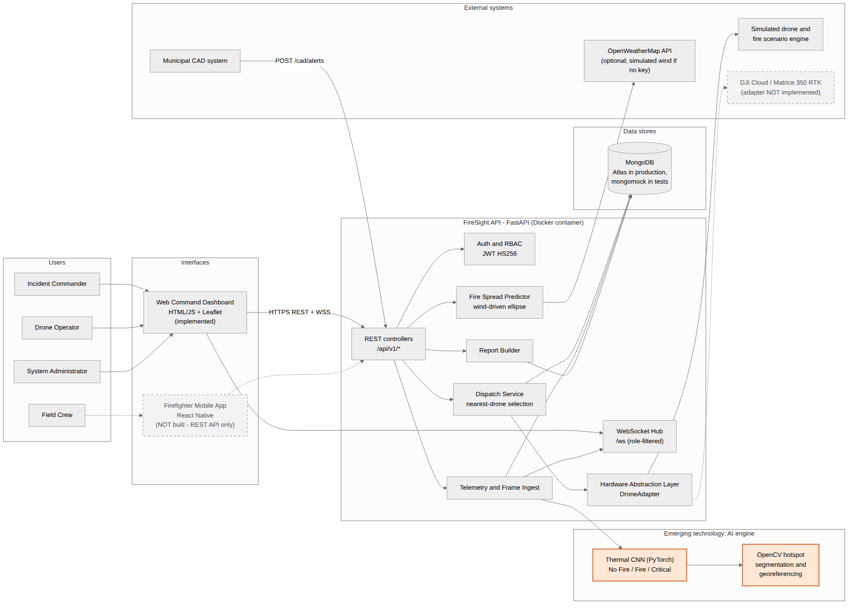
Figure 1. High-level architecture: users, interfaces, services, data store, external systems and the AI component (orange).
Users reach the API through the browser dashboard over HTTPS/WSS. The CAD system posts alerts to the same API. Inside the API container, controllers call the dispatch service, the ingest path (which calls the AI engine) and the report builder, and a role-filtered WebSocket hub pushes events back to the dashboards. The HAL hides the drone: the prototype uses the simulator, and a DJI adapter is a documented extension point. MongoDB stores all state. OpenWeatherMap is optional.

3.2 Use-case diagram and detailed use case
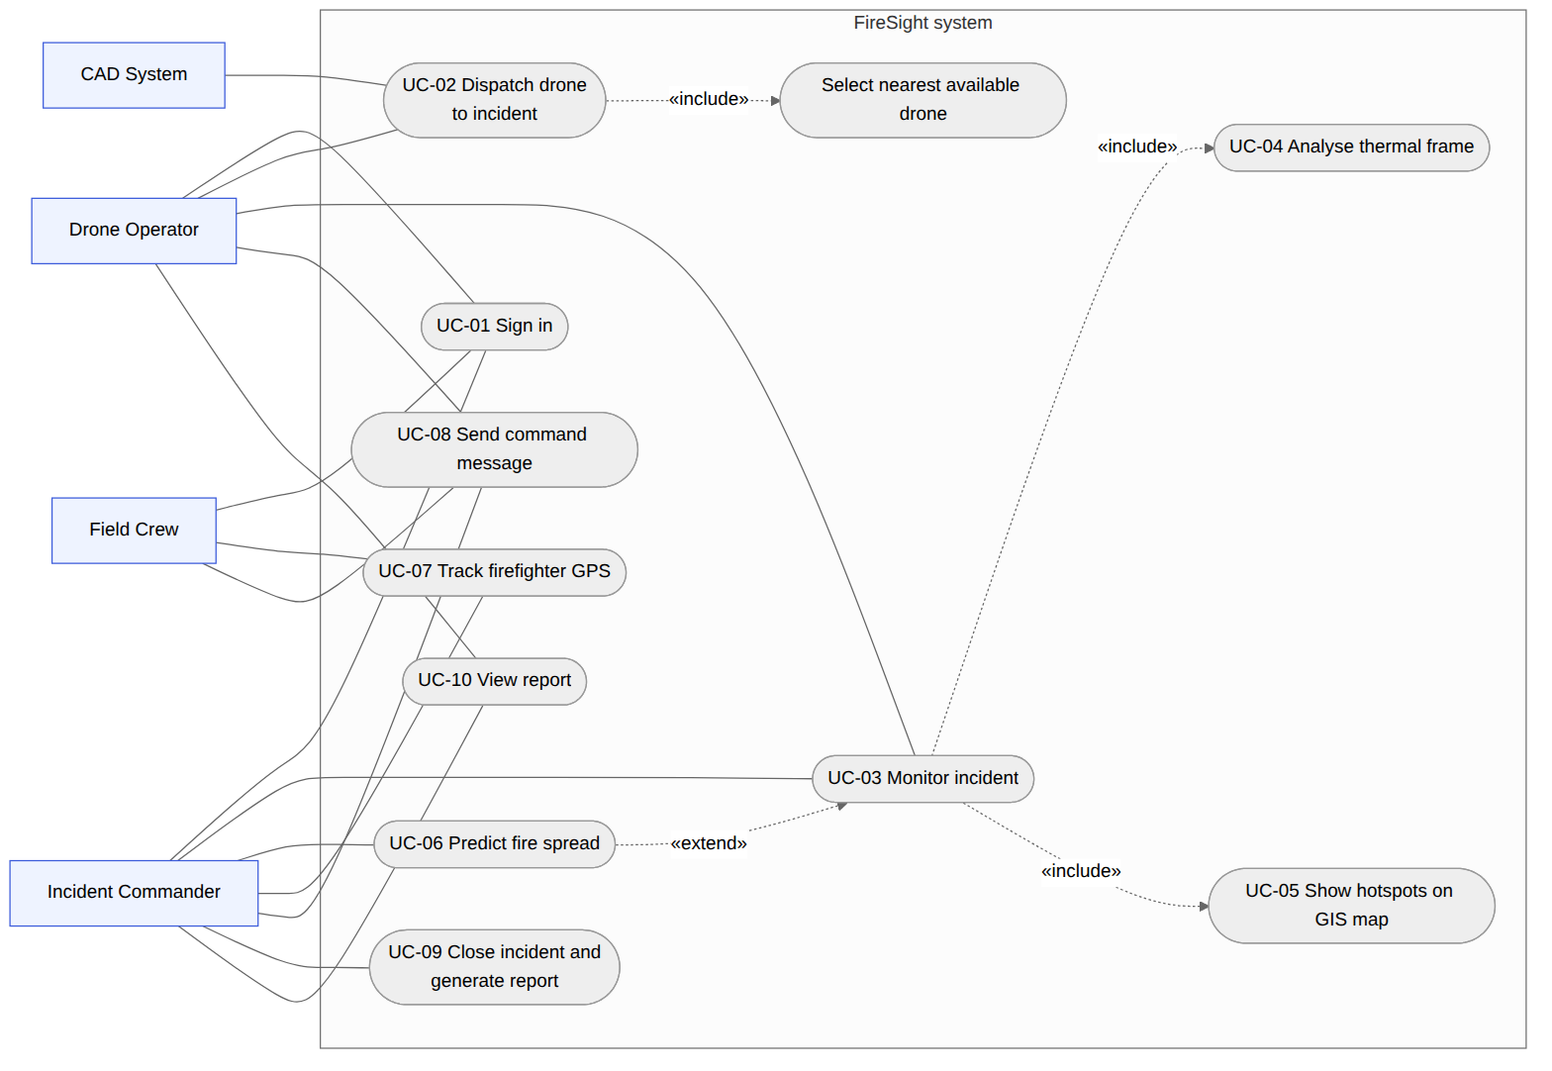
Figure 2. Use-case diagram of the implemented system (UC-04 and UC-05 are included in UC-03; UC-06 extends UC-03).
Changes from Assignment 2: the chain "Dispatch «include» Monitor telemetry «include» Analyse thermal feed" was replaced, because dispatching does not require monitoring. Monitoring an incident now includes thermal analysis and the hotspot display, and fire-spread prediction extends monitoring when hotspots exist.

Use case UC-02: Dispatch drone to incident
Primary actor | CAD system (posts through an operator or admin service account)
Secondary actors | Drone Operator (observes), HAL drone adapter
Trigger | A fire call is raised in CAD: POST /api/v1/cad/alerts
Preconditions | Caller holds a valid, unexpired token with role operator or admin. At least one drone is registered.
Postconditions (success) | An Incident exists with status open. The nearest eligible drone is en_route and linked to the incident. dispatchSeconds is stored. All connected dashboards were notified.
Postconditions (queued) | Incident exists with dispatchStatus = queued; no drone assigned yet.

Normal flow
- CAD posts the alert (call id, priority 1–3, latitude, longitude, description).
- The system authenticates the token and checks the role.
- The system validates the payload against the CadAlert model.
- The system checks that the call id has not been used before.
- The system creates Incident INC-nnnn (status open) and broadcasts an incident event.
- The system selects the nearest drone with status idle and battery of 30% or more.
- The system sets the drone to en_route, stores the drone id, distance and dispatchSeconds on the incident, and broadcasts the new dispatch status.
- The API returns 201 with the incident id, drone id, dispatch time and distance. The HAL mission starts (simulation mode): telemetry and thermal frames begin streaming.
Alternative and exception flows
Ref. | Condition | System behaviour
A1 | No drone is idle with battery of 30% or more (step 6) | Incident stays open with dispatchStatus = queued; API returns 201 with dispatched: false. When a mission ends, the next queued incident is dispatched.
A2 | Call id already exists (step 4) | 409 duplicate CAD call id; nothing is created.
A3 | Payload invalid, for example priority 7 or latitude outside ±90 (step 3) | 422 with the validation message; nothing is created.
A4 | Missing, invalid or expired token (step 2) | 401; nothing is created.
A5 | Token valid but role is crew or commander (step 2) | 403 role 'crew' not permitted.
E1 | Database unavailable | Not handled specifically; the request fails with 500. Listed as a limitation.

3.3 Class diagram
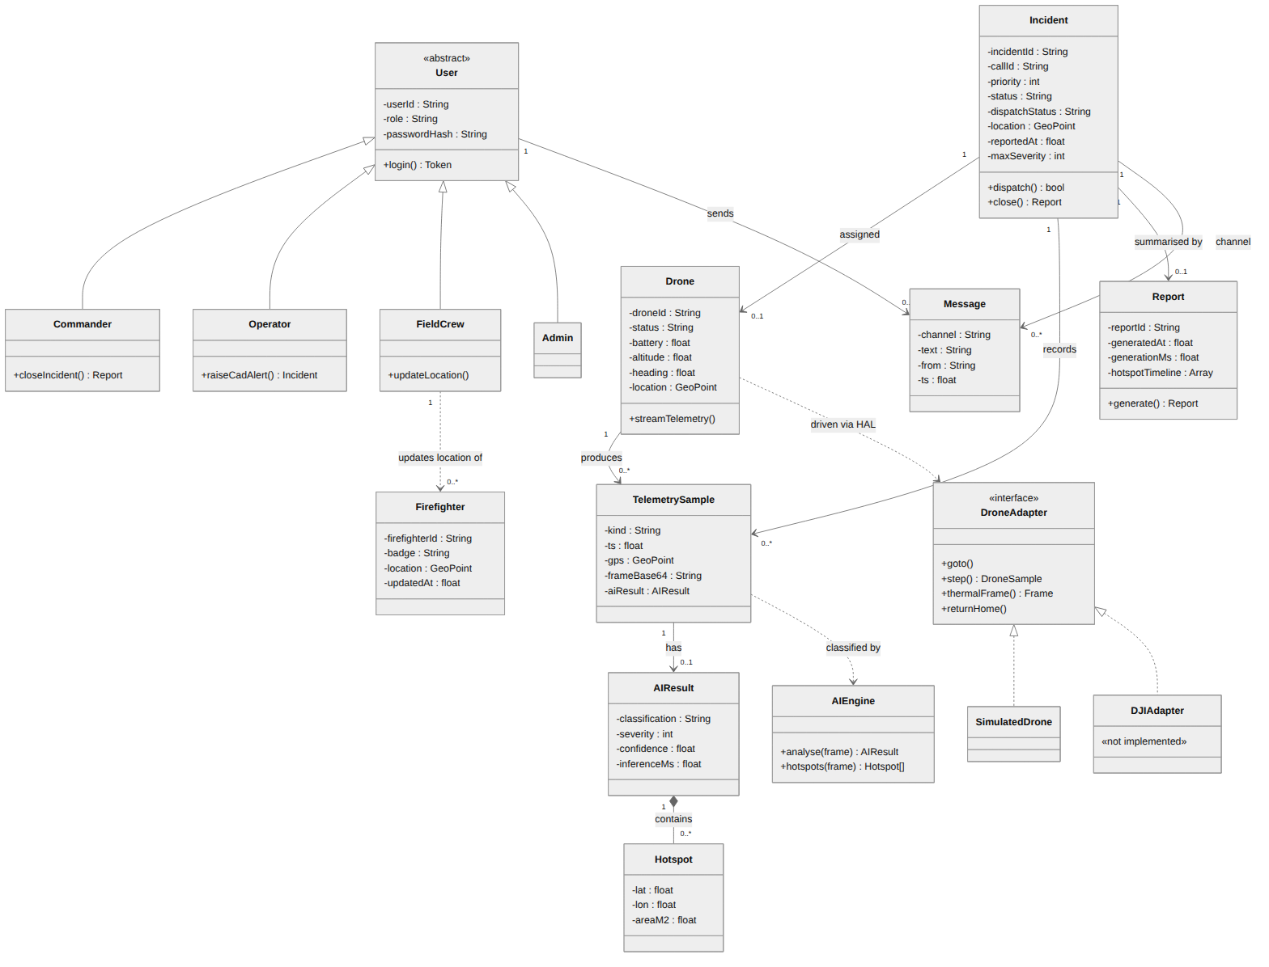
Figure 3. Class diagram of the implemented domain, with attributes, operations, associations and multiplicities.
Each domain class maps to a MongoDB collection or embedded document: Incident → incidents, Drone → drones, TelemetrySample → telemetry (with AIResult and Hotspot embedded), Firefighter → firefighters, Message → messages, Report → reports, User and its four roles → users. DroneAdapter is the HAL interface; SimulatedDrone implements it and DJIAdapter is a stub that raises NotImplementedError. One known gap: a FieldCrew user is not bound to a single Firefighter record, so the association is drawn as a dependency (Section 5.4).

3.4 Sequence diagram: thermal-frame analysis
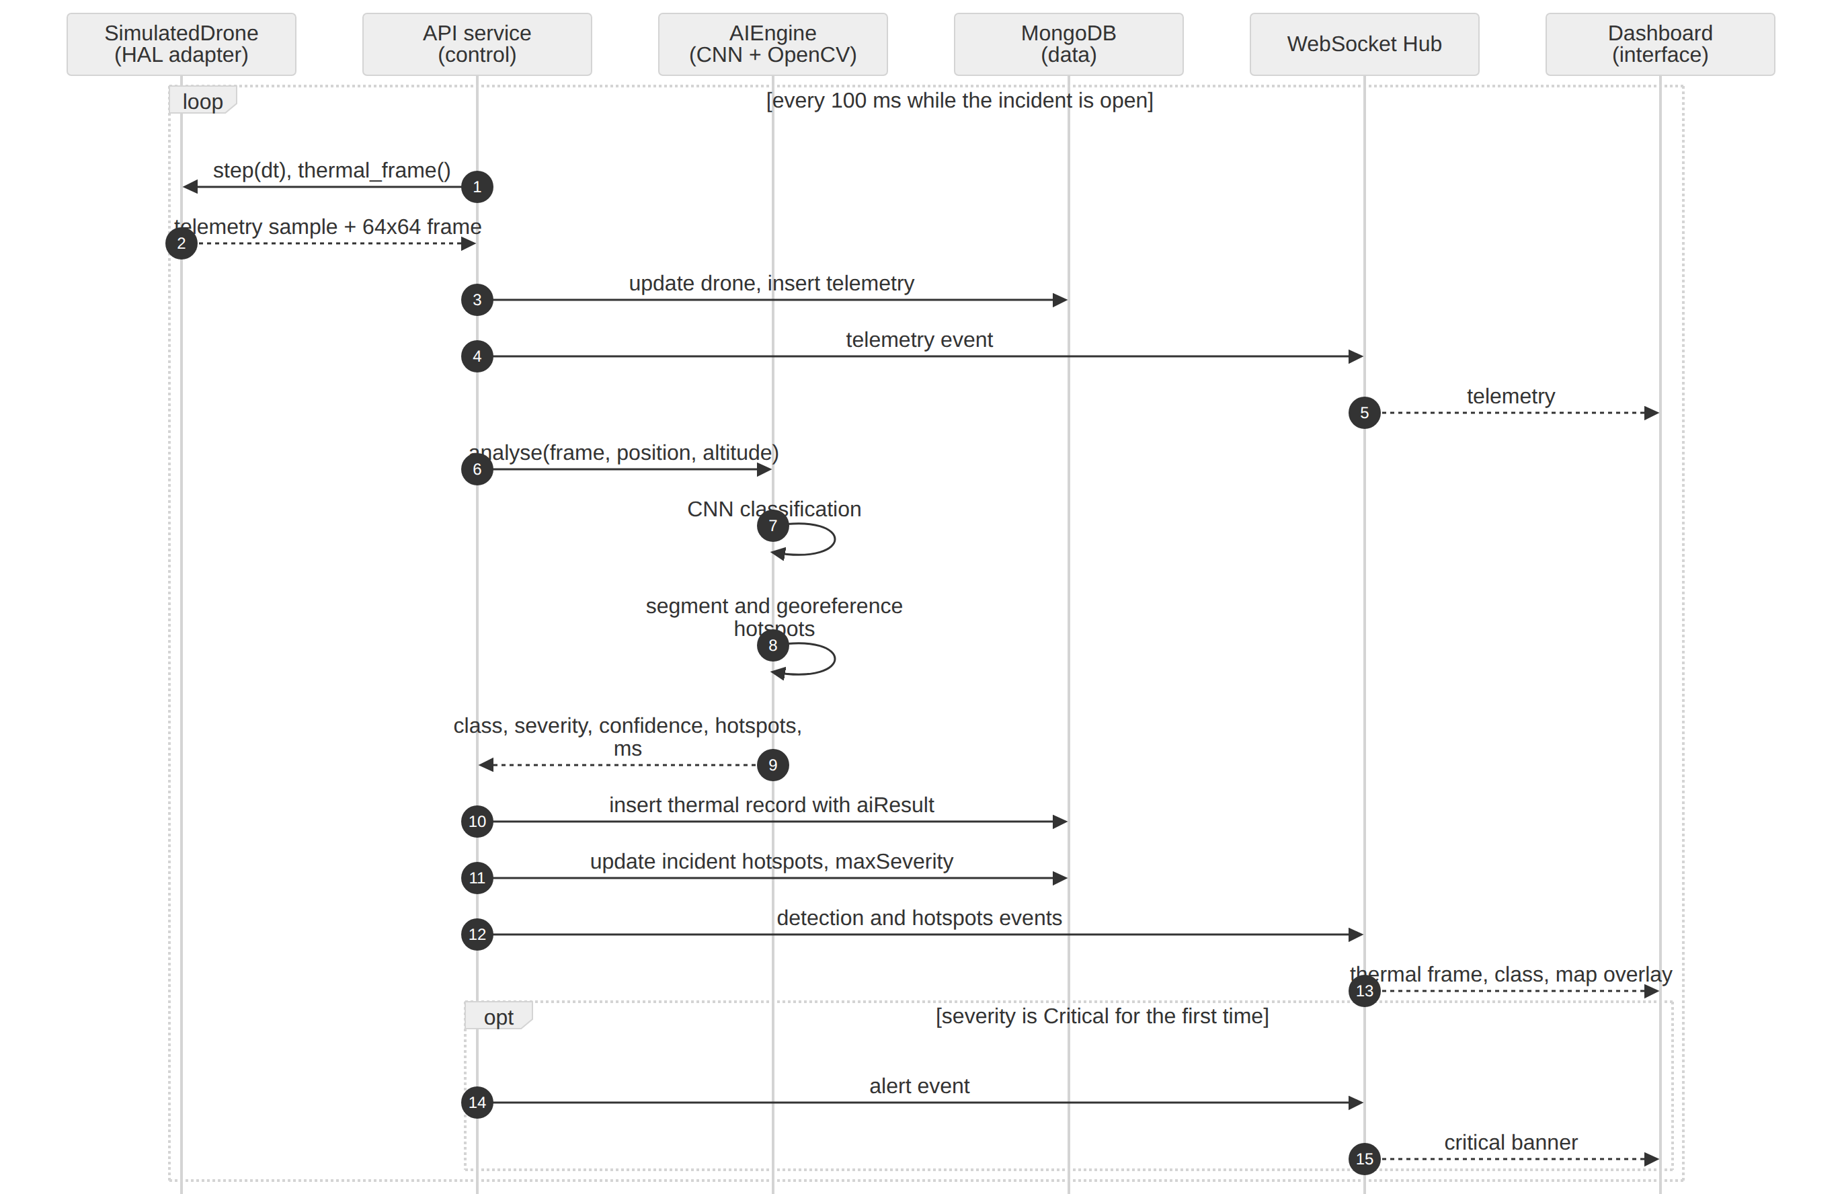
Figure 4. Sequence diagram of the core transaction: telemetry and thermal-frame analysis, showing interface, control, data and AI participants.
Layers: the interface is the dashboard; control is the API service (mission loop and analyse_frame()); data is MongoDB; the emerging technology is AIEngine (CNN then OpenCV segmentation). In simulation mode the API service calls analyse_frame() directly. A real drone adapter would reach the same function through POST /api/v1/ai/analyse, which has the same input and output (Section 4.3).

3.5 Activity diagram: end-to-end incident workflow
The workflow is split over two pages at connector A. It includes decisions, rejection exceptions (401/403, 422, 409, invalid frame) and both completion states (rejected request, and report generated).
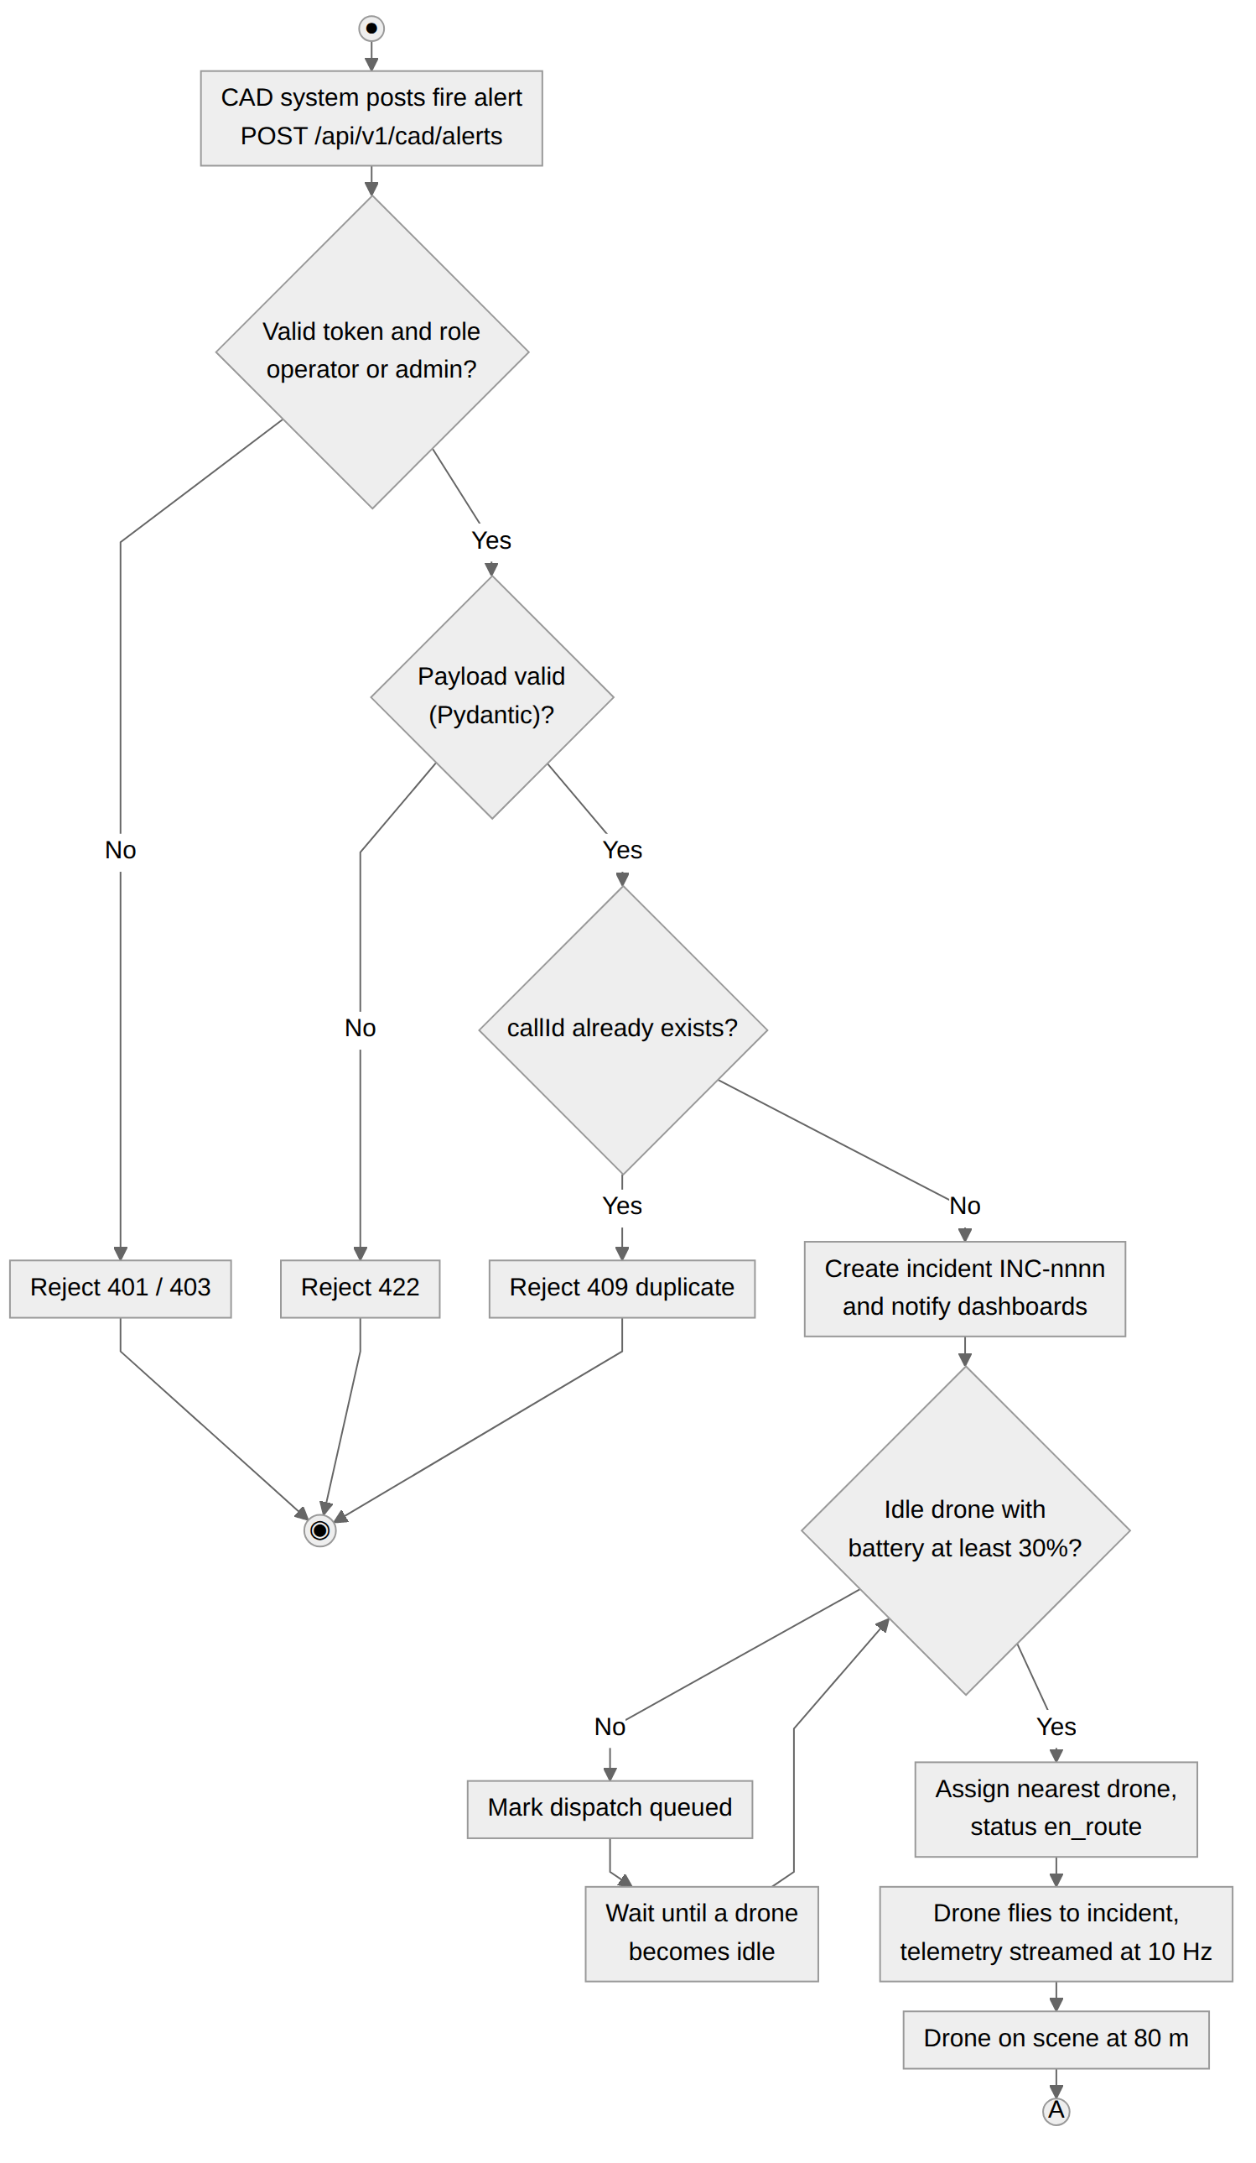
Figure 5a. Activity diagram, part 1: alert validation, dispatch and arrival on scene.
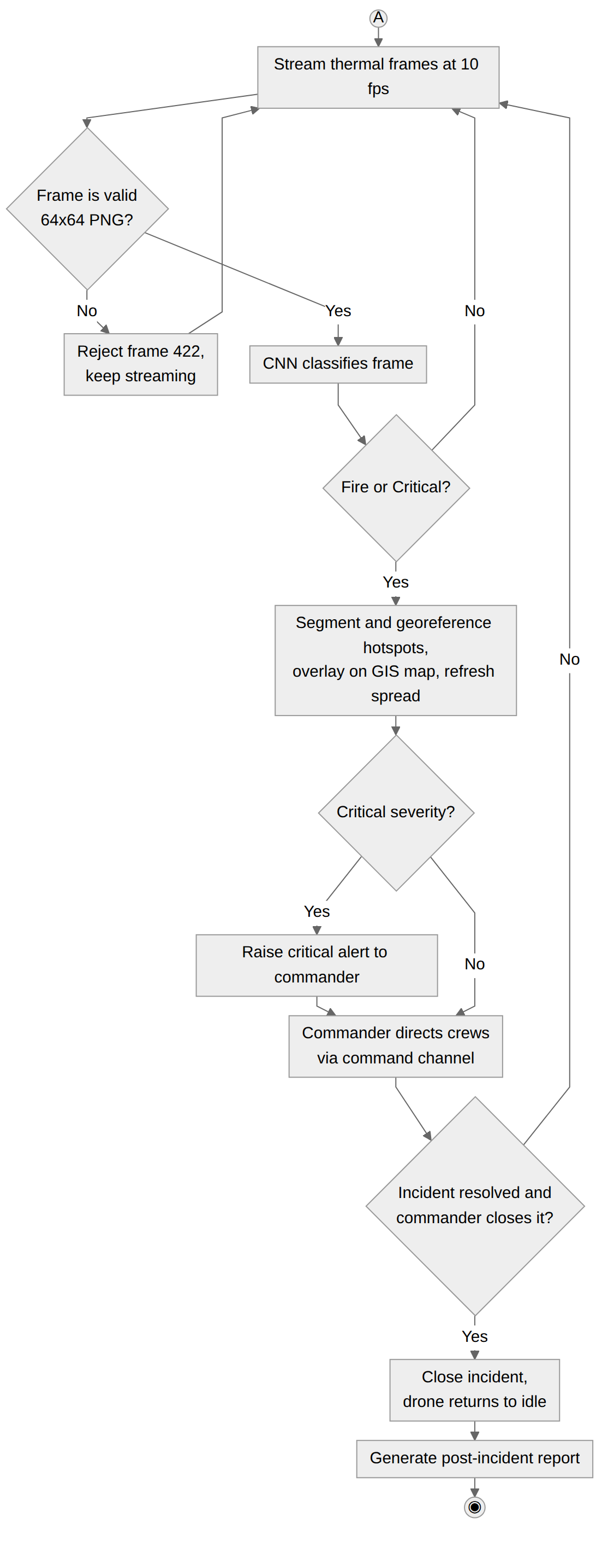
Figure 5b. Activity diagram, part 2: streaming, AI classification, alerting, command and closure.

3.6 Component and deployment diagrams
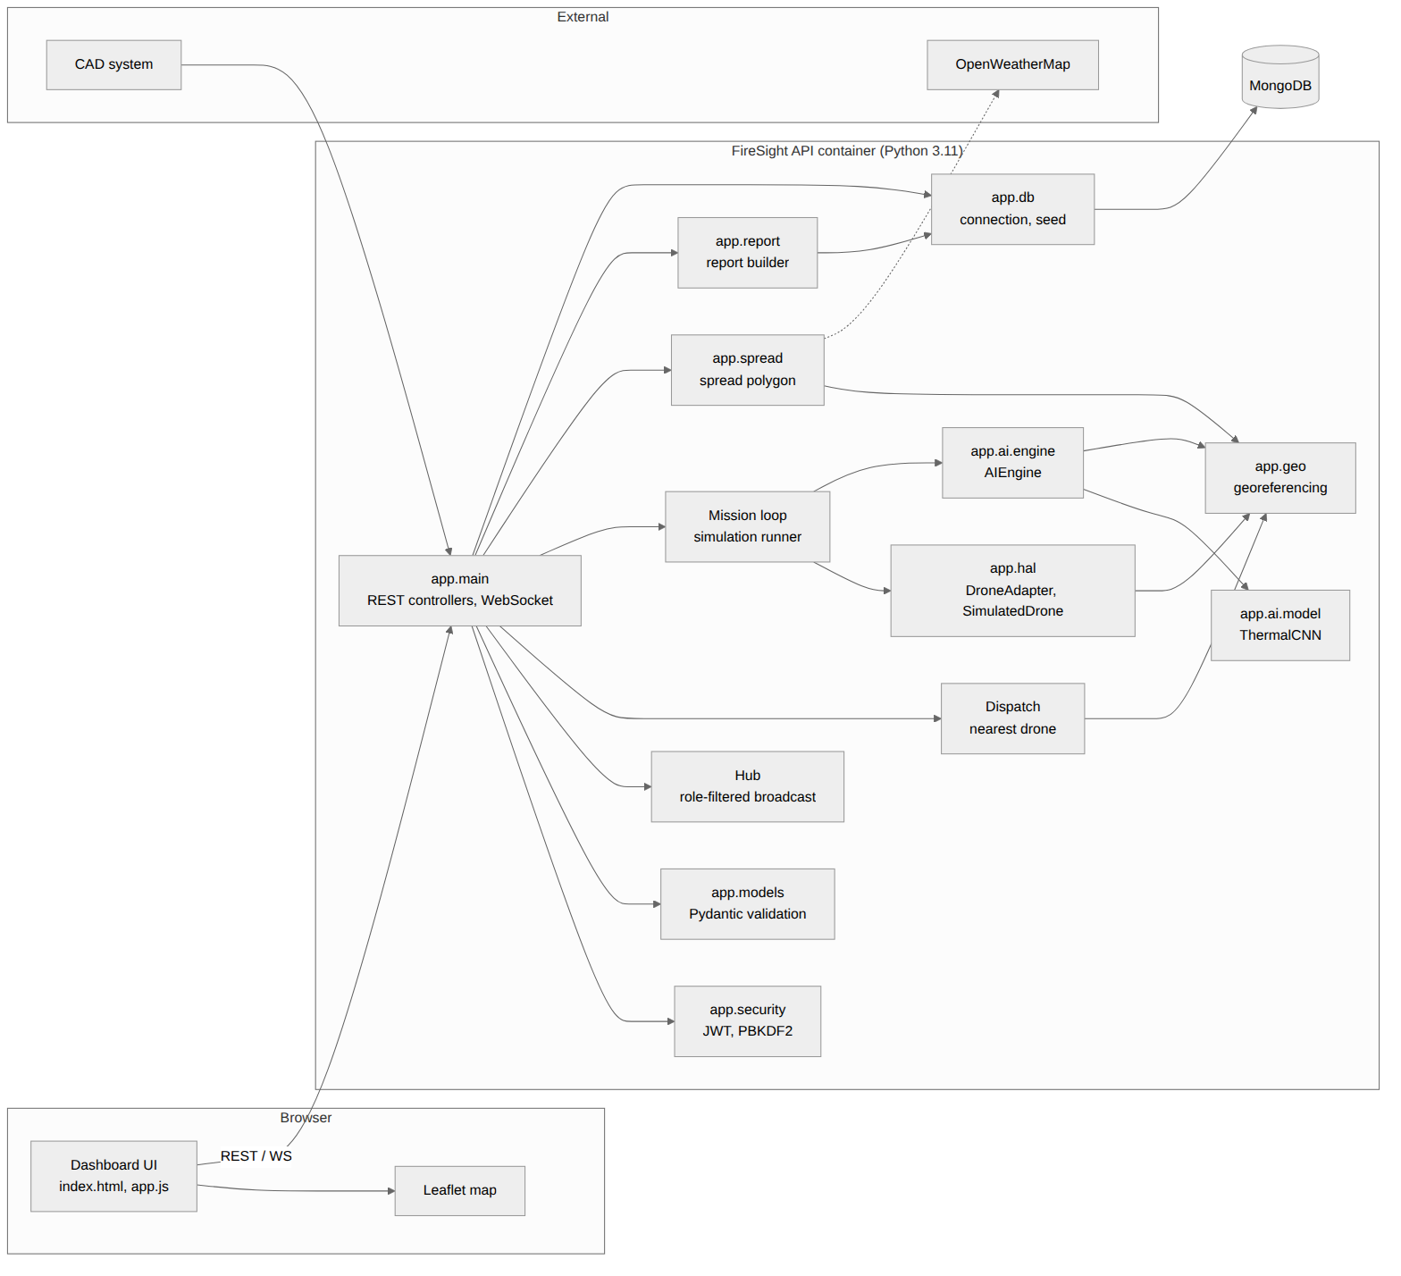
Figure 6. Component diagram: software components and their dependencies.
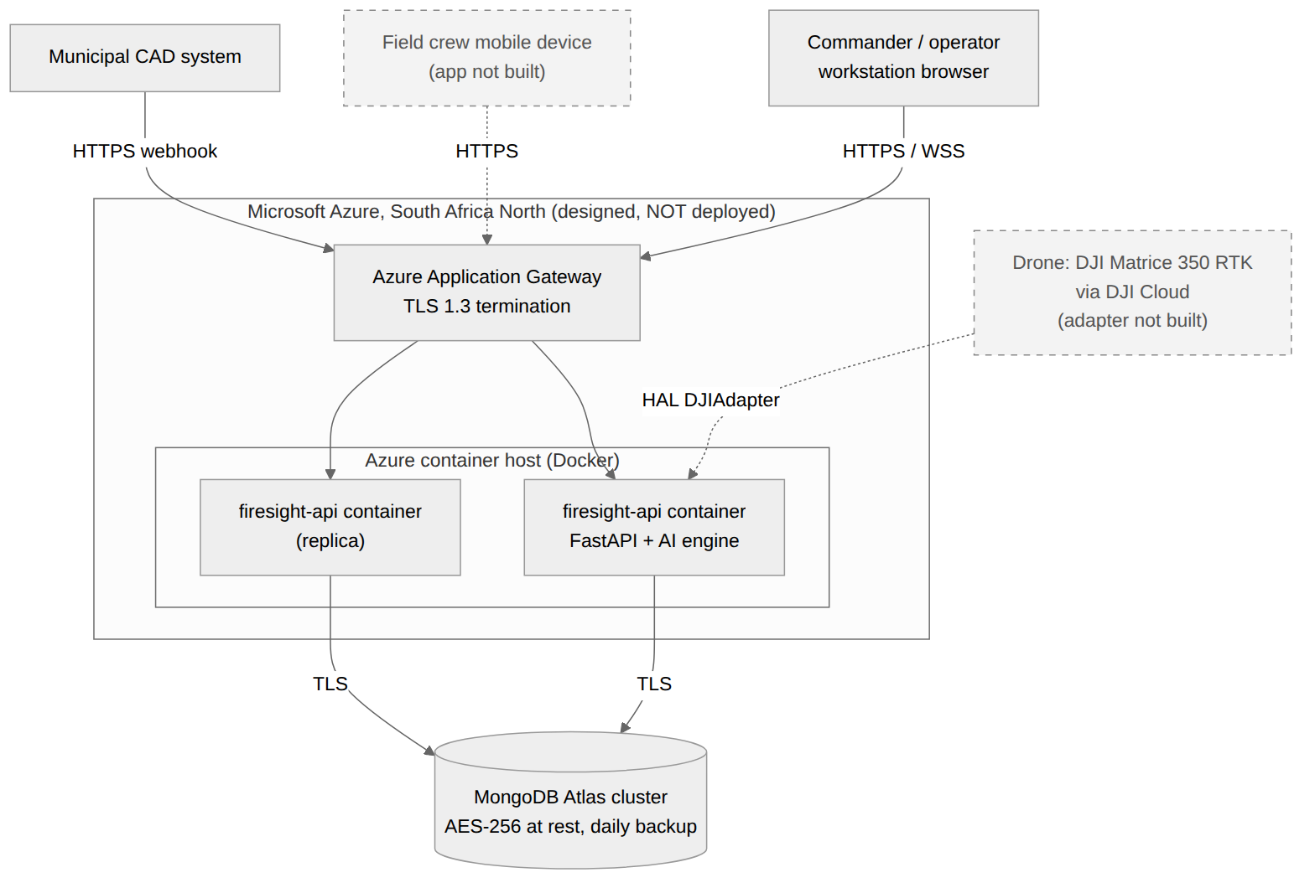
Figure 7a. Deployment diagram, target: the designed Azure South Africa North deployment (not deployed).
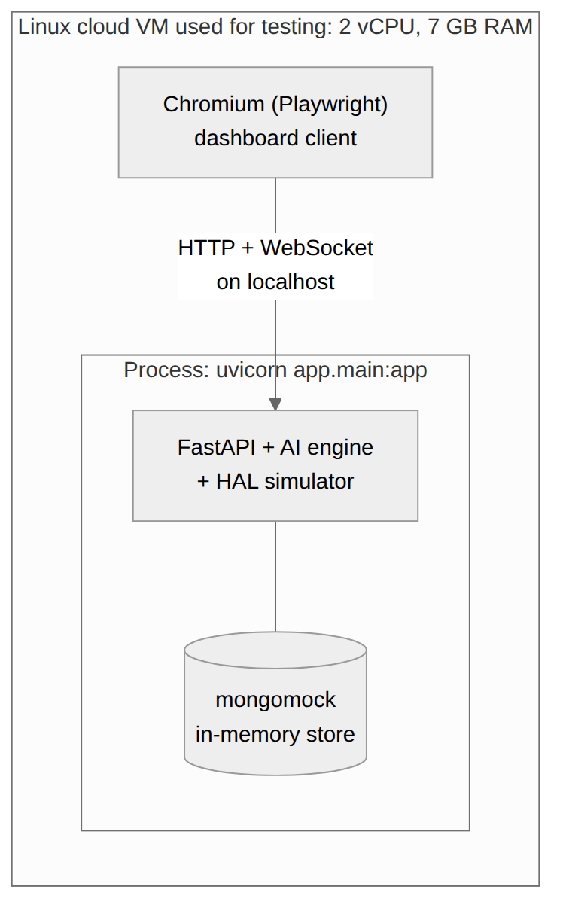
Figure 7b. Deployment diagram, tested: the environment in which every result in this document was measured.
Tested environment (Figure 7b). A Linux cloud VM with 2 vCPUs and 7 GB RAM ran one uvicorn process (API, AI engine and simulator) with an in-memory mongomock store, and headless Chromium as the client. Target environment (Figure 7a). Docker containers behind an Azure Application Gateway in South Africa North, connected over TLS to a MongoDB Atlas cluster. It is drawn as designed in Assignment 2 and has not been deployed or tested.

Key software dependencies
Package | Version | Used for
Python | 3.11 | Runtime
fastapi / uvicorn | 0.142.1 / 0.46.0 | REST, WebSocket, ASGI server
pydantic | 2.13.3 | Request validation
pymongo / mongomock | 4.18.2 / 4.3.0 | MongoDB driver / in-memory test store
torch | 2.14.0 | CNN model and inference
opencv-python-headless / numpy | 4.13.0.92 / 2.4.4 | Frame decoding, hotspot segmentation
Leaflet (browser) | 1.9.4 | Map, served locally from app/static/vendor
pytest, httpx, websockets, playwright | 9.1.1, 0.28.1, 17.1, 1.56.0 | Testing and screenshots

Important design decisions
# | Decision | Reason and trade-off
DD1 | HAL interface DroneAdapter with a simulation adapter. | Whole system runs and is testable with no hardware. Trade-off: the simulator's fire and camera are simplified, so results are not real-world results.
DD2 | Modular monolith in one container instead of separate microservices. | Simple to run and test. Modules (ai, hal, spread, report) keep clear boundaries so they can be split out later.
DD3 | Role-filtered WebSocket hub: crew never receive telemetry, detection or location events. | Data minimisation for sensitive location and imagery data (tested in IT-07).
DD4 | Stateless HS256 JWT with role claim; PBKDF2 password hashing (Python standard library). | No extra dependency and easy horizontal scaling. Trade-off: no token revocation and a shared secret.
DD5 | GeoJSON points with 2dsphere indexes. | Standard for MongoDB Atlas and Leaflet; supports $near queries in production.
DD6 | Fixed-rate mission scheduler (monotonic clock). | A plain sleep(0.1) gave only 9.43 frames/s; scheduling against a deadline gives 10.0.
DD7 | Heuristic wind-driven ellipse for fire spread. | Cheap, explainable and fast. Trade-off: not a validated fire-behaviour model and it ignores terrain.

Question 4: Implementation Documentation

4.1 Technology stack, structure, modules and interface
Layer | Technology (version) | Role
Language / runtime | Python 3.11 | Backend, AI, simulator, tests
Web framework | FastAPI 0.142.1, Uvicorn 0.46.0 | REST API, WebSocket, auto-generated OpenAPI
Validation | Pydantic 2.13.3 | Rejects malformed input with HTTP 422
Database | MongoDB (Atlas in production); PyMongo 4.18.2; mongomock 4.3.0 for tests | Documents with GeoJSON and 2dsphere indexes
AI / ML | PyTorch 2.14.0, OpenCV 4.13.0.92, NumPy 2.4.4 | CNN classification, hotspot segmentation
Front end | HTML, JavaScript, Leaflet 1.9.4 | Command dashboard and map
Security | HS256 JWT, PBKDF2-SHA256 (Python standard library) | Authentication and role-based access
Packaging | Docker, Docker Compose (files written, image not built) | Deployment
Testing | pytest 9.1.1, pytest-cov, httpx, websockets, Playwright 1.56.0 | Unit, integration, system tests, screenshots

Project structure
firesight/
├── app/
│ ├── main.py FastAPI app factory, REST + WebSocket, dispatch, ingest, mission loop
│ ├── models.py Pydantic request models (validation rules)
│ ├── security.py JWT and password hashing
│ ├── db.py MongoDB connection, seed data, indexes
│ ├── geo.py haversine, georeferencing (pixel <-> latitude/longitude)
│ ├── spread.py weather lookup and fire-spread polygon
│ ├── report.py post-incident report builder
│ ├── ai/ synth.py (data), model.py (CNN), engine.py (inference), train.py
│ ├── hal/ base.py (DroneAdapter), simulator.py (SimulatedDrone, FireScenario)
│ └── static/ index.html, app.js, vendor/leaflet
├── tests/ test_unit.py, test_integration.py, test_system.py
├── scripts/ ui_capture.py, collect_evidence.py
├── artifacts/ junit.xml, coverage.json, *_metrics.json, evidence.json
├── docs/ uml/ (sources + images), screens/
├── Dockerfile docker-compose.yml requirements.txt

Module | Responsibility
app.main | Creates the app; authentication dependency; REST endpoints; WebSocket endpoint and role-filtered Hub; dispatch; telemetry and frame ingest; simulation mission loop.
app.models | Defines and validates every request body (ranges, lengths, patterns).
app.security | Issues and verifies signed tokens; hashes and checks passwords.
app.db | Selects Atlas (MONGO_URI) or in-memory store; seeds 3 drones, 4 users, 3 firefighters; creates indexes.
app.ai.engine | Loads trained weights; decodes frames; classifies; segments and georeferences hotspots.
app.ai.synth / train | Generates synthetic thermal frames; trains the CNN and writes ai_metrics.json.
app.hal | DroneAdapter interface, SimulatedDrone, FireScenario (ground-truth fire), unimplemented DJIAdapter.
app.spread | Reads wind (OpenWeatherMap or simulated) and builds the spread polygon.
app.report | Builds and stores the incident report.
app.static | Dashboard: sign-in, map, telemetry, AI panel, spread panel, chat, report.

Selected interface screenshots
The map background is blank in these captures because the build environment cannot reach the OpenStreetMap tile server. On a normal connection the tiles load under the same markers and overlays.
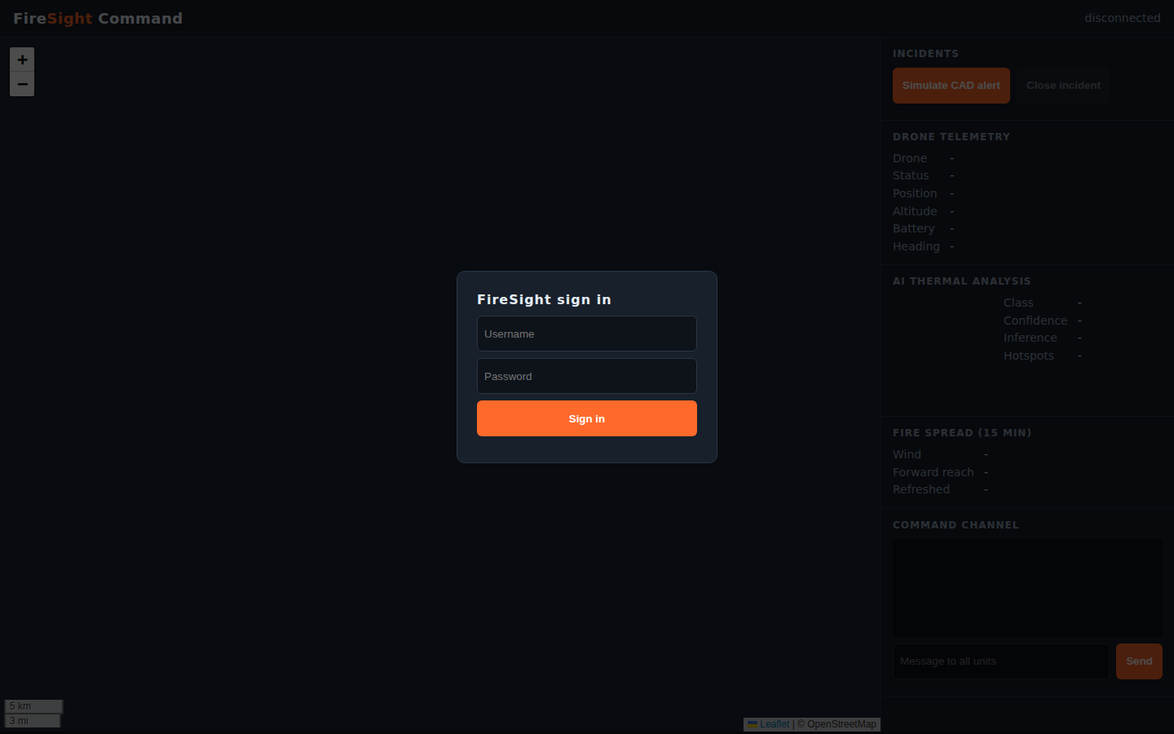
Figure 8. Sign-in screen. Access depends on the role held by the account.
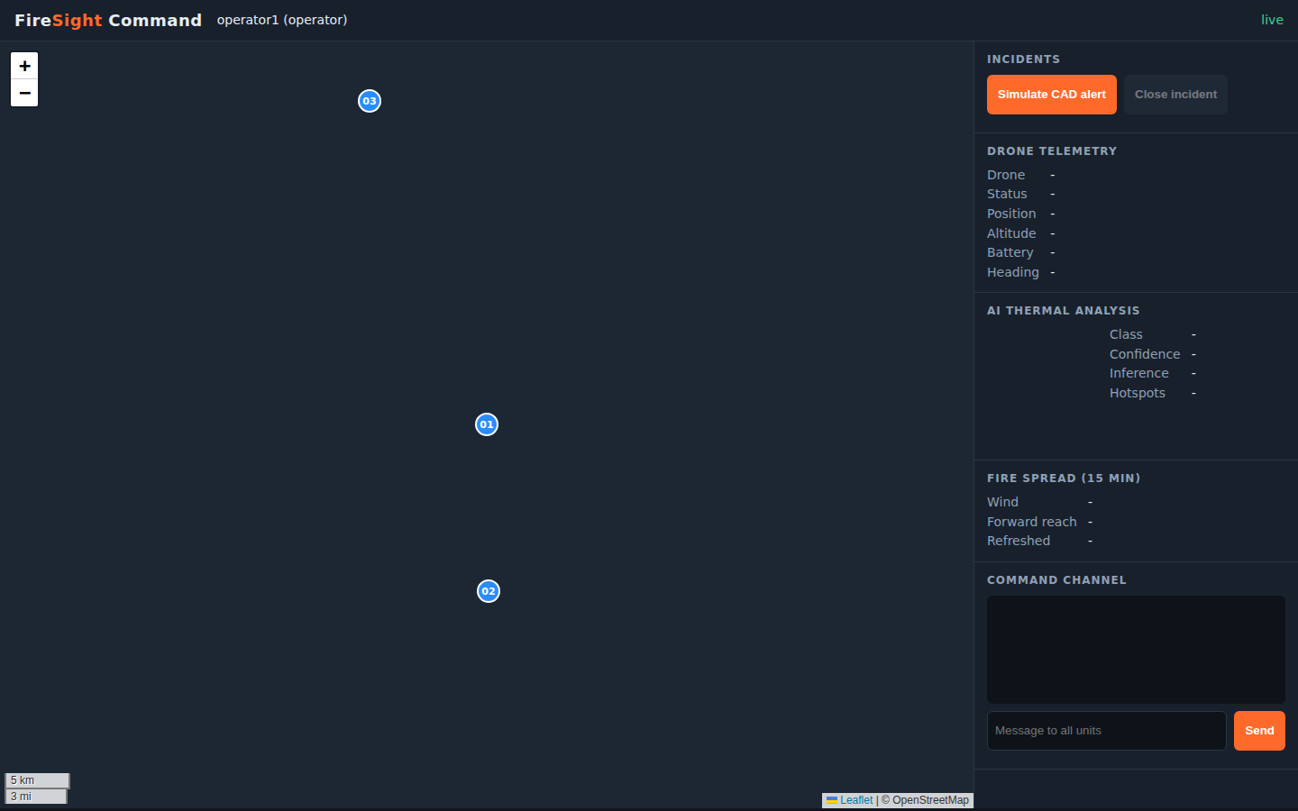
Figure 9. Operator view with no incident: map, incident list with the "Simulate CAD alert" control, empty telemetry and AI panels.
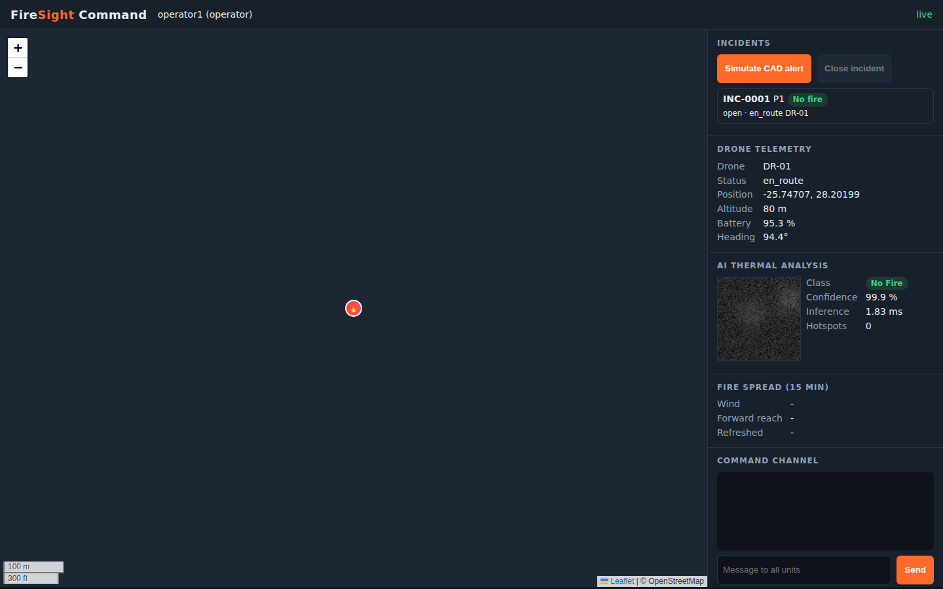
Figure 10. Incident INC-0001 dispatched: DR-01 flying to the scene, telemetry updating.
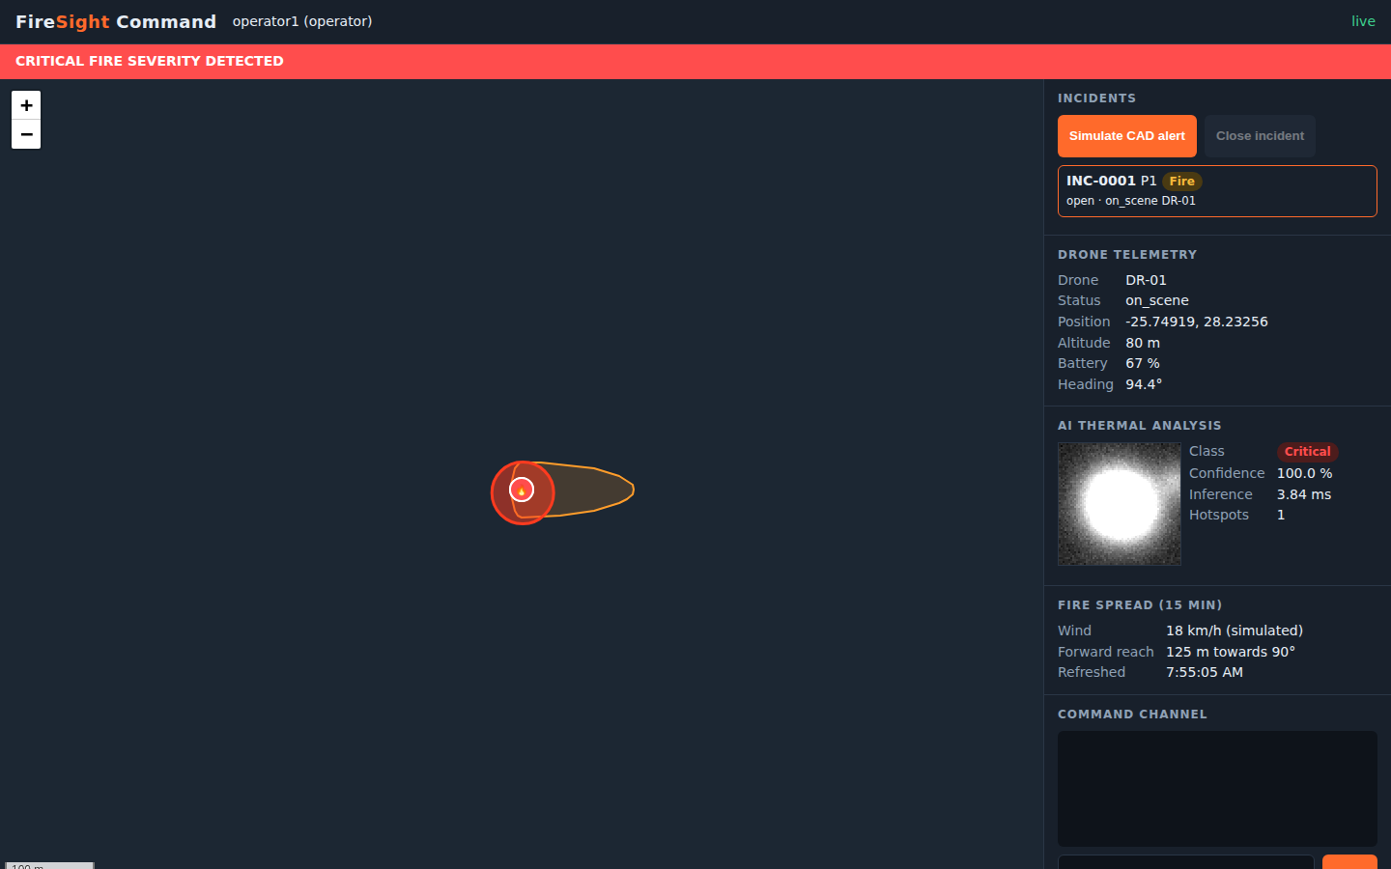
Figure 11. On scene: thermal frame with class, confidence, inference time, hotspot overlay, spread polygon and the critical-severity banner.
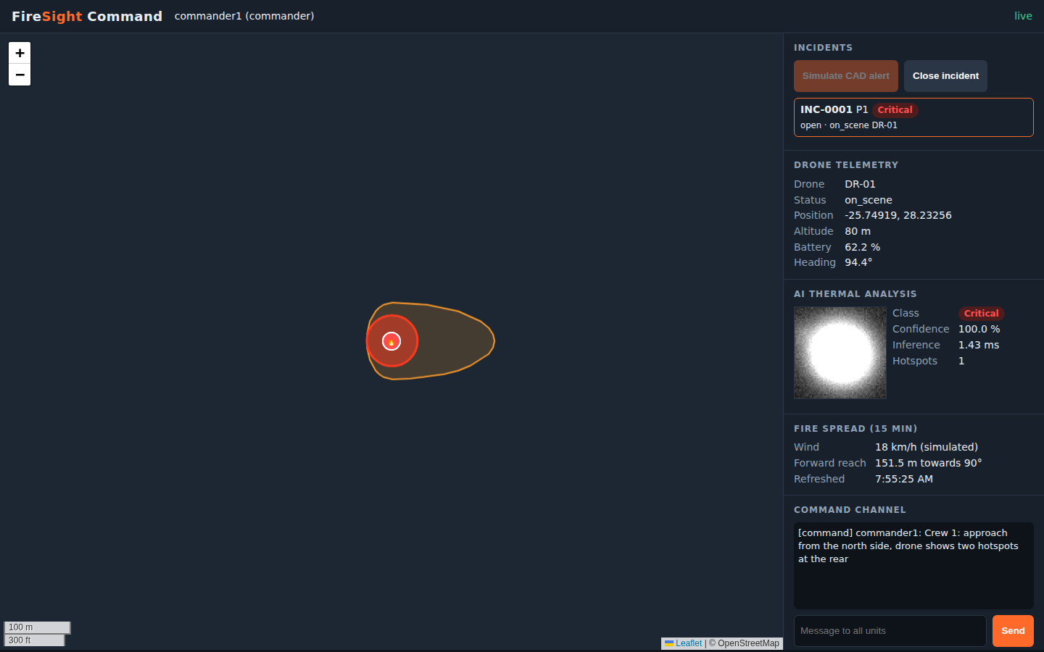
Figure 12. Commander view: a message sent on the command channel.
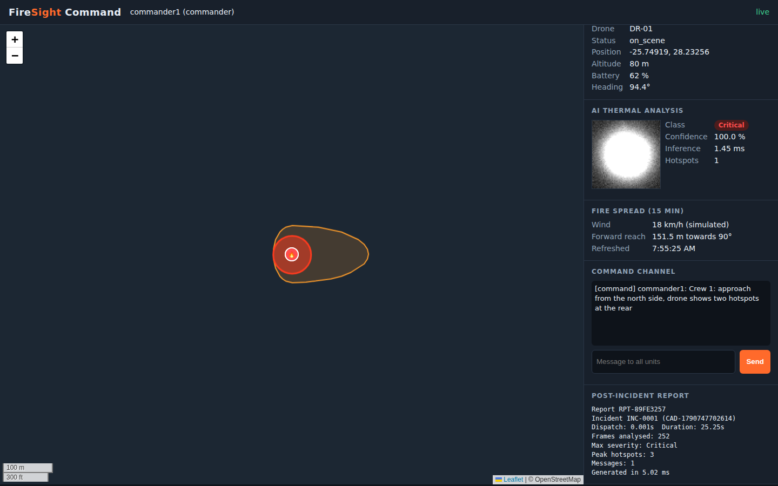
Figure 13. Closed incident and generated report (side panel scrolled to the bottom).
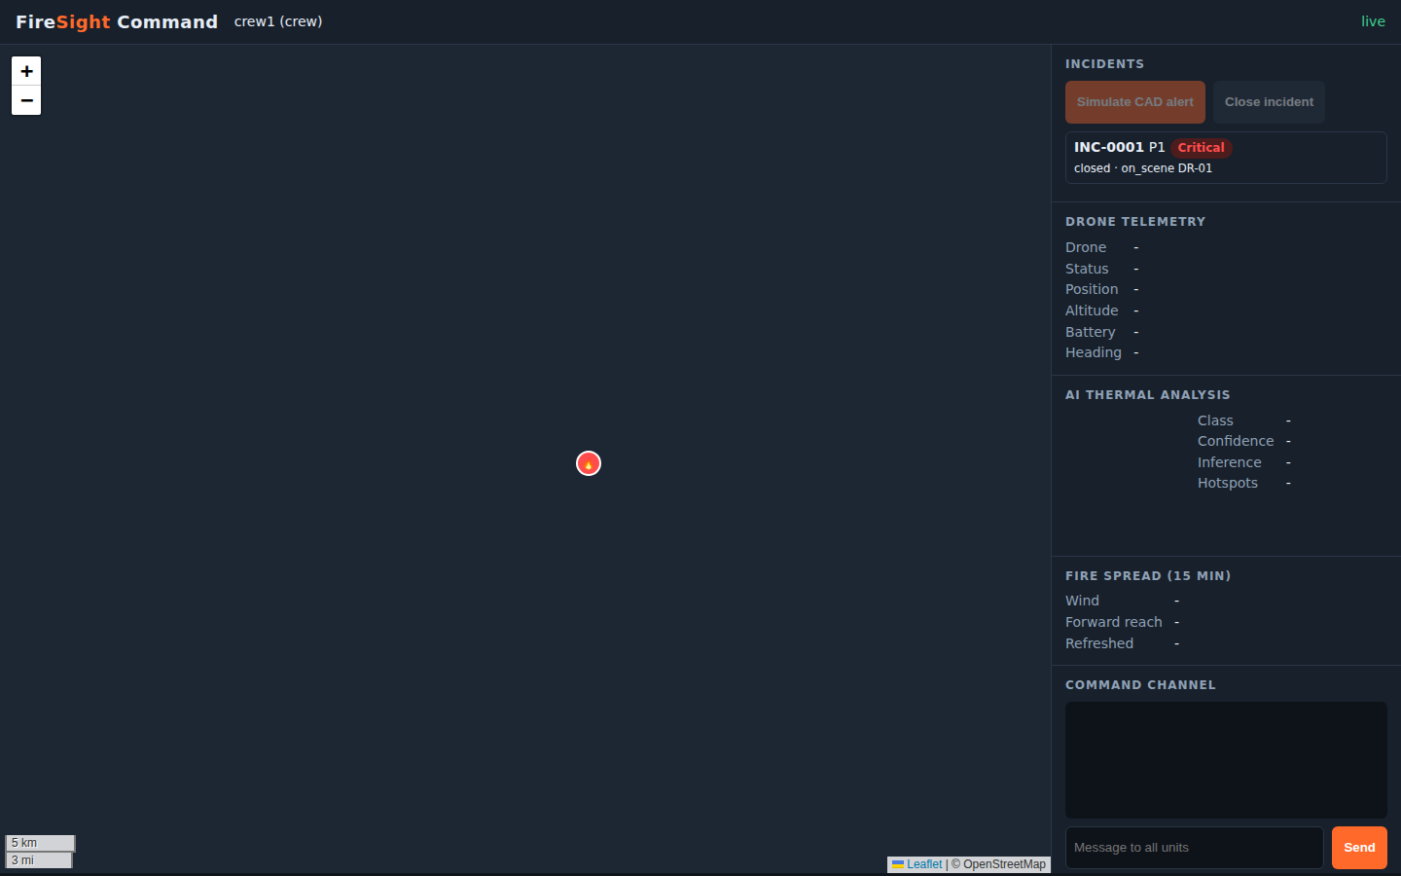
Figure 14. Field-crew view: telemetry and AI panels stay empty because crew do not receive those events (privacy control).

4.2 Database
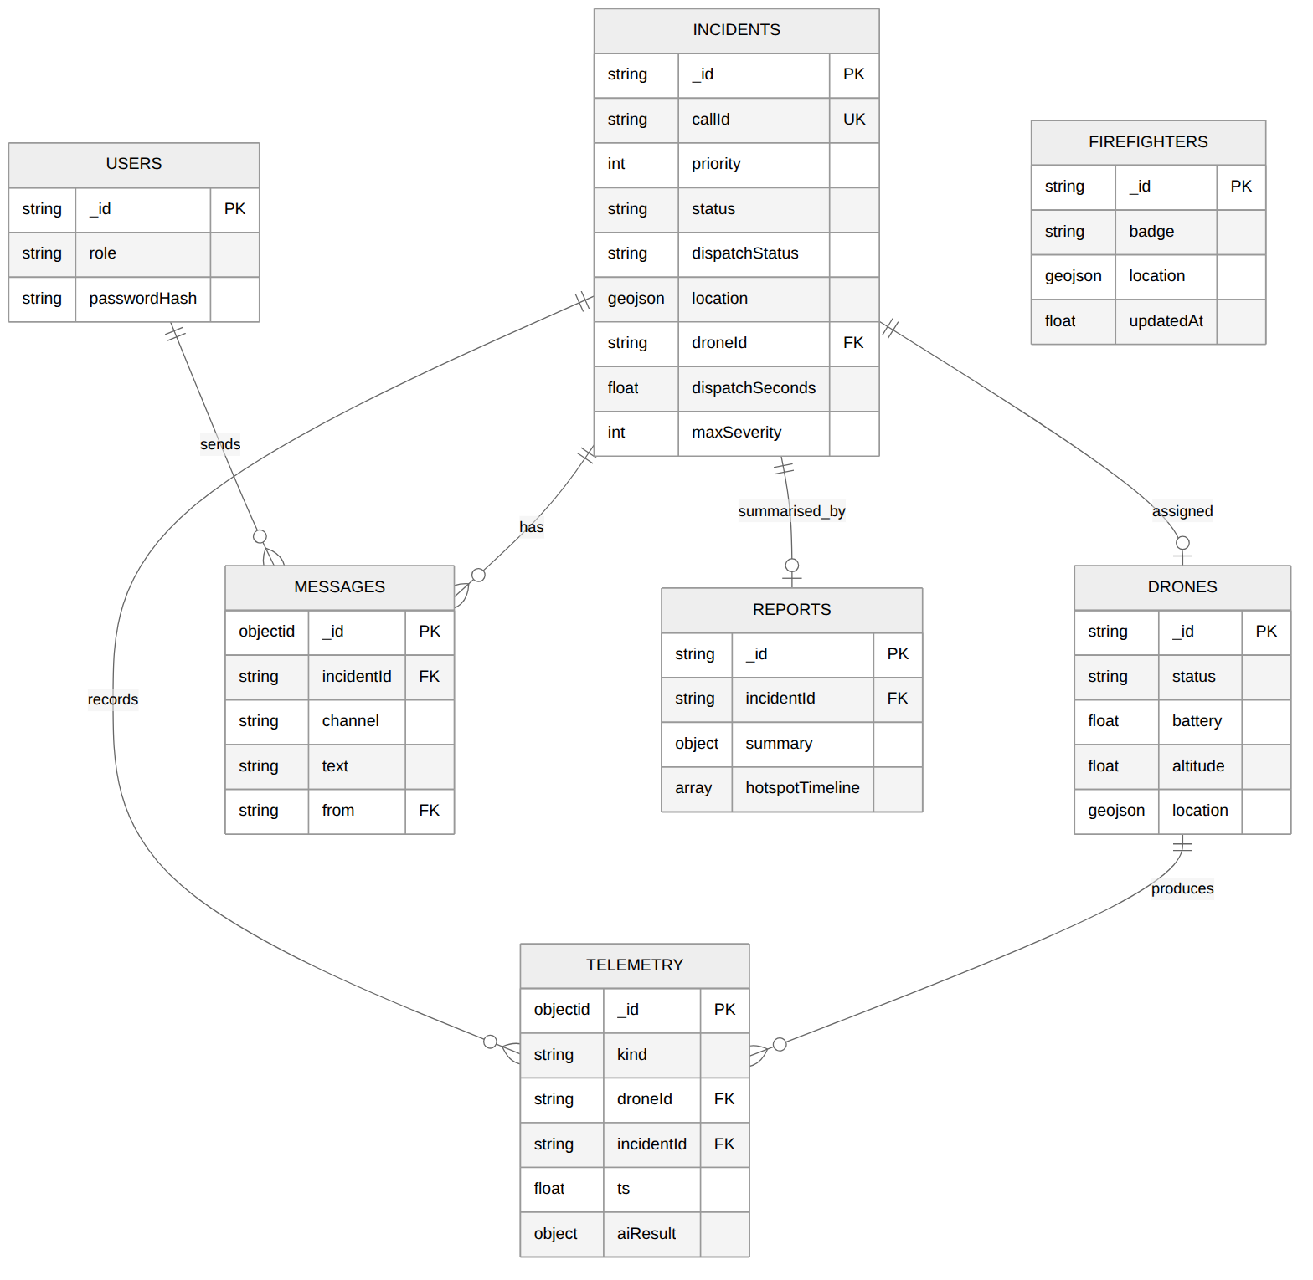
Figure 15. Entity-relationship diagram of the MongoDB collections (relationships are by id; MongoDB does not enforce foreign keys).

Data dictionary
Collection | Field | Type | Rules / notes
users | _id | string | Username, unique.
 | role | string | commander, operator, crew or admin.
 | passwordHash | string | Salted PBKDF2-SHA256 (120 000 iterations). Never returned by the API.
incidents | _id | string | INC-nnnn from an atomic counter.
 | callId | string | Unique CAD call id (duplicates rejected with 409).
 | priority | int | 1 to 3.
 | status / dispatchStatus | string | open, closed / pending, queued, en_route, on_scene.
 | location | GeoJSON Point | 2dsphere index.
 | droneId, distanceM, dispatchSeconds | string, number | Set on dispatch.
 | maxSeverity, detections, hotspots | int, int, array | Updated by each analysed frame.
 | reportedAt, closedAt | float | Epoch seconds.
drones | _id, base, status | string | DR-nn; idle, en_route, on_scene.
 | battery, altitude, heading | float | 0–100; 0–500 m; 0–360°.
 | location, homeLocation | GeoJSON Point | 2dsphere index on location.
telemetry | kind | string | position or thermal.
 | droneId, incidentId, ts | string, string, float | Indexed on incidentId + ts.
 | gps, altitude, battery, heading | GeoJSON, float | Position samples.
 | frameBase64, aiResult | string, object | Thermal samples: 64×64 PNG and classification, severity, confidence, hotspots, inferenceMs.
firefighters | _id, name, badge | string | FF-nn.
 | location, updatedAt | GeoJSON, float | Latest known position.
messages | incidentId, channel, text, from, role, ts | mixed | Channel: command, air or ground. Text 1–500 characters.
reports | _id, incidentId, generatedAt, generationMs | mixed | One report per incident (replaced if regenerated).
 | summary, hotspotTimeline, worstFrame | object, array, object | Timeline capped at about 200 points.
counters | _id, n | string, int | Incident id sequence.

Validation rules
Input | Rule | Enforced by | Response
Login | Username 3–40 and password 6–100 characters | Pydantic | 422; wrong credentials 401
CAD alert | callId 3–40; priority 1–3; latitude −90..90; longitude −180..180; description at most 300 | Pydantic | 422
Telemetry | Altitude 0–500; battery 0–100; heading 0–360 (exclusive) | Pydantic | 422
Thermal frame | Base64 PNG that decodes to exactly 64×64 greyscale | Engine decoder | 422
Message | Text 1–500 characters; channel command, air or ground | Pydantic | 422
Identifiers | Drone, incident and firefighter must exist | Endpoint lookup | 404

Privacy controls
- Role-based access: the API checks the role in the signed token on every protected endpoint. Crew cannot raise CAD alerts or list firefighters (tested in IT-03); drone, telemetry and report endpoints are likewise restricted to commander, operator and admin in the code.
- Event filtering: crew WebSocket clients never receive telemetry, detection, hotspot, location or spread events (IT-07).
- Credential handling: passwords are stored only as salted hashes; tokens expire after 8 hours.
- Encryption: TLS 1.3 was verified when the server is started with a certificate (ST-02). Encryption at rest (AES-256) is a MongoDB Atlas setting and was not configured or verified in this prototype.
- Personal information (POPIA): firefighter locations and drone imagery are personal or potentially identifying data. A production deployment needs a documented purpose, retention limit and access log. Assignment 2 proposed 5-year retention for incident data; this is not implemented.

Backup approach
Prototype: data lives in an in-memory store and is lost when the process stops. Production plan: MongoDB Atlas automated snapshots (daily, as stated in Assignment 2) and point-in-time restore on an Azure South Africa North cluster. This plan is documented but was not configured or tested.

4.3 Main API interface
Base path /api/v1. Every endpoint except login and health needs the header Authorization: Bearer <token>. Interactive OpenAPI documentation is generated by FastAPI at /docs (it loads its viewer assets from a CDN, so it needs internet access).
Method and path | Roles | Input | Output / errors
POST /auth/login | Any | username, password | token, role. 401 bad credentials.
POST /cad/alerts | operator, admin | CadAlert | 201 incidentId, droneId, dispatchSeconds, dispatchStatus. 409, 422.
GET /incidents, /incidents/{id} | Any signed in | none | Incident list or document. 404.
POST /incidents/{id}/close | commander, admin | none | reportId, generationMs. 409 if already closed.
GET /incidents/{id}/report | commander, operator, admin | none | Report document. 404.
GET /incidents/{id}/spread | commander, operator, admin | optional slope_deg 0–45 | GeoJSON Feature (polygon, wind, reach).
GET /drones, /firefighters | commander, operator, admin | none | Lists.
POST /drones/{id}/telemetry | operator, admin | Telemetry | 202 accepted. 404, 422.
POST /ai/analyse | operator, admin | droneId, incidentId, frameBase64, timestamp | classification, severity, confidence, hotspots[], inferenceMs. 404, 422.
POST /firefighters/{id}/location | crew, admin | lat, lon | 202 accepted.
POST /messages, GET /messages?incidentId= | Any signed in | incidentId, channel, text | 201 delivered / message list.
POST /sim/start | operator, admin | incidentId, timeScale | 202 started (simulation only).
GET /health | None | none | status: ok.
WebSocket /ws?token= | Any signed in | token in query string | Events: incident, telemetry, detection, hotspots, alert, location, message. Close code 4401 if the token is invalid.

Error handling
All errors use one JSON shape, {"error": <message>, "status": <code>}, except automatic field-level 422 responses from Pydantic. Codes used: 401 (no or invalid token), 403 (role not allowed), 404 (unknown id), 409 (duplicate or already closed), 422 (invalid input).

Real request and response examples
Captured from the running application (scripts/collect_evidence.py).
POST /cad/alerts: request
{
"callId": "CAD-2026-0930-01",
"priority": 1,
"lat": -25.7479,
"lon": 28.2293,
"description": "Structure fire"
}
Response (201)
{
"incidentId": "INC-0001",
"dispatched": true,
"droneId": "DR-01",
"dispatchSeconds": 0,
"distanceM": 4131,
"dispatchStatus": "en_route"
}
POST /ai/analyse: response (200), hotspots shortened
{
"classification": "Critical",
"severity": 2,
"confidence": 1,
"hotspots": [
{
"lat": -25.747896,
"lon": 28.22935,
"px": [
35.48677248677249,
31.65343915343915
],
"areaPx": 378,
"areaM2": 787.5
}
],
"inferenceMs": 1.94
}
Error examples
Case | Status | Body
No token | 401 | {"error":"missing bearer token","status":401}
Crew posts a CAD alert | 403 | {"error":"role 'crew' not permitted","status":403}
Duplicate call id | 409 | {"error":"duplicate CAD call id","status":409}
Priority 7 | 422 | "Input should be less than or equal to 3" (Pydantic message)
Invalid frame | 422 | {"error":"frameBase64 must be a base64 64x64 grayscale PNG","status":422}

4.4 Installation, configuration and deployment

Minimum requirements
Item | Prototype (measured) | Production (from Assignment 2)
CPU / RAM | 2 vCPU, 4 GB RAM minimum (tested on 2 vCPU, 7 GB) | 8-core with GPU, 32 GB recommended
Disk | About 6 GB with the default PyTorch build (less with the CPU-only wheel used in the Dockerfile) | 1 TB SSD with cloud backup
Software | Python 3.11, pip, a modern browser; Docker optional | Docker on Azure South Africa North, MongoDB Atlas
Network | None for the demo; internet for map tiles | 10 Mbps, 50 Mbps with 4G/5G failover recommended

Install and run (local demo)
cd firesight
python3 -m venv .venv && . .venv/bin/activate
pip install -r requirements.txt
python -m app.ai.train # optional: retrain (weights are included)
uvicorn app.main:app --port 8000 # open http://localhost:8000
# demo accounts: operator1, commander1, crew1, admin1 (password: firesight123)

Configuration (environment variables)
Variable | Purpose | Default
MONGO_URI, MONGO_DB | MongoDB Atlas connection; empty means in-memory demo store | empty, firesight
JWT_SECRET | Signing key for tokens. Set a long random value in production. | dev-secret-change-me
SIM_MODE | 1 starts a simulated mission on every dispatch; 0 waits for real adapters | 1
SIM_TIME_SCALE, SIM_CRITICAL_AFTER_S | Demo speed-up of flight; seconds on scene before the simulated fire turns critical | 10, 25
OPENWEATHER_KEY | Live wind data; otherwise simulated wind is used | empty
SIM_WIND_KMH, SIM_WIND_FROM | Simulated wind speed and direction (degrees it blows from) | 18, 270

Run the tests
PYTHONPATH=. pytest tests --cov=app --junitxml=artifacts/junit.xml
python scripts/ui_capture.py # dashboard screenshots and load-time measurement

Container deployment (files provided, not built or run)
export JWT_SECRET=<long random value> MONGO_URI=<atlas srv string>
docker compose up --build # API on port 8000
# In Azure: push the image to a registry, run it on a container host behind an
# Application Gateway that terminates TLS 1.3, and point MONGO_URI at Atlas.
The Docker daemon was not available in the build environment, so the image build and container run are untested. That is why NFR-05 is Partial.

Question 5: Evaluation and Responsible Use

5.1 Test summary
All automated tests were run together with coverage (pytest tests --cov=app). Result: 23 passed, 0 failed, line coverage 87.4% of app/ measured in-process (the separately launched server used in ST-01 and ST-02 is not included in the coverage figure).
Level | Tests | Passed | Tooling | What it covers
Unit | 10 | 10 | pytest | Tokens, hashing, distance and georeferencing maths, validation, CNN accuracy, hotspot accuracy, spread model, HAL adapters, frame codec.
Integration | 11 | 11 | pytest, FastAPI TestClient, WebSocket | API + database + WebSocket + AI together: login, dispatch, security errors, queueing, real-time events, privacy filtering, reports, full simulated mission.
System | 2 | 2 | pytest with a real uvicorn process | ST-01: live mission with latency, rate and CPU measurement. ST-02: TLS 1.3 negotiation.
Browser (system) | 1 script | Run | Playwright + Chromium | Cold-load time on a throttled 10 Mbps link; sign-in, dispatch, message, close and report for operator, commander and crew; screenshots.
User acceptance | 0 | n/a | n/a | Not executed. See the plan below.

Representative test results
Test case | Expected | Actual | Status | Evidence
UT-01 Token tamper and expiry | Altered or expired token rejected | Both rejected; valid token accepted | Pass | junit.xml
UT-06 CNN on 450 fresh frames | At least 90% correct | 445 of 450 correct (98.9%) | Pass | junit.xml; ai_metrics.json
UT-07 Hotspot position error | 95th percentile under 5 m | Test passed (p95 under 5 m). Wider sweep of 381 detections: p95 1.37 m, 379 within 5 m, worst 41.31 m | Pass | junit.xml; evidence.json
UT-08 Spread direction | Extends downwind; larger with stronger wind | East extent greater than west for a west wind; forward reach grows with wind | Pass | junit.xml
IT-02 Nearest-drone dispatch | Soshanguve call → DR-03 within 30 s; next call → DR-01 | DR-03, then DR-01; dispatch time under 1 s | Pass | junit.xml
IT-03 Security and validation | 401 no token, 403 crew CAD, 422 bad priority, 409 duplicate | All four returned as expected | Pass | junit.xml; Section 4.3
IT-04 No drone available | Incident queued, not dispatched | dispatchStatus = queued | Pass | junit.xml
IT-05 Telemetry to dashboard | Received within 500 ms | Received; assertion under 500 ms held | Pass | junit.xml
IT-06 AI analysis and events | Critical frame stored; events detection, hotspots, alert in order; bad frame 422 | As expected; inference under 100 ms | Pass | junit.xml
IT-07 Crew privacy | Commander gets location and telemetry; crew get only incident and message events | As expected | Pass | junit.xml
IT-09 Close and report | Operator 403; commander closes; report has 4 frames, max severity 2; second close 409 | As expected | Pass | junit.xml
IT-11 Simulated mission | Drone reaches scene, 5+ detections, closes to idle, report exists | Passed (24.7 s test) | Pass | junit.xml
ST-01 Live mission | Telemetry p95 under 500 ms; inference p95 under 100 ms; critical alert; report | Telemetry p95 1.84 ms; inference p95 2.41 ms; alert raised; 226 frames in report | Pass | system_metrics.json
ST-02 TLS 1.3 | TLS 1.3 negotiated | Negotiated TLSv1.3; TLS 1.2-only client refused: true | Pass | system_metrics.json
UI-01 Dashboard load (5 cold loads) | Under 3 s at 10 Mbps | Median 0.365 s, max 0.398 s | Pass | ui_metrics.json

User acceptance testing (planned, not executed)
No City of Tshwane fire personnel or other end users took part, so no acceptance result is claimed. The scenarios from Assignment 2 remain the plan:
UAT | Scenario | Participants | Pass criterion | Status
UAT-01 | Informal-settlement fire response | 2+ incident commanders | Commander can find the incident, read AI class and hotspots, and message crews without help | Not executed
UAT-02 | Wildfire spread prediction | Commander, operator | Spread polygon judged useful | Not executed
UAT-03 | Multi-crew tracking | Commander, crew | All crew positions visible; positions update | Not executed
UAT-04 | Post-incident report review | Commander | Average rating 4/5 or higher; 80% call it an improvement (Assignment 1 criterion) | Not executed

What was done instead is a developer walkthrough: scripted browser sessions for the operator, commander and crew roles ran the complete workflow (scripts/ui_capture.py) and produced the screenshots in Section 4.1. That checks the interface works. It does not test whether real users find it usable.

5.2 Quantitative evaluation

Non-functional requirements
Requirement | Target | Measured | Method and caveat | Verdict
NFR-02 Dashboard load | 3 s or less at 10 Mbps | Median 0.365 s; max 0.398 s | Chromium with 10 Mbps, 40 ms latency, cache off, 5 runs; map tiles blocked because they come from a third party; server on the same machine. | Pass
NFR-10 Encryption in transit | TLS 1.3 | TLSv1.3 negotiated; TLS 1.2-only client refused | Self-signed certificate on the running server. Production would terminate TLS at the gateway. | Pass
NFR-10 Encryption at rest | AES-256 in Atlas | Not measured | Atlas setting; the prototype used an in-memory store. | Not met
FR-02 Telemetry latency | 500 ms or less | p50 1.14 ms, p95 1.84 ms, max 4.28 ms | 227 events at 10 Hz; server timestamp to client receive on localhost. Real networks add delay. | Pass
NFR-01 Uptime 99.5% | 99.5% with failover | Not measured | Longest continuous run was under a minute; there is one process and no failover. | Not met

Emerging-technology metrics
Metric | Target | Measured | Verdict
Inference time (ETR-02, FR-03) | 100 ms or less per frame | median 1.69 ms, p95 2.41 ms, max 5.92 ms (226 frames, CPU only) | Pass
Sustained frame rate (ETR-02) | 10 frames/s or more | 10 frames/s over the 15 s on-scene window | Pass
CPU use (ETR-02) | 80% or less | 5.9% of one core on a 2-core VM (not an Azure App Service instance) | Partial
CNN accuracy (ETR-01) | 90% or more on FLAME | 98.58% on synthetic validation data; FLAME not evaluated | Partial
Hotspot position error (ETR-04) | 5 m or less | median 0.55 m, p95 1.37 m, 99.5% within 5 m, worst 41.31 m (simulated ground truth) | Partial

Confusion matrix (synthetic validation set, 1200 frames; rows are the true class):
True \ Predicted | No Fire | Fire | Critical | Recall
No Fire | 397 | 3 | 0 | 99.3%
Fire | 2 | 398 | 0 | 99.5%
Critical | 0 | 12 | 388 | 97.0%

The most important error for safety is that 12 of 400 Critical frames (3.0%) were labelled Fire, which understates severity. The hotspots and the commander's own judgement remain visible, but the alert banner would not fire on those frames.

5.3 User guide for the main workflow
Main workflow: from a fire call to a closed incident with a report. Figure numbers refer to the screenshots in Section 4.1 (Figures 8 to 14).
- Sign in (Figure 8). Open the dashboard address, enter your username and password. The header shows your name and role, and "live" at the top right means the real-time connection is working.
- Raise or receive the call (Figure 9). In production the CAD system posts the alert. For a demonstration, an operator or admin clicks Simulate CAD alert. An incident such as INC-0001 appears in the list.
- Watch the dispatch (Figure 10). The nearest idle drone is assigned and the incident shows en_route. The Drone telemetry panel shows position, altitude, battery and heading updating about ten times per second.
- Read the AI analysis (Figure 11). When the drone is on scene the AI thermal analysis panel shows the latest thermal frame, the class (No Fire, Fire or Critical), the confidence and the number of hotspots. Red circles on the map mark hotspots. The orange shape is the 15-minute fire-spread forecast; the Fire spread panel gives wind and forward reach. A red banner appears when severity first becomes Critical.
- Direct the crews (Figure 12). Select the incident, type in Command channel and press Send. Every signed-in user sees the message.
- Close the incident (Figure 13). A commander or admin selects the incident and presses Close incident. The drone is released and a report appears at the bottom of the side panel: dispatch time, duration, frames analysed, maximum severity, peak hotspots and message count.
- Crew view (Figure 14). Field crew see incidents and the command channel only. Telemetry and AI panels stay empty by design.

Troubleshooting
Symptom | Likely cause | What to do
"invalid credentials" at sign-in | Wrong username or password | Re-enter. Ask an administrator for the correct account.
Status shows "reconnecting…" | Server restarted or network lost | Wait: the page reconnects every 2 s. If it persists, reload and sign in again.
Simulate button greyed out | Your role is not operator or admin | Sign in with an operator account.
Close incident greyed out | No incident selected, incident already closed, or role is not commander/admin | Select an open incident; use a commander account.
Incident stays "queued" | No idle drone with battery of 30% or more | Wait for a drone to finish, or recharge or register another.
No thermal image yet | Drone still climbing above 20 m, or you are signed in as crew | Wait a few seconds. Crew do not receive imagery.
Map has no streets | Map tiles blocked or no internet | Check the connection. Markers and overlays still work.
Everything stops after some hours | Token expired (8 hours) | Sign in again.
API returns 422 | A field is out of range or malformed | Compare with the rules in Section 4.2.

5.4 Limitations, risks, ethics, maintenance and future work

Current limitations and unresolved risks
Area | Limitation or risk | Effect
Evidence | All results come from simulation on one machine. No real drone, thermal camera, network or CAD feed was used. | Real-world latency, accuracy and reliability are unknown.
AI data | The CNN was trained on synthetic frames, not FLAME or local footage. | Accuracy on real fires may be much lower; false negatives are the main safety risk.
AI errors | 3% of Critical test frames were labelled Fire. | Severity can be understated.
Spread model | Heuristic wind ellipse; terrain and fuel ignored; simulated wind unless a key is set. | Forecast is indicative only.
Mobile app | Not built (FR-08 Not met, FR-06 Partial). A crew account can post a location for any firefighter id. | No glove-friendly field client; location spoofing possible.
Resilience | Single process, in-memory store by default, no failover (NFR-01 Not met). | Data lost on restart; no availability guarantee.
Security | Seeded demo passwords, default JWT secret, no rate limiting or lockout, no token revocation, token in WebSocket URL. | Must be fixed before any real deployment.
Scalability | Synchronous database calls inside async handlers; telemetry stored at 10 Hz per drone without expiry. | Event loop can block under load; collection grows quickly.
Testing | No UAT with real users; Docker image and Azure deployment untested. | Usability and deployability unproven.

Ethical, legal and security concerns
- Human in the loop. The AI is advisory. Commanders decide; the interface shows confidence and the raw thermal frame so the classification can be questioned.
- Privacy and surveillance. Drones may film residents, and firefighter positions are personal data. Under POPIA the use needs a defined purpose, minimal collection, limited retention and access logging. Drone flights also need SACAA authorisation, which this project excludes from scope.
- Bias and fairness. Training data that under-represents informal-settlement materials could make detection worse where fires are most dangerous. Local footage should be added before use.
- Accountability. Reports record what the system detected and when, so decisions can be reviewed afterwards.
- Worker monitoring. Live crew tracking should be limited to active incidents and be explained to firefighters and their representatives.

Maintenance needs
- Retrain and re-validate the model periodically, and before each production update; track false positives and negatives flagged by commanders.
- Keep dependencies (FastAPI, PyTorch, OpenCV, pymongo) patched, rotate the JWT secret and change seeded passwords.
- Run the test suite (pytest) in continuous integration on every change, as planned in Assignment 2 (GitHub Actions; not yet set up).
- Monitor latency, frame rate, disk growth in telemetry, and Atlas backups; test a restore at least once per quarter.

Two realistic future improvements
- Train and validate on real data. Retrain on the FLAME dataset plus locally captured Tshwane footage, add a commander feedback loop for wrong classifications, re-check the 90% threshold and the 5 m localisation target on real flights, and implement the DJI adapter behind the existing HAL.
- Make it field-ready. Build the React Native crew app (glove-friendly, 44 px targets) bound to individual firefighter identities, move to Atlas with persistence and backups, run two or more replicas behind a gateway with health checks to earn the 99.5% target, and run UAT with City of Tshwane fire personnel.

References
- ISJ107V Assignment 3 brief, S2 2026.
- FireSight Assignment 1 (project proposal, marked test 218503322) and Assignment 2 (technical specification).
- Shamsoshoara, A., Afghah, F., Razi, A., Zheng, L., Fulé, P.Z. and Blasch, E. (2021). Aerial imagery pile burn detection using deep learning: the FLAME dataset. *Computer Networks*, 193, 108001.
- Republic of South Africa. Protection of Personal Information Act 4 of 2013.
- FastAPI, PyTorch, OpenCV, MongoDB, Leaflet and Mermaid documentation for the versions in Section 3.6.

