FinHealth: Financial Health Prediction for Southern African MSMEs
A data-driven multiclass classification study using LightGBM
Prepared by: FinHealth Research Team
Date: 2026-06-30

Abstract
This study presents a machine learning approach for predicting financial health classes (Low, Medium, High) for micro, small, and medium enterprises in Southern Africa. Using 9,618 labeled training records and 39 variables, we combine exploratory data analysis, structured feature engineering, and a multiclass LightGBM model. The final model, validated with stratified 5-fold cross-validation, achieved out-of-fold accuracy of 0.874, macro F1 of 0.805, and macro one-vs-rest ROC-AUC of 0.944. Findings show that insurance adoption, financial service usage, record-keeping behavior, and country-level effects are strong predictors.

1. Introduction
MSMEs are central to economic activity across Southern Africa, yet many operate with limited access to formal financial products and risk-management tools. Reliable classification of enterprise financial health can help prioritize interventions, improve targeting of support services, and strengthen ecosystem decision-making. This research frames the task as a supervised multiclass learning problem that maps enterprise survey profiles to financial health labels.

2. Research Objective
The objective is to build and evaluate a robust, interpretable, and deployable model that predicts financial health class from structured survey inputs while accounting for class imbalance and country-specific context.

3. Data Description
The modeling dataset contains 9,618 labeled records and 39 variables. Labels are imbalanced, with the Low class dominant and the High class relatively rare. Data profiling identified structured missingness patterns, motivating missingness-aware engineered features.

4. Methodology
The workflow consists of data profiling, feature engineering, model development, and cross-validated evaluation. Categorical and numeric signals were analyzed using Cramer V, mutual information, and distributional diagnostics. Engineered features captured insurance adoption tier, financial service breadth, and selected interactions. A LightGBM multiclass classifier was trained with stratified 5-fold cross-validation to preserve class proportions and reduce optimistic bias.

5. Results
Metric | Value
OOF Accuracy | 0.874
OOF Macro F1 | 0.805
Macro ROC-AUC (OVR) | 0.944
Training rows | 9,618
Features | 39
Model performance is strong under out-of-fold validation: accuracy = 0.874, macro F1 = 0.805, and macro ROC-AUC (OVR) = 0.944. Error analysis indicates most confusion occurs between adjacent classes (Low and Medium), while High class separability remains constrained by class rarity. Feature importance confirms that insurance and formalization variables are highly informative.

6. Visual Evidence
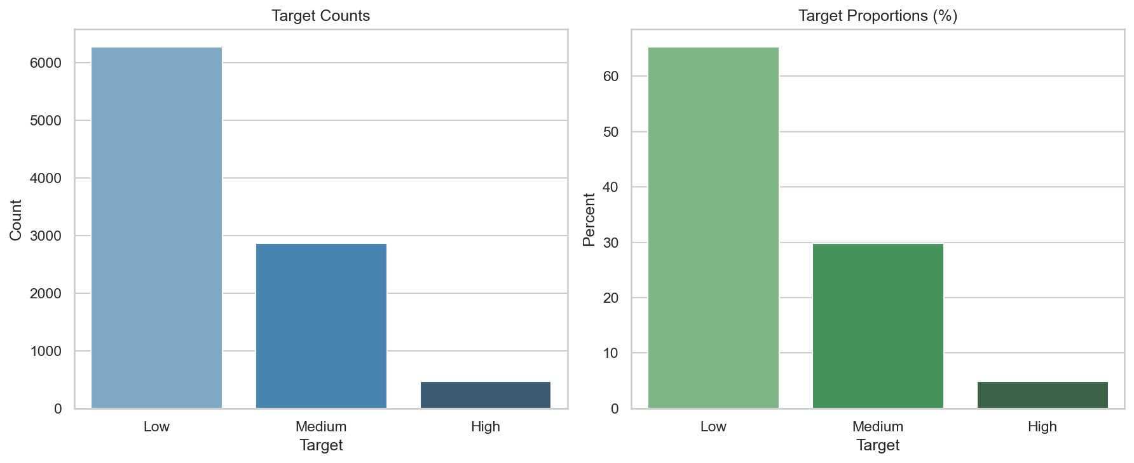
Figure 1. Target distribution across Low, Medium, and High financial health classes.
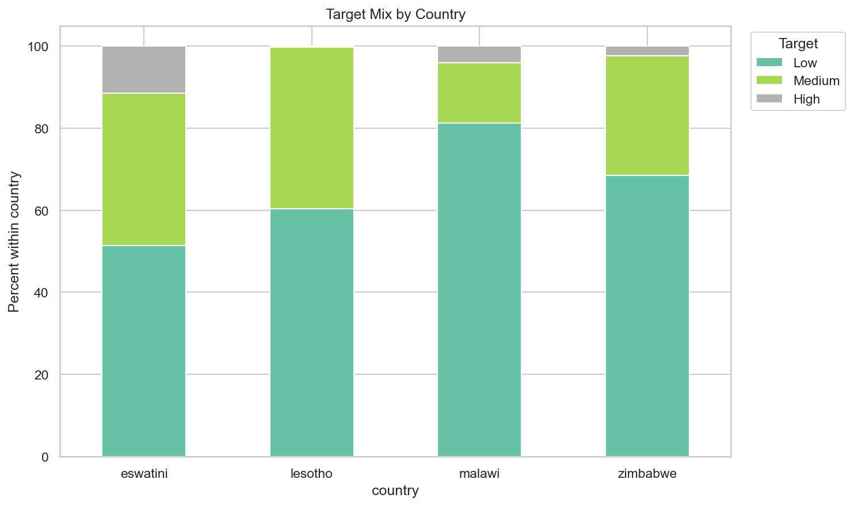
Figure 2. Financial health class distribution by country.
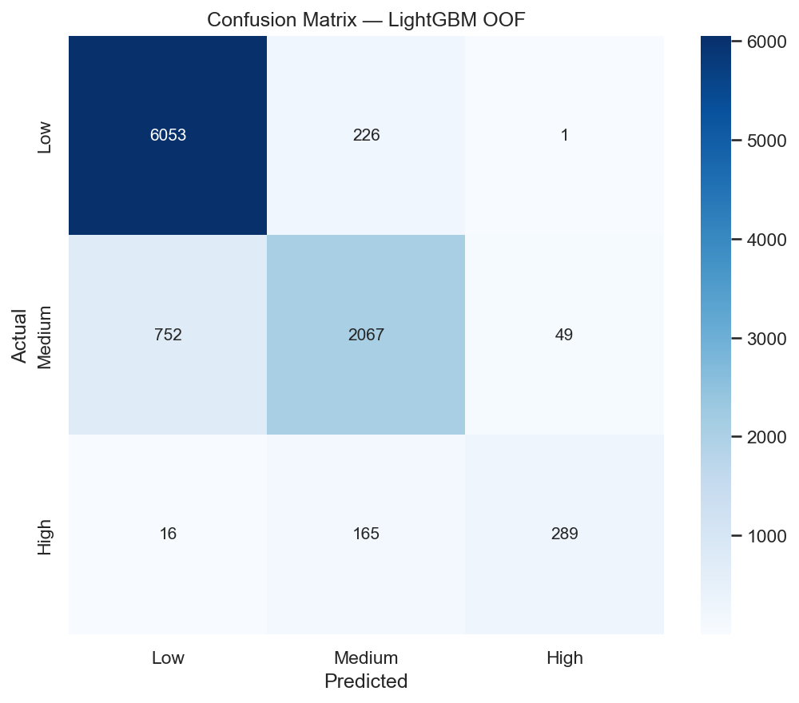
Figure 3. Out-of-fold confusion matrix for LightGBM v3.
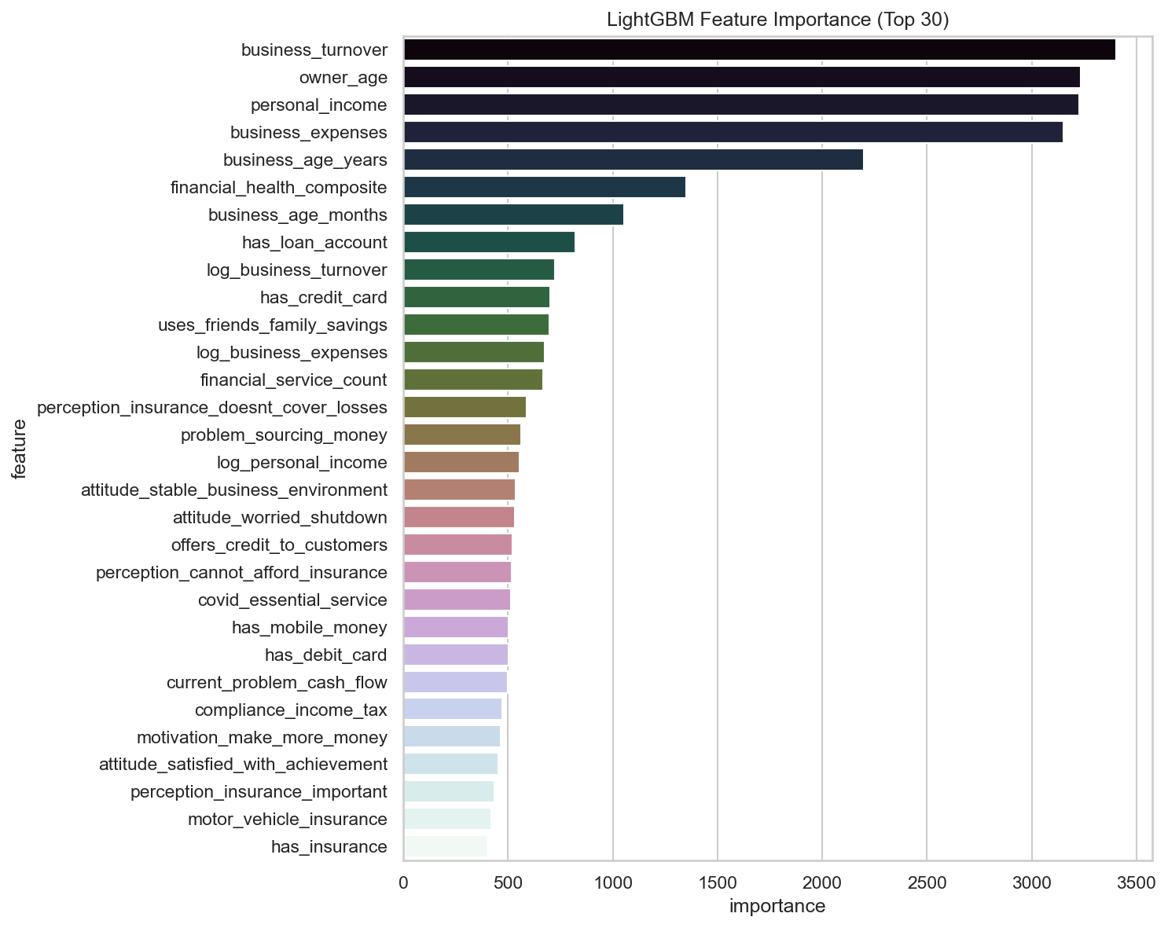
Figure 4. Top LightGBM features by importance.

7. Discussion
Results indicate practical utility for decision support in MSME ecosystems, especially where rapid triage is needed. However, class imbalance and country-specific shifts require monitoring. Future work should include calibration, threshold optimization, and temporal robustness testing.

8. Conclusion
This project demonstrates that a carefully engineered LightGBM pipeline can deliver strong multiclass financial health prediction from survey data. The approach is reproducible, interpretable, and suitable for integration into analytics dashboards and API services.

References
1. FinHealth project repository documentation, 2026.
2. EDA outputs in financial-prediction-model/eda, including decision_parameters_summary.csv.
3. LightGBM documentation and scikit-learn model evaluation references.
4. Data.org MSME Financial Health challenge resources and variable definitions.

