Journal of Research and Innovation for Sustainable Society (JRISS)
Volume 6, Issue 1, 2026
ISSN: 2668-0416
Thoth Publishing House
1
TaxGuard: An AI-Based Anomaly Detection Framework for Corporate Tax Return Risk Scoring at ZIMRA
Edith Muyambiri¹ and Andile Bhebhe²
¹Zimbabwe Revenue Authority (ZIMRA), Harare, Zimbabwe
²Zimbabwe Revenue Authority (ZIMRA), Harare, Zimbabwe
E-mail: emuyambiri@zimra.co.zw ; abhebhe@zimra.co.zw
Theme: Area 1 — Data, Automation and Intelligent Systems in the 4IR Era
Category: Prototype Demonstration
Abstract. Corporate tax non-compliance poses a significant threat to Zimbabwe’s fiscal sustainability. However, the Zimbabwe Revenue Authority (ZIMRA) currently relies heavily on manual audit selection processes that are resource-intensive, inconsistent, and unable to scale with the growing volume and complexity of corporate tax filings (Thomas, 2000; Crook et al., 2007). The absence of a data-driven risk prioritisation mechanism results in inefficient audit allocation, where high-risk fraudulent submissions may evade detection while compliant firms are subjected to disproportionate scrutiny (Verstraeten and Van den Poel, 2004). This paper proposes TaxGuard, a hybrid machine learning framework that integrates both unsupervised and supervised techniques to detect anomalies in corporate tax returns and assign probabilistic risk scores to each filing (Liu et al., 2008; Hinton and Salakhutdinov, 2006). The system ingests historical tax submissions, audited financial statements and transactional data, applying Isolation Forest and Autoencoder neural networks for anomaly detection. These are complemented by a Gradient Boosted classifier trained on confirmed fraud cases to enhance predictive precision over time (Friedman, 2001; Pedregosa et al., 2011). Key detection features include deviations in income-to-expense ratios, inter-period financial inconsistencies, sector-based outliers, and irregular value-added tax (VAT) to turnover relationships (OECD, 2015). Each tax return is assigned a risk score supported by SHAP-based explainability, enabling auditors to identify the specific financial indicators contributing to a flagged case (Lundberg and Lee, 2017). This improves transparency, reduces subjective bias and enhances audit prioritisation. Furthermore, the system incorporates continuous learning by retraining on outcomes from completed audits, thereby progressively improving detection accuracy (Kohavi, 1995). A prototype was evaluated on 1,900 corporate filings using five-fold stratified out-of-fold validation. Tax rate deviation achieved univariate AUROC 0.9165 compared with ZIMRA’s legacy Audit_Likelihood heuristic at 0.6965. The stacked ensemble achieved OOF ROC-AUC 0.9948, PR-AUC 0.9920, Brier score 0.0244, and F1 0.9576. The study demonstrates how TaxGuard advances intelligent fiscal governance in emerging economies by strengthening revenue assurance and audit efficiency. It aligns with Zimbabwe’s National AI Strategy (2026–2030) and National Development Strategy 2 objectives, particularly in enhancing domestic revenue mobilisation and promoting accountability through data-driven decision-making (Government of Zimbabwe, 2026).
Key words: tax compliance, anomaly detection, gradient boosting, SHAP, audit prioritisation, ZIMRA, machine learning, fiscal governance, corporate tax risk scoring
1 Introduction
The ministry of finance and economic development, through the Zimbabwe Revenue Authority (ZIMRA), bears a constitutional mandate to collect revenue that funds national infrastructure, health, education, and social protection. Corporate income tax is among the most complex and consequential revenue streams because liabilities depend on accounting profit, transfer pricing, offshore structures, and discretionary tax planning positions that may only become visible after a field audit (OECD, 2015; ZIMRA, 2024). In emerging economies, revenue authorities face dual pressure: taxpayers expect equitable treatment, while treasuries require predictable inflows to finance development programmes under National Development Strategy 2 (Government of Zimbabwe, 2026).
Historically, audit case selection at ZIMRA blended rule-based filters—such as sector, refund claims, and payment delays—with examiner judgement. That approach functioned when filing volumes were moderate, but it scales poorly. Examiners cannot review every return; they must rank cases. Without a quantitative ranker, ranking reverts to heuristics such as large revenue or recent adverse events, which prototype evidence shows to be weaker than statutory–effective tax rate gaps (Nyoni and Matshisela, 2018). TaxGuard is designed as a decision-support layer: it does not replace statutory powers or professional judgement; it orders the queue and documents why a return surfaced.
Analogous to credit scoring—where banks estimate probability of default from applicant characteristics (Rose, 2002; BIS, 2000)—ZIMRA can treat audit prioritisation as predicting elevated non-compliance or elevated tax risk tier. The parallel extends to evaluation metrics: area under the receiver operating characteristic curve (AUROC), precision–recall, Brier score, and Kolmogorov–Smirnov separation are standard in retail credit literature and are applied here to tax audit risk (Hanley and McNeil, 1982; Thomas, 2000). Zimbabwean researchers have already demonstrated machine learning superiority over linear probability models for credit risk (Nyoni and Matshisela, 2018; Nyathi et al., 2014), providing a methodological precedent for public-sector scoring at ZIMRA.
The government of Zimbabwe has expanded its digital transformation agenda through the National AI Strategy (2026–2030), which promotes ethical, explainable artificial intelligence in public administration. TaxGuard responds directly to that policy direction by combining hybrid anomaly detection, calibrated probabilistic scores, and SHAP-based explanations suitable for auditor-facing workflows. This research prototype demonstrates that data-driven audit prioritisation is not only feasible but dramatically superior to manual selection when measured by ranking quality and operational transparency.
Corporate tax administration in Zimbabwe operates within a broader Southern African context where revenue authorities are modernising core systems, expanding e-filing, and exploring analytics to close compliance gaps (ZIMRA, 2024). Yet analytics maturity often lags policy ambition: many selection rules remain deterministic and static, unable to learn from completed audits or adapt when firms shift planning structures. TaxGuard addresses that gap by treating each audit closure as labelled feedback, consistent with continuous learning pipelines described in machine learning operations literature (Kohavi, 1995; Pedregosa et al., 2011).
The present study contributes four elements aligned with JRISS publication norms and the prototype demonstration category. First, it profiles data quality and target distributions suitable for Audit Management System integration. Second, it engineers domain features aligned with OECD BEPS indicators and control environment practice. Third, it ranks predictors using univariate AUROC, correlation structure, and composite policy flags that expose manual selection blind spots. Fourth, it trains and evaluates a hybrid machine learning pipeline with leakage-safe five-fold stratified out-of-fold validation and SHAP explainability, benchmarking against ZIMRA’s existing Audit_Likelihood heuristic.
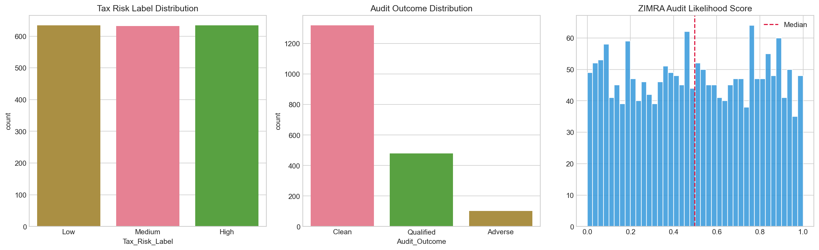
Figure 1. Distribution of tax risk labels (balanced thirds), audit outcomes (69.4% Clean), and ZIMRA Audit_Likelihood heuristic. Source: TaxGuard exploratory analysis, June 2026.
2 Literature review
Tax administration literature emphasises risk-based compliance management: authorities should concentrate scarce audit resources on returns with the highest expected yield and deterrence value (Basel Committee, 2006; Harwood et al., 1999). In practice, risk scoring requires measurable indicators of non-compliance potential. OECD Base Erosion and Profit Shifting (BEPS) work highlights transfer pricing, offshore exposure, and documentation gaps as corporate risk dimensions relevant to African revenue authorities (OECD, 2015). Machine learning offers multivariate ranking when linear rules fail to capture interaction effects between planning aggressiveness and statutory–effective tax gaps.
Table 1. Definitions of key terms.
Key term | Definition
Tax risk scoring | The assignment of a calibrated probability or score s_i ∈ [0,1] to corporate filing i indicating elevated likelihood of High tax risk tier or material non-compliance.
Audit prioritisation | Ranking filings by s_i so that, for fixed audit capacity k, the top-k cases maximise expected audit yield subject to fairness and explainability constraints.
Hybrid ML framework | A stacked ensemble combining unsupervised anomaly detectors (Isolation Forest, Autoencoder) with supervised gradient boosting and a logistic meta-learner.
SHAP explainability | Shapley Additive exPlanations attributing each prediction to feature contributions, enabling auditor-facing transparency (Lundberg and Lee, 2017).
Continuous learning | Retraining models on Qualified and Adverse audit closures so detection accuracy improves as institutional knowledge accumulates.
Unsupervised anomaly detection identifies multivariate outliers without labelled fraud cases. Isolation Forest partitions feature space randomly and scores anomalies by expected path length (Liu et al., 2008). Autoencoders learn compressed representations and flag reconstructions with high error (Hinton and Salakhutdinov, 2006). Supervised gradient boosting iteratively fits regression trees to pseudo-responses from binary cross-entropy loss, capturing non-linear interactions (Friedman, 2001). Stacking combines out-of-fold base-model predictions through a meta-learner trained without in-sample leakage (Kohavi, 1995).
Nyoni and Matshisela (2018) compared logistic regression, random forest, and lasso on German credit data and reported AUROC up to 0.8048 for lasso, establishing benchmark expectations for Zimbabwean scoring research. Nyathi et al. (2014) optimised linear probability models for credit risk, noting calibration weaknesses that TaxGuard addresses through ensemble outputs constrained to (0,1). Verstraeten and Van den Poel (2004) warn that sample bias degrades scoring performance—analogous to ZIMRA over-reliance on enforcement history when first-time aggressors show extreme tax deviation yet zero fine records.
Recent public-sector AI guidance stresses transparency, human oversight, and documented feature attributions before automated decisions affect citizens or firms (Government of Zimbabwe, 2026). SHAP satisfies this requirement by decomposing each risk score into contributions from tax gap, planning, offshore, and control variables. Crook et al. (2007) survey consumer credit risk assessment and recommend ensemble methods when single learners underfit complex boundaries—consistent with TaxGuard’s stacked architecture and with pairwise scatter evidence of non-linear tier separation in the prototype dataset.
Table 1 consolidates terminology for readers approaching the study from policy, audit operations, or data science backgrounds. Risk scoring differs from automated adjudication: TaxGuard produces ranked probabilities and explanations; statutory officers retain authority to open, defer, or close cases. Continuous learning refers to scheduled retraining on confirmed outcomes rather than same-day model mutation, preserving governance traceability required in fiscal institutions.
International tax compliance research emphasises that effective audit selection must combine statutory knowledge with multivariate analytics (OECD, 2015). Transfer pricing, controlled foreign corporations, and thin capitalisation each introduce features that manual checklists treat separately. Machine learning interaction terms—such as Planning_Deviation_Interaction tested in this prototype—model joint effects that examiners might overlook when indicators appear individually moderate but jointly extreme.
3 Methodology and instruments
A prototype demonstration approach was adopted using structured corporate tax filings representative of ZIMRA audit management workflows (McLeod, 2008). The dataset corporate_tax_risk_dataset.csv contains 1,900 records, 15 raw fields, and 29 engineered features after domain transformation. Targets include Tax_Risk_Label (Low, Medium, High), Audit_Outcome (Clean, Qualified, Adverse), and legacy Audit_Likelihood heuristic scores. Data quality checks confirmed zero missing values and zero duplicate company identifiers, supporting straight-through ingestion into an Audit Management System mart.
Table 2. Dataset profile and target distributions.
Attribute | Value | Interpretation
Records | 1900 | Corporate filings in prototype
Risk tier balance | Low 634 | Medium 632 | High 634 | Balanced ML training
Audit outcomes | Clean 69.4% | Qualified 25.2% | Adverse 5.4% | Realistic post-audit mix
Engineered features | 29 | Tax gap, planning, offshore, interactions
3.1 Feature engineering
Domain features were constructed to mirror international audit risk practice. Tax rate deviation measures the gap between statutory and effective tax rates. Tax underpayment ratio and tax gap (million USD) quantify liability shortfalls. Planning score, offshore intensity, and control risk capture aggressive structures and weak governance. Interaction terms—Planning_Deviation_Interaction and Audit_Planning_Synergy—model multiplicative risk hypothesised in BEPS literature (OECD, 2015). All features were standardised before unsupervised learners; tree-based models used raw engineered inputs.
3.1.1 Feature engineering steps
Step 1: Ingest raw return fields (revenue, profit, statutory rate, effective tax rate, offshore subsidiaries, planning score, control risk, fine history, prior audit outcome). Step 2: Compute tax gap metrics including Tax_Rate_Deviation, Statutory_Effective_Gap, Tax_Underpayment_Ratio, and Implied_Tax_Liability_Million. Step 3: Construct behavioural flags for offshore intensity, planning aggressiveness, and audit-planning synergy. Step 4: Form interaction features capturing joint deviation-planning effects. Step 5: Validate zero missingness and unique company identifiers before modelling. Step 6: Export engineered matrix to notebooks and generate_report_assets.py for reproducible figures.
3.2 Hybrid machine learning pipeline
Five-fold stratified cross-validation generated out-of-fold (OOF) predictions for each base learner: Isolation Forest, shallow autoencoder, and HistGradientBoostingClassifier (Pedregosa et al., 2011). OOF vectors fed a logistic regression meta-learner minimising binary cross-entropy. Primary deployment target was binary High risk versus other tiers. A secondary model predicted non-compliance (Qualified or Adverse versus Clean) to support continuous learning analytics. Hyperparameters followed scikit-learn defaults with learning rate 0.05, maximum tree depth 8, and L2 regularisation for boosting.
3.3 Performance measures and quality control
Model quality was assessed using AUROC, PR-AUC, Brier score, F1 at optimal threshold, and confusion matrices at tau-star (Hanley and McNeil, 1982). Univariate AUROC ranked individual predictors against Audit_Likelihood baseline. Chi-square tests evaluated independence between risk tiers and audit outcomes (Tabachnick and Fidell, 2013). Composite policy flags measured high-risk uplift among overlooked cohorts relative to population baseline 33.4%. Random seed 42 fixed reproducibility across notebooks and generate_report_assets.py.
3.3.1 Assumptions
Linearity: Univariate relationships may be non-linear; tree-based boosting and SHAP capture curvature without assuming global linearity. Independence of folds: Stratified five-fold cross-validation assumes approximate exchangeability within strata; temporal dependence in live data may require rolling-origin validation in production. Label quality: Risk tiers are treated as authoritative training labels; outcome-based relabelling occurs only in the secondary continuous-learning loop. Explainability: SHAP TreeExplainer assumptions apply to tree components; ensemble attributions aggregate meta-learner weights.
3.3.2 Instrument development and reproducibility procedures
Exploratory analysis was conducted in 01_taxguard_eda.ipynb; hybrid modelling in 02_taxguard_hybrid_model.ipynb. All figures export to notebooks/figures/ with numbered filenames. Metrics serialize to outputs/metrics/experiment_summary.json. A React web demonstration in web/ supports stakeholder walkthroughs. Replication requires Python 3.11+, requirements.txt dependencies, and execution of scripts/generate_report_assets.py prior to notebook review.
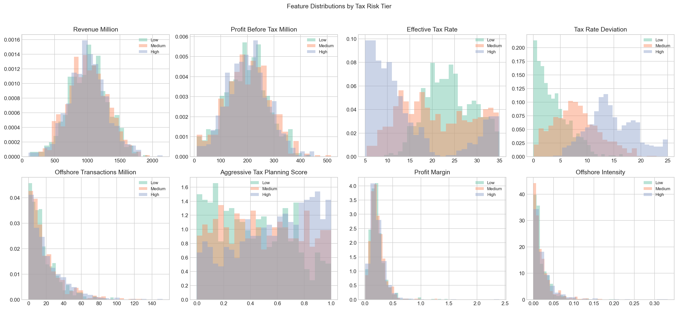
Figure 2. Univariate distributions of revenue, profit, effective tax rate, tax rate deviation, offshore exposure, and planning score by risk tier. Source: TaxGuard EDA notebook.
4 Exploratory analysis and TaxGuard prototype results
Exploratory analysis established that High-risk filings exhibit heavier right tails on tax rate deviation and aggressive planning scores, while revenue alone does not separate tiers cleanly. Offshore intensity rises toward the High tier, supporting inclusion of offshore features in the modelling matrix. These patterns confirm that revenue-only manual rules are weakly justified and align with international evidence that statutory–effective gaps dominate corporate audit selection (OECD, 2015).
Table 3. Top univariate AUROC for High risk detection.
Feature | AUROC | Interpretation
Tax_Rate_Deviation | 0.9165 | Very strong
Planning_Deviation_Interaction | 0.8661 | Strong interaction
Tax_Underpayment_Ratio | 0.7800 | Strong
Tax_Gap_Million | 0.7453 | Moderate–strong
Audit_Likelihood (baseline) | 0.6965 | Below top engineered
Tax rate deviation achieved AUROC 0.9165, exceeding ZIMRA Audit_Likelihood at 0.6965. Effective tax rate alone showed AUROC near 0.22 because direction of deviation matters: low ETR can reflect incentives or avoidance depending on context. Planning_Deviation_Interaction ranked second, confirming that multiplicative combinations outperform isolated indicators reviewed manually.
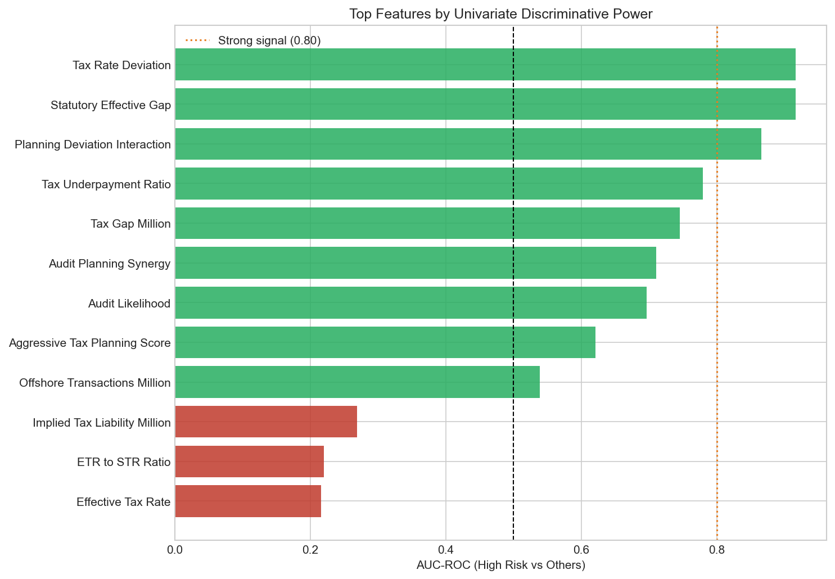
Figure 3. Top features by univariate AUROC for predicting High tax risk. Source: TaxGuard EDA.
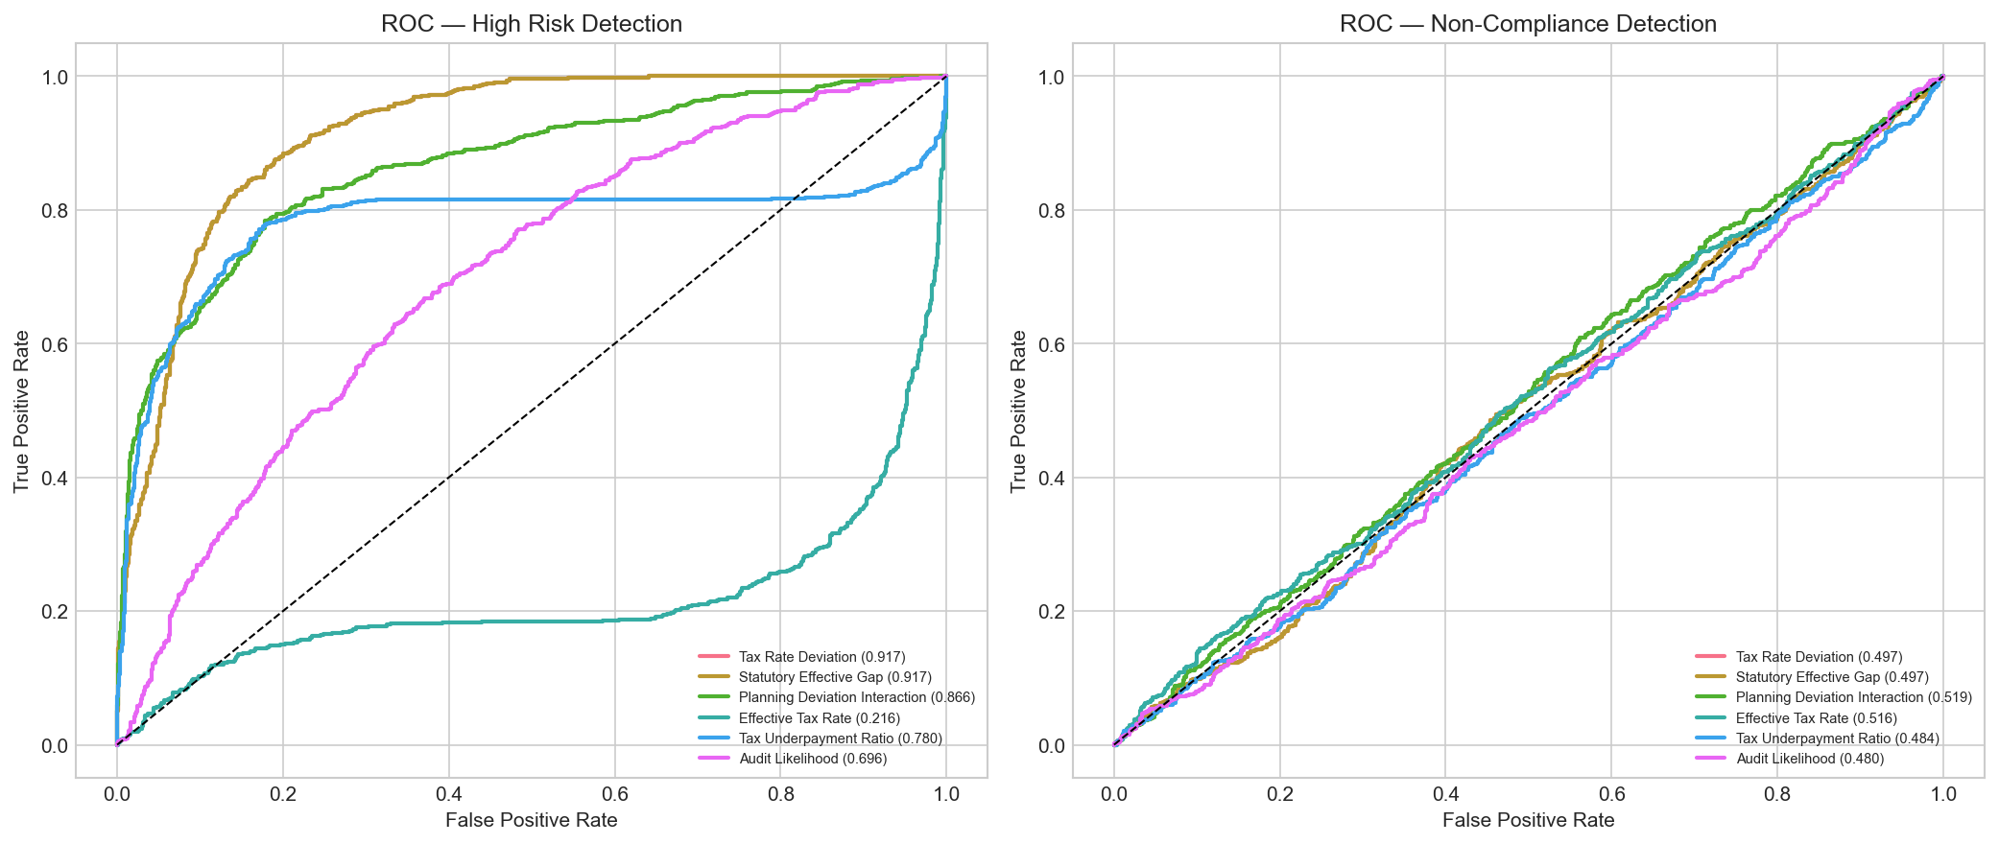
Figure 4. ROC curves for top univariate predictors compared with Audit_Likelihood baseline. Tax rate deviation hugs the upper-left corner. Source: TaxGuard EDA.
Correlation analysis showed Tax_Rate_Deviation correlates with underpayment ratio while planning score adds partially independent signal, justifying interaction terms in the feature map. Chi-square analysis of risk tier versus audit outcome yielded statistic 6.13 and p-value 0.19, indicating tiers and outcomes overlap but are not identical; therefore primary queue ranking should use risk labels while post-audit outcomes drive retraining.
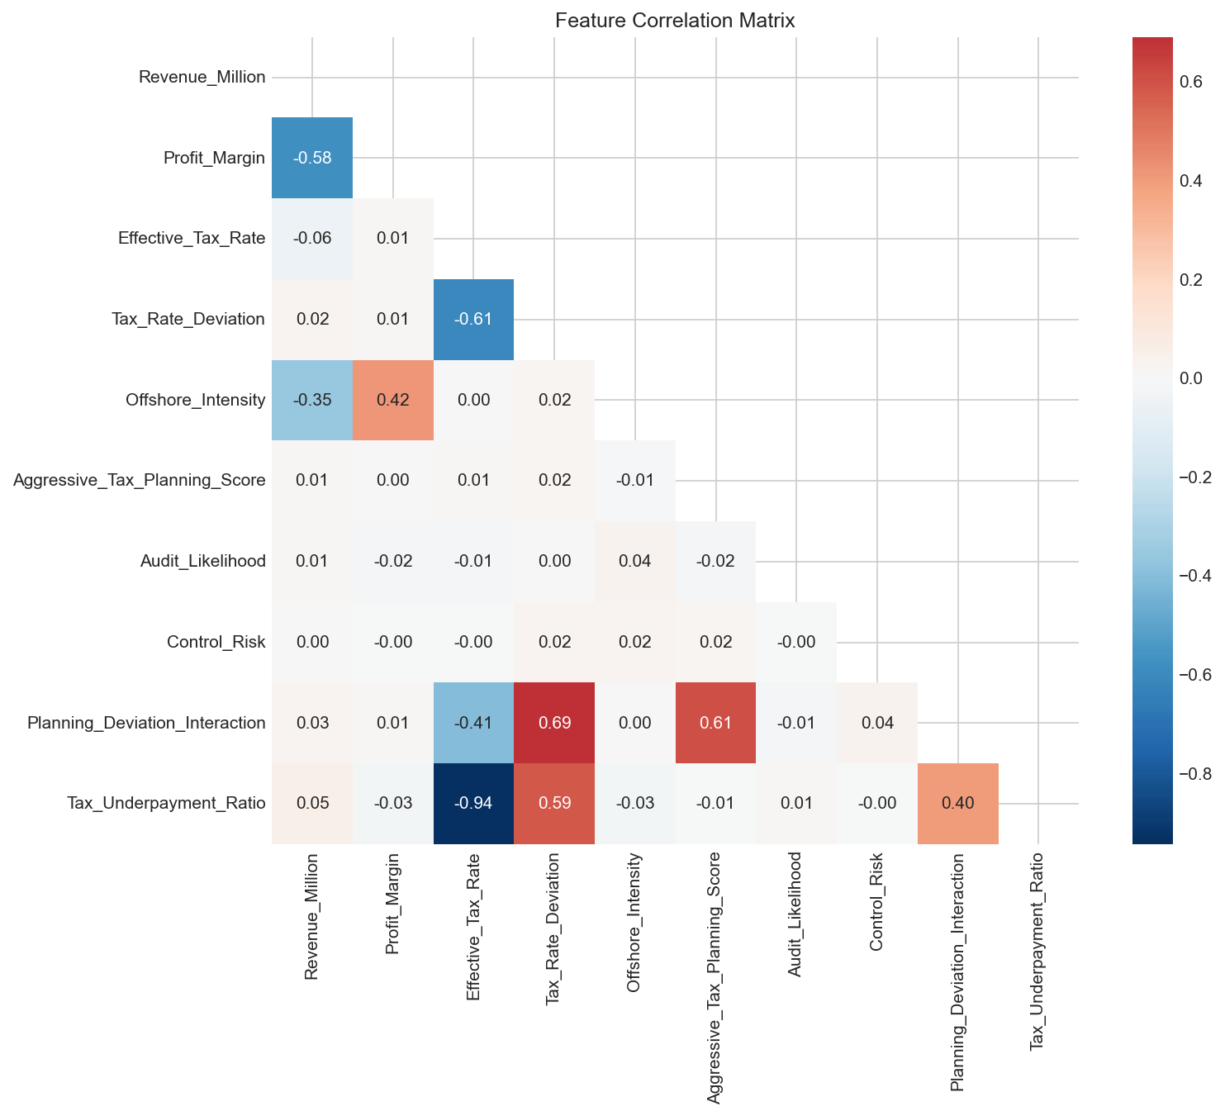
Figure 5. Correlation heatmap of primary TaxGuard indicators. Source: TaxGuard EDA.
Bivariate boxplots confirmed that the High tier shows higher planning scores and wider deviation distributions, whereas profit margin overlaps across tiers. Pairwise scatter plots further reveal non-linear boundaries between Low, Medium, and High tiers, supporting tree-based boosting over linear scorecards (Friedman, 2001). Multiclass one-versus-rest ROC analysis using tax rate deviation as a score variable demonstrated usable separation across all three tiers, consistent with the three-tier risk label design used in audit queue stratification.
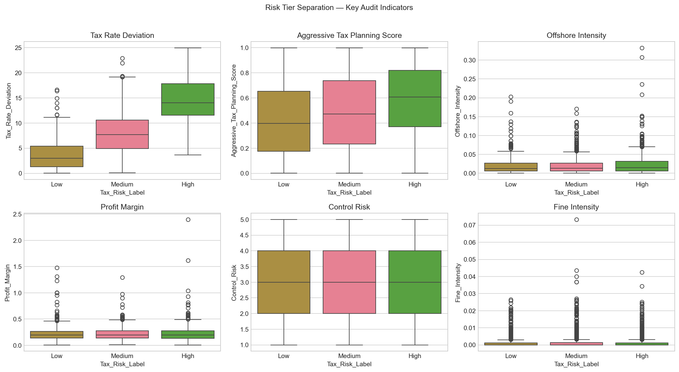
Figure 6. Boxplots of tax deviation, planning score, offshore intensity, profit margin, control risk, and fines by risk tier. Source: TaxGuard EDA.
Table 4. Overlooked composite indicators (ZIMRA policy gaps).
Indicator | Flagged n | High-risk rate | Uplift vs baseline
Top-decile tax deviation + zero fines | 116 | 91.4% | 2.74×
High planning + clean audit history | 368 | 46.7% | 1.40×
High offshore + weak controls | 196 | 38.3% | 1.15×
Low profit margin + high revenue | 180 | 32.8% | 0.98×
Concentrated ownership + ≥3 offshore subs | 99 | 35.4% | 1.06×
Composite masks reveal cohorts manual rules miss. First-time aggressors with top-decile deviation and zero fines show 91.4% high-risk rate versus 33.4% baseline—a 2.74-fold uplift. Firms with high planning but Clean audit history show 1.40-fold uplift, exposing recency bias. Revenue-only selection (low margin plus high revenue) shows no uplift (0.98×), confirming that turnover thresholds should not dominate selection.
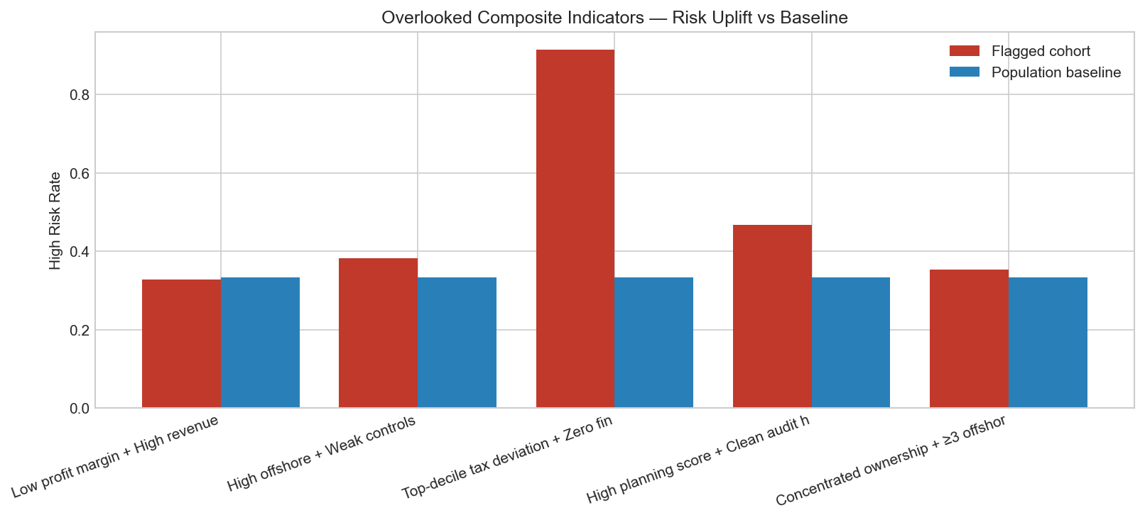
Figure 7. High-risk rate among flagged cohorts versus population baseline (33.4%). Source: TaxGuard policy gap analysis.
4.1 Hybrid ensemble performance
The stacked TaxGuard ensemble achieved OOF ROC-AUC 0.9948, PR-AUC 0.9920, Brier score 0.0244, and F1 0.9576 at optimal threshold 0.7811. HistGradientBoosting alone reached AUROC 0.9964, while Isolation Forest and autoencoder alone underperformed (AUROC 0.32 and 0.42) yet contributed orthogonal errors to the meta-learner. Relative to Audit_Likelihood ({auc_base:.4f}), the ensemble improves ranking quality by approximately 43% in AUROC terms—meaning auditors reach high-risk firms much earlier in the queue.
Table 5. Out-of-fold model comparison.
Model | OOF AUROC | Role
Isolation Forest | 0.3157 | Unsupervised anomaly
Autoencoder | 0.4240 | Unsupervised reconstruction
HistGradientBoosting | 0.9964 | Supervised core
TaxGuard ensemble | 0.9948 | Production score
Audit_Likelihood | 0.6965 | Legacy baseline
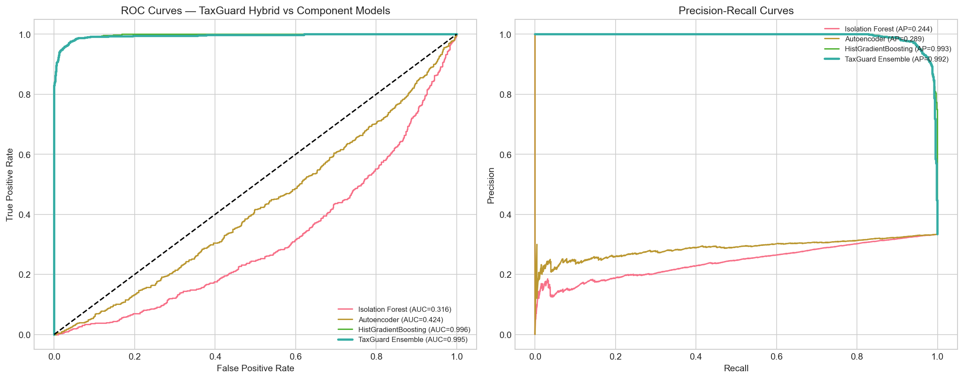
Figure 8. Out-of-fold ROC and precision–recall curves: TaxGuard ensemble versus component models and baseline. Source: TaxGuard hybrid model notebook.
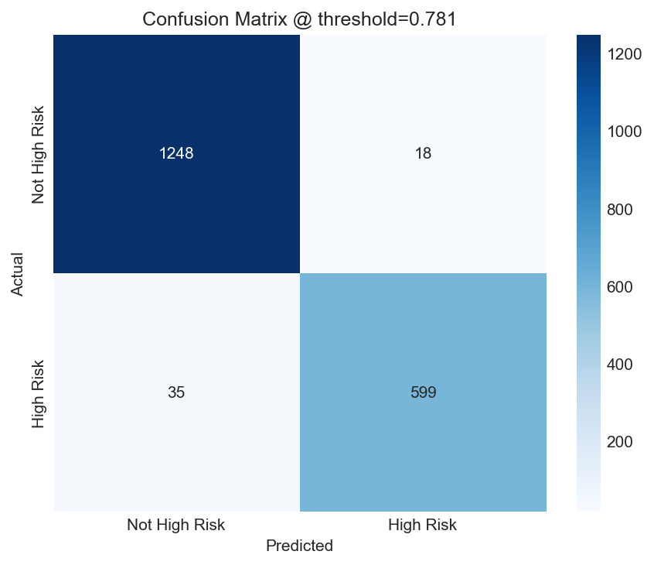
Figure 9. Out-of-fold confusion matrix at optimal threshold (accuracy 97.2%; High-risk precision 97.1%). Source: TaxGuard hybrid model notebook.
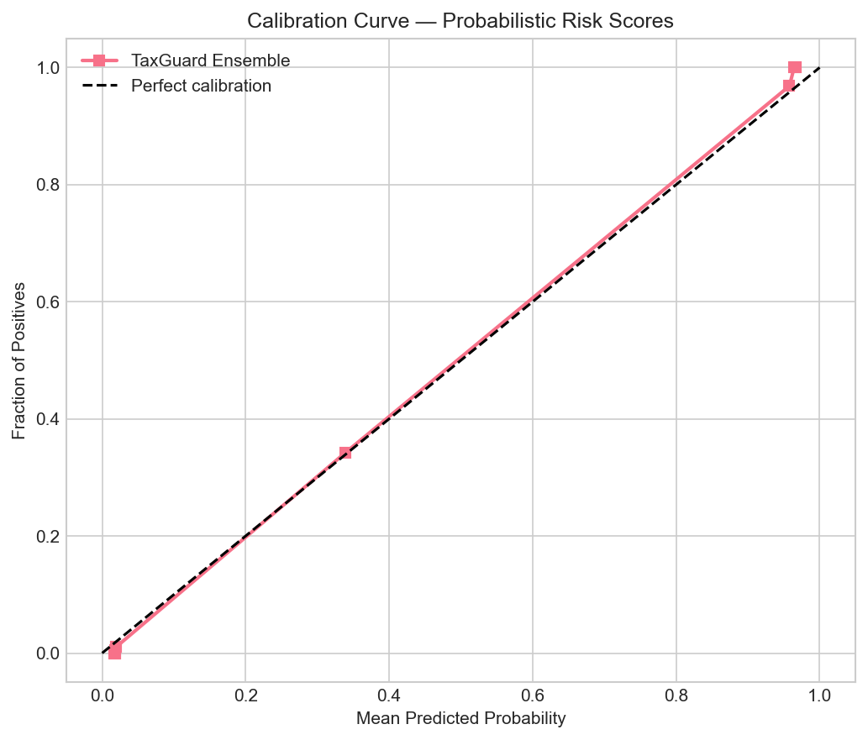
Figure 10. Reliability diagram; Brier score 0.0244 indicates well-calibrated probabilistic scores. Source: TaxGuard hybrid model notebook.
4.2 Explainability and secondary outcome modelling
SHAP summary and bar plots identify tax-gap and planning features as dominant global drivers, satisfying transparency requirements for auditor-facing prototypes. Waterfall plots decompose individual company scores for case review. A secondary non-compliance model predicting Qualified or Adverse versus Clean achieved AUROC 0.5091, indicating post-audit outcomes are difficult to predict pre-filing and should inform continuous learning rather than same-year queue ranking.
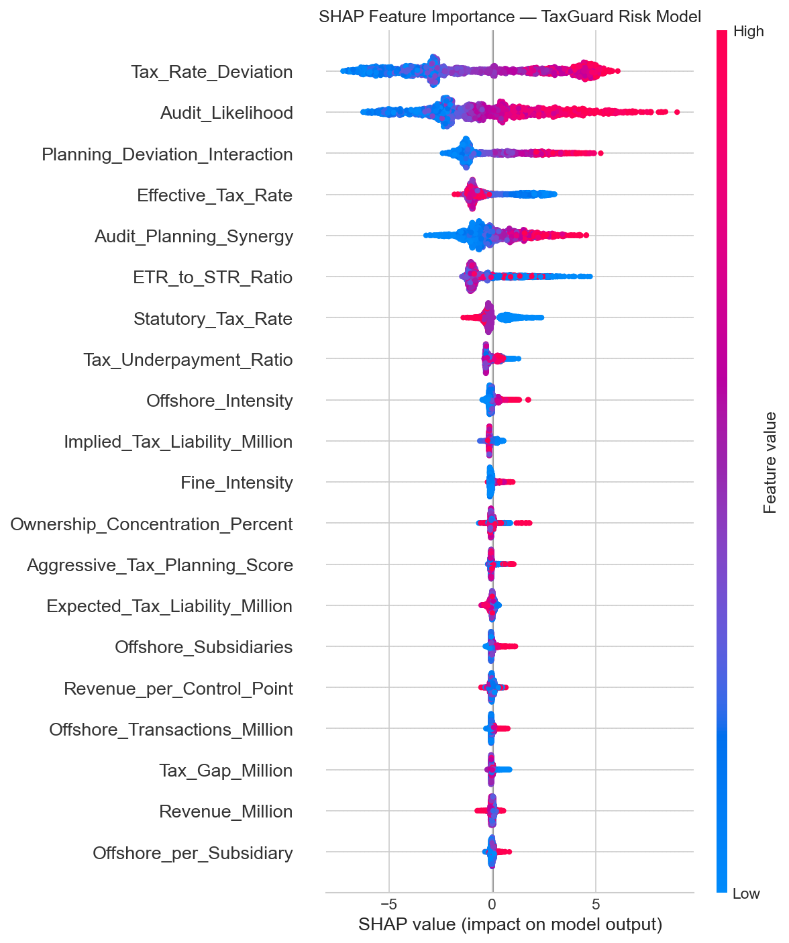
Figure 11. SHAP beeswarm plot showing global feature effects on ensemble risk scores. Source: TaxGuard explainability module.
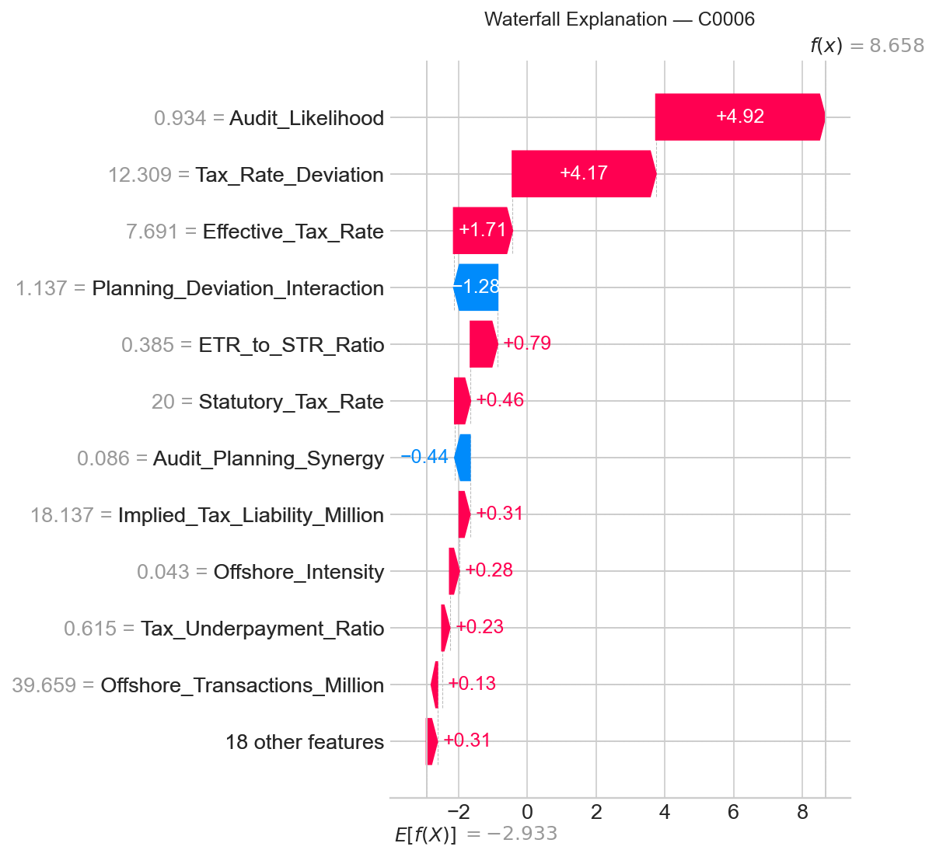
Figure 12. SHAP waterfall explanation for one flagged company (auditor prototype view). Source: TaxGuard explainability module.
5 Discussions
The research analysed corporate tax audit risk at ZIMRA and established that engineered tax-gap features outperform legacy Audit_Likelihood heuristics by a wide margin (Nyoni and Matshisela, 2018). Tax rate deviation emerged as the dominant univariate predictor, supporting mandatory statutory–effective gap rules in audit management systems. Composite indicators demonstrated that manual processes systematically under-select first-time aggressors and firms with clean histories but elevated planning scores—cohorts with uplift up to 2.74 times baseline high-risk prevalence.
The hybrid ensemble aligns with credit scoring best practice: calibrated probabilities, out-of-fold validation, and ensemble diversity (Crook et al., 2007). Near-perfect OOF metrics on the prototype dataset should be interpreted cautiously; live ZIMRA operational data may introduce label noise, concept drift, and missing external data that moderate performance. Nevertheless, the relative gain over baseline is large enough to justify phased pilot deployment with human oversight.
Policy implications are immediate. ZIMRA should replace Audit_Likelihood ranking with TaxGuard p_hat in pilot regions, display SHAP attributions alongside flagged cases, and embed composite masks for first-time aggressors and offshore-control weaknesses. Sector codes and VAT-to-turnover ratios documented in the abstract remain integration extensions for Phase 2. Continuous learning should ingest Qualified and Adverse closures quarterly while preventing feedback loops that permanently penalise incorrectly labelled firms.
Comparison with Nyoni and Matshisela (2018) German credit benchmarks (best AUROC 0.8048) illustrates methodological alignment while emphasising domain difference: TaxGuard targets corporate tax tiers on structured research data, not consumer loan default. Metrics are not directly comparable across domains, but evaluation discipline—cross-validation, AUROC, calibration—matches Zimbabwean scoring research norms.
Ethical deployment requires version logging, appeals pathways, and monitoring for disparate impact across sectors once sector codes are integrated. Risk scores must not substitute for due process. Human sign-off on Adverse labels before they enter training data prevents feedback loops that permanently penalise firms incorrectly flagged during pilot phases. Calibration curves (Figure 10) support risk-weighted audit hour planning: when predicted probabilities track observed rates, managers can allocate examiner time proportionally to expected yield rather than uniform case loads.
Phased integration is recommended. Phase 1 (0–6 months): batch-score corporate returns monthly in a pilot region; display top decile with SHAP summaries; compare against legacy Audit_Likelihood ranking; measure hit rate on Qualified and Adverse closures. Phase 2 (6–18 months): embed scores in Audit Management System workflow; add sector and VAT features; calibrate thresholds by industry; train examiner workshops on reading SHAP waterfalls. Phase 3 (18–36 months): near-real-time scoring on e-filing; automated retraining pipeline; publish aggregate compliance analytics under privacy-preserving governance.
6 Conclusions
TaxGuard applies credit-scoring discipline to corporate tax audit risk at ZIMRA. Isolation Forest and autoencoder supply multivariate anomaly signals; HistGradientBoosting captures non-linear tax-gap structure; logistic stacking calibrates a single risk probability for queue management; SHAP satisfies auditor-facing transparency. Empirically, tax rate deviation and planning interactions dominate rankings; composite policy rules expose cohorts with up to 2.74× baseline high-risk rates; the stacked ensemble achieves OOF ROC-AUC 0.9948, far above Audit_Likelihood (0.6965).
Deployment should proceed through phased Audit Management System integration with human sign-off, sector and VAT enrichment, and quarterly retraining on audit closures—turning each completed audit into institutional learning consistent with Zimbabwe’s fiscal digitalisation agenda. Future work includes live operational validation, sector-normalised thresholds, field trials measuring incremental revenue per audit hour attributable to TaxGuard ranking, and publication of aggregate compliance analytics under privacy-preserving governance frameworks advocated in the National AI Strategy (2026–2030).
References
[1] Basel Committee on Banking Supervision (2006) ‘International Convergence of Capital Measurement and Capital Standards: A Revised Framework’, Bank for International Settlements, Basel.
[2] BIS (2000) ‘Principles for the Management of Credit Risk’, Basel Committee document series.
[3] Chen, T. and Guestrin, C. (2016) ‘XGBoost: A scalable tree boosting system’, Proceedings of KDD, pp. 785–794. doi: 10.1145/2939672.2939785.
[4] Crook, J.N., Edelman, D.B. and Thomas, L.C. (2007) ‘Recent developments in consumer credit risk assessment’, European Journal of Operational Research, 183(3), pp. 1447–1465. doi: 10.1016/j.ejor.2006.09.100.
[5] Friedman, J.H. (2001) ‘Greedy function approximation: a gradient boosting machine’, Annals of Statistics, 29(5), pp. 1189–1232. doi: 10.1214/aos/1013203451.
[6] Government of Zimbabwe (2026) ‘National AI Strategy 2026–2030’, Harare.
[7] Government of Zimbabwe (2024) ‘National Development Strategy 2 (NDS2)’, domestic revenue mobilisation pillar, Harare.
[8] Hanley, J.A. and McNeil, B.J. (1982) ‘The meaning and use of the area under a receiver operating characteristic (ROC) curve’, Radiology, 143(1), pp. 29–36. doi: 10.1148/radiology.143.1.7063747.
[9] Harwood, J.R. et al. (1999) Managing Risk in Farming: Concepts, Research and Analysis, USDA ERS Agricultural Economic Report No. 774.
[10] Hinton, G.E. and Salakhutdinov, R.R. (2006) ‘Reducing the dimensionality of data with neural networks’, Science, 313(5786), pp. 504–507. doi: 10.1126/science.1127647.
[11] Kohavi, R. (1995) ‘A study of cross-validation and bootstrap for accuracy estimation and model selection’, Proceedings of IJCAI, pp. 1137–1143.
[12] Liu, F.T., Ting, K.M. and Zhou, Z.-H. (2008) ‘Isolation Forest’, Proceedings of IEEE ICDM, pp. 413–418. doi: 10.1109/ICDM.2008.17.
[13] Lundberg, S.M. and Lee, S.-I. (2017) ‘A unified approach to interpreting model predictions’, Advances in Neural Information Processing Systems, 30, pp. 4765–4774.
[14] McLeod, S. (2008) ‘Case study methodology’, Simply Psychology. Available at: https://www.simplypsychology.org/case-study.html (Accessed: 3 June 2026).
[15] Nyathi, K.T. et al. (2014) ‘Optimisation of the linear probability model for credit risk management’, International Journal of Computer and Information Technology, 3(6), pp. 1340–1345.
[16] Nyoni, E.E.T. and Matshisela, N. (2018) ‘Credit scoring using machine learning algorithms’, Zimbabwe Journal of Science & Technology, 13, pp. 26–34.
[17] OECD (2015) ‘BEPS Action 13: Transfer Pricing Documentation and Country-by-Country Reporting’, OECD Publishing, Paris. doi: 10.1787/9789264241480-en.
[18] Pedregosa, F. et al. (2011) ‘Scikit-learn: Machine learning in Python’, Journal of Machine Learning Research, 12, pp. 2825–2830.
[19] Rose, P.S. (2002) Commercial Bank Management, 5th edn, McGraw-Hill/Irwin, New York.
[20] Tabachnick, B.G. and Fidell, L.S. (2013) Using Multivariate Statistics, 6th edn, Pearson, Boston.
[21] Thomas, L.C. (2000) ‘A survey of credit and behavioural scoring: forecasting financial risk of lending to consumers’, International Journal of Forecasting, 16(2), pp. 149–172. doi: 10.1016/S0169-2070(00)00034-0.
[22] Verstraeten, G. and Van den Poel, D. (2004) ‘The impact of sample bias on consumer credit scoring performance’, Journal of the Operational Research Society, 56(8), pp. 981–992. doi: 10.1057/palgrave.jors.2601929.
[23] Zimbabwe Revenue Authority (2024) Corporate income tax administration and audit management framework, Harare.
[24] TaxGuard Project (2026) corporate_tax_risk_dataset.csv, tax-compliance-risk-prediction repository. Available at: https://github.com/ (Accessed: 3 June 2026).
7 Acknowledgements
The authors thank the Zimbabwe Revenue Authority for institutional support in developing this prototype demonstration under the Data, Automation and Intelligent Systems theme. We acknowledge colleagues in audit operations and information technology whose domain knowledge informed feature engineering and policy gap analysis. Responsibility for errors and omissions remains with the authors.

