Local attC search improves reconstruction of Vibrionaceae superintegrons with intervis
Liam Nguyen¹, Jan Engelstädter²˒³, Andrew Letten²
¹ School of Chemistry and Molecular Biosciences, The University of Queensland, Brisbane, QLD, Australia
² School of the Environment, The University of Queensland, Brisbane, QLD, Australia
³ ARC Centre of Excellence for Plant Success in Nature and Agriculture, The University of Queensland, Brisbane, QLD, Australia
Keywords Vibrio; integrons; superintegrons; gene cassettes; bioinformatics; visualisation

Abstract
Chromosomal superintegrons contain large arrays of gene cassettes whose reconstruction depends on detecting attC recombination sites. Sequence variation between these sites complicates detection and can obscure cassette boundaries. We compared four detection workflows using five genomes with previously characterised integrons and synthetic genomes containing a defined 80-cassette array. IntegronFinder with local search recovered more attC sites than its default setting in all four Vibrionaceae genomes. HattCI agreement varied markedly among genomes. In synthetic arrays, compensatory mutations designed to retain base pairing reduced the decline in IntegronFinder recall compared with random mutations. HattCI recall declined under both mutation schemes. These findings informed intervis, a workflow for cassette reconstruction, annotation and interactive comparison. Applied to Vibrio cholerae N16961, intervis identified 170 intervals between 171 attC sites. The results support local search for reconstructing long arrays and demonstrate the importance of evaluating detection settings before interpreting cassette organisation.

Introduction
Integrons enable bacteria to acquire and rearrange gene cassettes through site-specific recombination (Hall and Collis 1995; Cambray et al. 2010). Their platform comprises the integrase gene intI, an integration site called attI, and the cassette promoter Pc (Figure 1). The integrase inserts cassettes at attI and excises them through recombination involving attC sites. A cassette usually contains a gene and an attC site. Most lack their own promoter, and expression commonly decreases with distance from Pc (Collis and Hall 1995). However, internal promoters can also support expression within Vibrionaceae arrays (Blanco et al. 2024). Cassette organisation therefore has functional consequences.
Initially associated with antibiotic resistance, integrons also occur as ancient chromosomal systems across bacteria (Rowe-Magnus et al. 2001; Gillings 2014). Vibrionaceae superintegrons can exceed 100 kilobases (kb) and contain hundreds of cassettes (Mazel et al. 1998; Rowe-Magnus et al. 2003). Many cassette functions remain unknown, although characterised examples include toxin–antitoxin and anti-phage defence systems (Iqbal et al. 2015; Darracq et al. 2025; Getz et al. 2025). Natural transformation, the uptake of extracellular DNA, can introduce new cassettes into the V. cholerae chromosomal integron (Righi et al. 2026). Comparing cassette content and order can help investigate this diversity.
Such comparisons require accurate cassette boundaries. attC sites have variable sequences but share structural features formed when complementary regions pair within single-stranded DNA (Cury et al. 2016). IntegronFinder models sequence and secondary structure, while HattCI uses a generalised hidden Markov model of attC components (Pereira et al. 2016; Néron et al. 2022). I-VIP targets class 1 integrons, and BacAnt combines IntegronFinder predictions with database annotation (Zhang et al. 2018; Hua et al. 2021). Gene comparison viewers, including clinker and pyGenomeViz, do not automatically reconstruct attC-defined cassettes (Gilchrist and Chooi 2021; Shimoyama 2022). This study evaluated how detection settings affect superintegron reconstruction and developed intervis to connect detection with cassette annotation and visual comparison.
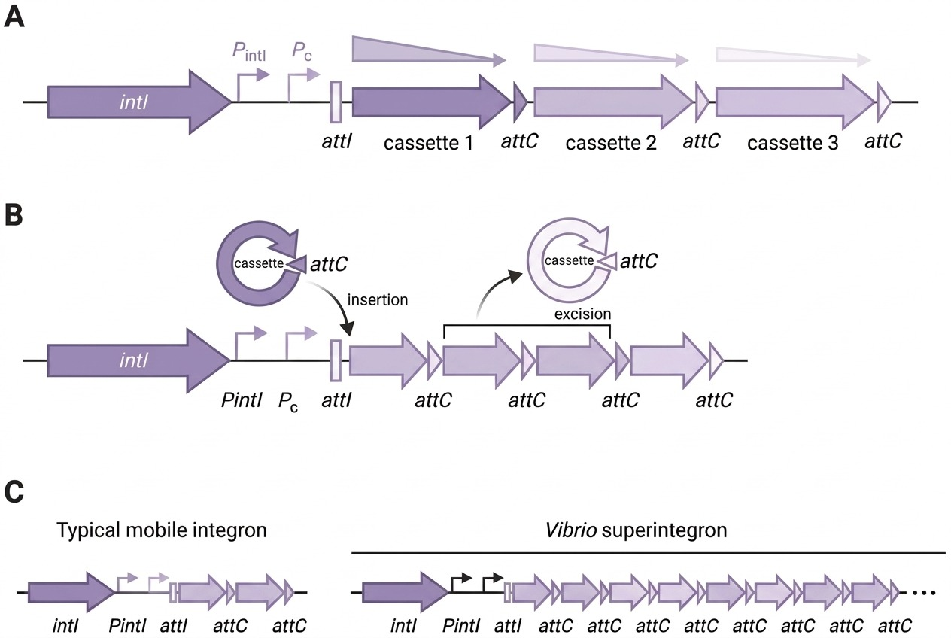
Figure 1. Integron organisation and cassette recombination. (A) The platform includes intI, the integrase promoter PintI, the cassette promoter Pc and the integration site attI. The shading illustrates the conventional positional effect on expression. Internal promoters can modify this pattern, so the gradient is schematic. (B) Integrase-mediated cassette insertion and excision. (C) A short mobile integron array and a long Vibrio superintegron. Diagrams are not to scale.

Methods

Reference genomes
Five genomes were selected because previous studies had characterised their integrons. These comprised four Vibrionaceae superintegrons and a shorter Xanthomonas campestris integron with unusually short attC sites (Table 1). The historical evidence establishes array presence and approximate architecture but does not provide a complete, experimentally verified catalogue of attC coordinates for these assemblies.

Detection benchmark
IntegronFinder 2.0.2 was run with default settings and with --local-max, which performs a more thorough search around candidate attC regions (Néron et al. 2022). Its dependencies include Prodigal for gene prediction, HMMER for protein profile searches and INFERNAL for covariance-model searches (Hyatt et al. 2010; Eddy 2011; Nawrocki and Eddy 2013). HattCI 1.0b searched both strands, retaining candidates with Viterbi scores of at least 2 (Pereira et al. 2016). I-VIP v1.2 and BacAnt 3.4.0 used their bundled databases (Zhang et al. 2018; Hua et al. 2021). Recorded outputs included attC counts, integron spans and database matches, as appropriate to each workflow.

Agreement between tools
IntegronFinder --local-max calls served as an operational reference for the real genomes because they gave the most extensive reconstructions. Candidate sites matched when their midpoints were within 100 base pairs (bp). Precision is the fraction of predictions matching the reference, and recall is the fraction of reference sites recovered. F1 combines them as 2 × precision × recall / (precision + recall). HattCI candidates were ranked by Viterbi score to calculate average precision (AP), the mean of the precision values recorded at each recovered reference site (a step summary of the precision–recall curve, not its trapezoidal area). Matching was one-to-one within the 100-bp window, so each reference site was recovered at most once (Appendix A2). These measures quantify concordance with the chosen reference and cannot establish biological accuracy independently.

Synthetic benchmark
Synthetic genomes provided known target coordinates. The native superintegron was excised from the V. cholerae 569B chromosome and replaced with an 80-cassette array assembled from its integrase region and cassette sequences. attC sites received either random substitutions or compensatory substitutions designed to retain pairing between the two arms of the site. Target divergence increased from 0% to 30% in 5% steps. An excised backbone without the inserted array served as a negative control. Detection outputs were compared with the recorded attC positions using the same midpoint criterion. Construction details are provided in Appendix A1.

The intervis workflow
intervis combines a Python engine, command-line interface and R/Shiny web interface. IntegronFinder --local-max output defines the array, which is displayed with the integrase on the left. Intervals between consecutive attC sites are treated as candidate cassettes. DIAMOND searches against Swiss-Prot provide protein annotations (Buchfink et al. 2021), supplemented by gene symbols from supplied GFF or GenBank files. Keyword-based functional categories are provisional annotations. Pairwise links use reciprocal best hits, meaning each sequence is the other's highest-scoring match, and are shaded by amino-acid identity. Computation used UQ's Bunya cluster. Source code is available at github.com/NqynX/intervis.
Table 1. Reference genomes and evidence supporting their integron arrays. SI denotes superintegron. VCR, VPR and XCcR denote cassette-associated repeats described in V. cholerae, V. parahaemolyticus and X. campestris, respectively. Historical evidence supports the presence of an array but does not validate every predicted attC site in the assembly analysed here.
Genome and strain | Accession | Experimental evidence used in this study | Primary sources
V. cholerae O1 569B | GCA_051903295.1 | ~120-kb VCR region mapped; 26 VCR cassettes sequenced; intI4 and attI4 defined | Mazel et al. 1998; Clark et al. 2000
V. vulnificus ATCC 27562 | GCA_002224265.1 | SI boundary and first cassette characterised; complete genome resolved a 158,319-bp SI with 230 cassettes | Rowe-Magnus et al. 2003; Rusch and Rowe-Magnus 2017
V. parahaemolyticus ATCC 17802 | GCA_001558495.2 | Chromosomal SI >100 kb with species-specific VPR/attC repeats and cassette sequence evidence | Rowe-Magnus et al. 2001
Aliivibrio fischeri DSM 507 | CP092712–CP092713 | SI >100 kb by Southern hybridisation; 27 cassettes cloned (19 unique); ccdAB cassette functionally tested | Rowe-Magnus et al. 2003
X. campestris pv. campestris ATCC 33913 | NC_003902.1 | Chromosomal integron; cassette-associated XCcR/attC sites of 53–54 bp amplified and sequenced | Gillings et al. 2005

Results

Local search increases attC recovery in Vibrionaceae
Local search increased attC counts in all four Vibrionaceae genomes (Figure 2, Table 2). Default and local searches recovered 45 and 118 sites in V. cholerae 569B, and 22 and 126 in Aliivibrio fischeri. Corresponding counts were 158 and 218 in V. vulnificus, and 92 and 143 in V. parahaemolyticus. Both settings recovered 22 sites in X. campestris. The local-search V. vulnificus array spanned 156.8 kb, close to the published 158.3-kb superintegron in this strain (Rusch and Rowe-Magnus 2017). Its 218 attC sites and the published 230 cassettes represent different counting units. The 76.1-kb reconstruction in 569B was shorter than the historical estimate of approximately 120 kb containing 150 cassettes (Clark et al. 2000).
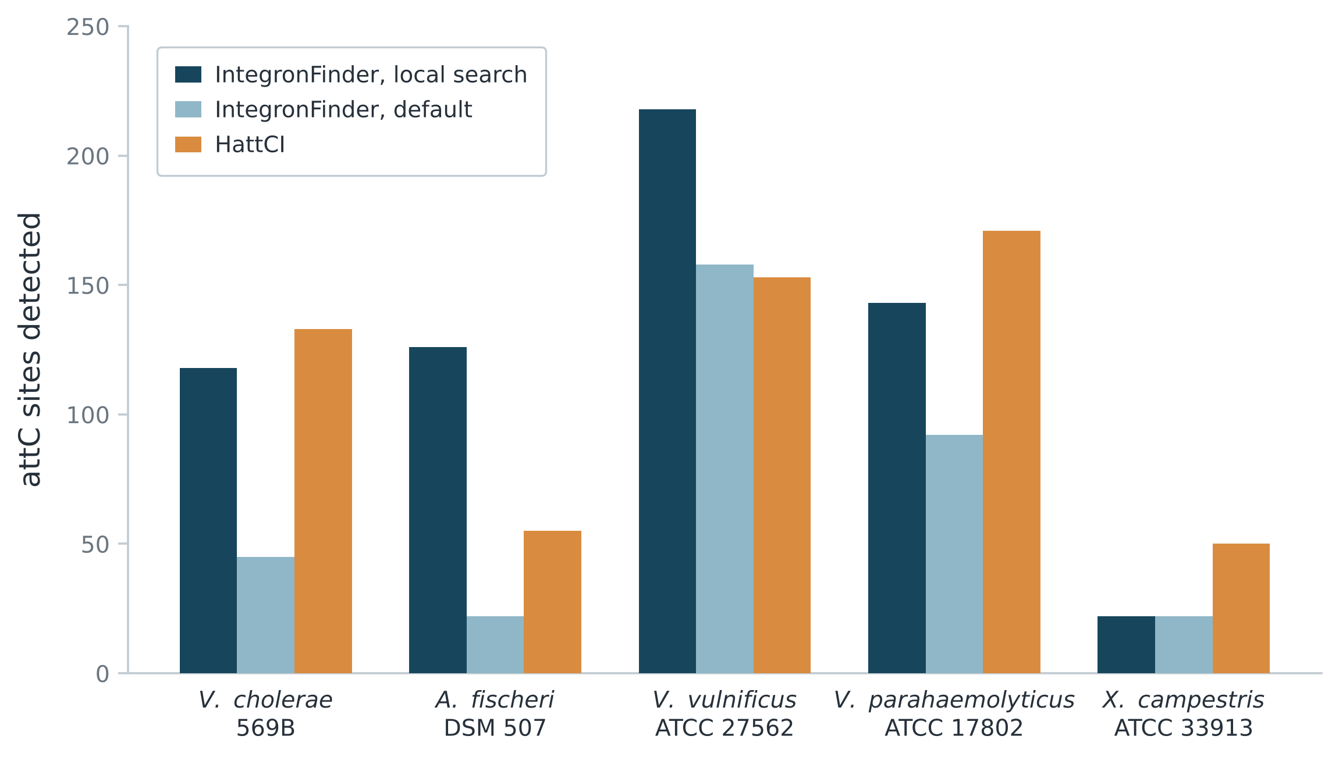
Figure 2. attC candidates detected in five reference genomes. IntegronFinder was run with default settings and local search. HattCI candidates met a Viterbi score threshold of 2. Counts alone do not establish detection accuracy. I-VIP and BacAnt database outputs use different reporting units and are summarised separately in Table 2.

HattCI concordance varies among genomes
HattCI F1 ranged from 0.67 in 569B to 0.01 in A. fischeri (Table 3). AP ranged from 0.95 in X. campestris to 0.004 in A. fischeri, demonstrating variation across score thresholds (Figure A1). In X. campestris, precision remained 1.00 up to approximately 95% recall. In A. fischeri, precision remained below 0.05 across evaluated thresholds, indicating that threshold adjustment alone did not achieve close agreement with the reference. I-VIP returned no integrons, while BacAnt returned 0–4 class 1 database matches. These outputs did not describe the full cassette arrays and were excluded from the real-genome site-level comparison.
Table 2. Outputs from the five-genome detection benchmark. IF denotes IntegronFinder. HattCI values are candidate attC sites with Viterbi scores ≥2. I-VIP values count reported integrons. BacAnt values count matches to the bundled class 1 integron database and are not attC counts. The span is that of the integrase-associated array recovered by IF local search.
Genome | IF local attC | IF default attC | IF local span (kb) | HattCI | I-VIP | BacAnt
V. cholerae 569B | 118 | 45 | 76.1 | 133 | 0 | 3
A. fischeri DSM 507 | 126 | 22 | 136.7 | 55 | 0 | 0
V. vulnificus 27562 | 218 | 158 | 156.8 | 153 | 0 | 2
V. parahaemolyticus 17802 | 143 | 92 | 73.7 | 171 | 0 | 4
X. campestris 33913 | 22 | 22 | 10.7 | 50 | 0 | 1
Table 3. Site-level concordance with the IntegronFinder local-search reference. F1 combines precision and recall. Average precision (AP) summarises performance across score thresholds. For the default IntegronFinder calls, all predictions matched the reference and the reported AP equals recall to the displayed precision. The mean is the unweighted arithmetic mean across genomes. These scores do not measure accuracy against an independently validated biological catalogue.
Genome | IF default F1 | HattCI F1 | IF default AP | HattCI AP
V. cholerae 569B | 0.55 | 0.67 | 0.38 | 0.69
A. fischeri DSM 507 | 0.30 | 0.01 | 0.18 | <0.01
V. vulnificus 27562 | 0.84 | 0.48 | 0.73 | 0.41
V. parahaemolyticus 17802 | 0.78 | 0.50 | 0.64 | 0.52
X. campestris 33913 | 1.00 | 0.58 | 1.00 | 0.95
Mean | 0.69 | 0.45 | 0.58 | 0.52

Compensatory mutations retain more IntegronFinder detections
On the excised control backbone, IntegronFinder and BacAnt returned no calls, while HattCI returned eight candidates. In the inserted arrays, IntegronFinder local-search recall declined from 1.00 to 0.06 at 15% random divergence (Figure 3). With compensatory substitutions, recall was 0.48 at 15% divergence and 0.36 at 25%. HattCI recall declined under both schemes, reaching 0.20 and 0.25 at 15% divergence. IntegronFinder precision remained 1.00 at the evaluated settings. HattCI precision fell from 0.86 at 0% divergence to 0.23 at 30%, similarly under both schemes; precision is not plotted in Figure 3. These results indicate different responses to the mutation schemes within this synthetic design.
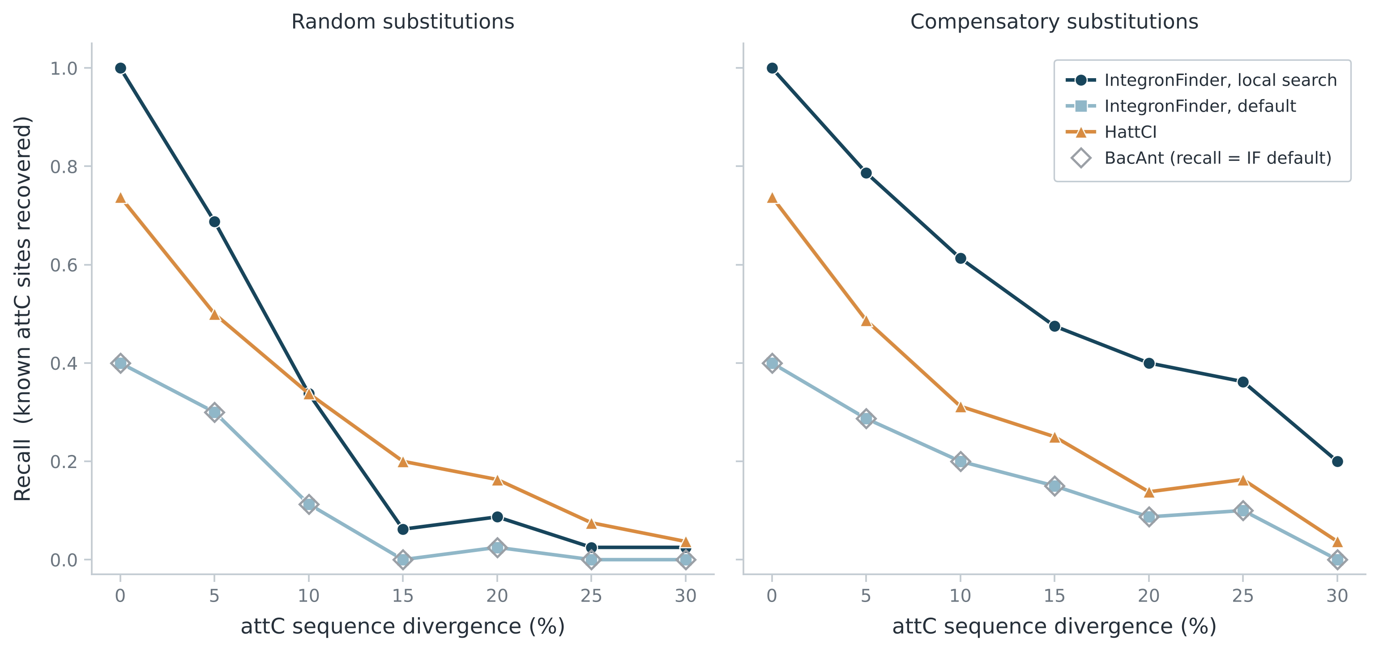
Figure 3. attC recall under two synthetic mutation schemes. An 80-cassette array derived from V. cholerae 569B was inserted into the excised chromosome. The left panel applies random substitutions. The right panel applies compensatory substitutions intended to retain paired positions. The panel labels describe the intended structural effects, which were not independently established by the reported analysis. Recall is the fraction of recorded target sites recovered. Open diamonds show the supplied BacAnt series, which coincides with default IntegronFinder. This series must be distinguished from the BacAnt database-match counts in Table 2. Lines connect evaluated divergence levels.

intervis reconstructs and compares cassette arrays
intervis represented the V. cholerae N16961 superintegron as 170 intervals between 171 detected attC sites. This count describes internal intervals and does not establish the total number of biological cassettes, including the promoter-proximal cassette between attI and the first attC. The single-array view retains cassette boundaries during annotation and supports inspection from the array scale to nucleotide sequence (Figure 4). The pairwise view places the integrase on the left of each array and links reciprocal best hits, allowing shared order and unmatched intervals to be inspected (Figure 5).
[Insert exported intervis single-array view here.]
Figure 4. intervis single-array view of the V. cholerae N16961 superintegron. The display places the integrase on the left and marks attC sites and reconstructed cassette intervals. Colour indicates provisional functional categories.
[Insert exported intervis comparison view here (with the two strain names).]
Figure 5. intervis pairwise comparison of two superintegron arrays. Each array is oriented with the integrase on the left. Links identify reciprocal best hits and their shading denotes amino-acid identity.

Discussion

Consequences of incomplete cassette boundaries
Detection settings alter the biological organisation inferred from a genome. Missing an internal attC site merges adjacent cassettes into one predicted interval, potentially assigning several genes to a single cassette. Larger gaps may also affect array grouping. The increased recovery with local search therefore matters for subsequent comparisons of cassette content and order. Agreement between the reconstructed and published V. vulnificus spans supports this setting, but a similar span cannot validate every boundary. The shorter 569B reconstruction requires comparison with the historical locus and the current assembly before its completeness can be established.

Detection models and sequence variation
IntegronFinder's covariance model incorporates sequence conservation and dependencies between paired positions, while HattCI models the component regions of attC using a generalised hidden Markov model (Cury et al. 2016; Pereira et al. 2016). The greater IntegronFinder recall under compensatory substitutions supports a contribution from pairing-compatible sequence changes. However, recall still declined substantially under this scheme, demonstrating that preserving designated pairs does not make detection independent of sequence. Species-specific attC variation described by Rowe-Magnus et al. (2003) offers a plausible explanation for the differences among real genomes. HattCI was originally evaluated on class 1 and 2 integron sites (Pereira et al. 2016), which also limits direct extrapolation to divergent chromosomal arrays. The synthetic results support a mechanistic interpretation but do not establish the cause of the A. fischeri result.

Scope of the benchmark evidence
The real-genome benchmark favours concordance with IntegronFinder by design. Unmatched HattCI candidates may include genuine sites outside the selected array. The synthetic benchmark supplies known insertion coordinates, but its source sites were initially selected by IntegronFinder, creating selection bias. Moreover, complementarity at designated positions does not establish preservation of the complete attC fold. Reported trends remain descriptive because independent mutation replicates and uncertainty estimates are unspecified. BacAnt also incorporates IntegronFinder (Hua et al. 2021), so its overlapping synthetic curve cannot be treated as independent support from a separate detector.

Contribution of intervis
intervis connects attC detection with interval reconstruction, annotation and comparative display. This supports inspection of cassette organisation while retaining the boundaries on which the reconstruction depends. General viewers such as clinker and pyGenomeViz provide flexible gene comparisons (Gilchrist and Chooi 2021; Shimoyama 2022), whereas intervis explicitly represents attC-defined intervals and integrase orientation. Its contribution is this integrated workflow. The current examples demonstrate output functionality, but do not quantify annotation accuracy, usability or improved biological inference.

Limitations and future work
Functional assignments remain limited by database coverage and require validation. Reciprocal best hits can omit duplicated or divergent cassette families, so an unmatched interval does not establish biological absence. A curated attC reference spanning integron types would strengthen detector evaluation. Replicated mutation experiments with structural validation would test the proposed mechanism more directly. Future development could improve family-level matching and link observed arrays to models of integron evolution. The web interface currently supports one or two genomes, with larger analyses handled through the command line.

Conclusion
Local search increased attC recovery in the four Vibrionaceae genomes, and synthetic mutations showed that detection depends on how sequence changes affect paired positions. These findings support local search while identifying limits to claims of complete reconstruction. intervis converts the resulting predictions into annotated cassette views and pairwise comparisons. Its biological interpretation remains dependent on detection quality, annotation coverage and independent validation.

Acknowledgements
I thank Jan Engelstädter and Andrew Letten for supervision and guidance. Computation used UQ's Bunya high-performance computing cluster. Anthropic Claude assisted with code debugging, figure generation and language editing, and OpenAI ChatGPT assisted with report editing. The author remains responsible for the analyses, interpretations and verification of computational outputs against primary data.

References
Blanco P, Hipólito A, García-Pastor L, et al. 2024. Identification of promoter activity in gene-less cassettes from Vibrionaceae superintegrons. Nucleic Acids Res. 52:2961–2976. doi:10.1093/nar/gkad1252.
Buchfink B, Reuter K, Drost H-G. 2021. Sensitive protein alignments at tree-of-life scale using DIAMOND. Nat Methods. 18:366–368.
Cambray G, Guerout A-M, Mazel D. 2010. Integrons. Annu Rev Genet. 44:141–166.
Clark CA, Purins L, Kaewrakon P, Focareta T, Manning PA. 2000. The Vibrio cholerae O1 chromosomal integron. Microbiology. 146:2605–2612.
Collis CM, Hall RM. 1995. Expression of antibiotic resistance genes in the integrated cassettes of integrons. Antimicrob Agents Chemother. 39:155–162.
Cury J, Jové T, Touchon M, Néron B, Rocha EPC. 2016. Identification and analysis of integrons and cassette arrays in bacterial genomes. Nucleic Acids Res. 44:4539–4550.
Darracq B, Littner E, Brunie M, et al. 2025. Sedentary chromosomal integrons as biobanks of bacterial antiphage defense systems. Science. 388:eads0768.
Eddy SR. 2011. Accelerated profile HMM searches. PLoS Comput Biol. 7:e1002195.
Getz LJ, Fairburn SR, Liu YV, Qian AL, Maxwell KL. 2025. Integrons are anti-phage defence libraries in Vibrio parahaemolyticus. Nat Microbiol. 10:724–733.
Gilchrist CLM, Chooi Y-H. 2021. clinker & clustermap.js: automatic generation of gene cluster comparison figures. Bioinformatics. 37:2473–2475.
Gillings MR. 2014. Integrons: past, present, and future. Microbiol Mol Biol Rev. 78:257–277.
Gillings MR, Holley MP, Stokes HW, Holmes AJ. 2005. Integrons in Xanthomonas: a source of species genome diversity. Proc Natl Acad Sci USA. 102:4419–4424.
Hall RM, Collis CM. 1995. Mobile gene cassettes and integrons: capture and spread of genes by site-specific recombination. Mol Microbiol. 15:593–600.
Hua X, Liang Q, Deng M, et al. 2021. BacAnt: a combination annotation server for bacterial DNA sequences to identify antibiotic resistance genes, integrons, and transposable elements. Front Microbiol. 12:649969.
Hyatt D, Chen G-L, LoCascio PF, Land ML, Larimer FW, Hauser LJ. 2010. Prodigal: prokaryotic gene recognition and translation initiation site identification. BMC Bioinformatics. 11:119.
Iqbal N, Guérout A-M, Krin E, Le Roux F, Mazel D. 2015. Comprehensive functional analysis of the 18 Vibrio cholerae N16961 toxin-antitoxin systems substantiates their role in stabilizing the superintegron. J Bacteriol. 197:2150–2159.
Mazel D, Dychinco B, Webb VA, Davies J. 1998. A distinctive class of integron in the Vibrio cholerae genome. Science. 280:605–608.
Nawrocki EP, Eddy SR. 2013. Infernal 1.1: 100-fold faster RNA homology searches. Bioinformatics. 29:2933–2935.
Néron B, Littner E, Haudiquet M, Perrin A, Cury J, Rocha EPC. 2022. IntegronFinder 2.0: identification and analysis of integrons across bacteria, with a focus on antibiotic resistance in Klebsiella. Microorganisms. 10:700.
Pereira MB, Wallroth M, Kristiansson E, Axelson-Fisk M. 2016. HattCI: fast and accurate attC site identification using hidden Markov models. J Comput Biol. 23:891–902.
Righi L, Stutzmann S, Bader L, Lemopoulos A, Blokesch M. 2026. Competence-mediated DNA uptake diversifies Vibrio cholerae sedentary chromosomal integrons. Science. 392:194–201.
Rowe-Magnus DA, Guerout A-M, Ploncard P, Dychinco B, Davies J, Mazel D. 2001. The evolutionary history of chromosomal super-integrons provides an ancestry for multiresistant integrons. Proc Natl Acad Sci USA. 98:652–657.
Rowe-Magnus DA, Guerout A-M, Biskri L, Bouige P, Mazel D. 2003. Comparative analysis of superintegrons: engineering extensive genetic diversity in the Vibrionaceae. Genome Res. 13:428–442.
Rusch DB, Rowe-Magnus DA. 2017. Complete genome sequence of the pathogenic Vibrio vulnificus type strain ATCC 27562. Genome Announc. 5:e00907-17.
Shimoyama Y. 2022. pyGenomeViz: a genome visualization Python package. GitHub. https://github.com/moshi4/pyGenomeViz.
Zhang A-N, Li L-G, Ma L, Gillings MR, Tiedje JM, Zhang T. 2018. Conserved phylogenetic distribution and limited antibiotic resistance of class 1 integrons revealed by assessing the bacterial genome and plasmid collection worldwide. Microbiome. 6:130.

Appendix

A1 Synthetic benchmark construction
The native 569B superintegron was excised using the IntegronFinder --local-max span plus a 5-kb margin. The resulting backbone produced no IntegronFinder attC calls. An array assembled from the native integrase, attI region and 80 cassette units was inserted at the excision point, recording target coordinates. One genome was generated per divergence level for each scheme (a single realisation per condition; random seed 20260101), each containing 80 target attC sites. In both schemes the number of substituted positions was set to the same fraction of each attC length, so the schemes are compared at matched target divergence; the realised mean divergence per genome is recorded in the generator manifest. Each unit comprised sequence between consecutive attC sites. Sites received random substitutions or compensatory changes at designated paired positions, with target divergence of 5–30%. Seven conserved bases at each end were held fixed in both schemes. Compensatory changes maintained complementarity at the selected positions, but the full fold and recombination activity were not independently validated in the reported analysis. The same 100-bp midpoint rule was used for scoring. Because the unmutated source sites were IntegronFinder predictions, baseline recall of 1.00 is not independent validation. The informative contrasts concern changes in detection with divergence and differences between the mutation schemes.
A2 Site-level scoring
A predicted attC site counted as matching a reference site when the two midpoints lay within 100 bp on the same replicon. Matching was one-to-one and greedy: predictions were taken in turn and each assigned to the nearest unused reference site within the window, so no reference site was matched twice and surplus predictions counted as false positives. Precision is matched predictions divided by all predictions; recall is matched predictions divided by all reference sites; F1 is their harmonic mean. Average precision is the mean of the precision values recorded at each successive matched site when predictions are ranked by score (HattCI by Viterbi score, IntegronFinder default by attC E-value). This is the recall-weighted, step summary of the precision–recall curve and can differ from the trapezoidal area under that curve. For IntegronFinder default, which returns no predictions outside the --local-max reference, average precision equals recall to the displayed precision.
A3 intervis parameters
intervis ran IntegronFinder 2.0.2 with --local-max, --circ, --keep-palindromes and a maximum inter-attC distance of 10 kb. Cassette intervals were defined between consecutive attC sites; the region between attI and the first attC was not counted as an interval, so a reconstruction with n attC sites yields n−1 intervals. Protein-coding regions in each interval were translated and named with DIAMOND 2.2.5 blastp against UniProtKB/Swiss-Prot (575,748 sequences, downloaded 11 June 2026; diamond blastp --more-sensitive --max-target-seqs 1 --evalue 1e-5), keeping the single top hit per protein. Intervals with no coding sequence, or no hit below the E-value threshold, were shown without a gene label; several proteins in one interval were each labelled from their own top hit. Gene symbols from a supplied GFF or GenBank annotation took precedence by coordinate overlap, with DIAMOND hits filling gaps. For the pairwise comparison, all cassette proteins were searched against one another with DIAMOND blastp (--more-sensitive, -k 50, --evalue 1e-5), and reciprocal best hits between different arrays were retained when amino-acid identity was at least 30% and coverage (alignment length divided by the shorter protein length) at least 0.5; each retained pair kept its own identity for ribbon shading.
A4 Software, commands and data
Detection used IntegronFinder 2.0.2 (Prodigal 2.6.3, HMMER 3.3.2, INFERNAL 1.1.4), HattCI 1.0b, I-VIP v1.2 and BacAnt 3.4.0, run on UQ’s Bunya cluster in micromamba environments. IntegronFinder was run as integron_finder --circ [--local-max] <genome.fna>; HattCI as hattci.out -b <genome.fna> <out.txt>; I-VIP and BacAnt with their bundled databases and default settings. Reference assemblies are listed in Table 1; the N16961 visualisation used chromosome II accession NC_002506.1. intervis source code, the detection and scoring scripts and the synthetic-genome generator are in the repository at github.com/NqynX/intervis (commit 6cb0bca, git describe v1.0.0-3-g6cb0bca). Run logs for each tool are retained with the analysis outputs. The N16961 reconstruction (171 attC, 170 intervals) was reproduced by an independent IntegronFinder --local-max run on the assembly (GCF_000006745.1).
A5 BacAnt outputs
BacAnt reports two kinds of result. For the real genomes, Table 2 lists matches to its bundled class 1 integron database (its integron.filter.tsv output). For the synthetic genomes, the BacAnt series in Figure 3 was taken from BacAnt’s detailed integron output (integrons.detail.tsv), produced by the IntegronFinder step that BacAnt runs internally; this is why that series coincides exactly with IntegronFinder default. Its lower precision than IntegronFinder default reflects additional coordinate rows in that output that do not correspond to reference attC sites. The two BacAnt quantities are distinct and were not combined.
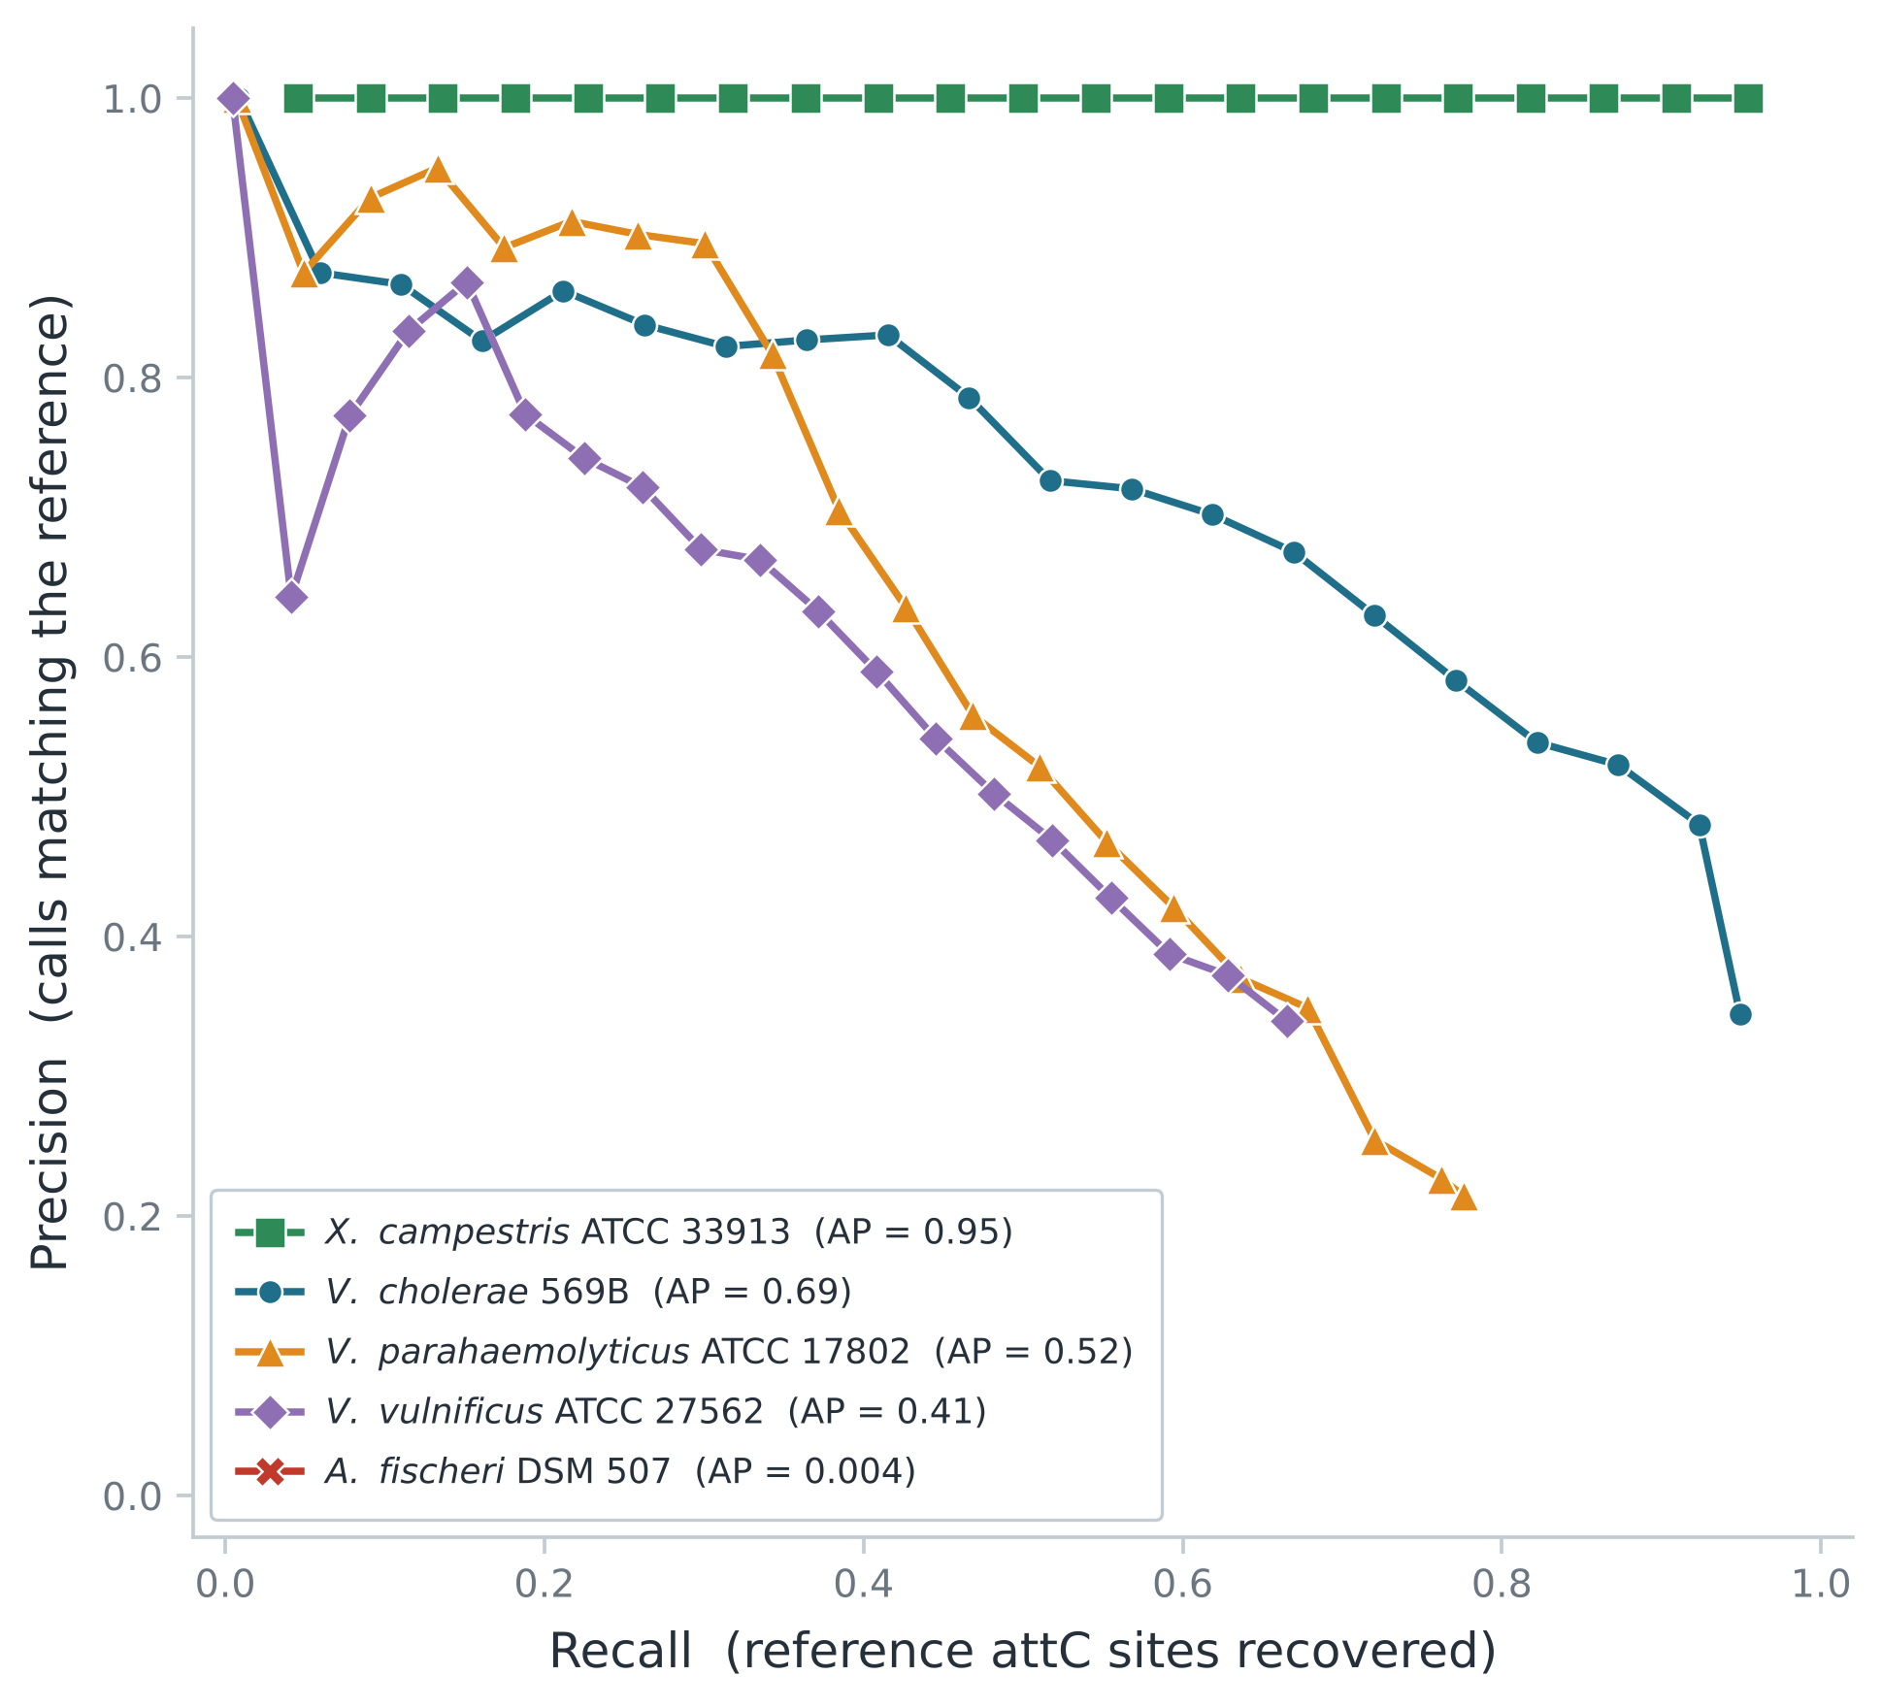
Figure A1. HattCI precision–recall curves against the IntegronFinder local-search reference. Candidates are ranked by Viterbi score. Average precision (AP) summarises concordance across thresholds. A. fischeri has AP = 0.004 and its curve is compressed near the origin. The curves measure agreement with the operational reference, not absolute biological accuracy.

