Inventory Management System

Proposal, Technical Project

Pham Dinh Vu Phuong

ISAAS CO., LTD
5-7 Hoang Viet Street, Ward 4, Tan Binh District, Ho Chi Minh City

This proposal is submitted to the ISAAS recruitment team for the purpose of evaluating interview candidate
TABLE OF CONTENTS

1.Introduction 3
2.Proposed TECHNICAL APPROACH 3
2.1Requirements 3
2.2Architecture Design 3
2.2.1Server 4
2.2.2Client 6
3.Estimation 7
4.Expected Project Results 8
5.Schedule 8

Introduction
This document is a technical proposal for developing an Inventory management system which is used to manage company's property

Proposed TECHNICAL APPROACH

Requirements
_ The inventory management system can save the status and location of hardware unit in the warehouse: type, model, serial number, import date, location in warehouse, status, owner (who is borrowing/using this device)
_ Deployed platform is Windows 10 (64 bits).
_ The application will be implemented by Python (version 2.x)
_ The maximum allowed connection is 5 clients to the application server.
_ There are 2 types of the clients:
  - Administrator: who can query/add/update/edit the device information from the management system
  - Normal user: who can only query the device information
_ User interface is either Console or GUI.
_ Database: there is no special requirement for DB

Architecture Design
_ The diagram below describes the high-level design of the Inventory System
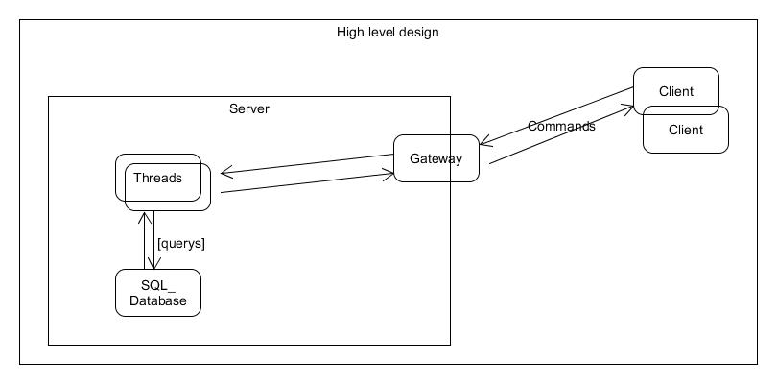

Server
_ Server contains two main components: Gateway(GW), Thread Handler.
    - Gateway: the main process of the server, which manages the socket connections, number of client. Refer to the following flow chart:
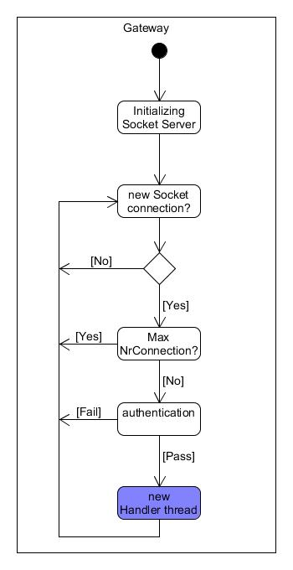
    - Thread Handler: a thread which plays the role of receiving commands from client, parsing the command and call appropriate query to the SQL database. Refer to the following flow chart:
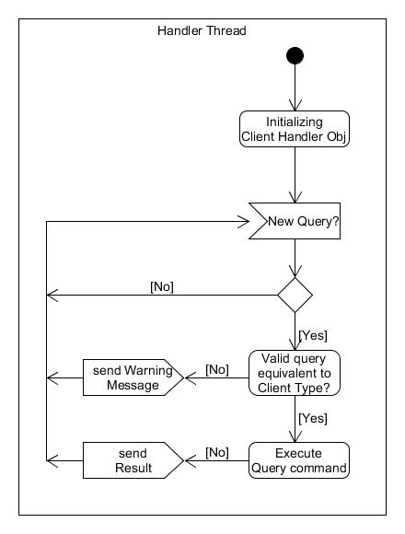

Client
_ Client is a single process which is used to connect to the Server via TCP/IP socket connect, and either perform sending command to server, or display received data.
_ There are two type of clients: administrator, normal user. It depends on the authentication information
_ User is required to specify a valid server IP.
_ Below is the main flow chart of a client

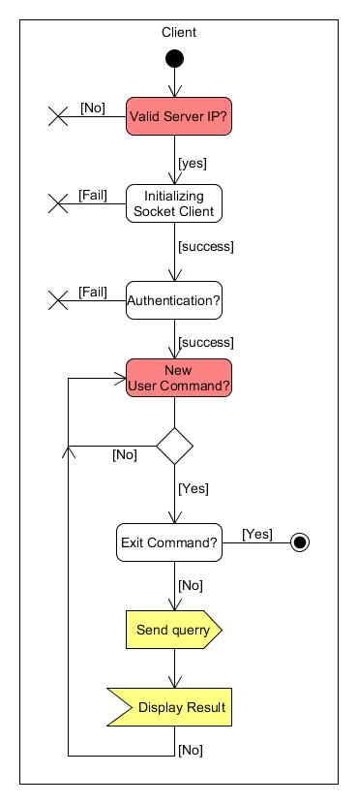

Estimation
Note: unit for this estimation is men-day
_ (0.5) Research:
+ Socket Programming connection
+ Multi threading, thread-safe
+ Sqlite database
_ (1) Design
_ (3) Implementation
  - Milestone 1
+ Gateway support new Thread Handler for each client connection
+ Client basics support for testing connection with Gateway, be able to send commands (query information) to server, and display received information
+ Thread-Handler supporting for connect to Database Manager. Thread-Handler should be common for any client types (administrator, normal user), and support only for query information.
+ Database Manager setup SQLite DB, supporting for query information only
  - Milestone 2
+ Adding authentication for Gateway
+ Update client sending commands (update, edit, delete, new etc.) to server
+ Update others query type for Database Manager (update, edit, delete, new etc.)
+ Adding setup-configuration (which user allows to do what) for Thread-Handler depend on the authentication information.
_ (1) Documentation
_ (0.5) Release preparation

Expected Project Results
_ The result from this project will be a software package which can be deployed on both server and client. There are documents come along with the software package such as high-level design, installation guide to help user can quickly using the application.
_ The software should be operated as described in the requirement.

Schedule
_ 07/20/2016: Project assigned
_ 07/23/2016: Submit technical proposal
_ 07/26/2016: Release milestone 1
_ 07/28/2016: Final release

