
School of Engineering
Department of Computer Science and Engineering

CERTIFICATE
This is to certify that the project work entitled “MOVIE RECOMMENDATION SYSTEM” is submitted by
T.KUSUMA (24B11CS435)
T.YAMUNA (24B11CS436)
N.RAMYA (24B11CS308)
N.SOWMYA (24B11CS309)
in partial fulfilment of the requirements for the award of the Bachelor of Techonology degree in Computer Science and Engineering for the academic year 2026-2027.

Project Guide  Dr.P.Subba Rao, Associate Professor  Computer Science and Engineering | Head of the Department  Dr.A.Phani Sridhar, Assistant Professor & HOD  Computer Science and Engineering

DECLARATION
We hereby declare that the project entitled “MOVIE RECOMMENDATION SYSTEM” is original and is submitted to ADITYA UNIVERSITY, Surampalem in partial fulfilment of the requirements for the award of the Bachelor of Techonology degree in Computer Science and Engineering. We further declare that this project work has not been submitted, either in full or in part, for the award of any degree in this or any other institution. We also confirm that this work complies with the Institutional Academic Integrity and AI Usage Policy.
Place:
Date:

By
T.KUSUMA (24B11CS435)
T.YAMUNA (24B11CS436)
N.RAMYA (24B11CS308)
N.SOWMYA (24B11CS309)

ACKNOWLEDGEMENT
It is with immense pleasure that we express our sincere gratitude to our Project Guide, Dr.P.Subba Rao, Associate Professor, who has guided us throughout the project. Their valuable support, encouragement, and guidance have greatly contributed to the successful completion of this work.
We would like to thank Dr.P.Siva Satya Prasad, Associate Professor for their support and valuable suggestions.
Our deepest thanks to our Head of the Department, Dr.A.Phani Sridhar, Assistant Professor
, for the inspiration and for providing all the necessary facilities and resources required for this project.
We also extend our sincere thanks to Dr.M.V.Rjaesh,Associate Dean for their encouragement and support during the course of our project.
Finally, we would like to thank the faculty members, lab technicians, non-teaching staff, and our friends who have directly or indirectly supported us in completing this project successfully.

ABSTRACT
The Movie Recommendation System using Machine Learning is designed to help users discover movies based on their interests and preferences. The system uses a dataset containing movies with features such as title, genre, rating, popularity, keywords, cast, and director. Python and Pandas are used for data handling and preprocessing, while Scikit-learn is used to implement the machine learning techniques. TF-IDF vectorization converts movie-related text into numerical features, and cosine similarity measures the similarity between movies. The K-Nearest Neighbors (KNN) algorithm recommends movies similar to a selected movie, while K-Means clustering groups movies based on their ratings and popularity after feature scaling using StandardScaler. The recommendation results are ranked using similarity scores and user preferences, and an interactive interface is developed using Streamlit. The system provides similar-movie recommendations, preference-based recommendations, and movie cluster exploration. This project demonstrates how machine learning and text-processing techniques can be applied to build a simple and interactive movie recommendation system that improves the movie discovery experience.

Keywords: Machine Learning, Movie Recommendation System, TF-IDF, K-Nearest Neighbors, K-Means Clustering, Cosine Similarity, Feature Extraction, Scikit-learn, Streamlit, Personalized Recommendations.

LIST OF CONTENTS
LIST OF FIGURES i
Chapter 1: Introduction 01
1.1 Introduction 01
1.2 Problem Statement 0x
1.3 Objectives of the Project 0x
1.4 Scope of the Project 0x
Chapter 2: System Overview 0x
2.1 Existing System 0x
2.2 Limitations of Existing System 0x
2.3 Proposed System 0x
2.4 Software Requirements 0x
2.5 Hardware Requirements 0x
Chapter 3: System Implementation 0x
Chapter 4: System Architecture 0x
Chapter 5: Data Preprocessing 0x
Chapter 6: Methodology and Algorithms 0x
Chapter 7: Results and Analysis 0x
Chapter 8: Output Screens 0x
Chapter 9: Conclusion 0x
Chapter 10: Future Scope 0x
Chapter 11: References 0x

LIST OF FIGURES
Fig 3.1: [Development environment setup]
Fig 5.1: [Data distribution / missing values plot]
Fig 6.1: [Model 1 output]
Fig 6.2: [Model 2 output]
Fig 7.1: [Confusion matrix / evaluation chart]
Fig 8.1: [Sample prediction output]

CHAPTER 1
INTRODUCTION

1.1 Introduction
The rapid growth of digital platforms has made a large number of movies available to viewers. However, selecting a movie that matches a person's interests can be difficult because of the wide variety of genres, stories, actors, and directors. Traditional methods of searching for movies require users to browse through many options manually. A Movie Recommendation System helps solve this problem by analyzing movie information and suggesting movies that match the user's interests. Machine learning techniques make this process more efficient by identifying similarities and patterns in movie data.
Machine learning is useful in recommendation systems because it can process different movie features and provide relevant suggestions. In this project, a sample movie dataset containing information such as movie title, genre, rating, popularity, keywords, cast, and director is used. Python and Pandas are used for data handling and preprocessing, while TF-IDF converts textual movie information into numerical features. Cosine similarity measures the similarity between movie descriptions, and the K-Nearest Neighbors (KNN) algorithm identifies movies that are similar to a selected movie. Additionally, K-Means clustering groups movies based on numerical features such as rating and popularity.
The main objective of this project is to develop an interactive Movie Recommendation System using Streamlit. It provides three main functionalities: recommending movies similar to a selected movie, suggesting movies based on user-entered preferences, and exploring groups of movies created using K-Means clustering. The system combines text-based similarity, machine learning, and preference-based ranking to help users discover relevant movies easily. This project demonstrates the practical application of machine learning in personalized recommendation systems and provides a foundation for developing more advanced systems using larger and real-world movie datasets.

1.2 Problem Statement
With the increasing availability of movies across different genres and categories, users often face difficulty finding movies that match their interests and preferences. Traditional movie-search methods mainly depend on manual browsing, fixed categories, or basic filters such as genre and rating. These methods may not effectively identify similarities between movies based on their textual information, keywords, cast, and other characteristics. As a result, users may spend more time searching for suitable movies and may miss other relevant options.
The problem addressed by this project is to develop a machine learning-based Movie Recommendation System that can analyze movie information and suggest relevant movies automatically. The system uses TF-IDF and cosine similarity to identify similar movies, the K-Nearest Neighbors (KNN) algorithm to recommend movies based on their features, and K-Means clustering to group movies according to numerical characteristics such as rating and popularity. Unlike manual searching, this approach combines multiple movie features to generate useful recommendations and provides an interactive interface through Streamlit. The system aims to simplify movie discovery, reduce manual searching effort, and improve the overall user experience.

1.3 Objectives of the Project
The main objectives of the Movie Recommendation System using Machine Learning are:
- Objective 1: Dataset Collection and Preprocessing — To use the movie dataset containing details such as title, genre, rating, popularity, keywords, cast, and director, and prepare the data for machine learning.
- Objective 2: Feature Extraction — To apply TF-IDF vectorization to convert textual movie information into numerical features for identifying similarities between movies.
- Objective 3: Implement Machine Learning Algorithms — To use K-Nearest Neighbors (KNN) for recommending similar movies and K-Means clustering for grouping movies based on numerical features such as rating and popularity.
- Objective 4: Movie Similarity Analysis — To apply cosine similarity to measure the similarity between movies and generate relevant recommendations based on movie features and user preferences.
- Objective 5: Develop an Interactive Application — To build a user-friendly Streamlit application that allows users to explore movie recommendations, search based on preferences, and view movie clusters.
- Objective 6: Improve Movie Discovery — To reduce the time required for manual movie searching by providing relevant and easily accessible movie suggestions.

1.4 Scope of the Project
The scope of the Movie Recommendation System using Machine Learning is to develop an interactive application that helps users discover movies based on their interests and preferences. The project uses a movie dataset containing information such as title, genre, rating, popularity, keywords, cast, and director. Python and Pandas are used for data handling and preprocessing, while Scikit-learn is used for feature extraction and machine learning. TF-IDF and cosine similarity are applied to identify similar movies, K-Nearest Neighbors (KNN) is used to recommend movies, and K-Means clustering groups movies based on numerical features such as rating and popularity. Streamlit is used to provide a simple and user-friendly interface for exploring recommendations and movie clusters.
The project focuses on generating recommendations from the available dataset, exploring movie similarities, and providing preference-based suggestions. It is intended primarily for academic and demonstration purposes. The current scope does not include real-time movie data collection, integration with live streaming platforms, large-scale production deployment, user account management, or continuous learning from user feedback. The recommendation quality also depends on the completeness and quality of the available dataset. In the future, the system can be extended by incorporating larger datasets, real-time movie information, user ratings, feedback-based personalization, and cloud deployment.

CHAPTER 2
SYSTEM OVERVIEW

2.1 Existing System
In the existing system, users generally find movies through manual searching, browsing movie lists, checking ratings, and exploring categories such as action, comedy, romance, and thriller. Many movie websites and streaming platforms also provide basic search options, genre filters, popularity rankings, and recommendations based on trending movies or previously watched content. These methods help users discover movies, but users may still need to spend considerable time comparing different options to find a movie that matches their interests.
Traditional movie-search methods mainly depend on predefined categories, simple filtering, and manual selection. They may not effectively identify relationships between movies based on keywords, cast, director, and other features simultaneously. As a result, users may miss movies that are similar to their preferences. This creates a need for a machine learning-based recommendation system that can analyze movie information, identify similarities, group related movies, and automatically suggest relevant options to users.

2.2 Limitations of Existing System
- Time-Consuming Search: Users may need to browse through many movies manually to find suitable options based on their interests.
- Limited Personalization: Basic search and filtering methods may not consider multiple movie features, such as genre, keywords, cast, and director, together.
- Difficulty Identifying Similar Movies: Traditional methods may not effectively identify movies with similar characteristics when users search by a particular movie title.
- Limited Recommendation Flexibility: Simple category-based systems may not provide flexible recommendations by combining movie similarity, user preferences, and grouping techniques.

2.3 Proposed System
The proposed system is a Machine Learning-based Movie Recommendation System designed to help users discover movies according to their interests and preferences. It uses a movie dataset containing details such as title, genre, rating, popularity, keywords, cast, and director. The data is processed using Python and Pandas to prepare the required features for recommendation. TF-IDF vectorization converts textual information into numerical representations, and cosine similarity is used to identify similarities between movies. The K-Nearest Neighbors (KNN) algorithm helps recommend movies similar to a selected movie, while K-Means clustering groups movies based on numerical features such as rating and popularity.
The system follows a data processing and recommendation pipeline that includes dataset preparation, feature extraction, similarity calculation, recommendation generation, and result presentation. Unlike manual searching, the proposed system analyzes multiple movie characteristics to provide relevant suggestions. A Streamlit interface allows users to explore similar movies, enter preferences to find suitable recommendations, and examine movie clusters. The system focuses on improving movie discovery, reducing manual searching effort, and providing a simple interactive experience. The implementation demonstrates the application of machine learning techniques to recommendation tasks, while future improvements could include larger datasets, user feedback, and more extensive model evaluation.

2.4 Software Requirements
- Operating System: Windows 10 / Windows 11
- Programming Language: Anaconda Navigator
- Libraries:
Pandas – for data handling and preprocessing.
NumPy – for numerical operations.
Scikit-learn – for TF-IDF vectorization, K-Nearest Neighbors (KNN), K-Means clustering, cosine similarity, and feature scaling.
Streamlit – for developing the interactive user interface.
- IDE: Visual Studio Code (VS Code) / Anaconda environment.
- Data Format: CSV (Comma-Separated Values).
- Web Browser: Google Chrome or Microsoft Edge to access the Streamlit application

2.5 Hardware Requirements
- Processor: Intel Core i5 or higher (Intel Core i5 recommended)
- RAM: Minimum 4 GB; 8 GB or higher recommended.
- Storage: Minimum 10 GB of free disk space; SSD preferred for better performance.
- System Type: 64-bit OS
CHAPTER 3
SYSTEM IMPLEMENTATION

3.1 Overview of Development Tools

3.1.1 Visual Studio Code (VS Code)

Visual Studio Code (VS Code) is used as the primary code editor for developing the Movie Recommendation System. It is a lightweight editor that supports Python programming and provides features such as syntax highlighting, debugging, and terminal access. Anaconda is used to manage the Python environment and required libraries. The project code is written and executed using VS Code with the Anaconda Python environment. Libraries such as Pandas and Scikit-learn are used for data preprocessing and machine learning algorithms, including K-Nearest Neighbors (KNN) and K-Means clustering. Streamlit is used to develop the interactive application interface. The combination of VS Code and Anaconda provides a convenient environment for implementing, testing, and running the recommendation system.

3.1.2 Machine Learning Library – Scikit-learn
Scikit-learn is a Python machine learning library used to implement machine learning techniques in the Movie Recommendation System. It provides tools for feature extraction, similarity calculation, clustering, and data preprocessing. In this project, Scikit-learn is used for TF-IDF vectorization, cosine similarity, K-Nearest Neighbors (KNN), K-Means clustering, and feature scaling using StandardScaler. These techniques help identify similar movies, generate recommendations, and group movies based on their characteristics.
Installation and Setup Steps:
- Open Anaconda Navigator and launch Anaconda Prompt.
- Activate the Anaconda environment used for the project, if required.
- Check the Python version using the command:
python --version
- Install Scikit-learn if it is not already installed:
pip install scikit-learn
- Verify the installation using:
python -c "import sklearn; print(sklearn.__version__)"
- Open the project folder in VS Code and select the Python interpreter associated with the correct Anaconda environment.
- Import the required Scikit-learn modules into the Python program:
- from sklearn.feature_extraction.text import TfidfVectorizer
- from sklearn.metrics.pairwise import cosine_similarity
- from sklearn.neighbors import NearestNeighbors
- from sklearn.cluster import KMeans
from sklearn.preprocessing import StandardScaler
After completing the setup, Scikit-learn can be used to perform the machine learning operations required by the recommendation system.

3.2 Dataset Description
The Movie Recommendation System uses a sample movie dataset stored in the file movies.csv inside the data folder. The dataset contains 50 movie records and 7 features. Each record represents a movie and includes its title, genres, rating, popularity, keywords, cast, and director. The dataset is included with the project and contains information about movies that can be used to identify similarities and generate recommendations.
The dataset is processed using Python and Pandas. Missing textual values in genres, keywords, cast, and director are handled during preprocessing. TF-IDF vectorization converts the combined textual features into numerical vectors, which are used by the K-Nearest Neighbors (KNN) algorithm and cosine similarity to identify similar movies. Additionally, rating and popularity are standardized using StandardScaler and used by the K-Means algorithm to group movies into five clusters. The system does not have a single predefined target variable because it generates recommendations based on movie similarity and user preferences rather than predicting a fixed class or numerical value.
Dataset Details:
- Dataset Name: Movie Recommendation Sample Dataset
- File Name: movies.csv
- Location: data/movies.csv
- Source: Sample dataset included in the uploaded project ZIP
- Number of Records: 50 movies
- Number of Features: 7
- Data Format: CSV (Comma-Separated Values)
- Target Variable: Not applicable; the system generates movie recommendations and cluster assignments.

Features of the Dataset:
Feature | Description
title | Name of the movie
genres | Movie categories, such as Action, Drama, and Thriller
rating | Rating assigned to the movie
popularity | Popularity score of the movie
keywords | Words describing the movie's themes and content
cast | Names of actors appearing in the movie
director | Name of the movie's director
The dataset supports three main functions: recommending movies similar to a selected title, generating preference-based recommendations, and exploring movie groups formed by K-Means clustering. The resulting recommendations are ranked using similarity scores and movie ratings.

CHAPTER 4
SYSTEM ARCHITECTURE
The system architecture describes the complete workflow of the Movie Recommendation System, from loading the movie dataset to displaying recommendations to the user. The proposed system uses Python, Pandas, Scikit-learn, and Streamlit to preprocess movie information, extract useful features, apply machine learning algorithms, and present the results.
One adjustment to your diagram is recommended: since your project focuses on movie recommendations rather than conventional prediction, model evaluation should describe recommendation quality and clustering analysis, not classification accuracy unless you have implemented a separate classification model.

4.1 System Workflow
1. Data Collection
The system uses the movies.csv dataset available in the project's data folder. It contains 50 movie records with seven features: title, genres, rating, popularity, keywords, cast, and director. These features provide the information required to generate movie recommendations.
2. Data Preprocessing
The dataset is loaded using Pandas. The movie information is checked and prepared for further processing. Missing textual values are handled, and the relevant movie features are organized for feature extraction. Numerical features such as rating and popularity are prepared for clustering.
3. Exploratory Data Analysis / Visualization
The movie data can be examined to understand the distribution of ratings, popularity values, and movie genres. These observations help users understand the characteristics of the dataset. This stage supports the analysis of movie features before recommendation generation.
4. Feature Engineering / Selection
The textual features, including genres, keywords, cast, and director, are combined to represent the characteristics of each movie. TF-IDF vectorization converts this combined text into numerical vectors. StandardScaler is applied to numerical features such as rating and popularity before clustering. These prepared features are used by the machine learning algorithms.
5. Model Training (ML Algorithms)
The system uses the K-Nearest Neighbors (KNN) algorithm to identify movies similar to a selected movie. Cosine similarity measures the similarity between the textual feature vectors. The K-Means clustering algorithm groups movies based on numerical features such as rating and popularity. The project uses five clusters to organize the movies into groups with similar characteristics.
6. Model Evaluation
The recommendation results can be examined to determine whether the suggested movies are relevant to the selected movie or user preferences. The generated clusters can also be inspected to understand the grouping of movies. Since the system is a recommendation application, classification metrics such as accuracy, precision, recall, and F1-score are not directly applicable to its current implementation.
7. Results and Insights
The processed results are presented through the Streamlit application. Users can obtain recommendations for similar movies, explore movies based on their preferences, and examine the movie clusters. The system combines textual similarity and numerical movie characteristics to make movie discovery easier and reduce the effort required for manual searching.

CHAPTER 5
DATA PREPROCESSING

5.1 Introduction
Data preprocessing is an important step in the Movie Recommendation System because the quality and consistency of the input data affect the relevance of the recommendations. The movie dataset contains information such as title, genres, rating, popularity, keywords, cast, and director. Missing textual values or inconsistent data may affect feature extraction and similarity calculations. Therefore, the dataset must be checked and prepared before applying machine learning algorithms.
In this project, Python and the Pandas library are used to load, inspect, and process the movie dataset. Missing textual values are handled during preprocessing, and relevant movie attributes are combined to prepare the text for TF-IDF vectorization. The numerical features, rating and popularity, are prepared and scaled using Scikit-learn's StandardScaler before applying K-Means clustering. These preprocessing steps help the system represent movie information consistently, identify similarities between movies, and generate useful recommendations.

5.2 Handling Missing Values
In this project, Anaconda was used as the Python development environment, and the Pandas library was used to load and inspect the movie dataset. Missing values were identified using the isnull().sum() function, which displays the number of missing values in each column.
The dataset contains textual features such as genres, keywords, cast, and director, as well as numerical features such as rating and popularity. Missing textual values can be replaced with empty strings to support text processing. Missing numerical values should be checked and handled using an appropriate method, such as median imputation, if required by the dataset.
These steps help maintain data consistency before applying TF-IDF vectorization, cosine similarity, KNN, and K-Means clustering.
Python code to check missing values:
import pandas as pd
df = pd.read_csv("data/movies.csv")
print(df.isnull().sum())
Python code to handle missing textual values, if needed:
text_columns = ["genres", "keywords", "cast", "director"]
for col in text_columns:
df[col] = df[col].fillna("")
This preprocessing helps prepare the dataset for the movie recommendation process.

5.3 Data Cleaning
Data cleaning is an important step in preparing the movie dataset for analysis and recommendation. It helps identify duplicate records, invalid values, and inconsistent data that may affect the results.
In this project, the movie dataset was loaded using the Pandas library in the Anaconda Python environment. The dataset was checked for duplicate movie records and invalid or missing values. Movie details such as title, genres, rating, and popularity were considered during data inspection. Duplicate records, if present, can be removed to avoid repeated entries, while inconsistent or invalid values should be corrected or handled appropriately.
Data cleaning helps improve the consistency and quality of the dataset before applying TF-IDF vectorization, cosine similarity, KNN, and K-Means clustering.
Python code to check and remove duplicate rows:
import pandas as pd
df = pd.read_csv("data/movies.csv")
print("Duplicate rows:", df.duplicated().sum())
df = df.drop_duplicates()
print("Dataset shape after cleaning:", df.shape)
This process helps prepare a more consistent dataset for the movie recommendation system.

5.4 Outlier Detection and Range Validation
Outlier detection and range validation help identify unusual or invalid values in a dataset. In this project, the movie dataset contains numerical attributes such as rating and popularity. These values are checked to ensure they are suitable for analysis and machine learning.
The Interquartile Range (IQR) method can be used to identify outliers. It calculates the difference between the third quartile (Q3) and the first quartile (Q1). Values below Q1 − 1.5 × IQR or above Q3 + 1.5 × IQR are considered potential outliers. Boxplots can also be used to visualize these values.
Range validation checks whether numerical values fall within reasonable limits. For example, movie ratings should generally be between 0 and 10 if the dataset uses a 10-point rating scale. Popularity values should be non-negative if they represent a popularity score. Unusual values should be investigated before deciding whether to correct or remove them.
This process helps improve data quality before applying StandardScaler and K-Means clustering. However, an outlier is not always an error, so valid unusual values should not be removed automatically.
Python code for checking numerical ranges:
import pandas as pd
df = pd.read_csv("data/movies.csv")
print(df["rating"].describe())
print(df["popularity"].describe())
print("Invalid ratings:")
print(df[(df["rating"] < 0) | (df["rating"] > 10)])
print("Negative popularity values:")
print(df[df["popularity"] < 0])
The results help identify values that may need further inspection before clustering.

5.5 Feature Engineering / Encoding
In this Movie Recommendation System, text features and numerical features are processed to generate meaningful movie recommendations.
1. Text Feature Engineering using TF-IDF
The dataset contains text attributes such as genres, keywords, cast, and director. These attributes provide information about each movie. TF-IDF (Term Frequency–Inverse Document Frequency) converts text into numerical vectors so that the system can compare movies based on their content.
2. Cosine Similarity
Cosine similarity measures the similarity between movie feature vectors. Movies with more similar content receive higher similarity scores and can be recommended to users.
3. Feature Scaling using StandardScaler
Numerical attributes such as rating and popularity may have different value ranges. StandardScaler transforms numerical features to have a mean close to 0 and a standard deviation close to 1. This helps prevent features with larger numerical scales from dominating the K-Means clustering process.

4. Categorical Encoding
The text attributes are represented numerically using TF-IDF rather than ordinary one-hot or label encoding. The numerical attributes, rating and popularity, are used for clustering after scaling. K-Means groups movies based on these numerical features.
5. Derived Features
The project uses the existing movie attributes to create text-based feature representations for recommendation and scaled numerical features for clustering. No additional derived movie attributes are assumed beyond these transformations.
These feature engineering steps prepare the movie data for KNN-based recommendations, cosine similarity calculations, and K-Means clustering.

5.6 Data Visualization
In the Movie Recommendation System, visualization can be used to examine numerical features such as rating and popularity and understand how movies are distributed across different values.
1. Rating Distribution: A histogram can show how movie ratings are distributed and help identify whether most movies have low, medium, or high ratings.
2. Popularity Distribution: A histogram can help understand the popularity scores of movies and identify highly popular or less popular movies.
3. Outlier Visualization: A boxplot can be used to identify unusual values in numerical features such as rating and popularity.
4. Rating and Popularity Relationship: A scatter plot can show the relationship between movie ratings and popularity. It helps observe whether highly rated movies also tend to have higher popularity.
5. Cluster Visualization: A scatter plot can display movies grouped into clusters using rating and popularity. Different colors can represent the clusters created by the K-Means algorithm.
These visualizations help understand the movie dataset and interpret the clustering results. Python libraries such as Pandas, Matplotlib, and Seaborn can be used to create these charts.

5.7 Train-Test Split
In this Movie Recommendation System, the main objective is to recommend similar movies using TF-IDF and cosine similarity, apply K-Nearest Neighbors (KNN) for finding similar movies, and group movies using K-Means clustering.
Unlike a traditional supervised classification model, this recommendation system does not require a target variable for its main content-based recommendation process. Therefore, a conventional 80:20 train-test split may not be applicable to every part of the project. The recommendation results can instead be examined using sample movie inputs and the relevance of the recommended movies.
No separate validation set, stratified split, or cross-validation should be reported unless these methods are explicitly implemented in the project code.
This approach focuses on generating relevant movie recommendations rather than predicting a predefined target class.

5.8 Summary
Data preprocessing is an important step in the Movie Recommendation System because it prepares the raw movie dataset for machine learning. The dataset was loaded and inspected using Pandas in the Anaconda Python environment.
The preprocessing stage focuses on checking missing values, identifying duplicate records, validating numerical values, and preparing the movie attributes for further processing. Textual features such as genres, keywords, cast, and director are converted into numerical representations using TF-IDF. Cosine similarity is then used to measure the similarity between movies. Numerical features such as rating and popularity can be standardized using StandardScaler before applying K-Means clustering.
These preprocessing and feature engineering techniques help represent movie information in a format suitable for recommendation and clustering. As a result, the prepared data supports the KNN-based recommendation process, similarity calculations, and grouping of movies using K-Means.
Overall, data preprocessing provides the foundation for building a functional and useful Movie Recommendation System.

CHAPTER 6
METHODOLOGY AND ALGORITHMS

6.1 Introduction
The Movie Recommendation System was implemented using Python in the Anaconda environment. Anaconda was used to manage the Python environment and required libraries, while Streamlit was used to develop the user interface.
The project uses machine learning and text-processing techniques to recommend movies based on their similarities. The dataset contains movie details such as title, genres, rating, popularity, keywords, cast, and director.
The main techniques implemented in this project are:
- TF-IDF: Converts movie-related text into numerical vectors.
- Cosine Similarity: Measures the similarity between movies based on their text features.
- K-Nearest Neighbors (KNN): Helps identify similar movies for recommendation.
- K-Means Clustering: Groups movies based on numerical features such as rating and popularity.
- StandardScaler: Standardizes numerical features before clustering, if applied in the implementation.
These techniques are implemented using Python libraries, including Pandas and Scikit-learn. The system processes movie information, identifies similar movies, groups movies into clusters, and displays recommendations through the Streamlit application.
The project primarily uses content-based recommendation and unsupervised learning techniques. It does not require a traditional classification or regression model because its main purpose is to recommend similar movies rather than predict a predefined target value.

6.2 Content-Based Recommendation Techniques

6.2.1 Term Frequency–Inverse Document Frequency
Working:
TF-IDF is a text-processing technique that converts textual information into numerical values. It identifies important words in movie details such as genres, keywords, cast, and director. Words that are more useful for distinguishing movies receive higher importance. These numerical representations allow the system to compare movie content.

Advantages:
- Converts text data into numerical features.
- Identifies important words in movie descriptions and attributes.
- Works well with textual data.
- Helps find movies with similar content.
Application in Project:
In this project, TF-IDF is used to convert movie-related text into numerical vectors. These vectors help the system compare movies and identify similar content for recommendations.

6.2.2 Cosine Similarity
Working:
Cosine Similarity is a mathematical technique used to measure how similar two numerical vectors are. It calculates the cosine of the angle between the feature vectors of two movies. A value closer to 1 indicates greater similarity, while a value closer to 0 indicates lower similarity for non-negative TF-IDF vectors.
Advantages:
- Measures similarity between movie features.
- Works effectively with TF-IDF text vectors.
- Helps identify movies with similar content.
- Supports personalized content-based recommendations.
Application in Project:
In this project, Cosine Similarity is used to compare the TF-IDF vectors of movies. When a user selects a movie, the system calculates similarity scores and uses them to identify movies with similar genres, keywords, cast, and director information. The similar movies are then used to generate recommendations.

6.3 Neighbor-Based Recommendation Techniques

6.3.1 K-Nearest Neighbors (KNN)
Working:
K-Nearest Neighbors (KNN) is a machine learning algorithm that identifies the nearest data points to a given input based on a distance or similarity measure. The value of K represents the number of neighbors considered. In a movie recommendation system, KNN can help identify movies that have similar feature representations to the selected movie.
Advantages:
- Simple and easy to understand.
- Helps identify similar movies based on their features.
- Does not require a complex training process.
- Can be used for recommendation tasks involving numerical feature representations.
Application in Project:
In this project, KNN is used to find movies similar to the movie selected by the user. The movie features are processed into a suitable numerical representation, and the algorithm identifies nearby movies to support the recommendation process. The resulting recommendations are displayed through the Streamlit interface.

6.4. Clustering Techniques
Working:
K-Means is an unsupervised machine learning algorithm that groups data points into a predefined number of clusters based on their features. It starts by selecting K cluster centers and assigns each data point to the nearest center. The centers are then updated based on the assigned data points. This process repeats until the clusters become stable or the stopping condition is reached.
Advantages:
- Groups similar movies into clusters.
- Helps identify patterns in movie data.
- Simple and computationally efficient for small datasets.
- Does not require predefined class labels.
- Makes it easier to analyze movies based on numerical features.
Application in Project:
In this project, K-Means clustering is used to group movies based on numerical attributes such as rating and popularity. The algorithm creates clusters containing movies with similar numerical characteristics. These groups help organize the dataset and provide additional insights into the movies. The clustering results can also be displayed or stored for further analysis

6.5 Model Evaluation Metrics
In this Movie Recommendation System, TF-IDF and cosine similarity are used to identify similar movies, KNN helps find nearby movies, and K-Means groups movies based on numerical attributes.
The following evaluation methods are relevant to the project:
1. Recommendation Relevance: The recommended movies can be inspected to determine whether they are similar to the movie selected by the user in terms of genres, keywords, cast, and director.
2. Cosine Similarity Score: Cosine similarity measures the similarity between movie feature vectors. A higher score indicates greater similarity between the vectors.
3. Silhouette Score (for clustering): The Silhouette Score can be used to evaluate how well the movies fit within their assigned clusters compared with other clusters. A higher score generally indicates better-defined clusters. This metric should be reported only if it was calculated in the implementation.
4. Accuracy, Precision, Recall, and F1-Score: These metrics are mainly used for classification tasks with known true labels. They are not directly applicable to this project unless suitable ground-truth labels and an appropriate evaluation procedure are available.
5. RMSE, MAE, and R²: These metrics are mainly used for regression tasks. Since this project focuses on movie recommendations and clustering rather than predicting a continuous target value, they are not required.

CHAPTER 7
RESULTS AND ANALYSIS

7.1 Introduction
This chapter presents the results obtained from the Movie Recommendation System implemented using Python in the Anaconda environment. The main objective of this chapter is to analyze the performance of the techniques discussed in Chapter 6 and examine how effectively they support movie recommendations and clustering.
The system uses TF-IDF to convert movie-related text into numerical features, cosine similarity to measure the similarity between movies, K-Nearest Neighbors (KNN) to identify similar movies, and K-Means clustering to group movies based on numerical attributes such as rating and popularity.
The results are analyzed by observing the movies recommended for a selected movie, examining their content similarity, and reviewing the groups created by the clustering algorithm. The Streamlit interface provides a user-friendly way to select a movie and view the recommendations.
This chapter focuses on the relevance of the recommended movies, the usefulness of the similarity-based approach, and the organization of movies through clustering. Any evaluation scores or numerical performance results are reported only when they are produced by the actual project implementation.

7.2 Experimental Setup
The Movie Recommendation System was implemented using Python in the Anaconda environment. The required libraries, including Pandas and Scikit-learn, were used for data processing and machine learning operations. Streamlit was used to provide an interactive interface for users.
The dataset contains movie information such as title, genres, rating, popularity, keywords, cast, and director. The text attributes were processed using TF-IDF, and cosine similarity was used to compare movies. K-Nearest Neighbors (KNN) was used to identify similar movies, while K-Means clustering was applied to group movies based on numerical features.
Train-Test Split: A conventional train-test split was not used for the main content-based recommendation process because it does not depend on a predefined target variable. Recommendations were examined by selecting movies and checking the relevance of the resulting suggestions.
Cross-Validation: Cross-validation was not required for the main similarity-based recommendation process. No cross-validation results are reported unless this procedure was implemented separately.
Evaluation Metrics: The system can be assessed using cosine similarity scores and the relevance of recommended movies. The Silhouette Score may be used to evaluate clustering if it was calculated in the code. Accuracy, precision, recall, F1-score, RMSE, MAE, and R² are not reported because the project does not implement a conventional supervised classification or regression task.
This experimental setup focuses on examining the recommendation results and clustering behavior using the implemented techniques.

7.3 TF-IDF and Cosine Similarity Results
TF-IDF and Cosine Similarity are used in the Movie Recommendation System to identify movies with similar content. TF-IDF converts textual movie attributes, such as genres, keywords, cast, and director, into numerical vectors. Cosine Similarity compares these vectors and measures how closely the movies are related.
Results and Interpretation:
When a user selects a movie, the system compares its feature representation with those of other movies and identifies movies with similar content. Movies with higher cosine similarity scores are considered more similar to the selected movie. The resulting recommendations are displayed through the Streamlit interface.
This approach helps users discover movies with similar characteristics without requiring predefined class labels or a supervised training target.
Evaluation Metrics:
- Cosine Similarity Score: Indicates the similarity between two movie feature vectors.
- Recommendation Relevance: Assesses whether the suggested movies are meaningfully related to the selected movie.
- Accuracy, Precision, Recall, and F1-Score: Not reported because these metrics require suitable ground-truth labels and an appropriate evaluation procedure.
Output Screenshot:
Insert a screenshot of the Streamlit application showing a selected movie and the recommended movies here.
Figure 7.1: Movie Recommendations Using TF-IDF and Cosine Similarity

7.4 K-Nearest Neighbors (KNN) Results
The K-Nearest Neighbors (KNN) algorithm is used to identify movies that are similar to a selected movie based on their feature representations. It finds nearby movies and helps generate relevant recommendations.
Results and Interpretation:
When a user selects a movie, KNN helps identify similar movies from the dataset. The quality of the recommendations depends on the features used and how similarity or distance is calculated. The recommended movies can be inspected to determine whether they share relevant characteristics with the selected movie.

Evaluation Metrics:
- Recommendation Relevance: Examines whether the suggested movies are related to the selected movie.
- Neighbor Similarity or Distance: Helps assess how close the selected movie is to the recommended movies, depending on the implementation.
- Accuracy, Precision, Recall, and F1-Score: Not reported because a suitable set of ground-truth recommendation labels and a corresponding evaluation procedure have not been established.
Output Screenshot:
Insert a screenshot of the Streamlit application showing the selected movie and the recommendations generated by the system.
Figure 7.2: Movie Recommendations Using K-Nearest Neighbors (KNN)

7.5 Comparison of Models

The Movie Recommendation System uses different techniques for content-based recommendation and clustering. Since these techniques perform different tasks, traditional classification metrics such as accuracy, precision, recall, and F1-score are not directly applicable without a suitable labeled evaluation dataset.
Model | Accuracy | Precision | Recall | F1-Score
TF-IDF + Cosine Similarity
  N/A
  N/A
  N/A
  N/A
K-Nearest Neighbors (KNN)
  N/A
  N/A
  N/A
  N/A

Interpretation:

TF-IDF and Cosine Similarity represent movie content and measure similarity between movies. KNN identifies nearby movies based on the feature representation used in the implementation. Both techniques support the movie recommendation process, but their performance should be evaluated using recommendation-specific measures rather than classification metrics.

K-Means clustering is evaluated separately because its purpose is to group movies based on numerical attributes such as rating and popularity. If calculated in the project, the Silhouette Score can be reported to assess the quality of the clusters.

Overall, the techniques serve complementary purposes in the Movie Recommendation System. The usefulness of the recommendations can be examined by checking whether the suggested movies are relevant to the movie selected by the user.

7.6 Key Findings
The following key findings were identified from the design and implementation of the Movie Recommendation System:
- Finding 1 – Importance of Movie Features: Textual attributes such as genres, keywords, cast, and director help represent movie content. TF-IDF converts these attributes into numerical vectors, while cosine similarity helps identify movies with similar content.
- Finding 2 – Recommendation Techniques: TF-IDF with cosine similarity and K-Nearest Neighbors support the identification of similar movies. Their usefulness depends on the quality of the movie features and the recommendation logic implemented in the system.
- Finding 3 – Movie Clustering: K-Means groups movies based on numerical attributes such as rating and popularity. These clusters help organize the dataset and identify groups of movies with similar numerical characteristics.
- Finding 4 – User-Friendly Interface: The Streamlit application allows users to select movies and view recommendations through a simple interface.
- Finding 5 – Evaluation Limitations: Since the project focuses on recommendation and clustering rather than supervised classification or regression, accuracy, precision, recall, and F1-score cannot be reported directly without suitable ground-truth labels and an evaluation procedure.
- Overall, the project demonstrates how text-processing techniques and machine learning algorithms can be combined to build a movie recommendation system.

CHAPTER 8
OUTPUT SCREENS

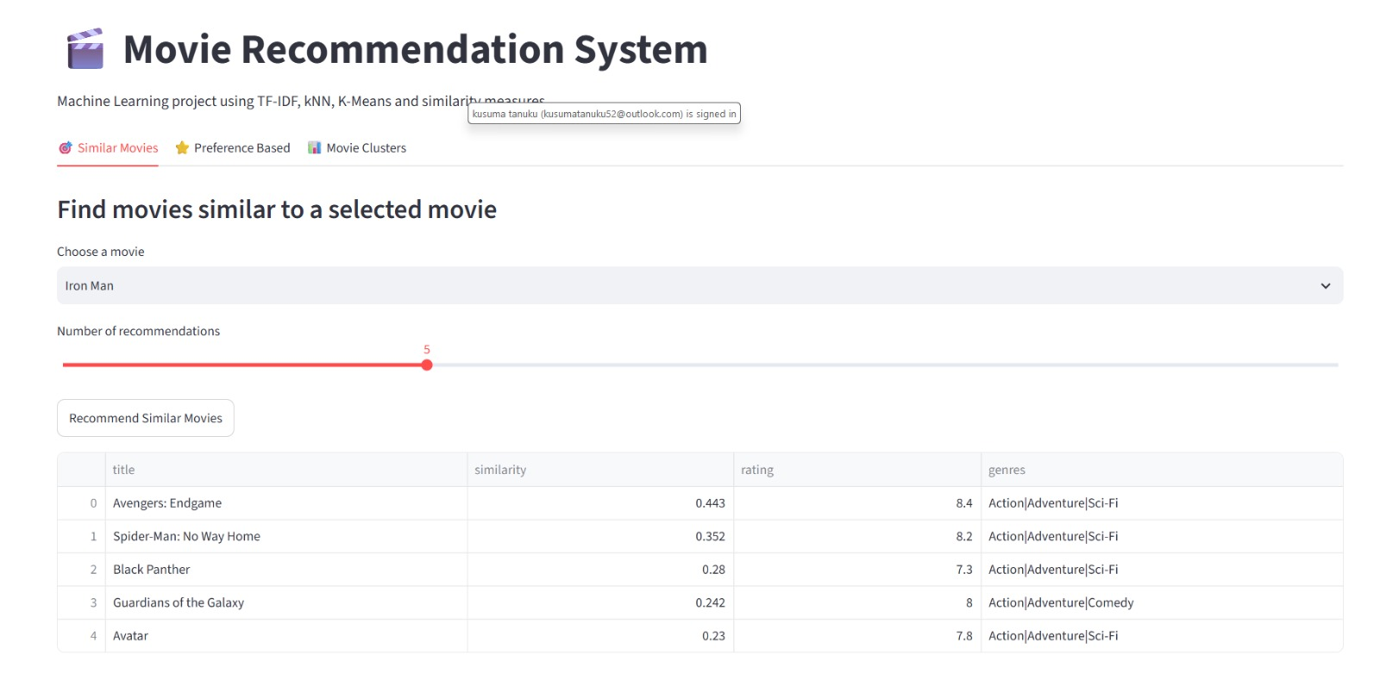

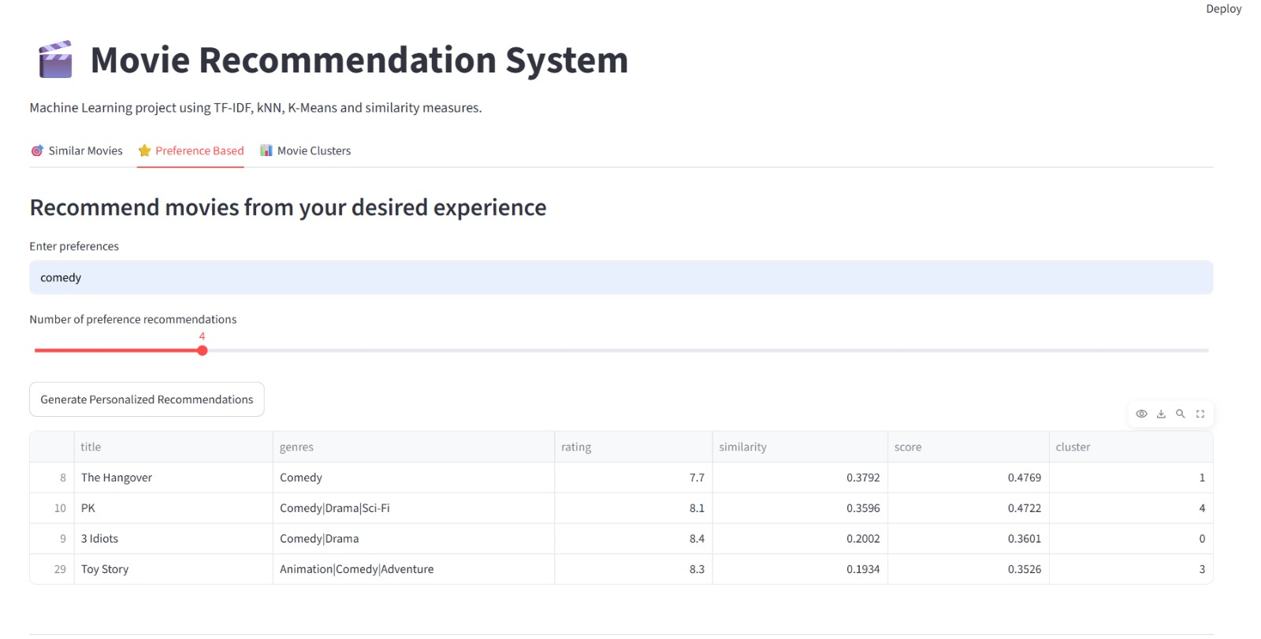

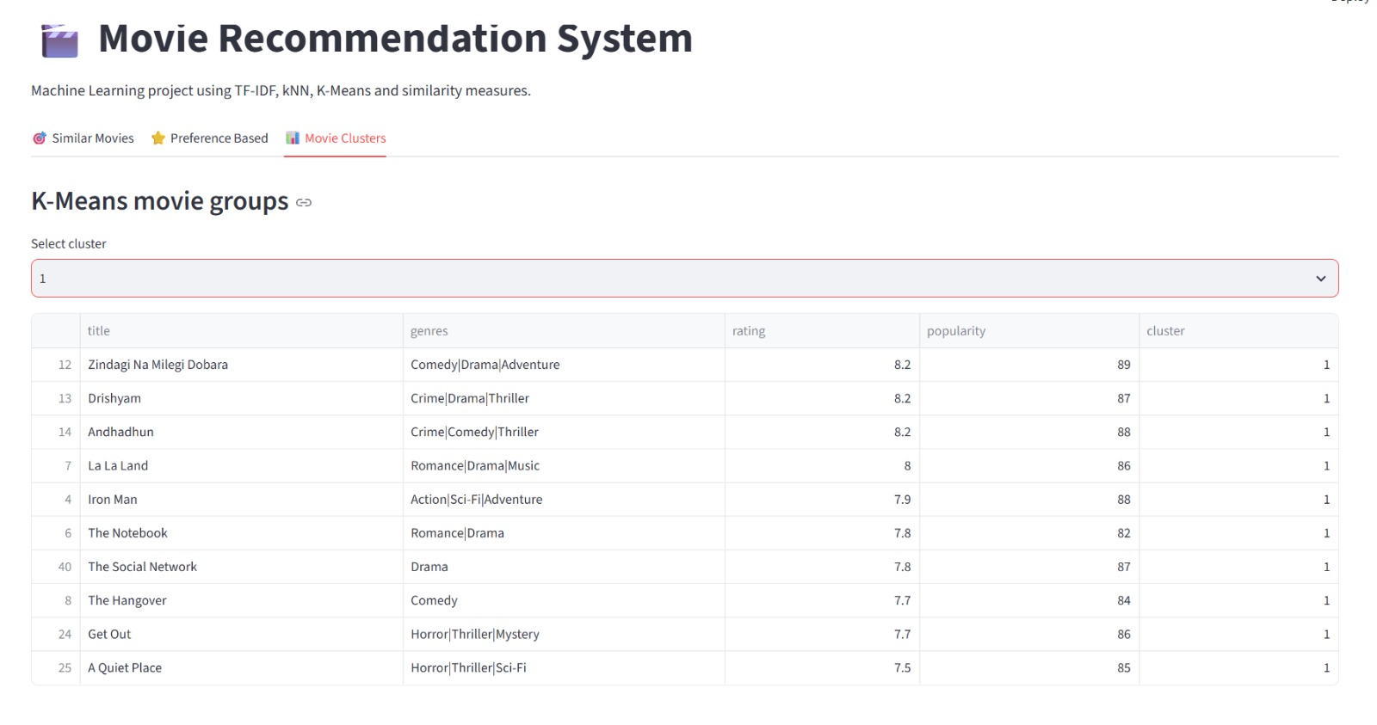
CHAPTER 9
CONCLUSION
The Movie Recommendation System was developed to address the problem of helping users discover movies that match their interests. Searching through a large collection of movies can be time-consuming, so the system provides recommendations based on similarities between movie attributes such as genres, keywords, cast, and director.
The project was implemented using Python in the Anaconda environment, with Scikit-learn for machine learning operations and Streamlit for the user interface. Data preprocessing involved inspecting the dataset and preparing textual and numerical features for analysis. TF-IDF was used to convert movie-related text into numerical vectors, and cosine similarity was applied to measure the similarity between movies. K-Nearest Neighbors (KNN) was used to identify similar movies, while K-Means clustering grouped movies based on numerical attributes such as rating and popularity.
Among the implemented techniques, TF-IDF combined with cosine similarity forms the core content-based recommendation approach because it compares movie content and identifies movies with similar characteristics. KNN supports the identification of nearby movies when applied to the prepared feature representations, while K-Means provides additional organization through clustering. However, a definitive best-performing algorithm cannot be established without a suitable comparative evaluation using actual results.
The project demonstrates the practical application of text processing and machine learning in building a movie recommendation system. Its Streamlit interface makes the system easier to use by allowing users to select a movie and view related recommendations. The system can be further improved by increasing the dataset size, incorporating user preferences and viewing history, and evaluating recommendation quality using suitable metrics such as Precision@K, Recall@K, or NDCG when relevant ground-truth data is available.
In conclusion, the project provides a foundation for a useful and user-friendly movie recommendation application and demonstrates how machine learning techniques can help users discover movies more efficiently.

CHAPTER 10
FUTURE SCOPE
The Movie Recommendation System can be improved in several ways to provide more accurate, personalized, and efficient recommendations. The following enhancements can be considered in future development.
- Integrating Real-Time Data: The system can be connected to movie databases or APIs to retrieve updated information about newly released movies, ratings, genres, and popularity. This would help keep the recommendations up to date.
- Applying Deep Learning Models: Advanced techniques such as neural networks and deep learning-based recommendation models can be explored to identify complex relationships between movies and improve recommendation quality.
- Deploying as a Web or Mobile Application: The Streamlit application can be deployed online so that users can access the system through a web browser. A mobile-friendly interface could also be developed to make the application accessible on different devices.
- Expanding the Dataset and Features: The dataset can be expanded to include more movies, languages, release years, user ratings, reviews, actors, directors, and production details. A larger and more diverse dataset could help the system provide a wider range of recommendations.
- Building a Personalized Recommendation System: User preferences, favorite genres, ratings, and viewing history can be incorporated to recommend movies according to individual interests. A hybrid recommendation approach combining content-based filtering and collaborative filtering could also be explored.
- Developing an Automated Pipeline and Dashboard: An automated pipeline could periodically update the dataset, preprocess new records, and refresh the recommendation results. An analytics dashboard could display popular movies, rating distributions, genre trends, and clustering results.
- Improving Model Evaluation: Recommendation-specific evaluation metrics, such as Precision@K, Recall@K, and NDCG, can be introduced when suitable evaluation data is available. This would help measure how relevant and useful the recommended movies are.
- In conclusion, these future enhancements could transform the current Movie Recommendation System into a more personalized, scalable, and intelligent application that provides users with relevant movie suggestions.

CHAPTER 11
REFERENCES
[1] C. D. Manning, P. Raghavan, and H. Schütze, Introduction to Information Retrieval, Cambridge University Press, 2008. Available: https://nlp.stanford.edu/IR-book/
[2] T. M. Cover and P. E. Hart, “Nearest Neighbor Pattern Classification,” IEEE Transactions on Information Theory, vol. 13, no. 1, pp. 21–27, 1967. Available: https://doi.org/10.1109/TIT.1967.1053964
[3] J. B. MacQueen, “Some Methods for Classification and Analysis of Multivariate Observations,” in Proceedings of the Fifth Berkeley Symposium on Mathematical Statistics and Probability, vol. 1, pp. 281–297, 1967.
[4] Scikit-learn Developers, “Feature Extraction: Text Feature Extraction,” Scikit-learn Documentation. Available: https://scikit-learn.org/stable/modules/feature_extraction.html
[5] Scikit-learn Developers, “Clustering,” Scikit-learn Documentation. Available: https://scikit-learn.org/stable/modules/clustering.html
[6] Streamlit, Inc., “Streamlit Documentation: Build Data Apps,” Streamlit Documentation. Available: https://docs.streamlit.io/

