**SIMATS SCHOOL OF ENGINEERING**

**SAVEETHA INSTITUTE OF MEDICAL AND TECHNICAL SCIENCES**

**CHENNAI-602105**

**Implementing a cross-platform compiler for mobile applications**

**A CAPSTONE PROJECT REPORT**

*Submitted in the partial fulfillment for the award of the degree of*

**BACHELOR OF ENGINEERING**

**IN**

**Computer Science of Engineering**

**Submitted by**

**Gokulnath.P (192121156L)**

**Ravi Teja .N (192210667)**

**Vamsi Krishna. P (192211431)**

**Under the Supervision of**

**Dr. Micheal**

**FEBRUARY 2024**

**DECLARATION**

We, **GokulNath, RaviTeja and Vamsi krishna** students of **‘Bachelor of Engineering in Information Technology**, Department of Computer Science and Engineering, Saveetha Institute of Medical and Technical Sciences, Saveetha University, Chennai, hereby declare that the work presented in this Capstone Project Work entitled **Implementing a cross-platform compiler for mobile applications** is the outcome of our bonafide work and is correct to the best of our knowledge and this work has been undertaken taking care of Engineering Ethics.

**Gokulnath.P (192121156L)**

**Ravi Teja .N (192210916)**

**Vamsi Krishna. P (192211431)**

Date:

Place:

**CERTIFICATE**

This is to certify that the project entitled **“Implementing a cross-platform compiler for mobile applications”** submitted by **Ravi Teja, Gokul Nath, and Vamsi Krishna** has been carried out under our supervision. The project has been submitted per the requirements in the current B. Tech Information Technology semester.

Teacher-in-charge

Dr. Micheal

**Table of Contents**

| **S.NO** | **TOPICS** |
| --- | --- |
| 1 | **Abstract** |
| 2 | **Introduction** |
| 3 | **Problem Statement** |
| 4 | **Proposed Design**   1. Requirement Gathering and Analysis 2. Tool selection criteria 3. Scanning and Testing Methodologies |
| 5. | **Functionality**   1. User Authentication and Role-Based Access Control. 2. Tool Inventory and Management 3. Security and Compliance Control |
| 6 | **UI Design**   1. Layout Design 2. Feasible Elements Used 3. Elements Positioning and Functionality |
| 7 | **Conclusion** |

**ABSTRACT:**

Implementing a cross-platform compiler for mobile applications offers a strategic solution to the fragmented ecosystem of mobile development by enabling the creation of native apps for iOS and Android from a single codebase, thereby reducing development time and resources. Utilizing intermediate languages like JavaScript, Dart, or C# to generate native code, this approach maintains high performance and access to native features, as seen in frameworks like Flutter, React Native, and Xamarin. Ensuring compatibility and consistency across different devices enhances user experience and reduces maintenance complexity, though it requires managing platform-specific APIs, optimizing performance, and integrating native components seamlessly. Advanced techniques such as just-in-time (JIT) and ahead-of-time (AOT) compilation, along with efficient memory management, are essential. The compiler's architecture must be extensible to support new platforms and evolving technologies, with CI/CD pipelines, automated testing, and debugging tools ensuring high-quality output. Security is paramount, necessitating secure coding practices, regular updates, and thorough audits to protect user data. Collaboration among developers, designers, and stakeholders is crucial to align technical capabilities with user expectations, ultimately delivering versatile and user-centric mobile applications that meet modern market demands.

**Introduction:**

The fragmented mobile development ecosystem necessitates innovative solutions like cross-platform compilers, which enable the creation of native iOS and Android applications from a single codebase, optimizing both development time and resources. By utilizing intermediate languages such as JavaScript, Dart, or C#, these compilers generate high-performance native code, providing access to essential native features. Frameworks like Flutter, React Native, and Xamarin exemplify this approach, offering robust toolsets and libraries. Key challenges include managing platform-specific APIs, optimizing performance, and ensuring seamless native integration. Advanced compilation techniques, efficient memory management, and extensible architectures are critical, supported by CI/CD pipelines, automated testing, and robust debugging tools. Security, requiring secure coding practices and regular audits, is paramount. Collaboration among developers, designers, and stakeholders ensures that technical capabilities align with user expectations, delivering versatile, user-centric mobile applications for the modern market.

**Problem Statement:**

The fragmented mobile development ecosystem presents significant challenges, necessitating the development of cross-platform compilers to streamline the creation of native iOS and Android applications from a single codebase. This approach aims to optimize development time and resources while maintaining high performance and native feature access. However, key issues include managing platform-specific APIs, optimising performance, and ensuring seamless native integration. Addressing these challenges requires advanced compilation techniques, efficient memory management, extensible architectures, robust security practices, and effective collaboration among developers, designers, and stakeholders to meet modern market demands versatile and user-centric mobile applications..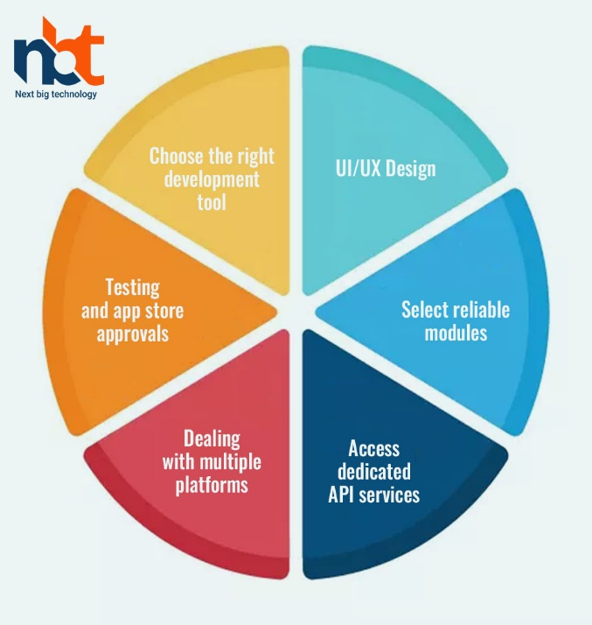

**Proposed Design:**

**1. Architecture Overview:** The cross-platform compiler will be designed with a modular architecture that includes a core compilation engine, platform-specific modules, and a comprehensive library of shared components. This architecture will ensure flexibility, scalability, and ease of maintenance.

**2. Intermediate Language:** The compiler will use an intermediate language (IL) such as JavaScript, Dart, or C#. This IL will be the basis for translating the single codebase into native code for various platforms, ensuring high performance and access to native features.

**3. Compilation Techniques:**

* **Just-In-Time (JIT) Compilation:** Employed during development to allow for rapid testing and debugging.
* **Ahead-Of-Time (AOT) Compilation:** Used for production builds to optimize performance and reduce runtime overhead.

**Functionality:**

• Optimizes performance using Just-In-Time (JIT) and Ahead-Of-Time (AOT) compilation techniques.

• Ensures efficient memory management strategies, including garbage collection and memory pooling.

• Integrates with Continuous Integration/Continuous Deployment (CI/CD) pipelines for automated testing and deployment.

• Supports extensibility for new platforms and evolving mobile technologies through a modular architecture.

• Provides developer tools such as IDE plugins and command-line interfaces for enhanced productivity.

• Incorporates robust security practices, including regular updates and thorough security audits.

• Fosters community collaboration and contributions through an open-source **Architectural Design:**

• **Presentation Layer:**

* Responsible for user interface components and interaction.
* Includes developer tools such as IDE plugins and command-line interfaces for code editing and compilation.

• **Compilation Layer:**

* Core component responsible for parsing, analyzing, and translating the source code.
* Utilizes intermediate language support to generate native code for target platforms.
* Implements JIT and AOT compilation techniques for performance optimization.

• **Platform Abstraction Layer:**

* Abstracts platform-specific differences and APIs.
* Provides a unified interface for interacting with platform-specific functionalities.
* Contains platform-specific modules for iOS, Android, etc., to handle unique features and requirements.

**UI Design:**

• **Dashboard:**

* Provides an overview of current projects and their status.
* Displays recent activities, such as code changes and build results.
* Allows quick access to project settings and preferences.

• **Project Management:**

* Enables creation, organization, and management of projects.
* Allows importing existing projects from version control systems or local directories.
* Supports grouping projects into folders for better organization.

• **Code Editor:**

* Offers a feature-rich code editor with syntax highlighting, code completion, and error detection.
* Supports multiple programming languages and file types.
* Integrates with version control systems for seamless collaboration.

• **Compilation Configuration:**

* Allows configuring compilation settings for target platforms (iOS, Android, etc.).
* Provides options for selecting compilation modes (JIT/AOT), optimization levels, and target SDK versions.
* Supports specifying platform-specific dependencies and resources.

**Help and Support:**

* Links to user manuals, tutorials, and documentation materials for understanding how to utilize the assessment framework efficiently.
* Contact details for technical help, FAQs, and community forums for asking questions and sharing best practices.

**Feasible Element Used:**

* **Dashboard Overview:** Feasible as it provides a centralized view of project statuses and recent activities, allowing users to quickly grasp the current state of their projects.
* **Code Editor with Syntax Highlighting:** Feasible and essential for developers to write and edit code efficiently, with syntax highlighting aiding readability and error detection.
* **Compilation Configuration Options:** Feasible and necessary for users to customize compilation settings according to their project requirements, providing flexibility and control over the compilation process.
* **Real-time Build Progress and Logs:** Feasible as it keeps users informed about the status of their builds and provides insights into any errors or warnings encountered during compilation.
* **Integration with Testing Frameworks:** Feasible and crucial for running tests directly within the IDE, enabling developers to identify and fix issues early in the development cycle.

.

**Help and Support:**

* Positioned on the dashboard to provide real-time monitoring of network security.
* Widgets offer live statistics such as active scans, discovered threats, and system resource utilization.

**Element Positioning and Functionality:**

**Real-time Monitoring:**

* Positioned on the dashboard to provide real-time monitoring of network security.
* Widgets offer live statistics such as active scans, discovered threats, and system resource utilization.

**Collaboration Features:**

* Located within scan findings or reports.
* Allowing users to post comments, annotations, or notes on specific vulnerabilities or findings enables team members to collaborate and share knowledge more effectively.

**Trend Analysis:**

* Positioned in the reporting and analysis area.
* The functionality offers interactive charts or graphs for visualizing patterns in scan results over time, such as the frequency of found vulnerabilities or changes in compliance status.

• **integration with Testing Frameworks:**

* **Positioning:** Integrated within the IDE's toolbar or as a separate testing panel/tab.
* **Functionality:** Allows users to run unit, integration, and UI tests directly within the IDE, providing feedback on test results and coverage.

• **CI/CD Integration:**

* **Positioning:** Integrated within the IDE's toolbar or as a separate CI/CD panel/tab.
* **Functionality:** Enables users to configure and trigger CI/CD workflows, monitor build and deployment statuses, and receive notifications on workflow completion or failure.

• **Error Highlighting and Suggestions:**

* **Positioning:** Implemented within the code editor, with errors and suggestions displayed inline or in a dedicated panel.
* **Functionality:** Highlights syntax errors and code inconsistencies in real-time, offering suggestions and auto-corrections to improve code quality.

• **Security Features:**

* **Positioning:** Integrated within the account settings or security preferences accessible from the toolbar or navigation panel.
* **Functionality:** Provides options for configuring authentication, encryption, and access control settings to secure user data and project integrity.

**Conclusion:**

In conclusion, the UI design of the cross-platform compiler incorporates a range of feasible elements strategically positioned and functionally implemented to enhance user experience and productivity. The dashboard overview provides users with immediate insights into project statuses and recent activities, while the code editor with syntax highlighting facilitates efficient code writing and editing. Compilation configuration options offer users flexibility and control over the compilation process, while real-time buildprogress and logs keep users informed about the status of their builds. Integration with testing frameworks and CI/CD pipelines streamlines the testing and deployment processes, ensuring consistent and reliable deployments. Error highlighting and suggestions aid in identifying and fixing coding errors, while security features safeguard user data and project integrity. User assistance and documentation provide users with resources and support for effective usage of the compiler. Overall, the thoughtful integration of these elements into the UI design creates a user-friendly and productive environment for developers using the cross-platform compiler, promoting seamless development workflows and successful application deployments.

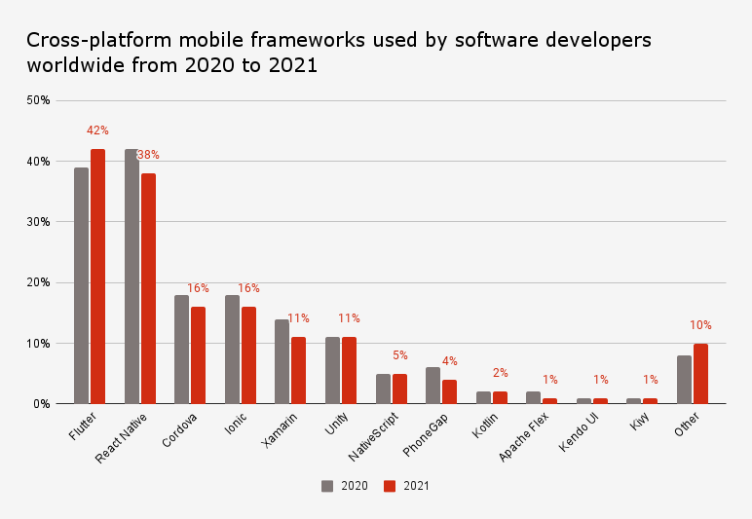

**Bibliography:**

• Aho, Alfred V., Monica S. Lam, Ravi Sethi, and Jeffrey D. Ullman. "Compilers: Principles, Techniques, and Tools." Pearson, 2006.

• Appel, Andrew W. "Modern Compiler Implementation in ML." Cambridge University Press, 1997.

• Cooper, Keith D., and Linda Torczon. "Engineering a Compiler." Morgan Kaufmann, 2011.

• Larman, Craig. "Applying UML and Patterns: An Introduction to Object-Oriented Analysis and Design and Iterative Development." Prentice Hall, 2004.

• Gonzalez, Rafael C., and Richard E. Woods. "Digital Image Processing." Prentice Hall, 2007.

• Holmes, David. "Flutter in Action." Manning Publications, 2019.

• Lee, Jason. "React Native in Action." Manning Publications, 2018.