* What is Exploratory Testing?

Exploratory testing is done without knowing any documentation part.

Exploratory testing means exploring the whole application or website and if you found any problem with that.

* What is a traceability matrix?

A traceability matrix is to make a matrix where we get to know easily what is the functionality requirement and with which it integrated.

Like we take a requirement of the logo of the website which is shown in every component/module.

Here it traces that that requirement should be seen in every module.



* What is Boundary value testing?

Boundary value testing is one of the techniques used for testing. It is a methodology for designing test cases nearer to the valid data range already given.

Suppose: It says that the username of login should range between 1 to 10 characters.

Then test cases prepared according to this boundary value analysis that the username should be valid having a character ranging between 1 to 10 otherwise invalid.

* What is Equivalence partitioning testing?

Equivalence partitioning is a technique used in testing. Here as per the requirement, we select the data in a range where equivalence partitioning applies.

For example, if any client wants an OTT application where age should be defined for watching shows.

Here It applies to like kids section where the age is defined from 0 to 12 years.

Teenage shows age defined as 13 to 18 years.

For adult shows an age defined above 18 years.

So, here we prepare test cases according to the functional requirement of an OTT whether it is valid or invalid.

* What is Integration testing?

Integration testing is done after unit testing. It is done to test whether the units integrated are working properly or not.

Integration testing is to be done on units that are integrated or the components or a system integrated, that interface working properly or not.

Integration testing has 2 levels:

Component integration: Component integration needs to test the interface of components.

system integration testing: System integration to find defects in an interface of the system.

* What determines the level of risk?

Risk is based on project-level risk or product-level risk.

Project level risk: there is so many risk factor considered like resources not working before the launch of the project.

Product level risk: There is a risk considering as the product is made but is on working in the market environment.

Both are high high-risk that need to be resolved.

* What is Alpha testing?

Testing which is done by the tester or the developer at the time of software development and testing process is known as Alpha testing.

As it also considers a form of both black-box and white-box testing.

It is done at a time of software development before launching it.

It is done only in the environment of the developer or testing team.

* What is beta testing?

Testing which is done by the User/ customer’s team/ client known as Beta testing.

It is a form of acceptance testing. This testing is done after the completion of the whole software development.

Here customer tests how the product will work in the real environment of a market.

We can say it is a form of black-box testing.

* What is component testing?

Component testing is how the different component works of the module.

Is All the functionality of the component working properly or not? is it having any issues? All these things need to be checked during component testing.

* What is functional system testing?

Functional system testing is to test the functionality of a system which it made is working properly or not.

Functional system testing has two approaches to testing

Requirement-based: where the functionality of the system is checked as per requirements given by the customers in the documentation.

Process-based: where the functionality of the system is checked as per the process like the customer’s profile, business scenario, use-case, and environment of the market.

* What is Non-Functional Testing?

Non-functional testing is done where it has no relation to the functionality of the system.

Like, as its usability, adaptability, look and feel, whether the system is secure or not, data of users are secured or not, etc.

Performance, load & stress testing, and GUI testing all are types of Non-functional testing but these are not the only ones.

* What is GUI Testing?

GUI( Graphical User Interface) testing is done to check whether the system’s look is good or not.

It covers the size of the font and any picture it has, the Arrangement of lines or pictures or tabs and buttons given, Length, and width.

Also the color of font and lines, etc. background of the system, different colors of error msg, etc.

GUI testing has 3 approaches: Manual, Record & Replay, and Model-based.

* What is Adhoc testing?

Adhoc testing has the main aim to break the system means finding the defects.

Adhoc testing is done without any documentation part.

It is performed by an experienced person which has high knowledge of the system.

There are 3 types of Adhoc testing

Buddy testing: Mostly buddy testing is done by the team having one from the developer and another buddy from the testing team.

Pair testing: two testers working on the same module are considered pair testing.

Monkey testing: Checking the system randomly without any test plan or cases, with the main aim of breaking the system. It is done by an experienced person.

* What is load testing?

It is a form of performance testing that check how the system will perform under the load or how much load can be taken by the system without low performance.

Mostly high-traffic websites like famous brands’ websites or apps, and e-commerce websites need to go through this testing when so many people use the same website or app.

* What is Stress Testing?

Stress testing was also done up to the breaking point (failure) of the system.

Stress is given continuously to the system up to an extreme point where the system fails. It shows how the system will work under extreme conditions and up to which point.

* What is white box testing and list the types of white box testing?

White box testing is testing based on known internal structure and knowing software implementation.

White box testing is also known as glass box testing because the person is known for front-end and back-end structures.

In white box testing coverage techniques used for test cases

Like statement coverage, decision coverage, and condition coverage.

Types of white box testing

* Unit testing
* Integration testing
* What is black box testing? What are the different black box testing techniques?

Black box testing is done on functional or non-function requirements without any focus on the internal structure of a component.

Black box testing also known as Specification-based or input-output testing by reviewing the documentation part.

Mainly how all the component works, and how the system works is tested not what structure is used for it to work.

Black box testing techniques are:

Equivalence testing

Boundary Value Analysis

Decision table

State Transaction Examples

* Mention what are the categories of defects?

Categories of defects are:

Database defect: any defect found related to the database like the database not working or data being incorrect is known as a database defect.

Critical functionality defect: A defect related to any functionality of the system which creates a critical situation for the system.

Functionality: The functionality for which the system is made is not working appropriately.

Security: whether it is related to the database or any other security defect found.

User Interface defect: Defect related to warning msgs, alignment, etc.

* Mention what Big bang testing is?

In Big bang testing, all the components are integrated at once. Before integration testing starts all components integration is done.

Here it is good enough for small projects because testing after all the integrated systems, it becomes difficult to find where a defect arises.

* What is the purpose of exit criteria?

In the general purpose of Exit, the criteria are to give closure by checking all work is done of any particular cycle or phase of testing you are doing or that the whole cycle is completed.

Like In testing Exit criteria says:

* All the priority bugs need to be fixed.
* All the test cases we performed are submitted in the documentation part.
* Detail report should be submitted.
* The time limit is over
* All the documentation is submitted with a release note of the system.
* When should "Regression Testing" be performed?

When the whole system is working properly and after that new requirement of any feature or else is added by the client, then the regression testing is performed.

Here the whole system is tested in a limited amount of time because the system is already in working mode just a new feature need to be checked whether it affects the whole system integration or not.

* What are the 7 key principles? Explain in detail.

The 7 key principles are:

1. Testing shows the defect: Always Keep in mind that whenever testing is done, defects will be there for sure.
2. Exhaustive testing is impossible: All the data needs a particular input that has more than one of the possible values. So considering all the values we can not do the testing because it becomes impossible to complete. So instead based on requirement and priority testing should be done.
3. Early Testing: Testing should start as early as possible in the software development life cycle. So it becomes easy to find out defects and fix them.
4. Defect cluster: If a smaller is ignored from starting it gathers and becomes a cluster at end of the testing which is hard to resolve.
5. Pesticide paradox: As we say take the medicine as per the illness. Just like that same kind of testing can not be applicable everywhere. We need to change or choose the testing methodology/ techniques for that kind of defect found.
6. Testing is context-dependent: For different-different projects/products, we need different testing implementations.

Suppose For a college website: Database security testing is more important

Or for a bank functionality, and any highly confidential government app needs more network security testing like that.

1. Absence of error is a fallacy: If any add-on things developer puts in a website which doesn’t match the requirement it also becomes defect for a testing.

* Difference between QA v/s QC v/s Tester

|  |  |  |
| --- | --- | --- |
| QA | QC | Tester |
| QA verifies and makes sure that the whole testing process is done properly, as per the standards, and all in the developed software. | QC verifies the requirement in the documentation and other things in the developed software. | The tester finds the defects in developed or developing software. |
| They mainly concentrate on the process and procedure of testing, not on the actual testing done. | They concentrate on doing proper testing by following processes and all procedures. | Testers always do actual testing. |
| QA comes under STLC. | QC comes under the QA. | The tester comes under QC. |

* Difference between Smoke and Sanity?

|  |  |
| --- | --- |
| Smoke testing | Sanity testing |
| Smoke testing is to be done on a build that is unstable to stabilize it like end-to-end functionality. | Sanity testing is done on the system where any new features have been added and any bug is detected. |
| It is done by a tester who knows the structure or a developer. | It is done by the tester only. |
| Smoke testing is planned. | Sanity testing is usually unscripted |
| Smoke testing is done like doing general testing on the software to check whether all the builds are stabilized or not. | Sanity testing is like specialized testing done for a particular feature of a bug. |

* Difference between verification and Validation

|  |  |
| --- | --- |
| Verification | Validation |
| Verification is done as an ongoing process of software development whether going properly or not as per code, functionality others. | Validation is to validate the actual software after development. |
| Verification can be considered static testing. | Validation is considered under dynamic testing. |
| Verification is done by testing on an ongoing process where code execution is not required. | Validate any software that may need codes to execute. |
| Verification is done by reviewing, and walkthrough through other similar ways. | Validation needs to be done by black-box, and white-box testing. |
| The verification process finds defects in the early stage of development | Validation finds defects/bugs which not identified by the verification process. |
| It process is done manually before the validation phase. | This process needs automation. |

* Explain types of Performance testing.

Types of performance testing:

Load testing: A test to check how much load the will application be able to take without lowering performance.

Stress testing: Stress testing is to break the software, here stress is given to the software up to a critical breaking point when the system fails.

Endurance testing: this testing is done to test the application’s endurance on the application due to the heavy load of users.

Spiketesting: it comes under stress testing which rapidly increases the use of the application to see its usability, and speed of application.

Volume testing: it is done to test the data of software after a certain limit of data store how will application perform with more input of data.

Scalability testing: It is considered to identify the limit of users for that application of the software.

* What is Error, Defect, Bug and failure?

A problem that arises in software or application is called an error.

As a tester, any error that arises that hurdles the flow of the system whether it is functional or non-functional is known as a Defect.

Bug: A defect that is given to the developer is known as Bug.

Failure: Any bug/ defect can not be resolved so the application is called a failure.

* Difference between Priority and Severity

|  |  |
| --- | --- |
| Priority | Severity |
| Priority is should be set by a developer. | Severity should be set by a tester. |
| Priority considered from the perspective of the developer that which bug needs to fix first. | Severity is considered from the perspective of the system which defect needs to resolve first. |
| Priority is divided into high, medium, and low. | Severity is divided into blocked, critical, major, or minor. |

* What is Bug Life Cycle?

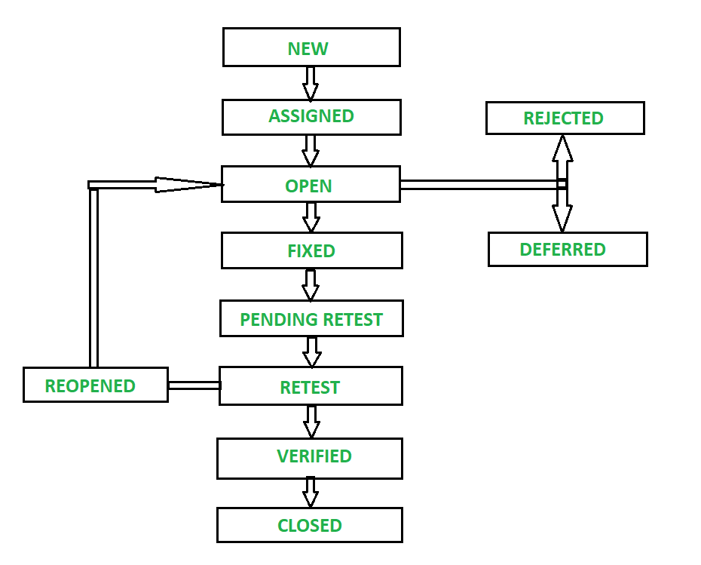

Starting a bug life cycle as shown in the diagram:

New- A new bug was found during the testing.

Assigned- Now to resolve the bug it should be assigned to one of the members of the developer team

Open- A bug is opened by the person to whom it is assigned.

Rejected- If the developer finds that it is not a bug then it will reject it.

Deferred- If the developer says this bug is not the priority. so it is deferred.

Fixed- The bug is fixed by changing the needed code.

Pending retest- Now again it goes to the person who assigned it.

Retest- now the person retests it. And if it ok then go further but if not fixed again reassigned it. and goes for reopening.

Varified- now in retest bug is fixed verified and goes for further step.

Closed- If no issue related to the same bug is found then it is declared closed.

* Explain the difference between Functional testing and Non-Functional testing

|  |  |
| --- | --- |
| Functional testing | Non-functional testing |
| Functional testing is to test the functionality specified in the requirement. | Non-functionality testing is to test the usability, performance, and adaptability of a system. |
| Functionality testing is carried out before non-functional testing without it system can not work. | Non-functional testing should be done last it does not affect the flow. |
| Manual or automation are both tools that can be used for this testing. | Automation is beneficial for this testing. |
| Functional testing shows why is software made for. | Non-functional testing shows how well is software working. |
| Types of functional testing are as follows:  Unit testing  Smoke testing  Sanity testing  Integration testing  White box testing  Black box testing  User acceptance testing  Regression testing | Types of Non-functional testing:  Performance testing  Load testing  Volume testing  Security testing  Stress testing  Compatibility testing  Penetration testing  Migration testing |

* What is the difference between the STLC (Software Testing Life Cycle) and SDLC (Software Development Life Cycle)?

|  |  |
| --- | --- |
| STLC(Software testing life cycle) | SDLC(Software development life cycle) |
| STLC is the life cycle of testing. | SDLC is the life cycle of software development. |
| STLC has phases:  Requirement analysis  Test planning  Test case development  Test environment setup  Test execution  Test cycle closure | SDLC has phases:  Requirement gathering  Analysis  Designing  Implementation  Testing  Maintenance |
| STLC focus on Finding defect to make software/system high in quality. | SDLC itself focuses on developing any software. |

* What is the difference between test scenarios, test cases, and test scripts?

Test scenarios: Test scenarios are seen from both the perspective of positive and negative. It is prepared to visualize the result of different valid or invalid inputs of data in all the functionality and non-functional views.

Test cases: Test cases are the form of actual testing data. This means it is prepared to execute tests on any software/ application/ website to find out how it will give results on applying different inputs of data for all functionality.

Test scripts: A test script is like a set of instructions on what comes after what and what to do. It prepares all the things that should be covered in a scenario and how can we execute it by following certain instructions.

* Explain what Test Plan is? What is the information that should be covered?

The test plan is when what, and how to do the test. The short test plan is a plan/ strategy for doing testing from all aspects.

The test Plan covers the information of what resources we need, what to assign whom for how much time, which tools we need, and when we execute all the things based on requirement analysis.

* What is a priority?

Priority is in terms of bug defines which need to be fixed first.

It has 3 categories:

1. P1 (High) – It is considered that the developer has given it a high-level priority which needs to fix first, the system won’t work properly without fixing it.
2. P2 (Medium)- It is considered as a medium level which can wait to fix,
3. P3 (Low)- It is considered as the low level which can be fixed at last.

* What is the severity?

Severity is considered based on for which software/ application is made. If that functionality is not working then why do we need it?

Severity is set by a tester that what functionality is more important to fix first to make the flow of software better.

There 4 types of severity:

Blocked: when any function is not working how then it comes under this?

Suppose we made a college website where all the students can log in and check all the things related to study. If login functionality is not working then what it is for?

Critical: When any functionality becomes a necessity then it is critical. Like payment to mode on an e-commerce website is not working then it becomes critical because in the end business is most important.

Major: It is also a very important severity but less than the two above like confirmation msg are not getting.

Minor: It is of lowermost importance given the issue of color, and background.

* Bug categories are…

Bug categories are:

Security, Database, functionality, UI

Severity- It is categorized as blocked, critical, major, and minor also based on

Priority- High level, medium level, low level.

* Advantage of Bugzilla.

The advantage of Bugzilla is it becomes easy for a tester and developer to assign the Bug, Categories the Bug, To see if it is Open and fixed or not everything in just one place.

* What are the different Methodologies in Agile Development Model?

The most common Agile methodology nowadays used is Jira, Scrum framework, and Kanban Framework.

Jira it’s self a methodology of agile development model where different frameworks like scrum or Kanban are used to assign and tracking of bug resolve.

* Explain the difference between Authorization and Authentication in Web testing. What are the common problems faced in Web testing?

|  |  |
| --- | --- |
| Authorization | Authentication |
| The authorization permits users what can be accessed and what not. | Authentication is to make sure that You are the right person who using it or not |
| For example, Some of the platforms do not give authorization below 18 years to watch the show | For example, Many websites give a captcha where have to select pictures to prove they are not robots. |
| Authorization is given after successful authentication. | Authentication becomes first in web testing. |

The most common problems faced in web testing are:

* Integration: How the different pages work After integration. Is there an issue arising in the interface of the modules? The integrated module needs to open and works as per the functionality.
* Security: Web testing should be very focused on security because different security problem arises like network security, and database security.
* Performance: The performance of the website becomes a problem in web testing like any e-commerce website needs to test its performance regularly because of heavy traffic.
* Usability: usability affects the website users…the user is friendly and attractive to the website more people will see it.
* When to use Usability Testing?

Usability testing is mainly done when any application or website is made more user-friendly. Like any social media application, we see Instagram, Facebook, and e-commerce site.

It says how good it looks will say how good the application or software is.

So it is used for how well the application looks, and how it can be more easily used by users.

* What is the procedure for GUI Testing?

The procedure of GUI testing is:

* Checking all the font sizes, colors, alignments, widths, positions, and numerals can be added or not, and special characters can be typed or not everything.
* Checking whether any mandatory field has showing messages or not, if any error is there then an error msg should be pop-up or not.
* Pictures are displayed properly as per dimension or not, background colors, picture quality.
* Checking the overall look of software/ website/ application.