Dubai Urban Heat Analysis (DUHA)
An AI-Driven Decision Support System for Urban Heat Mitigation
BSc Computer Science - University of Birmingham Dubai
Nithin Santhosh
March 2026

Abstract
Dubai Urban Heat Analytics (DUHA) is a city-scale Decision Support System that combines multi-source satellite imagery, supervised machine learning, and explainable AI to produce 30 m resolution Land Surface Temperature anomaly maps of Dubai across three daily time windows: morning (10:30 AM via Landsat 8/9), afternoon (1:30 PM via VIIRS), and night (1:30 AM via VIIRS). A LightGBM downscaling model trained on 13 physically interpretable urban features achieves RMSE values of 2.71 K (R² = 0.92) for the morning slot, 2.05 K (R² = 0.52) for the afternoon, and 1.303 K (R² = 0.59) at night. The resulting maps are delivered through an interactive web platform that allows urban planners to explore heat vulnerability across 173 communities, inspect individual 30 m pixels via SHAP attribution values, and simulate six categories of urban intervention with live temperature re-prediction and integrated cost estimation. The system reveals a striking diurnal inversion: the urban core acts as a cool island relative to the scene mean at peak solar radiation (−4.21 K mean anomaly) but inverts to a heat island at night (+0.81 K), with urban pixels shifting an average of 5 K between their afternoon and nighttime anomaly states.

1. Introduction and Motivation

1.1 Motivation and Problem Statement
Dubai is one of the fastest-urbanizing cities on earth. Over the past four decades, its built-up area has expanded from a small coastal settlement into a metropolitan region characterised by dense high-rise corridors, major road infrastructure, and large expanses of sealed impervious surfaces. This rapid transformation has been accompanied by a well-documented thermal penalty: Land Surface Temperatures in central Dubai regularly exceed 50°C during summer afternoons, and urban areas retain measurable heat well above the surrounding desert long into the night. For residents, this translates into acute pedestrian heat stress, elevated cooling energy demand, and increased risk of heat-related illness during the May-to-September peak season.
The Urban Heat Island (UHI) effect (the phenomenon by which densely built environments retain more heat than surrounding rural or desert land) is well established in the scientific literature. Its principal drivers are equally well understood: the replacement of reflective sand and sparse vegetation with dark asphalt and concrete, the elimination of evaporative cooling as permeable surfaces give way to sealed ones, the trapping of longwave radiation in urban street canyons, and the emission of waste heat from air-conditioning systems, traffic, and industry. What has been absent from Dubai’s planning toolkit, however, is an operational system that translates this physical understanding into spatially precise, actionable intelligence at the scale at which planning decisions are actually made.

1.2 The Resolution and Temporal Gap
Satellite remote sensing provides the most practical route to city-wide thermal monitoring at scale. The NASA VIIRS instrument captures Land Surface Temperature at 750 m resolution at approximately 1:30 PM and 1:30 AM local time, providing both peak-heat and nocturnal observations. The USGS Landsat 8/9 mission provides a 10:30 AM overpass at a native resolution of 30 m. Neither source alone is sufficient for the planning task: VIIRS covers the thermally critical afternoon and night slots but is far too coarse to distinguish individual city blocks; Landsat provides the spatial sharpness required for block-level analysis but captures only the cooler morning transition. No freely available product currently combines the temporal coverage of VIIRS with the spatial resolution of Landsat across all three time windows simultaneously.

1.3 Beyond Observation: The Need for Decision Support
Even where high-resolution thermal data exist, existing tools share a deeper limitation: they are purely observational. A planner can identify which district is hottest, but cannot ask “What would happen to temperatures here if we coated these rooftops with reflective paint?” or “Which intervention delivers the most cooling per dirham spent?” Answering such questions requires a system that couples high-resolution thermal mapping with explainable machine learning and a live physics-constrained simulation engine, a combination that does not currently exist in any publicly available urban heat platform.
This project addresses both gaps. DUHA combines a three-slot LightGBM downscaling pipeline with an interactive web platform that moves beyond thermal observation into active intervention simulation, allowing planners to modify individual 30 m pixels, receive SHAP-based explanations, and estimate intervention costs in AED. The system moves unambiguously from passive thermal observation to active decision support.

2. Project Background and Context

2.1 The Urban Heat Island Effect and the Desert City Problem
As mentioned before, the Urban Heat Island effect arises from the well-documented replacement of natural surfaces with low-albedo impervious materials, the elimination of evaporative cooling, and the trapping of longwave radiation in street canyons. Dubai presents an extreme case: due to the high summer ambient temperatures, the thermal dynamics produce a counterintuitive diurnal inversion. At 1:30 PM, the desert sand heats so aggressively that it dominates the scene mean, causing urban pixels (shaded by buildings and cooled by irrigated vegetation) to appear cool relative to it. At 1:30 AM, the scene mean falls as non-urban surfaces cool rapidly, while concrete and steel re-radiate their stored heat, producing a positive nocturnal anomaly across the urban core. Figure 1 illustrates this inversion across the three modelled time windows. Because absolute LST values are dominated by day-to-day weather, all three DUHA models are trained on the LST anomaly (each pixel’s deviation from its scene mean), which isolates the structural contribution of land cover and makes predictions transferable across scenes and seasons.
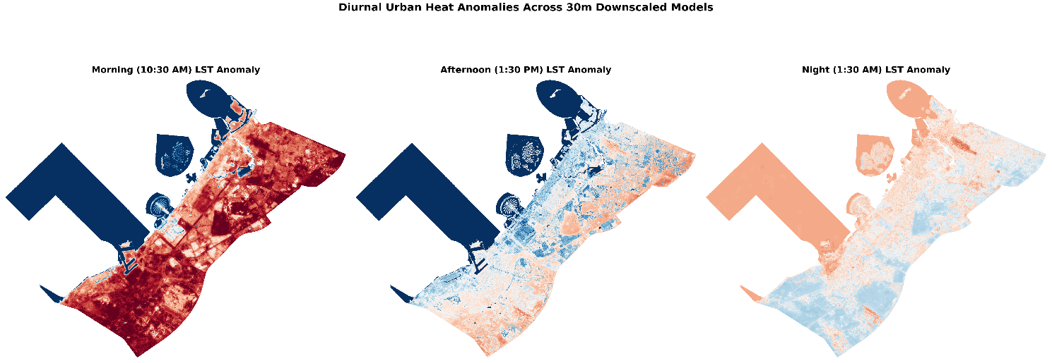
Figure 1. Diurnal LST anomaly maps at 30 m resolution across three time windows: morning (10:30 AM via Landsat 8/9), afternoon (1:30 PM via VIIRS), and night (1:30 AM via VIIRS). Red pixels are hotter than the scene mean; blue pixels are cooler. The afternoon panel reveals a city-wide cool island effect (−4.21 K mean) as the surrounding desert sand absorbs solar radiation; the night panel inverts to a heat island (+0.81 K) as urban materials slowly re-radiate stored heat. See Appendix A for the statistical consistency scatter plots underpinning these maps.

2.2 Prior Work: Downscaling Methods
The earliest and most widely cited downscaling approaches are statistical sharpening algorithms. DisTrad (Kustas et al., 2003) exploits the inverse NDVI–LST relationship to disaggregate coarse thermal data, achieving errors of ~1.5°C over Oklahoma grassland. TsHARP (Agam et al., 2007) refined this by substituting fractional vegetation cover for NDVI, reaching RMSE of 0.67 - 1.35°C over Iowa cropland. However, both methods carry a fundamental limitation for urban and arid environments: the NDVI–LST relationship breaks down where vegetation cover approaches zero, which is precisely the condition across Dubai’s desert margins and impervious fabric. The TsHARP authors explicitly cautioned that urban areas “should be carefully considered” when applying the algorithm.
Machine learning methods overcome this by incorporating multi-feature urban descriptors. Wang et al. (2020) showed that Random Forest substantially outperforms TsHARP and MLR for MODIS 1km→100m downscaling over Hangzhou across all four seasons. Ebrahimy and Azadbakht (2019) confirmed that RF, SVR, and ELM all outperform TsHARP in a heterogeneous area, with ML averaging RMSE≈2.5°C versus TsHARP's 3.02°C. More recently, Tahooni et al. (2025) achieved R²=0.82 and RMSE=1.18K in semi-arid Tabriz using tuned RF with SHAP explainability which is the most climatically analogous published study to Dubai's desert context. Hoang et al. (2025) demonstrated that LightGBM achieves R² up to 0.92 at native 30m in Da Nang, the most directly comparable task in the literature to DUHA's Landsat model. The only prior work targeting Dubai specifically is Abunnasr and Mhawej (2023), who applied an automated OLS approach to downscale Landsat data to 0.5m using commercial RGB imagery; however, their reliance on simple linear regression and single-band optical sharpening remains distinct from DUHA's multi-feature ML prediction of sub-pixel thermal structure from coarse 750m inputs. Table 1 situates these studies alongside DUHA; the Ratio column highlights that the VIIRS models perform a 25:1 downscaling, more spatially aggressive than any published comparison, which gives a VIIRS R² of 0.52–0.59 relative to studies operating at 4:1 to 10:1 ratios.
Table 1. Comparison of selected LST downscaling and modelling approaches in the literature.
Study | Method | Source → Target | Ratio | R² | RMSE | Time Slots
Kustas et al. (2003); Agam et al. (2007) | Statistical  (NDVI/FVC–LST regression) | ~1 km → 192–250 m | ~4:1 | N/A | ~1.5°C (agri.) | Single (daytime, agricultural)
Ebrahimy & Azadbakht (2019) | RF / SVR / ELM vs TsHARP | MODIS 1 km → 240 m | ~4:1 | N/A | ~2.5°C (ML avg) | Single (daytime)
Wang et al. (2020) | RF / TsHARP / MLR | MODIS 1 km → 100 m | 10:1 | 0.93–0.97† | SD 1.56°C vs Landsat | Daytime + nighttime (4 seasons)
Tahooni et al. (2025) | RF / SVR / XGBoost + SHAP | Landsat 360 m –600 m → 240 m | 1.5:1 – 2.5:1 | 0.82 | 1.18 K @ 360 m | Single (daytime)
Hoang et al. (2025) | LightGBM + SHAP | Landsat 30 m native | 1:1 | 0.85–0.92 | 1.64 –2.30°C | Single (daytime)
This work - DUHA (Dubai, UAE) | LightGBM + SHAP + Intervention DSS | 750 m → 30 m (VIIRS); 30 m native (Landsat) | 25:1 / 1:1 | 0.52–0.92‡ | 1.30–2.71 K‡ | Morning + afternoon + night
† Wang et al. (2020) R² values reflect internal model fit against training data; independent Landsat validation reports mean error 0.26°C with SD = 1.56°C without an R² figure. ‡ VIIRS model metrics are consistency checks (30 m…30m→750 m aggregation vs real VIIRS observations); Landsat metrics are spatial block-holdout validation (N = 7,586,713 pixels). RMSE values in Kelvin (K); °C and K are numerically equivalent for temperature differences.

2.3 Explainability and Decision Support in Urban Heat Research
While ML downscaling has matured, the integration of explainability into operational urban planning tools remains limited. SHAP has been adopted retrospectively in several recent studies. Tahooni et al. (2025) used it to identify dominant warming predictors in Tabriz and Hoang et al. (2025) used it to track shifting thermal drivers across survey years in Da Nang. But in both cases SHAP is applied to a static, pre-trained model. No existing study embeds per-pixel live SHAP attribution into an interactive platform where a planner can click any location and immediately understand why it is hot or cool. Existing operational tools provide static community-level choropleth maps at best; none permit the user to modify a pixel’s physical properties and observe the model-predicted thermal consequence. In building energy modelling, users can test “what-if” scenarios and instantly see the results, but no urban LST platform currently offers this capability.

2.4 Dataset Choices and Justification
DUHA draws on six primary data sources. For thermal observations, VIIRS VNP21 (750 m, dual daily overpasses) was selected over ECOSTRESS. Despite the latter’s higher native resolution (~70 m), its non-sun-synchronous orbit produces irregular revisits and a narrow swath that frequently leaves Dubai partially uncovered, whereas VIIRS guarantees daily full-city coverage at consistent overpass times. Only the VNP21 standard science product was used (not the Near Real Time variant) ensuring permanent archival provenance and strict QA bitmask filtering. For building footprints, Overture Maps was preferred over OpenStreetMap, yielding 314,347 buildings versus OSM’s 235,319, a 33 % increase driven by AI-detected footprints from Microsoft, Esri and others that are particularly valuable in peri-urban industrial zones. Building heights come from the Global Building Atlas (GBA, TU Munich / DLR, 3 m resolution), preferred over GHS-OBAT for its finer resolution and more complete coverage of Dubai’s high-rise corridors. Road density is derived from OSM via osmnx with lane-based adaptive buffering to measure it’s width. Vegetation, albedo, and surface indices are computed from Sentinel-2 Level-2A imagery using the Bonafoni and Sekertekin (2020) broadband albedo formula, chosen to account for Dubai’s non-European surface composition.
3. Methodology and Specification
3.1 System Architecture
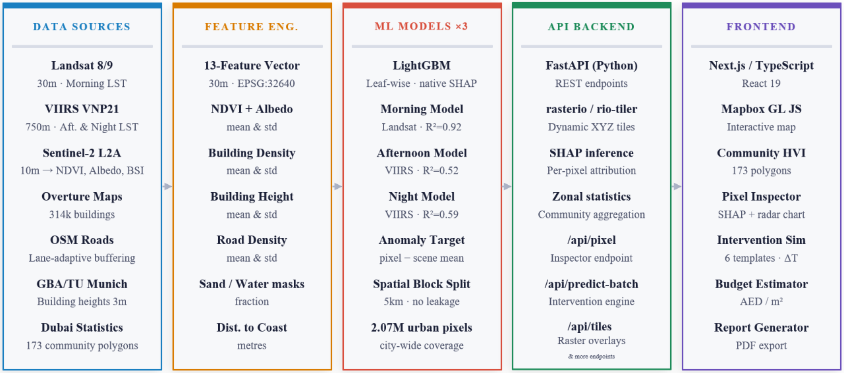
DUHA is structured as an end-to-end pipeline spanning five logical stages, illustrated in Figure 2. The Data Sources stage draws from six inputs: Landsat 8/9 (30m morning LST), VIIRS VNP21 (750m afternoon and night LST), Sentinel-2 L2A (NDVI, albedo, and surface indices), Overture Maps (314,347 building footprints), OSM road networks with lane-adaptive buffering, and the Global Building Atlas from TU Munich (3m building heights). The Feature Engineering stage transforms these into a consistent 13-feature vector at 30m resolution in EPSG:32640, with each applicable feature produced as both a per-pixel mean and a spatial heterogeneity measure (_std). The ML Models stage trains three independent LightGBM models (one per time slot), each predicting the LST anomaly on a 5km spatial block split, covering 2.07 million valid urban pixels city-wide. The API Backend exposes endpoints for dynamic XYZ tile rendering via rasterio and rio-tiler, per-pixel SHAP inference, community-level zonal statistics, and a batch intervention prediction engine. The Frontend delivers an interactive Next.js application on Mapbox GL JS, providing community HVI mapping across 173 polygons, a pixel inspector with SHAP waterfall and radar chart visualisations, a six-template intervention simulator, a density-aware budget estimator in AED, and a PDF report generator. Full implementation details for each stage are covered in Section 4.

Figure 2. DUHA system architecture: raw satellite and geospatial data sources; feature engineering producing a 13-feature vector at 30m resolution; three independent LightGBM models covering morning, afternoon, and nighttime slots; a FastAPI backend serving predictions, SHAP inference, and intervention simulation; and a Next.js frontend delivering the interactive Decision Support System. The spatial block split used for model validation is illustrated in Appendix C.

3.2 Anomaly Target and Spatial Block Split
All three DUHA models predict the LST anomaly (each pixel’s deviation from the mean temperature of its satellite scene) rather than absolute LST. Formally, for a scene with N pixels, the anomaly for pixel i is δTᵢ = LSTᵢ − (1/N)∑LSTⱼ. This formulation removes the dominant influence of day-to-day atmospheric variation and isolates the spatially structured contribution of land cover, making predictions transferable across time.
To prevent spatial autocorrelation leakage (a well-documented confound in geospatial machine learning whereby test pixels that are geographically adjacent to training pixels yield artificially inflated accuracy metrics (Roberts et al., 2017)), the study area is partitioned into contiguous 5 km × 5 km spatial blocks, each assigned entirely to either the training or test set. This ensures no test pixel shares a neighbourhood with any training pixel. The block assignment pattern for the Landsat model, illustrated in Appendix C, confirms that test blocks span the full geographic extent of Dubai, from Jebel Ali in the southwest to Deira in the northeast, providing a genuinely held-out evaluation across all urban district types.

3.3 Feature Engineering
Each 30 m pixel is described by a 13-dimensional feature vector drawn from four main data sources. Eight features capture per-pixel mean values of the primary surface descriptors; five capture within-pixel spatial heterogeneity via the standard deviation (_std) computed over a 25 × 25 pixel (750 m) neighbourhood window to match the VIIRS footprint. The heterogeneity features are physically motivated, as a pixel surrounded by mixed high-rise towers and empty plots behaves thermally differently from a uniformly medium-density neighbourhood, and this neighbourhood context is invisible to the mean features alone. Table 2 lists all 13 features with their data source and physical thermal role.
Table 2. The 13-feature input vector used by all three LightGBM models.
Feature | Source | Type | Physical Role
ndvi_mean | Sentinel-2 | Mean | Vegetation density; evapotranspiration cooling proxy
ndvi_std | Sentinel-2 | Het. | Canopy patchiness; mixed urban-green pixels
albedo_mean | Sentinel-2 | Mean | Surface solar reflectance; bright surfaces reject heat
albedo_std | Sentinel-2 | Het. | Surface material heterogeneity within neighbourhood
building_density_mean | Overture Maps | Mean | Fraction of pixel covered by building footprints
building_density_std | Overture Maps | Het. | Mixed high-rise / open-lot neighbourhood structure
height_mean | GBA (TU Munich) | Mean | Mean building height; thermal mass and shading
height_std | GBA (TU Munich) | Het. | Height variation; canyon geometry effects
road_density_mean | OSM / osmnx | Mean | Impervious asphalt fraction; heat absorption
road_density_std | OSM / osmnx | Het. | Road network heterogeneity
sand_mask_fraction | Sentinel-2 | Mean | Bare desert sand fraction; strongest afternoon driver
water_mask_full_fraction | Sentinel-2 | Mean | Open water fraction; evaporative cooling
dist_to_coast_m | Sentinel-2 | Mean | Distance to Arabian Gulf; sea-breeze gradient
Het. = spatial heterogeneity feature (standard deviation over 25 × 25 pixel neighbourhood).

3.4 Model Selection and Training
LightGBM was selected as the modelling algorithm after empirical comparison against Random Forest, HistGradientBoosting, and XGBoost on the afternoon training set, where it achieved the lowest RMSE and highest R² across all configurations. This finding is consistent with the broader literature: Hoang et al. (2025) similarly found LightGBM to outperform RF, SVR, and Deep Neural Networks for LST prediction from urban surface features.
The choice of LightGBM over depth-wise gradient boosting implementations (XGBoost, HistGradientBoosting) is technically motivated by its leaf-wise tree growth strategy. Depth-wise methods split all leaves at a given depth simultaneously, producing balanced trees. LightGBM instead always splits the single leaf with the highest loss reduction, producing asymmetric trees that concentrate model complexity where it is most needed (in this dataset, the thermally complex transition zones between desert and dense urban fabric where prediction is hardest). This also introduces a second independent complexity axis. Where depth-wise growers are tuned primarily through max_depth, LightGBM is tuned through both max_depth (a guard against excessively deep single branches) and num_leaves (the primary control over total tree complexity). This dual-axis control allows finer regularisation of the model’s capacity than is possible with depth alone. Additionally, LightGBM’s native TreeExplainer integration enables exact SHAP value computation without approximation, which is essential for the per-pixel live attribution engine in the DSS.
Hyperparameters were tuned via 100-iteration random search with 10-fold spatial cross-validation. The search space covered nine parameters: learning rate (log-uniform 0.01–0.3, favouring smaller values); number of estimators (500–2999); max depth (3–15); num leaves (31–254); min child samples (10–99, controlling leaf smoothness); L1 regularisation reg_alpha (0–10); L2 regularisation reg_lambda (0–10); subsample bagging fraction (0.5–1.0); and column subsampling per tree colsample_bytree (0.5–1.0). Three independent models are trained (one per time slot), allowing each to learn the physically distinct feature importance patterns that govern morning, afternoon, and nighttime thermal dynamics, as discussed in Section 5.

3.5 Decision Support System Specification
The Heat Vulnerability Index (HVI) aggregates the thermal anomaly with socioeconomic exposure using the formula: HVI = 0.4 × normalised anomaly + 0.3 × normalised population density + 0.3 × normalised extreme heat percentage. Communities are then flagged as 'Priority Exposure' zones (Zones requiring high attention) if their HVI score ranks within the top 5% city-wide (≥95th percentile) for a given time of day and total population exceeds the city-level median. Six physics-grounded intervention templates are available to planners, each with empirically derived target feature values and eligibility guards; their implementation is described in Section 4.4.
4. Implementation Details

4.1 Data Pipeline
The data pipeline produces all 13 feature rasters at 30 m resolution in EPSG:32640. Sentinel-2 Level-2A imagery is processed using a block-based windowed approach in 2,052 × 2,052 pixel (~20.5 km) tiles to stay within memory bounds. A Scene Classification Layer (SCL) cloud mask and median compositing across five cloud-free scenes acquired between July and September 2025 was done to suppress atmospheric noise. NDVI is computed from the normalized difference of B08 and B04. Broadband albedo is calculated using the Bonafoni (2020) weighted spectral integration formula, chosen for its suitability to arid-type surfaces. Sand and water masks are derived from physics-based spectral thresholds, with an explicit nodata validity guard ensuring that the -9999 sentinel value is excluded before threshold comparisons. Without this guard, background nodata regions would be misclassified as water due to their low numerical values satisfying the spectral conditions.
Building density is rasterised from Overture Maps footprints using a 10× super-sampling approach (computing footprint coverage at 3 m before aggregating to 30 m) to accurately capture sub-pixel fractions. An STRtree spatial index accelerates intersection queries over 314,347 building polygons. Road density follows the same strategy using OSM geometries buffered by 3.5 m per lane (capped at 60 m for motorways). Building heights from the GBA are processed across ten tiles with a ground noise filter removing all returns at or below 2 m, eliminating roads, parked vehicles, and terrain noise that caused initial mean height estimates to be spuriously low (~0.87 m over urban pixels before filtering, rising to a physically realistic ~3.95 m after). Standard deviation is computed via a sum-of-squares accumulator to avoid storing full per-pixel arrays. Distance to coast is computed as a Euclidean distance transform derived dynamically from the Sentinel-2 water mask raster.
A minimum urban fraction threshold of 0.99 is applied when assembling VIIRS training data so that only pixels where at least 99 % of contributing 30 m pixels lie within the urban study area are retained. This ensures the model learns purely from urban thermal signatures rather than mixed urban-desert pixels at community boundaries, which were found to introduce noise into the training set. Applying this filter reduced the VIIRS afternoon training dataset from 42,521 to 39,693 pixels but improved the consistency RMSE from 2.145 K to 2.055 K and reduced the mean bias from −0.269 K to −0.186 K.

4.2 Model Development and Iteration
The final LightGBM models are the product of seven documented development iterations on the VIIRS afternoon model, each addressing a specific failure mode. The initial baseline used a RandomForestRegressor predicting absolute LST with a random 70/30 pixel split, achieving only R² = 0.18 and RMSE = 3.1 K which was a consequence of spatial data leakage, where neighbouring pixels with nearly identical feature values appear on both sides of the split, causing the model to memorise geographic proximity rather than learn physical relationships (Roberts et al., 2017).
Iteration 2 produced the largest single improvement in the entire process by addressing both issues simultaneously: switching the prediction target to the scene anomaly (δT = LST − scene mean) removed weather-driven variation, while replacing the random split with 5 km spatial blocks forced generalisation to unseen areas. R² rose from 0.18 to 0.45 and RMSE fell to 2.61 K. Iteration 3 replaced RandomForestRegressor with HistGradientBoostingRegressor, whose sequential error-correction mechanism and native NaN handling gave a further gain to R² = 0.48 (RMSE = 2.53 K). Iteration 4 added building height to address systematic errors clustering in tall-building districts such as Downtown Dubai and Business Bay (R² = 0.49), and Iteration 6 added distance to coast after persistent coastal residuals identified the Gulf sea breeze gradient as an unmodelled thermal driver, which gave the largest post-baseline improvement, lifting R² to 0.53 and RMSE to 2.40 K.
Iteration 7 performed hyperparameter tuning via 30-iteration random search with 5-fold spatial cross-validation but produced no meaningful improvement (R²=0.527, RMSE=2.42K), confirming the model's ceiling was constrained by feature availability rather than configuration. The further step combined two changes: migrating from HistGradientBoosting to LightGBM and adding the five _std spatial heterogeneity features bringing the vector to 13. LightGBM with zero tuning immediately outperformed HistGBT's best 100-combination result (R²=0.54, RMSE=2.39K vs R²=0.53, RMSE=2.40K), validating the switch decisively. The tightening of the MIN_URBAN_FRACTION to 0.99 from 0.30, reduced the dataset from 42,521 to 39,693 pixels. This produced final training metrics of R²=0.48 and RMSE=2.10K. The R² drop relative to the unfiltered LightGBM result occurs because removing the easier mixed pixels leaves only the harder pure-urban examples, raising the task difficulty. The consistency check against real held-out VIIRS observations improved to 2.055K, confirming that overall prediction quality genuinely improved despite the lower training R².
30m resolution city-wide inference runs in 500,000-pixel chunks across 2,067,972 valid urban pixels. One implementation issue required a targeted fix: _std features produce NaN at the raster fringe where the 25×25 window exceeds the study area boundary. These must be filled with zero rather than treated as missing data to avoid losing valuable data. Below, Figure 3 illustrates the resolution improvement; Figure 4 shows feature importance for the afternoon model, with sand fraction dominating (R² drop of 0.31), followed by NDVI (0.16), water fraction (0.10), coast distance (0.09), and albedo (0.09). Figure 5 confirms residuals are spatially random with no geographic bias.
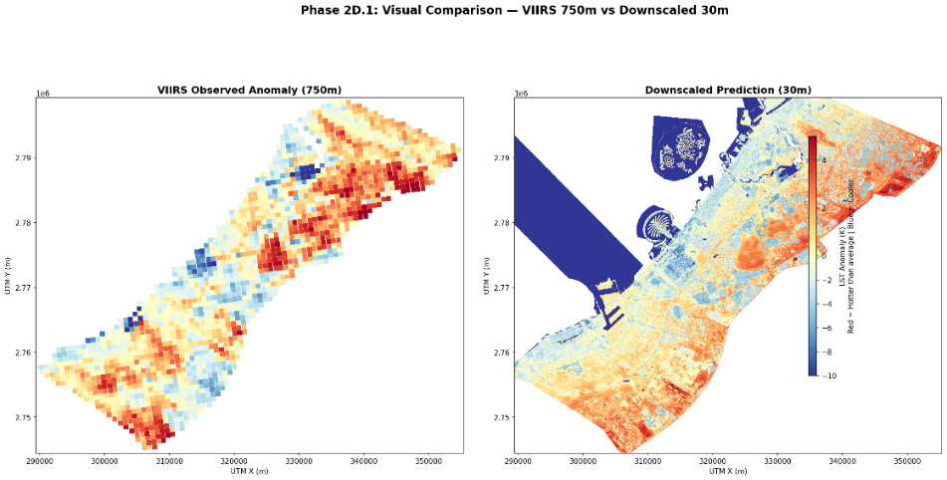
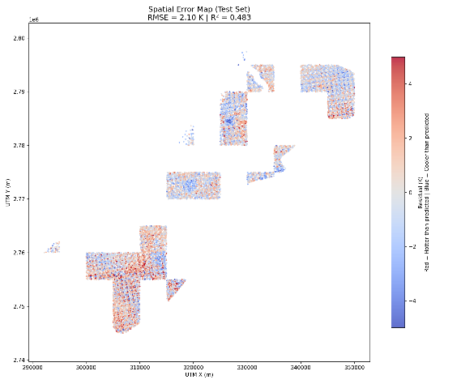
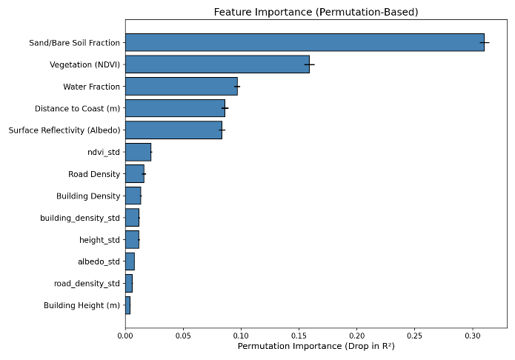
Figure 3. Visual comparison of VIIRS observed LST anomaly at 750 m (left) and the LightGBM downscaled prediction at 30 m (right) for the same afternoon overpass. At 750 m individual city blocks, road networks, and coastal features are indistinguishable; at 30 m the Palm Jumeirah, Dubai Creek, and individual urban districts are clearly resolved while broad spatial patterns remain consistent with the coarse-resolution source.
Figure 4. Permutation feature importance (afternoon model). Sand fraction and NDVI collectively account for ~49% of explained variance. Full partial dependence plots are in Appendix D. | Figure 5. Spatial residuals across afternoon test blocks (RMSE = 2.10 K, R² = 0.483). Errors are spatially random with no coherent geographic bias.

4.3 Backend API
The FastAPI application uses a lifespan context manager to load all three LightGBM models, 16 raster file handles (Additional 3 rasters are the anomalies across morning, afternoon and night), and three SHAP TreeExplainers into memory at startup, eliminating per-request I/O latency. Seven REST endpoints are exposed. The /api/communities endpoint returns the enriched GeoJSON for all 173 community polygons alongside global feature ranges used to normalise the frontend radar chart. The /api/tiles/{layer}/{z}/{x}/{y}.png endpoint serves dynamic XYZ Web Mercator tiles for any configured raster layer (both the three LST anomaly rasters and all 13 feature rasters) via rio-tiler with configurable colourmap and value range, enabling the frontend to overlay any model output or input feature on the interactive map. The /api/pixel endpoint samples all rasters at a clicked coordinate and returns the raw feature vector and LST anomalies for all three time slots. The /api/community/{comm_num}/pixels endpoint returns a GeoJSON FeatureCollection of all 30 m pixels within a selected community, enabling fine-grained community drill-down on the map.
The /api/shap endpoint computes exact SHAP values for a given location via the pre-loaded TreeExplainer and additionally generates a plain-language explanation sentence: for example, “This location is 3.2°C warmer than the city average. The primary factors are: open sand = 0.84 (heating by 2.1°C), vegetation cover = 0.02 (heating by 0.8°C)...” This natural language output requires no technical knowledge to interpret and is a key differentiator of DUHA from existing urban heat tools. The /api/predict endpoint runs an arbitrary feature vector through all three models, supporting single-pixel what-if queries. The /api/predict-batch endpoint powers the intervention simulator: for each modified pixel it calls recompute_std_for_batch(), which reads the actual 25×25 raster window around that pixel, substitutes the intervention’s target feature values for all modified pixels within that window, and recomputes the neighbourhood standard deviation before passing the updated feature vector to the model. This ensures _std features reflect the physical state of the modified neighbourhood rather than using stale cached values. The implementation is provided in Appendix E.

4.4 Frontend Decision Support System
The frontend is built with Next.js 16 and TypeScript on a Mapbox GL JS 3 base map, with Recharts for data visualisation. The user interaction is structured as a progressive drill-down: from city-wide community ranking, to community-level pixel mapping, to individual pixel inspection and finally to multi-pixel intervention simulation. On load, GET /api/communities fetches enriched GeoJSON for all 173 community polygons; HVI scores are computed client-side from the returned anomaly, population, and extreme-heat statistics, and rendered as a choropleth map. Selecting a community triggers GET /api/community/{id}/pixels, which returns a GeoJSON grid of all 30 m pixels within that polygon coloured by LST anomaly. Clicking any pixel fires two parallel requests - POST /api/pixel for the raw feature vector and anomalies, and POST /api/shap for SHAP values and the auto-generated plain-language explanation, which together populate the Pixel Inspector with a SHAP waterfall chart, radar chart, and vitals panel.
The intervention simulator activates on ‘Shift+Click’ on one or more pixels on the map. When pixels are added, the suggestion engine automatically calls POST /api/predict-batch for each eligible intervention template and surfaces the top three cooling candidates with predicted ΔT values, giving the planner an immediate sense of which intervention is most effective before any manual selection. Each of the six templates enforces physics-grounded eligibility guards: park installation and water feature require sand_mask_fraction == 0; cool roof, green roof, and cool road require the relevant built feature to be non-zero; new construction also requires sand_mask_fraction == 0 to prevent buildings from being placed on existing urban fabric. Target feature values are empirically grounded: the cool roof albedo target of 0.80 is sourced from a Dubai-specific energy simulation study (Solar Energy, 2024), and the park NDVI target of 0.3991 is computed from raster analysis of 56,332 existing park-type pixels within the study area.
On intervention submission, per-pixel predictions recolour the affected 3D blocks on the live map via Mapbox’s feature-state system without triggering a server-side tile re-render, providing immediate spatial feedback on the simulated temperature change. The budget estimator applies density-aware unit costs in AED per m², scaled by each pixel’s building footprint fraction, to produce a cumulative cost estimate across all selected pixels. The detailed intervention applied to all pixels can also be downloaded as a PDF, making it easier to share the intervention details and cost amongst team members within an organisation as well. The Layer Panel allows users to toggle any of the 7 feature rasters as map overlays on the interactive map.

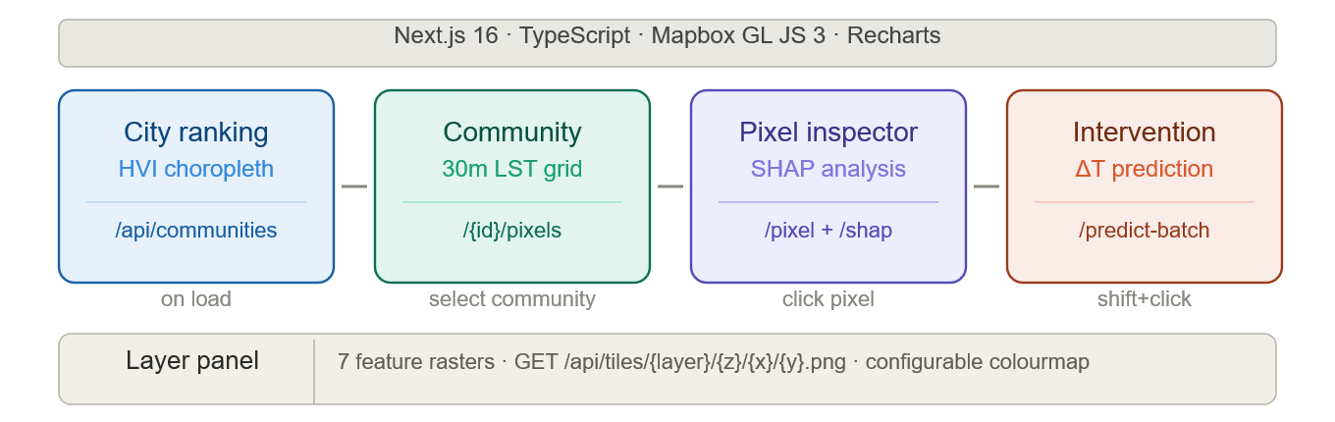
Figure 6. Progressive drill-down architecture of the DUHA web platform, from city-wide HVI ranking to community pixel mapping, pixel-level SHAP inspection, and intervention simulation.

5. Results and Conclusions

5.1 Model Performance
Table 3 summarises the final validation metrics across all three models. The Landsat morning model achieves R² = 0.920 and RMSE = 2.708 K evaluated against 7,586,713 pixels on a held-out spatial block test set, with a near-zero mean bias of +0.048 K, confirming no systematic over- or under-prediction across the city. The VIIRS models are validated via consistency checks, aggregating the 30 m prediction map back to 750 m and comparing against real VIIRS observations never seen during training. The afternoon model achieves R² = 0.520, RMSE = 2.055 K; the nighttime model achieves R² = 0.592, RMSE = 1.303 K. Both VIIRS results represent a 25:1 spatial downscaling (more aggressive than any published comparable study, which operate at 4:1 to 10:1) and should be interpreted as absolute performance on a novel task rather than relative to an established benchmark.

Table 3. Final validation metrics for all three DUHA LightGBM models.
Model | Validation | N | R² | RMSE | Bias | Pearson r
Landsat 10:30 AM | Block holdout (30 m native) | 7,586,713 | 0.920 | 2.708 K | +0.048 K | 0.959
VIIRS 1:30 PM | Consistency (30 m→750 m) | 39,693 | 0.520 | 2.055 K | −0.186 K | 0.732
VIIRS 1:30 AM | Consistency (30 m→750 m) | 35,968 | 0.592 | 1.303 K | −0.164 K | 0.785

5.2 Diurnal Thermal Inversion
The three anomaly maps (Figure 1) reveal a striking diurnal inversion specific to Dubai’s desert-urban context. At 10:30 AM, urban pixels sit near the scene mean (mean anomaly of 0.31 K) as solar loading has not yet differentiated urban and desert surfaces. By 1:30 PM, the surrounding desert sand superheats to much higher temperatures under peak irradiance, dragging the scene mean sharply upward while the urban core, shaded by buildings and cooled by irrigated vegetation, resists this heating, producing a city-wide afternoon anomaly of
-4.21 K: a pronounced Urban Cool Island. By 1:30 AM the pattern inverts: sand cools instantly while concrete and steel slowly re-radiate their stored heat, producing a nocturnal heat island of +0.81 K. The mean diurnal range of -5.02K reflects the average shift each urban pixel undergoes between its afternoon and nighttime anomaly state: pixels in the densest urban cores (most strongly cooled in the afternoon by building shade and irrigated vegetation) show the largest swing as the same thermal mass that resists daytime heating slowly re-radiates that energy through the night.

5.3 Feature Driver Shift Across the Diurnal Cycle
Figure 7 presents the permutation feature importance for all three models and reveals a physically coherent progression in the dominant thermal drivers across the day. At 10:30 AM, distance to coast accounts for approximately 44 % of the Landsat model’s explained variance when shuffled. The morning sea breeze from the Arabian Gulf is the overwhelmingly dominant thermal control, while all urban morphology features (building density, height, road density) show near-zero importance because concrete has not yet absorbed sufficient heat to differentiate itself. By 1:30 PM the driver shifts: sand fraction dominates (0.31 R² drop), followed by NDVI (0.16), water fraction (0.10), coast distance (0.09), and albedo (0.09). At peak solar irradiance, land cover composition determines which pixels heat most aggressively. By 1:30 AM a further shift occurs: albedo and sand fraction become co-dominant (~0.22 and ~0.23 respectively), NDVI comes to ~0.11, and building density and road density show measurable importance for the first time as twelve hours of solar loading activates their stored thermal mass. Coast distance importance decreases as, without sunlight, the sea breeze no longer exists. This progression from geography-controlled, to land-cover-controlled, to material-controlled thermal behaviour is the central mechanistic finding of the project.
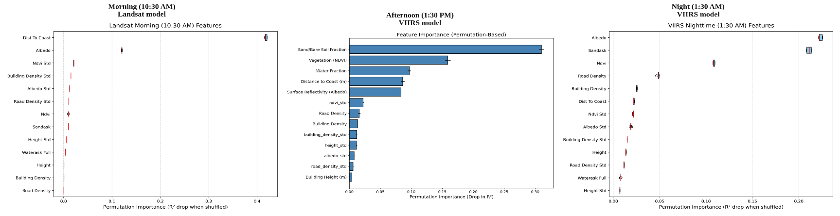
Figure 7. Permutation feature importance (R² drop when shuffled) for the Landsat morning model (left), VIIRS afternoon model (centre), and VIIRS nighttime model (right). The dominant driver shifts from coast distance at 10:30 AM, to sand fraction and NDVI at 1:30 PM, to albedo and sand co-dominance at 1:30 AM, reflecting the transition from sea-breeze control, to solar-loading control, to thermal-mass control.

5.4 Limitations, Planning Output and Future Directions
The models collectively explain 52–92% of spatial variance depending on the time slot. The remaining unexplained variance is attributable to dynamic variables absent from the static feature set: wind speed and direction, atmospheric humidity, HVAC waste heat etc. (Figure 8) confirms two specific failure modes in the afternoon model. Sandy pixels produce RMSE=2.171K (the highest of any land cover category) because at peak solar irradiance, desert sand superheats uniformly across large areas, and the spatial structure within sandy zones is weak, giving the model little to learn from. Near-coast pixels carry a consistent +0.067K warm bias because the depth to which the Gulf sea breeze penetrates inland varies daily with wind conditions, something a time-invariant distance raster cannot resolve.
Both limitations point to the same underlying gap: the absence of per-scene meteorological inputs. Incorporating ERA5 wind and humidity fields matched to each VIIRS overpass would directly address these residuals, though doing so reliably requires a scene-by-scene alignment pipeline that was beyond the scope of this project. A more sophisticated temporal extension would use domain adaptation techniques to train across multiple years while explicitly decorrelating the spatial land-cover signal from inter-annual weather variation. Naive pooling of additional years was tested and found to degrade consistency metrics, confirming that the binding constraint is signal separation rather than data volume.

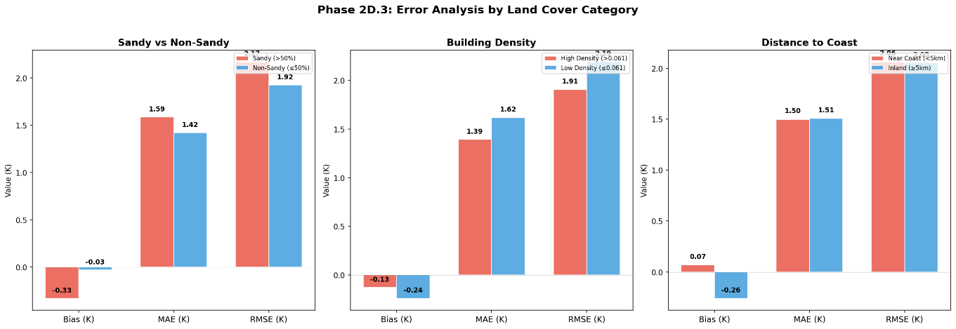

Figure 8. VIIRS afternoon error by land cover. Sandy R² = 0.257 reflects limited target variance, not inaccuracy. Near-coast bias = +0.067 K. Full table in Appendix B.

6. Main References
[1] Abunnasr, Y. and Mhawej, M. (2023) 'Fully automated land surface temperature downscaling based on RGB very high spatial resolution images', City and Environment Interactions, 19, p. 100110.
[2] Agam, N., Kustas, W.P., Anderson, M.C., Li, F. and Neale, C.M.U. (2007) 'A vegetation index based technique for spatial sharpening of thermal imagery', Remote Sensing of Environment, 107(4), pp. 545–558.
[3] Ebrahimy, H. and Azadbakht, M. (2019) 'Downscaling MODIS land surface temperature over a heterogeneous area: An investigation of machine learning techniques, feature selection, and impacts of mixed pixels', Computers & Geosciences, 124, pp. 93–102.
[4] Hoang, N.D., Tran, V.D. and Huynh, T.C. (2025) 'From Data to Insights: Modeling Urban Land Surface Temperature Using Geospatial Analysis and Interpretable Machine Learning', Sensors, 25(4), p. 1169.
[5] Kustas, W.P., Norman, J.M., Anderson, M.C. and French, A.N. (2003) 'Estimating subpixel surface temperatures and energy fluxes from the vegetation index–radiometric temperature relationship', Remote Sensing of Environment, 85(4), pp. 429–440.
[6] Roberts, D.R., Bahn, V., Ciuti, S., Boyce, M.S., Elith, J., Guillera-Arroita, G., Hauenstein, S., Lahoz-Monfort, J.J., Schröder, B., Thuiller, W., Warton, D.I., Wintle, B.A., Hartig, F. and Dormann, C.E. (2017) 'Cross-validation strategies for data with temporal, spatial, hierarchical, or phylogenetic structure', Ecography, 40(8), pp. 913–929.
[7] Tahooni, A., Kakroodi, A.A., Kiavarz, M. and Mansourian, H. (2025) 'High-resolution urban LST downscaling via machine learning and SHAP: A case study in a rapidly urbanizing semi-arid region', Sustainable Cities and Society, 134, p. 106897.
[8] Wang, R., Gao, W. and Peng, W. (2020) 'Downscale MODIS Land Surface Temperature Based on Three Different Models to Analyze Surface Urban Heat Island: A Case Study of Hangzhou', Remote Sensing, 12(13), p. 2134.

Appendix A (Statistical Consistency: VIIRS Afternoon Model)

The scatter plot below shows the statistical consistency check for the VIIRS afternoon model. The 30 m prediction map is aggregated back to 750 m by averaging 25×25 pixels per VIIRS cell, then compared against the original VIIRS LST anomaly observations (N = 39,693). The best-fit slope of 0.46 reflects regression to the mean, an expected consequence of predicting spatial sub-pixel structure from a 25:1 downscaling ratio. The near-zero bias (−0.186 K) confirms no systematic over- or under-prediction.
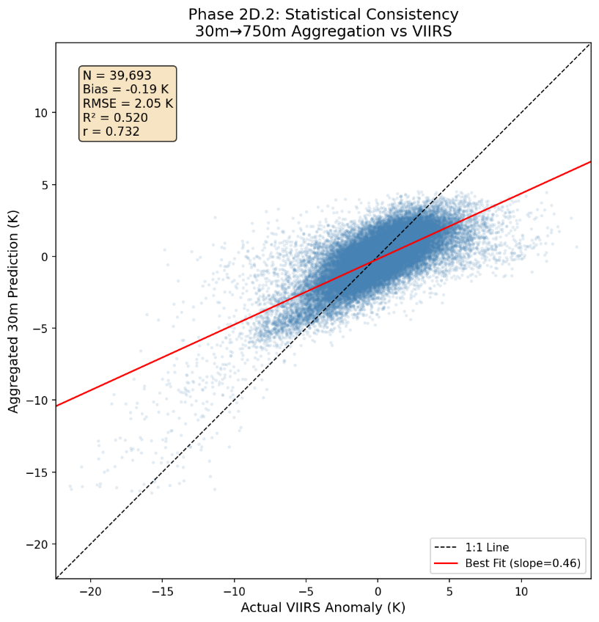

Appendix B (Stratified Error Analysis: VIIRS Afternoon Model)

Table B.1 provides the full per-category error metrics for the VIIRS afternoon model, stratified by land cover type and geographic proximity.

Category | N | Bias | MAE | RMSE | R²
Sandy (>50%) | 20,348 | −0.333 K | 1.586 K | 2.171 K | 0.257
Non-Sandy (≤50%) | 19,345 | −0.032 K | 1.420 K | 1.924 K | 0.591
High Density (>0.061) | 19,846 | −0.130 K | 1.392 K | 1.907 K | 0.481
Low Density (≤0.061) | 19,847 | −0.243 K | 1.619 K | 2.192 K | 0.523
Near Coast (<5 km) | 8,945 | +0.067 K | 1.498 K | 2.063 K | 0.508
Inland (≥5 km) | 30,748 | −0.260 K | 1.507 K | 2.052 K | 0.470
All metrics from the VIIRS afternoon consistency check (30 m→750 m aggregation vs real VIIRS observations). Density threshold = 0.061 (median).

Appendix C (Spatial Block Split Visualisation)

The map below shows the 5 km×5 km block assignment used for the Landsat morning model. Entire blocks are assigned to either the training or test set, ensuring that no test pixel shares a local neighbourhood with any training pixel within the same block. The test blocks span the full geographic extent of Dubai, from Jebel Ali in the southwest to Deira in the northeast.

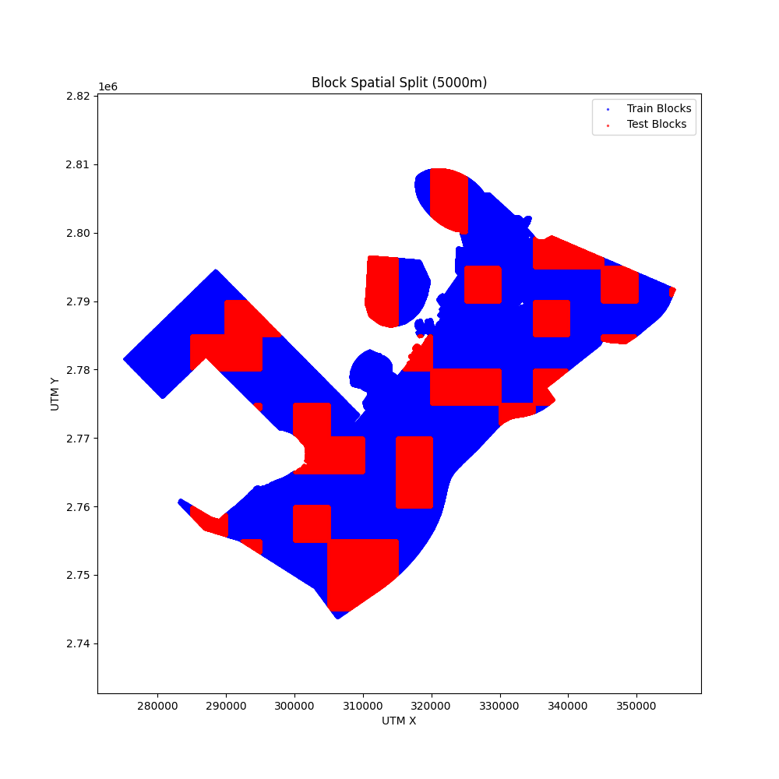

Appendix D (Partial Dependence Plots (Afternoon Model, All 13 Features))

Partial dependence plots show the marginal effect of each feature on the predicted afternoon LST anomaly, holding all other features at their mean values. Sand fraction shows a predominantly positive relationship while NDVI exerts a monotonically negative cooling effect across the full observed range (NDVI 0.02–0.14), with no clear saturation point. Distance to coast shows the strongest directional effect among the spatial features: pixels within approximately 10 km of the Arabian Gulf coastline are predicted measurably cooler, with the effect diminishing and plateauing beyond that distance. Albedo exhibits a broadly negative relationship, with higher-reflectivity surfaces associated with lower anomalies across the 0.33–0.55 range. Urban morphology features (building density, road density, height) show effects of smaller magnitude relative to land cover features, consistent with their lower permutation importance in the afternoon model, though building density (mean) does exhibit a negative relationship spanning approximately 0.45 K across its observed range.
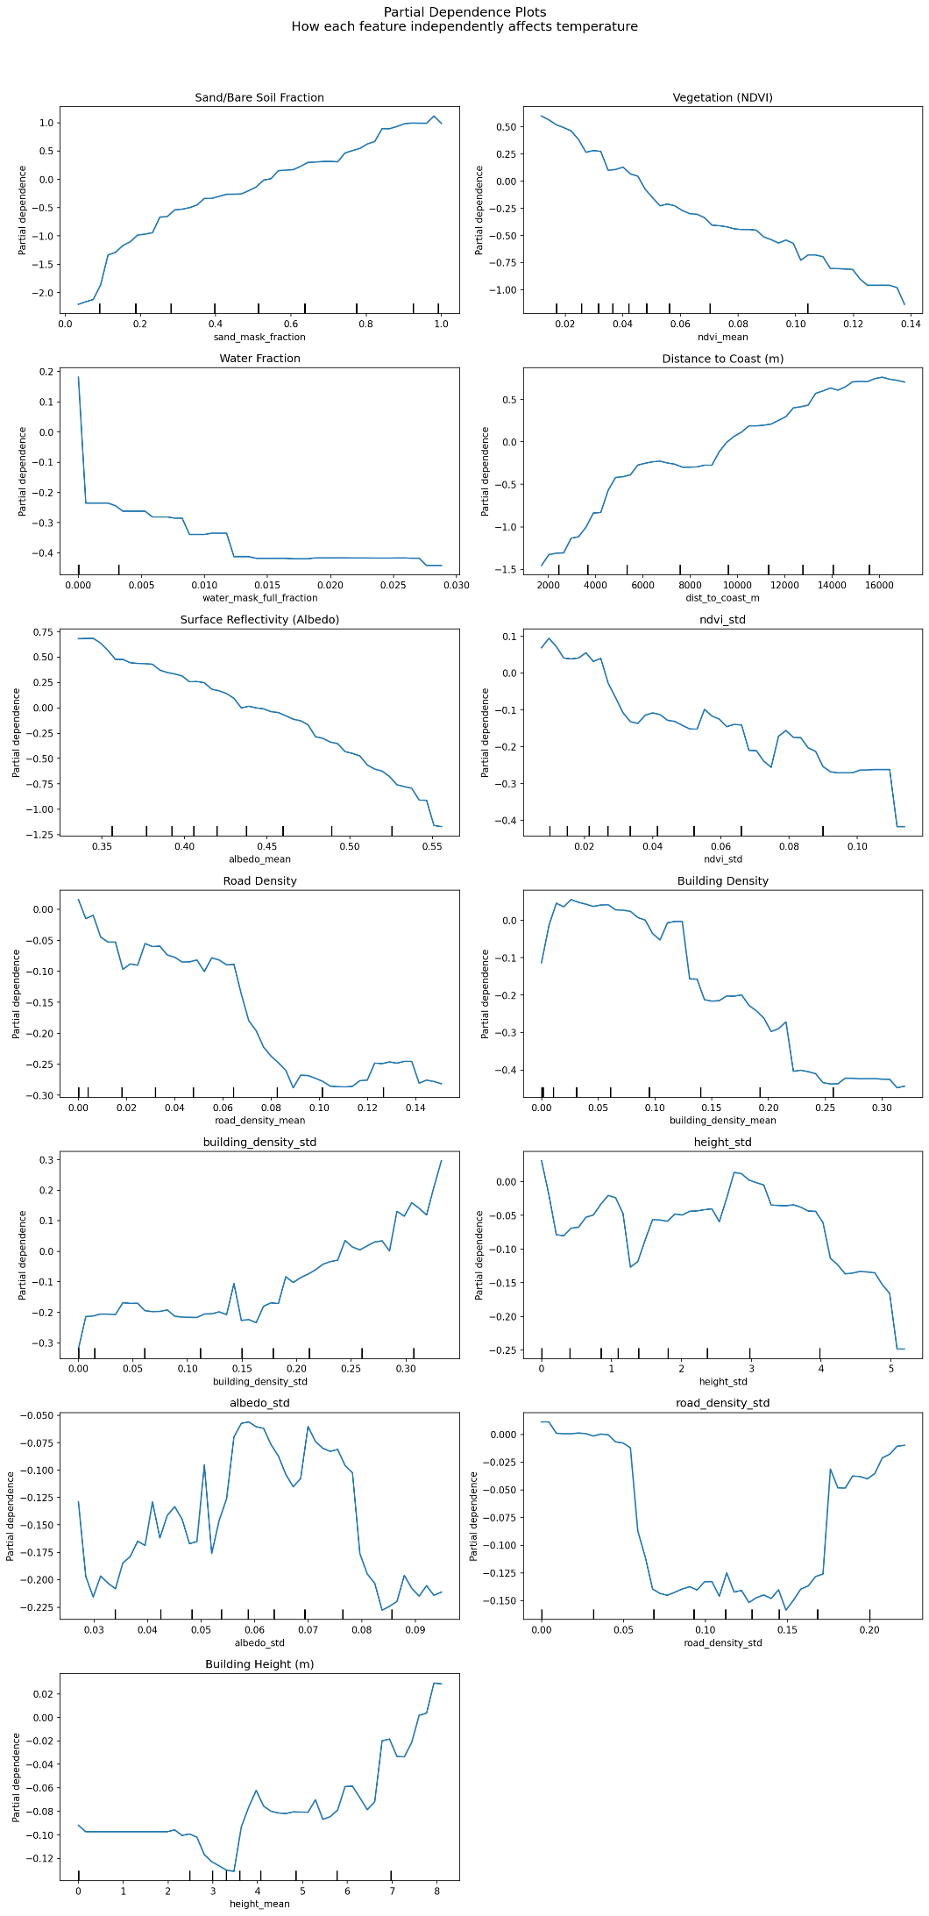

Appendix E (Code: recompute_std_for_batch())

The function below is called by the /api/predict-batch endpoint for every intervention prediction.

