FREIGHT INVOICE
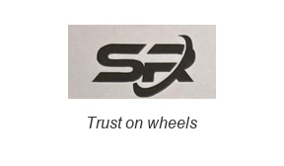
SR Trans and Trade India Private Limited
1-2-597/36 to 41, SVSS SANKALP Apts, C-303 LOWER TANK BUND, HYDERABAD-500 080
Phone No: +91 9704527762 Email:rudrajagan.b@gmail.com
M/S. {{customer_name}} GSTIN: {{gstin}}  {{customer_address_1}} STATE: {{customer_state}} |  |  |  |  |  |  |  |  |  |  | INVOICE NO: | {{invoice_number}}
 |  |  |  |  |  |  |  |  |  |  | DATE: | {{invoice_date}}
{{customer_address_2}} STATE CODE: {{customer_state_code}}

CONSIGNOR: {{consignor}} CONSIGNEE: {{consignee}}
ADDRESS: {{consignor_address}} ADDRESS: {{consignee_address}}
GSTIN: {{consignor_gstin}} STATE CODE: {{consignor_state_code}} GSTIN: STATE CODE: {{consignee_state_code}}
SL NO: | LR NO: | LR DATE | LOADING | UN-LOADING | DESCRIPTION | VEHICLE |  | WEIGHT | RATE | FREIGHT | OTHERS | TOTAL
 |  |  |  |  |  | NO. | No: of Bags
{{sl_no}} | {{lr_number}} | {{lr_date}} | {{loading_location}} | {{unloading_location}} | {{goods_description}} | {{vehicle_number}} | {{packages}} | {{weight}} | {{rate}} | {{freight}} | {{other_charges}} | {{total}}
Note: | Others include: {{remarks}} |  |  |  |  |  |  |  | GRAND TOTAL |  | ₹ {{grand_total}}
Amount Charged(in words): {{amount_in_words}}
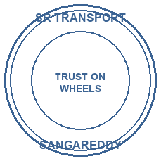
For SR Trans and Trade India Private Limited
PLEASE PAY BY RTGS/NEFT
PAN CARD: ELKPK3812H SAC CODE: 996511 Bank: Kotak Mahindra Bank
GSTIN: 36ELKPK3812H1ZP (GTA SERVICES) A/C NO: 1720252626
(EXEM_NOTF. 12/2017) Branch: Sarojini Devi Road Authorised Signatory
CIN: UDYAM-TS-25-0001670 IFS CODE: KKBK0007489
Udyam Certificate: UDYAM-TS-02-0048963
* GST under rcm is not applicable for outward expmted supply

(Interest @24%p.a will be charged on all outstanding bills)
E.& O.E (SUBJECT TO SANGAREDDY JURISDICTION) *THIS IS COMPUTER GENERATED BILL

