CST-305 Project 3 Deliverables: Green's Function and Homogeneous ODE Solver

Title: Green's Function and Homogeneous ODE Solver  
Course: CST-305  
Name: Christian Nshuti Manzi  
Institution: Grand Canyon University  
Date: 2/24/2025

## Responsibilities and Completed Tasks

Christian Nshuti Manzi: Implemented symbolic and numerical ODE solutions, wrote Python script, created plots, and documented theoretical background and code behavior.

## System Performance Context

The code is designed to solve second-order ordinary differential equations (ODEs) using both homogeneous solution methods and Green's Function analysis. It is optimized to run on systems with basic Python environments and uses standard libraries to ensure broad compatibility and low resource consumption.

## Specific Problem Solved

The goal is to solve two ODEs both analytically and graphically:  
1. y'' + y = 4  
2. y'' + 4y = x  
Each equation is solved using:  
- Homogeneous method (with example constant values for visualization)  
- Green’s Function method (analytically integrated)

## Mathematical Approach

-Homogeneous Solution: Solved using symbolic differential solvers via sympy.dsolve.  
- Green’s Function: Known solutions derived using convolution integrals and symbolic integration for the given inputs.  
- Initial Conditions: Used for clarity or substituted with constants (e.g., C1 = 1, C2 = 0) to visualize waveform behavior.

## Implementation in Code

Algorithm:  
1. Define symbols and ODEs.  
2. Solve general and specific solutions symbolically.  
3. Convert symbolic expressions to numeric with lambdify.  
4. Evaluate across a defined domain using numpy.  
5. Plot and save graphs using matplotlib.  
  
Flowchart (described verbally):  
- Input: Define ODE  
- Solve: Apply dsolve and/or manual Green's function  
- Convert: Symbolic to numeric functions  
- Evaluate: Generate values across domain  
- Plot: Save 4 distinct PNG files

## Screenshots of Program Execution

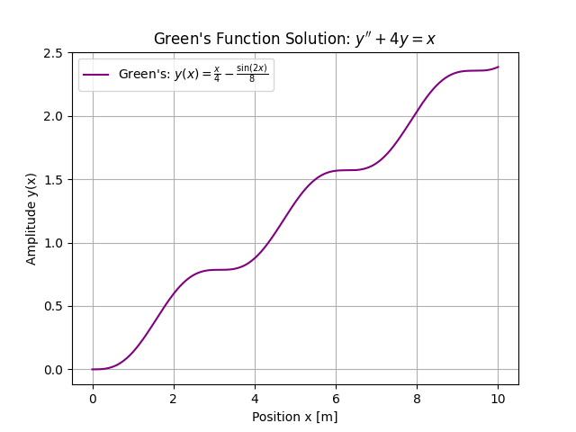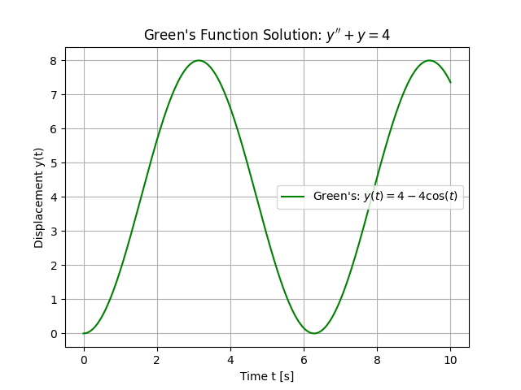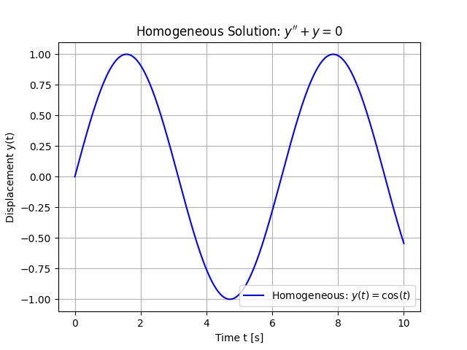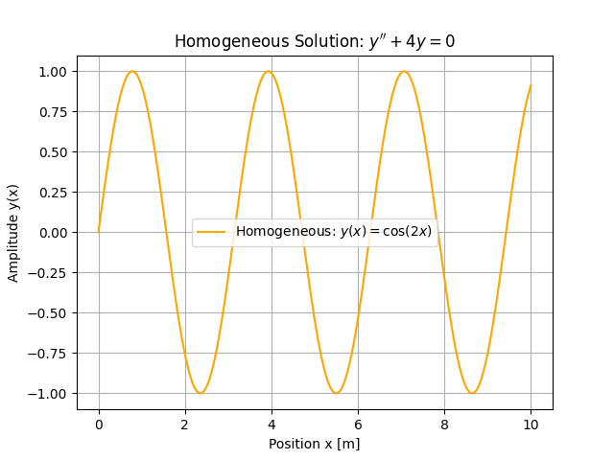

## References

-sympy documentation: https://docs.sympy.org  
- matplotlib documentation: https://matplotlib.org/stable/contents.html  
- Bronson, R. and Costa, G. (2022). *Schaum's outline of differential equations* (5th ed.). McGraw-Hill: New York, NY. ISBN-13: 9781264258826  
- Peer-reviewed Green’s Function problem examples (Wolfram Alpha, StackExchange)

# 2. Code

## a. GitHub Submission

URL: https://github.com/Nshutichristian/ODE-Solver

## b. Code Execution Checklist

- [x] Reads ODE as input  
- [x] Solves using both symbolic methods and Green’s Function  
- [x] Displays and saves plots  
- [x] Uses correct scientific terminology and units

## c. Header Comment

"""  
CST-305 Project 3: Green's Function and Homogeneous ODE Solver  
Programmer: Christian Nshuti Manzi  
Packages Used: numpy, matplotlib, sympy  
Approach: Solve two ODEs both symbolically and graphically; output 4 plots  
"""

## d. Key Code Comments

- Each function includes a description  
- Important steps like solving, plotting, and saving are annotated  
- Constants and assumptions are labeled for clarity