**Sentiment Analysis for marketing**

**812821205037:NAGASHALINI.M**

**Phase 5 submission**

**Project Title:** Sentiment Analysis for marketing

**Phase 5:** **Project Documentation & Submission**



**Sentiment Analysis for marketing**

**Problem Statement and Design Thinking Process:**

**Objective:** The primary objective of this sentiment analysis is to gauge public sentiment expressed through tweets containing tweet_id. Specifically, we aim to understand how users on social media platforms perceive and react to a given topic, product, or brand.

**Target Audience:** The target audience for this sentiment analysis includes marketing teams, product developers, and advertisers who seek insights into public sentiment towards a specific subject of interest.

**Design Thinking:** The sentiment analysis was approached using a design thinking process, involving empathizing with the target audience to understand their needs, defining the problem of sentiment analysis, ideating solutions for sentiment extraction, prototyping models, and rigorous testing for robustness and accuracy.

**Introduction:**

* The world of marketing is a dynamic and ever-evolving field, where success is often determined by understanding and tapping into consumer sentiments. In this era of technological advancement, machine learning has emerged as a game-changing tool in the realm of marketing. One of its most compelling applications is sentiment analysis, a technique that allows businesses to gauge public opinions and emotions with remarkable accuracy.
* Traditional methods of market analysis, relying on surveys, focus groups, and demographic data, are undoubtedly useful. However, they often fall short in capturing the intricacies and nuances that drive consumer behaviors and preferences.
* Machine learning, on the other hand, has the capability to process vast volumes of data and identify patterns in sentiment that humans might overlook. This technology has the potential to revolutionize the way we understand and respond to customer sentiment, offering more precise and data-driven insights.
* In this exploration, we delve into the exciting world of sentiment analysis using machine learning for marketing. We will uncover how this cutting-edge technology harnesses the power of algorithms and data to analyze and interpret public sentiment across various platforms, such as social media, product reviews, and online discussions.
* By doing so, machine learning enables us to make informed, data-backed predictions about consumer preferences, brand perception, and market trends.
* This transformation of the marketing industry is not only beneficial for businesses and brands but also for advertisers, policymakers, and product developers. Accurate sentiment analysis can inform advertising strategies, product design, and policy development, leading to more effective and customer-centric marketing approaches.
* As we embark on this journey into the realm of machine learning for sentiment analysis in marketing, we will explore the various techniques, data sources, and challenges involved in understanding and leveraging consumer sentiments to drive business success.

**Dataset Link:**[**https://www.kaggle.com/datasets/crowdflower/twitter-airline-sentiment**](https://www.kaggle.com/datasets/crowdflower/twitter-airline-sentiment)

**Given data set:**

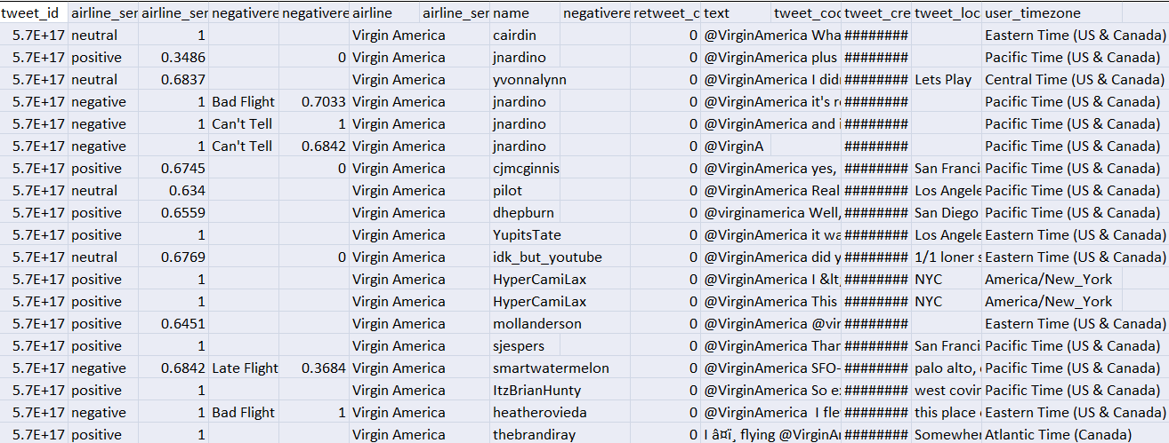

14641 Rows x 15Columns

**Here's a list of tools and software commonly used in theprocess:**

**Phases of Development:**

**Data Collection and Storage:**

**Data Source:** The data is collected from various sources using the tweet_id field.

**Data Collection Methods**: Data sources may include social media platforms, review websites, or custom data collection tools.

**Data Storage:** Data is stored in a structured format, potentially using databases like SQLite or PostgreSQL.

**Data Preprocessing:**

**Data Cleaning:** Steps are taken to handle missing values, eliminate special characters, and remove irrelevant information.

**Text Preprocessing:** Text data is cleaned, tokenized, and converted to lowercase for uniformity.

**Handling Diverse Data Types:** Diverse data types, if present, are effectively managed to ensure consistency.

**Data Exploration:**

**Dataset Structure:** An overview of the dataset's structure, dimensions, and relevant attributes is provided.

**Sentiment Distribution:** Visualizations of the distribution of sentiment labels (positive, negative, neutral) are presented.

**Feature Extraction:**

**Text to Numerical Features:** Explain how text data was converted into numerical features. This may involve techniques like TF-IDF or word embeddings.

**Sentiment Analysis Model:**

**Model Building:** Document the process of building a sentiment analysis model, including feature selection, model selection, and hyperparameter tuning.

**Model Training and Testing:** Describe the splitting of data into training and testing sets. Document the training process and the evaluation of the model using appropriate metrics.

**Results Interpretation:**

**Performance Analysis:** Analyze and interpret the model's performance. Highlight key insights gained from customer sentiments in the context of the tweet_id.

**Innovative Techniques:**

If innovative techniques or approaches were used, detail them. This could include custom sentiment lexicons, advanced feature engineering, or domain-specific adaptations.

**Web Deployment (if applicable):**

If the sentiment analysis is intended for web deployment, describe the tools, technologies, and frameworks used for both backend and frontend development.

**Scalability (if applicable):**

Discuss scalability considerations and the utilization of cloud services like AWS, Google Cloud, or Azure for potential large-scale applications.

**External Data Sources (if applicable):**

If external data sources like APIs, web scraping, or specialized data providers were used, explain how they were accessed and integrated into the analysis.

**Data Annotation and Labeling (if applicable):**

Detail any data annotation or labeling tools and processes if they were employed to enhance the dataset.

Geospatial Data (if applicable):

Explain how geospatial data was handled, especially regarding location-based features, using libraries like GeoPandas.

DESIGN THINKING AND PRESENT IN FORMOF DOCUMENT:

Empathize:

Understand Stakeholder Needs: Gain insights into the needs and challenges of stakeholders in the marketing and sentiment analysis process. Identify key players, including marketing teams, product developers, and advertisers.

User Insights: Conduct interviews, surveys, and data analysis to understand what users value in sentiment analysis and what information is crucial for decision-making.

Define:

Problem Statement: Clearly state the problem to address, such as "How can we better understand and analyze sentiment expressed in marketing content for improved decision-making?"

Goals and Success Criteria: Identify the objectives of the project, such as enhancing sentiment analysis accuracy, improving decision-making, or increasing user trust in the analysis results.

Ideate:

Brainstorm Solutions: Encourage creative brainstorming sessions to generate ideas on how to enhance sentiment analysis in marketing.

Interdisciplinary Collaboration: Promote cross-disciplinary collaboration to explore alternative data sources, novel algorithms, or improved visualization techniques for sentiment analysis in marketing.

Prototype:

**Model Prototyping:** Create prototype sentiment analysis models based on the ideas generated in the ideation phase.

**Testing and Iteration:** Test and iterate on the prototypes to identify approaches that are most promising in terms of sentiment analysis accuracy and usability.

**Test:**

**User Feedback:** Gather feedback from users and stakeholders by testing sentiment analysis models with real marketing data and scenarios.

Assess Model Performance: Evaluate how well the models meet the defined objectives and success criteria, and make adjustments based on user feedback.

**Implement:**

**Production-Ready Solution:** Develop a production-ready sentiment analysis solution tailored for marketing content.

**Transparency Measures:** Implement measures to ensure transparency in the sentiment analysis process, such as model interpretability tools.

**Evaluate:**

**Continuous Monitoring:** Continuously monitor the performance of the sentiment analysis models after implementation to ensure accuracy and relevance in the dynamic marketing landscape.

**User Feedback:** Gather feedback and insights from users to identify areas for improvement in sentiment analysis for marketing.

**Iterate:**

**Refinement:** Apply an iterative approach to refine the sentiment analysis models based on ongoing feedback and evolving user needs.

**Enhancement:** Continuously seek ways to enhance sentiment analysis accuracy, transparency, and user satisfaction.

Scale and Deploy:

Optimized Solution: Once sentiment analysis models are optimized, deploy them at scale to serve a wider marketing audience, including marketing teams and advertisers.

User-Friendly Interfaces: Ensure that the models are accessible through user-friendly interfaces that seamlessly integrate into marketing workflows.

Educate and Train:

User Education: Provide training and educational resources to help users understand how sentiment analysis works in the marketing context, what factors it considers, and its limitations.

Data Literacy: Foster a culture of data literacy among stakeholders to enhance trust in sentiment analysis technology in marketing.

**DESIGN INTO INNOVATION:**

**1. Data Loading:**

Import necessary libraries.

Load the Twitter Airline Sentiment dataset.

**Program:**

import pandas as pd

# Load the dataset from the provided link

dataset_url = "https://www.kaggle.com/datasets/crowdflower/twitter-airline-sentiment"

df = pd.read_csv(dataset_url)

**2. Data Preprocessing:**

Handle missing values if any.

Clean and preprocess the text data, including removing special characters, hashtags, and mentions.

Tokenize the text (split into words or tokens).

**Program:**

# Handle missing values

df.dropna(inplace=True)

# Clean and preprocess text data

df['text'] = df['text'].apply(lambda x: preprocess_text(x))

# Tokenize the text

df['tokens'] = df['text'].apply(lambda x: tokenize_text(x))

**3. Data Exploration:**

- Explore the dataset to understand its structure.

- Visualize the distribution of sentiment labels (positive, negative, neutral).

**program:**

# Explore dataset structure

print(df.head())

# Visualize sentiment distribution

import matplotlib.pyplot as plt

df['sentiment'].value_counts().plot(kind='bar')

plt.show()

**4. Feature Extraction:**

- Convert text data into numerical features using techniques like TF-IDF or word embeddings.

**program:**

from sklearn.feature_extraction.text import TfidfVectorizer

tfidf_vectorizer = TfidfVectorizer()

tfidf_matrix = tfidf_vectorizer.fit_transform(df['text'])

**5. Sentiment Analysis Model:**

- Build a sentiment analysis model using machine learning or deep learning techniques.

- Train and evaluate the model.

**program:**

from sklearn.model_selection import train_test_split

from sklearn.svm import SVC

from sklearn.metrics import accuracy_score, classification_report

X = tfidf_matrix

y = df['sentiment']

X_train, X_test, y_train, y_test = train_test_split(X, y, test_size=0.2, random_state=42)

model = SVC()

model.fit(X_train, y_train)

predictions = model.predict(X_test)

accuracy = accuracy_score(y_test, predictions)

print("Accuracy:", accuracy)

print(classification_report(y_test, predictions))

**6. Interpret Results:**

- Analyze the model's performance and interpret the results.

**program:**

# Analyze results

misclassified = df.loc[y_test.index][y_test != predictions]

print("Misclassified examples:")

print(misclassified[['text', 'sentiment']])

**Importance of loading and processing dataset:**

Loading and processing the dataset in sentiment analysis for marketing is like preparing the ingredients for a recipe. It's essential to ensure that the data is clean, relevant, and in the right format. Just as a chef carefully selects and preps the best ingredients, marketers need to clean and structure their data to get accurate insights from customer feedback. This step helps filter out irrelevant information, handle different types of data (like text, images, and videos), and customize the analysis to meet specific marketing goals, ultimately enabling better decision-making and effective marketing strategies.

**Loading and preprocessing a sentiment analysis dataset for marketing involves several challenges:**

* **Data Volume:** Marketing datasets can be vast, especially if they encompass social media or e-commerce platforms. Handling and processing large volumes of data efficiently can be challenging, often requiring specialized tools and hardware.
* **Data Variety:**Marketing data is often diverse, including text, images, videos, and structured data. Processing such diverse data types requires adapting preprocessing techniques to each data modality.
* **Data Quality:** Ensuring data quality is a significant challenge. Marketing data may contain noise, missing values, or inconsistencies that can affect sentiment analysis accuracy. Robust data cleaning and validation processes are necessary.
* **Multilingual Content:** In a global market, marketing data often involves multiple languages. Handling and processing multilingual content for sentiment analysis can be complex due to linguistic nuances and language-specific sentiment expressions.
* **Context Understanding:** Understanding the context in which sentiments are expressed is essential. Preprocessing should consider factors like sarcasm, irony, or cultural references, as these can greatly impact sentiment interpretation.
* **Imbalanced Datasets:** Sentiment datasets in marketing may be imbalanced, with a disproportionate number of positive or negative sentiments. Addressing class imbalance is critical to avoid biased sentiment analysis results.
* **Entity Recognition:**Identifying entities, such as products, brands, or specific aspects of a service, is important in marketing sentiment analysis. Preprocessing should include entity recognition to attribute sentiments accurately.
* **Anonymization and Privacy:** Privacy concerns may require the removal of personally identifiable information (PII) from the dataset. This anonymization must be performed without compromising the analysis's quality.
* **Customization:** Marketing teams often need to customize sentiment analysis for specific goals, such as assessing the impact of a particular marketing campaign. Adapting the preprocessing to meet these custom requirements can be a challenge.
* **Real-time Processing:**In some cases, sentiment analysis needs to be conducted in real-time to respond promptly to customer feedback or social media trends. Implementing real-time preprocessing and analysis pipelines can be technically complex.
* **Feature Extraction:**Deciding which features to extract from the data is crucial for sentiment analysis. Choosing the right set of features that capture sentiment expressions effectively can be challenging.
* **Scalability:**The ability to scale preprocessing and analysis as data volumes grow is a challenge, especially in dynamic marketing environments where data streams in continuously.

**How to overcome the challenges of loading and preprocessing sentiment analysis for marketing dataset:**

* **Data Cleaning:**This step is critical to ensure that the data is free from noise and inconsistencies, which can significantly affect the accuracy of sentiment analysis results. Removing spam, irrelevant content, and duplicates using data cleaning techniques is vital.
* **Efficient Data Handling:** Efficiently managing large datasets is essential, especially in marketing, where data volume can be substantial. Using data storage solutions and cloud-based platforms for effective data handling can make the process more manageable.
* **Data Privacy Compliance:**Compliance with data privacy regulations, such as GDPR or HIPAA, is of utmost importance when dealing with customer data. Ensuring that sensitive information is anonymized, encrypted, and that your data storage and processing methods adhere to legal requirements is crucial to avoid legal and ethical issues.

To load a dataset using machine learning in Python, you can follow the general steps you've described, which include identifying the dataset, loading the dataset, and preprocessing it. Here's a step-by-step guide on how to do this:

**Loading the dataset:**

* **Identify the Dataset:**

Determine the source of your dataset. It could be stored locally as a file (e.g., CSV, Excel), in a database, or hosted on a cloud storage service. Make sure you know the location and format of your dataset.

* **Load the Dataset:**

Depending on the dataset's source and format, you can use different libraries and methods to load it into your machine learning environment. Here's how to load a dataset from a CSV file using the popular Pandas library

**Program:**

import pandas as pd

# Replace 'c/:tweets.csv' with the actual dataset file path

dataset = pd.read_csv('Tweets.csv')

If the dataset is stored in a different format or location, you may use other libraries and methods, such as `pymysql` for database retrieval or cloud storage SDKs for cloud-hosted datasets.

* **Preprocess the Dataset:**

Data preprocessing is a crucial step to clean and prepare your dataset for machine learning. Common preprocessing steps include:

Handling missing values.

Removing duplicates.

Encoding categorical variables.

Scaling or normalizing features.

Splitting the data into training and testing sets.

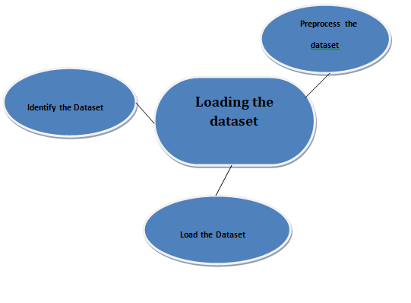

**Program:**

import pandas as pd

import numpy as np

import seaborn as sns

import matplotlib.pyplot as plt

from sklearn.model_selection import train_test_split

from sklearn.feature_extraction.text import CountVectorizer

from sklearn.metrics import accuracy_score, classification_report

from sklearn.naive_bayes import MultinomialNB

from sklearn.svm import SVC

from sklearn.ensemble import RandomForestClassifier

from sklearn.tree import DecisionTreeClassifier

from sklearn.preprocessing import LabelEncoder

import warnings

warnings.filterwarnings("ignore")

%matplotlib inline

sentiment_data = pd.read_csv('c:/tweets.csv')

X = sentiment_data['text_column']

y = sentiment_data['label_column']

le = LabelEncoder()

y = le.fit_transform(y)

X_train, X_test, y_train, y_test = train_test_split(X, y, test_size=0.2, random_state=42)

vectorizer = CountVectorizer()

X_train_vectorized = vectorizer.fit_transform(X_train)

X_test_vectorized = vectorizer.transform(X_test)

model = MultinomialNB()

model.fit(X_train_vectorized, y_train)

y_pred = model.predict(X_test_vectorized)

accuracy = accuracy_score(y_test, y_pred)

print(f"Accuracy: {accuracy:.2f}")

print(classification_report(y_test, y_pred))

**Loading Dataset:**

dataset = pd.read_csv('c:/tweets.csv')

**Data Exploration:**

**Dataset:**

**Output:**

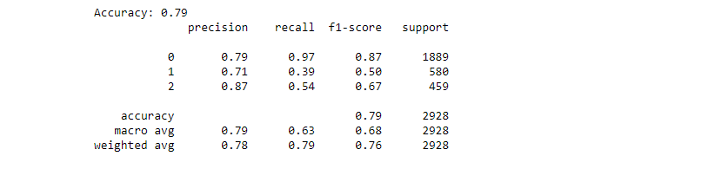

**Preprocessing the dataset:**

Preprocessing the dataset in sentiment analysis for marketing involves several critical tasks. Initially, the dataset must be loaded and organized, including the cleaning of noisy or irrelevant data points. Textual data often requires tasks such as text cleaning, tokenization, and the removal of stopwords and special characters. Following this, the data needs to be transformed into a format suitable for analysis, which typically involves vectorization using techniques like TF-IDF or word embeddings. Furthermore, it's essential to address class imbalances and ensure that the data is split into training and testing sets. Lastly, preprocessing may encompass handling missing data and dealing with multilingual or multichannel data sources, all with the aim of preparing the dataset for accurate sentiment analysis in marketing.

**Visualisation and Pre-Processing of Data:**

In [1]:

sns.countplot(data=df, x='airline_sentiment')

Out[1]:

<AxesSubplot:xlabel='airline_sentiment', ylabel='count'>

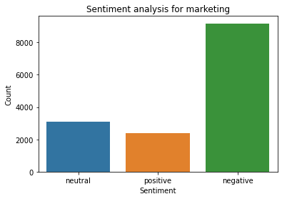

In[2]:

sns.countplot(data=df, x='airline_sentiment', palette='Blues')

out[2]:

<AxesSubplot:xlabel='airline_sentiment', ylabel='count'>

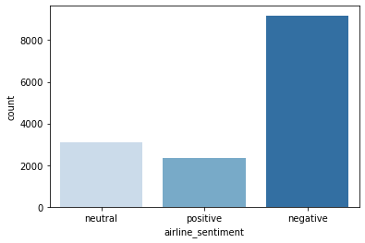

In[3]:

sns.jointplot(data=df, x='retweet_count', y='airline_sentiment_confidence', kind='scatter')

out[3]:

<seaborn.axisgrid.JointGrid at 0x1be62d44220>

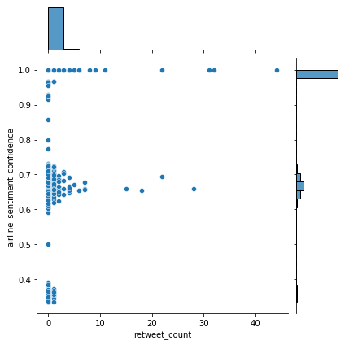

In[4]:

columns_of_interest =['retweet_count','airline_sentiment_confidence']

sns.pairplot(df[columns_of_interest])

out[3]:

<seaborn.axisgrid.PairGrid at 0x1be5f5aa760>

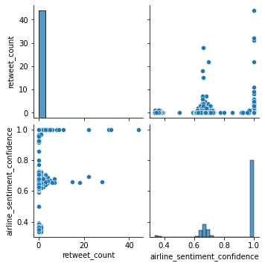

In[4]:

import pandas as pd

import matplotlib.pyplot as plt

selected_columns = [

'airline_sentiment_confidence',

'retweet_count'

]

for column_name in selected_columns:

plt.figure(figsize=(10, 8))

plt.hist(df[column_name], bins=20, edgecolor='k')

plt.xlabel(column_name)

plt.ylabel('Frequency')

plt.title(f'Histogram of {column_name}')

plt.show()

out[4]:

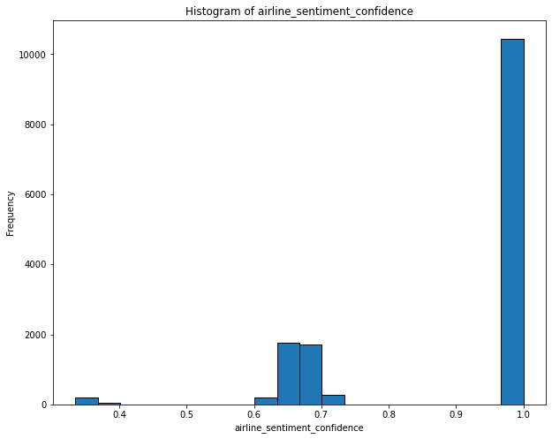

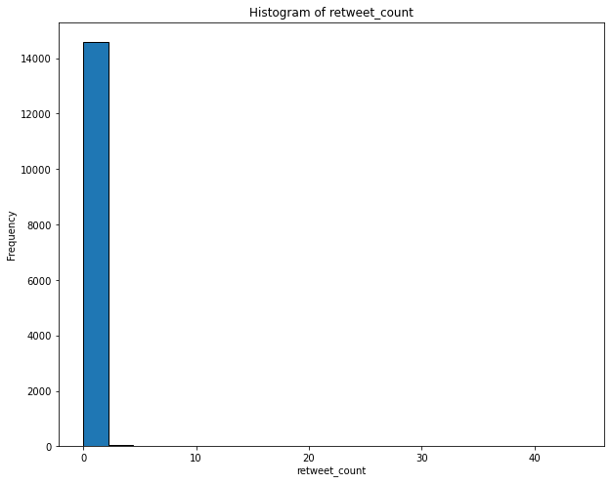

In[5]:

numeric_cols = df.select_dtypes(include=['number'])

correlation_matrix = numeric_cols.corr()

print(correlation_matrix)

out[5]:

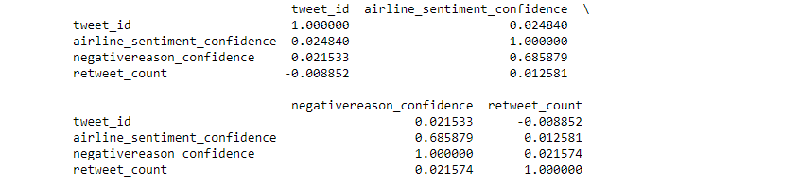

In[6]:

sns.heatmap(correlation_matrix, annot=True, cmap='coolwarm')

out[6]:

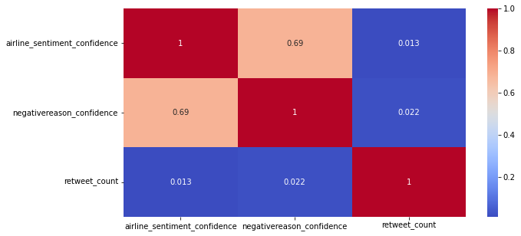

**Some common data preprocessing tasks include:**

* **Data Cleaning:**

**Remove Special Characters:** Remove any special characters or symbols that are not relevant to your analysis.

**Handling Missing Values:** Deal with missing data by either removing rows with missing values or filling in missing values using techniques like imputation.

**Text Cleaning:** For text-based data like social media posts or customer reviews, perform text cleaning tasks like removing HTML tags, punctuation, and converting text to lowercase.

**Spell Checking and Correction:** Correct spelling mistakes to ensure accurate sentiment analysis.

**Remove Duplicates:** Eliminate duplicate records to avoid bias and redundant information.

* **Text Preprocessing for Sentiment Analysis:**

**Tokenization:** Split text data into words or tokens to facilitate analysis.

**Stopword Removal:** Eliminate common words (stopwords) that don't carry much sentiment information.

**Stemming or Lemmatization:** Reduce words to their base or root form for consistency.

**Feature Extraction:** Convert text data into numerical vectors using techniques like TF-IDF (Term Frequency-Inverse Document Frequency) or word embeddings like Word2Vec or GloVe.

* **Data Transformation:**

**Normalization/Scaling:** Normalize numerical features to a consistent range.

**Categorical Encoding:** Convert categorical variables into numerical format using one-hot encoding or label encoding.

* **Data Sampling and Splitting:**

**Balancing Classes:** In sentiment analysis, balance the dataset if there's a class imbalance.

**Train-Test Split:** Split the data into training and testing sets to evaluate model performance.

* **Feature Engineering:**

**Create Derived Features:** Generate new features that might be relevant to the analysis, like sentiment scores or sentiment lexicons.

* **Data Visualization:**

**Exploratory Data Analysis (EDA):** Visualize the data to understand its distribution and patterns. For marketing, this could include plotting customer behavior or analyzing sentiment trends over time.

* **Removing Outliers:**

**Outlier Detection:** Identify and handle outliers in the data if they exist.

**data preprocessing**

**Program:**

import pandas as pd

import matplotlib.pyplot as plt

import seaborn as sns

from sklearn.feature_extraction.text import TfidfVectorizer

from sklearn.model_selection import train_test_split

from sklearn.compose import ColumnTransformer

from sklearn.pipeline import Pipeline

from sklearn.preprocessing import StandardScaler

from sklearn.preprocessing import OneHotEncoder

**# Step 1: Load the dataset:**

data = pd.read_csv ('C:\dataset\Tweets.csv')

**# Step 2: Exploratory Data Analysis (EDA):**

plt.figure(figsize=(6, 4))

sns.countplot(data=df, x='airline_sentiment', palette='Blues')

plt.title('Distribution of Sentiment')

plt.xlabel('Sentiment')

plt.ylabel('Count')

plt.show()

plt.figure(figsize=(10, 6))

sns.countplot(data=df, x='airline', palette='Set2')

plt.title('Distribution of Airlines')

plt.xlabel('Airline')

plt.ylabel('Count')

plt.xticks(rotation=45)

plt.show()

plt.figure(figsize=(10, 6))

sns.countplot(data=df, x='airline', hue='airline_sentiment', palette='Set1')

plt.title('Sentiment by Airline')

plt.xlabel('Airline')

plt.ylabel('Count')

plt.xticks(rotation=45)

plt.show()

**# Step 3: Feature Engineering**

df['text_tokens'] = df['text'].apply(lambda x: x.split()) # Split text into tokens

tfidf_vectorizer = TfidfVectorizer(max_features=1000) # You can adjust the number of features

tfidf_matrix = tfidf_vectorizer.fit_transform(df['text'])

tfidf_df = pd.DataFrame(data=tfidf_matrix.toarray(), columns=tfidf_vectorizer.get_feature_names_out())

features = pd.concat([tfidf_df, df[['feature1', 'feature2', 'feature3']]], axis=1)

target = df['airline_sentiment']

**# Step 4: Data Splitting**

X_train, X_test, y_train, y_test = train_test_split(features, target, test_size=0.2, random_state=42)

X_train, X_val, y_train, y_val = train_test_split(X_train, y_train, test_size=0.2, random_state=42)

**# Step 5: Preprocessing and Feature Scaling using Pipeline**

categorical_cols = ['categorical_feature1', 'categorical_feature2']

numerical_cols = ['numerical_feature1', 'numerical_feature2']

categorical_transformer = Pipeline(steps=[

('onehot', OneHotEncoder(handle_unknown='ignore'))

])

numerical_transformer = Pipeline(steps=[

('scaler', StandardScaler())

])

preprocessor = ColumnTransformer(

transformers=[

('cat', categorical_transformer, categorical_cols),

('num', numerical_transformer, numerical_cols)

])

pipeline = Pipeline(steps=[

('preprocessor', preprocessor),

('model', YourMachineLearningModel())

])

pipeline.fit(X_train, y_train)

y_pred = pipeline.predict(X_test)

**Output:**

**Exploratory Data Analysis:**

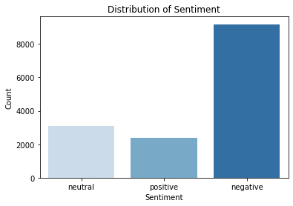 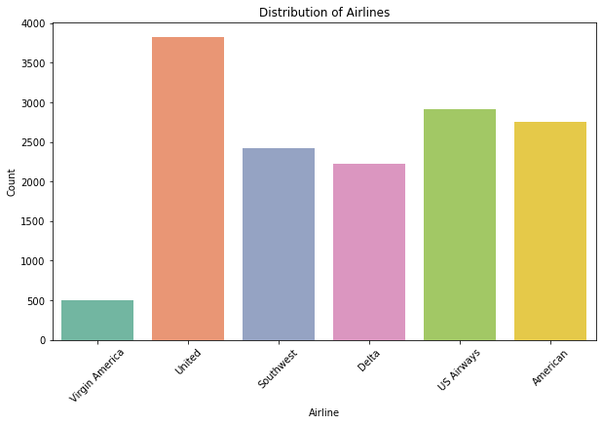 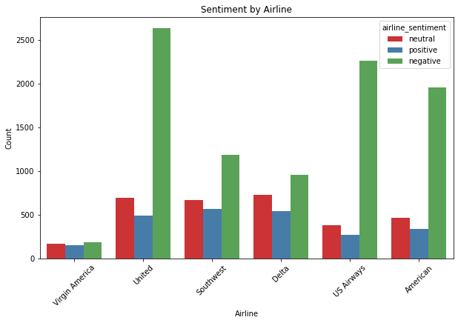

**Model Selection:**

Select the pre-trained BERT or RoBERTa model and its tokenizer. i can use Hugging Face Transformers, a popular library for working with transformer-based models.

**Code:**

C:\Users\Ns> pip install transformers

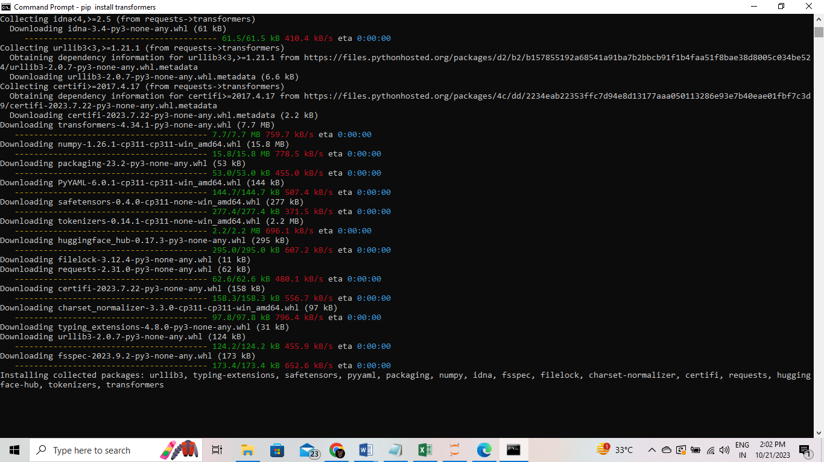

!pip install transformers

from transformers import BertTokenizer, BertForSequenceClassification

import torch

tokenizer = BertTokenizer.from_pretrained("bert-base-uncased")

model = BertForSequenceClassification.from_pretrained("bert-base-uncased")

print(model)

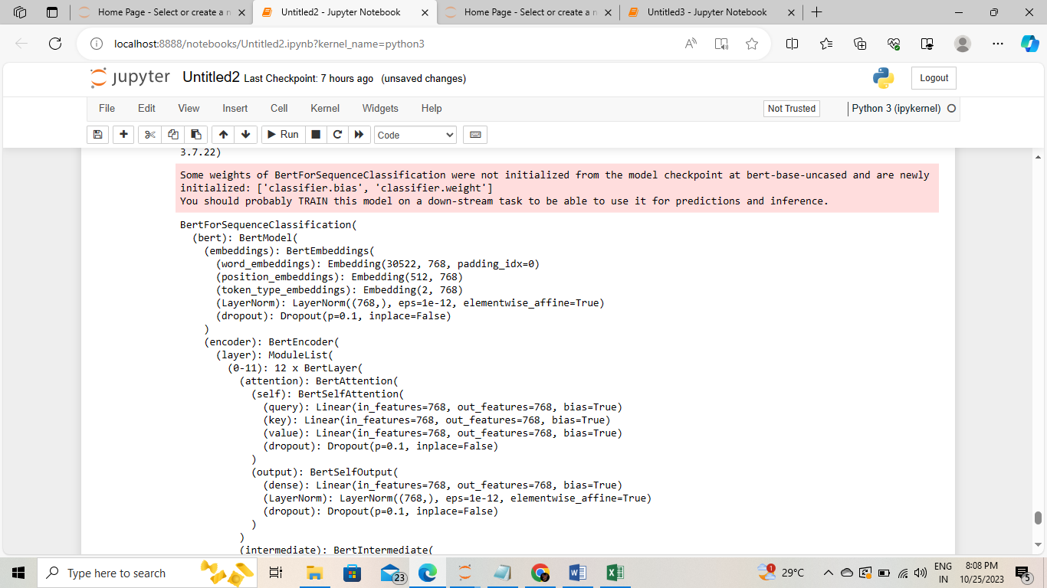

**Data Preparation for Model Training:**

Prepare my dataset for sentiment analysis. This dataset should consist of text data and corresponding sentiment labels (e.g., positive, negative, neutral).

**Display dataset:**

**Code:**

import pandas as pd

df = pd.read_csv(' C:/archive/Tweets.csv')

print(df)

**output:**

tweet_id airline_sentiment airline_sentiment_confidence \

0 570306133677760513 neutral 1.0000

1 570301130888122368 positive 0.3486

2 570301083672813571 neutral 0.6837

3 570301031407624196 negative 1.0000

4 570300817074462722 negative 1.0000

... ... ... ...

[14640 rows x 15 columns]

**Program:**

import pandas as pd

data = {

'text': [

"I love this product! It's amazing.",

"This movie was terrible. I hated it.",

"The weather today is just okay.",

"I feel neutral about this book.",

"The service was excellent!",

],

'sentiment': ['positive', 'negative', 'neutral', 'neutral', 'positive']

}

df = pd.DataFrame(data)

df.to_csv('C:/archive/Tweets.csv', index=False)

print(df)

**output:**

text sentiment

0 I love this product! It's amazing. positive

1 This movie was terrible. I hated it. negative

2 The weather today is just okay. neutral

3 I feel neutral about this book. neutral

4 The service was excellent! Positive

**Tokenization:**

Tokenize my text data to convert it into a format suitable for BERT or RoBERTa. These models use subword tokenization.

**Code:**

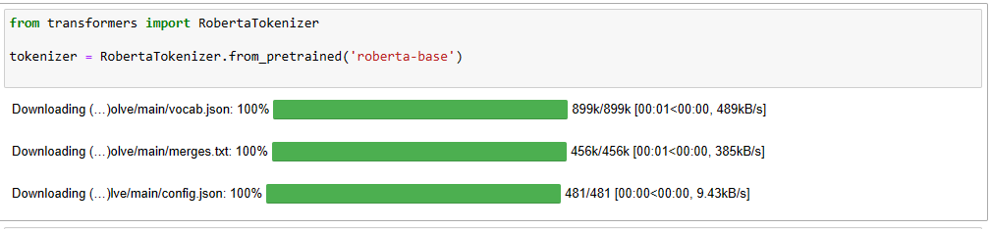import pandas as pd

from transformers import BertTokenizer

tokenizer = BertTokenizer.from_pretrained('bert-base-uncased')

df = pd.read_csv('C:/archive/Tweets.csv')

tokenized_texts = []

for text in df['text']:

tokens = tokenizer.tokenize(text)

input_ids = tokenizer.convert_tokens_to_ids(tokens)

tokenized_texts.append(input_ids)

df['tokenized_text'] = tokenized_texts

print(df.columns)

print(df[['text', 'sentiment', 'tokenized_text']])

**output:**

Index(['text', 'sentiment', 'tokenized_text'], dtype='object')

text sentiment \

0 I love this product! It's amazing. positive

1 This movie was terrible. I hated it. negative

2 The weather today is just okay. neutral

3 I feel neutral about this book. neutral

4 The service was excellent! positive

tokenized_text

0 [1045, 2293, 2023, 4031, 999, 2009, 1005, 1055...

1 [2023, 3185, 2001, 6659, 1012, 1045, 6283, 200...

2 [1996, 4633, 2651, 2003, 2074, 3100, 1012]

3 [1045, 2514, 8699, 2055, 2023, 2338, 1012]

4 [1996, 2326, 2001, 6581, 999]

**Tokenization:**

Tokenization is an essential step in preparing text data for BERT or RoBERTa models. Tokenization breaks text into smaller units, often subwords, and converts them to numerical tokens. This step is crucial for input into these models.

**Code:**

import pandas as pd

df = pd.read_csv('C:/archive/Tweets.csv')

print(df.head())

print(df.describe())

columns_to_drop = ['tweet_coord', 'airline_sentiment_gold', 'name']

df = df.drop(columns=columns_to_drop)

df['tweet_created'] = pd.to_datetime(df['tweet_created'])

df['tweet_date'] = df['tweet_created'].dt.date

df['tweet_time'] = df['tweet_created'].dt.time

sentiment_distribution = df['airline_sentiment'].value_counts()

print(sentiment_distribution)

average_confidence = df['airline_sentiment_confidence'].mean()

print(f'Average sentiment confidence: {average_confidence}')

negative_reasons = df['negativereason'].value_counts()

print(negative_reasons)

import matplotlib.pyplot as plt

import seaborn as sns

sns.countplot(data=df, x='airline_sentiment')

plt.title('Airline Sentiment Distribution')

plt.show()

df.to_csv('processed_dataset.csv', index=False)

**output:**

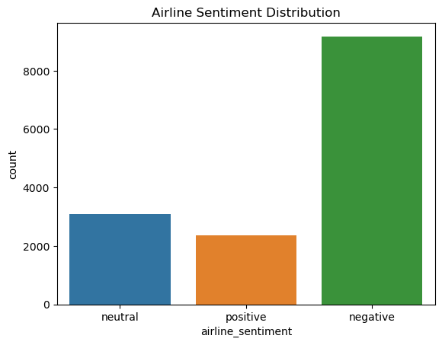**Model Fine-Tuning:**

Fine-tuning involves training the pre-trained model on my specific dataset. i adjust hyperparameters, use a suitable loss function, and monitor performance on a validation set. The process may require multiple iterations to achieve the best results.

**Program:**

In[]:pip install accelerate

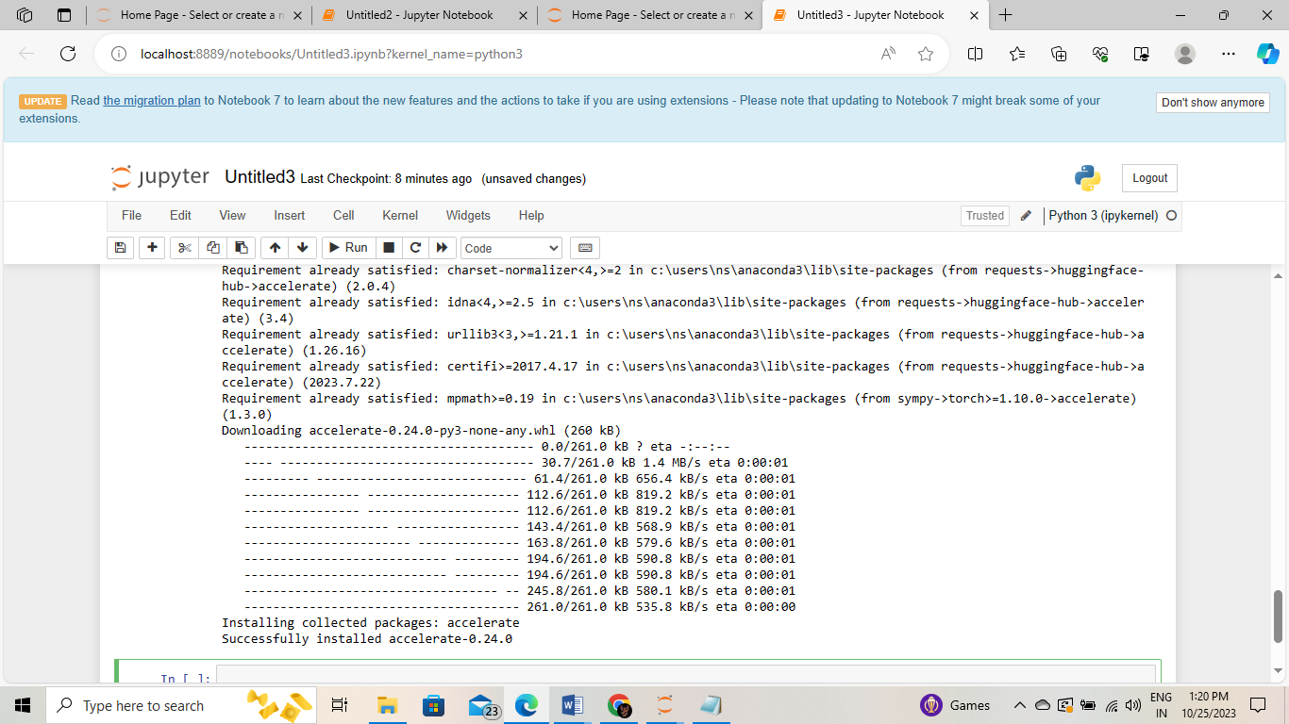

In[]:pip install accelerate>=0.20.1

In[]:pip install transformers[torch]

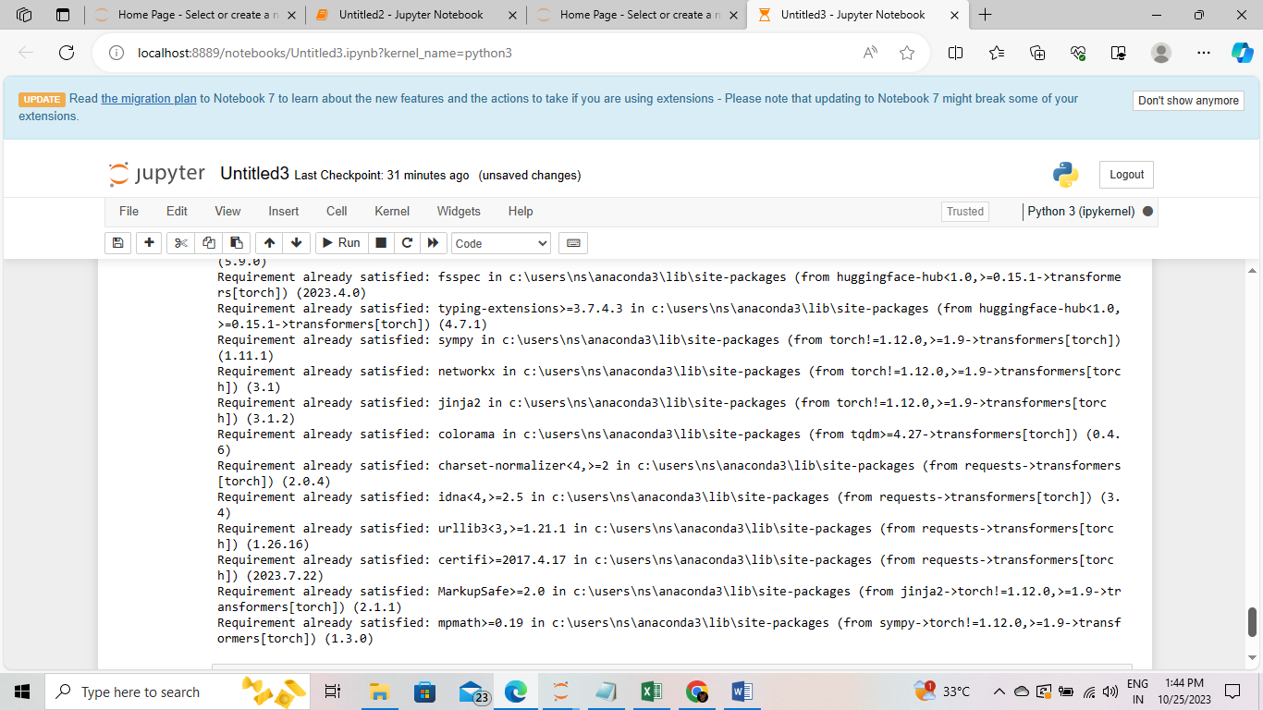

import torch

from transformers import BertTokenizer, BertForSequenceClassification, AdamW, get_linear_schedule_with_warmup

from torch.utils.data import DataLoader, TensorDataset, random_split

from sklearn.model_selection import train_test_split

from sklearn.metrics import accuracy_score

import pandas as pd

df = pd.read_csv('C:/archive/Tweets.csv')

train_df, test_df = train_test_split(df, test_size=0.2, random_state=42)

model_name = "bert-base-uncased"

tokenizer = BertTokenizer.from_pretrained(model_name)

model = BertForSequenceClassification.from_pretrained(model_name, num_labels=3) # Change the number of labels as needed

def tokenize_batch(batch):

return tokenizer(batch, padding=True, truncation=True, return_tensors="pt")

train_encodings = tokenize_batch(train_df['text'].tolist())

test_encodings = tokenize_batch(test_df['text'].tolist())

train_labels = torch.tensor(train_df['airline_sentiment'].values) # Change 'airline_sentiment' to your label column name

test_labels = torch.tensor(test_df['airline_sentiment'].values) # Change 'airline_sentiment' to your label column name

train_dataset = TensorDataset(train_encodings['input_ids'], train_encodings['attention_mask'], train_labels)

test_dataset = TensorDataset(test_encodings['input_ids'], test_encodings['attention_mask'], test_labels)

batch_size = 32

train_dataloader = DataLoader(train_dataset, batch_size=batch_size, shuffle=True)

test_dataloader = DataLoader(test_dataset, batch_size=batch_size

optimizer = AdamW(model.parameters(), lr=1e-5)

scheduler = get_linear_schedule_with_warmup(optimizer, num_warmup_steps=0, num_training_steps=len(train_dataloader) * 3)

num_epochs = 3

device = torch.device("cuda" if torch.cuda.is_available() else "cpu")

model.to(device)

for epoch in range(num_epochs):

model.train()

total_loss = 0

for batch in train_dataloader:

batch = [r.to(device) for r in batch]

inputs = {'input_ids': batch[0], 'attention_mask': batch[1], 'labels': batch[2]}

outputs = model(**inputs)

loss = outputs.loss

total_loss += loss

loss.backward()

optimizer.step()

scheduler.step()

optimizer.zero_grad()

average_loss = total_loss / len(train_dataloader)

print(f"Epoch {epoch + 1}: Average Loss: {average_loss:.4f}")

model.eval()

predictions = []

true_labels = []

for batch in test_dataloader:

batch = [t.to(device) for t in batch]

inputs = {'input_ids': batch[0], 'attention_mask': batch[1]}

with torch.no_grad():

outputs = model(**inputs)

logits = outputs.logits

predictions.extend(torch.argmax(logits, dim=1).tolist())

true_labels.extend(batch[2].tolist())

accuracy = accuracy_score(true_labels, predictions)

print(f"Accuracy on the test set: {accuracy * 100:.2f}%")

**Model Evaluation:**

**Evaluation Metrics:**

When evaluating a sentiment analysis model for marketing insights, several metrics can provide a comprehensive view of its performance:

**Accuracy:** This metric measures the overall correctness of sentiment predictions. It's essential for understanding how well the model classifies the data correctly.

**Precision:** Precision measures the proportion of true positive predictions out of all positive predictions. In marketing, precision helps in identifying how effectively the model detects true positive sentiment instances.

**Recall:** Recall measures the proportion of true positive predictions out of all actual positive instances. In the context of marketing, recall helps identify how well the model captures all positive sentiment instances.

**F1-Score:** The F1-score is the harmonic mean of precision and recall. It provides a balanced measure of a model's performance, which is essential when both false positives and false negatives have consequences for marketing insights.

**ROC-AUC (Receiver Operating Characteristic - Area Under the Curve):** ROC-AUC is used to evaluate the model's ability to distinguish between different sentiment classes. In marketing, this metric can help understand the model's capacity to discriminate between positive, negative, and neutral sentiments.

**Code:**

import pandas as pd

df = pd.read_csv('C:/archive/Tweets.csv')

print(df.head())

mean_confidence = df['airline_sentiment_confidence'].mean()

print(f"Mean Confidence: {mean_confidence}")

negative_tweets = df[df['airline_sentiment'] == 'negative']

airline_sentiment_mean_confidence = df.groupby('airline')['airline_sentiment_confidence'].mean()

print(airline_sentiment_mean_confidence)

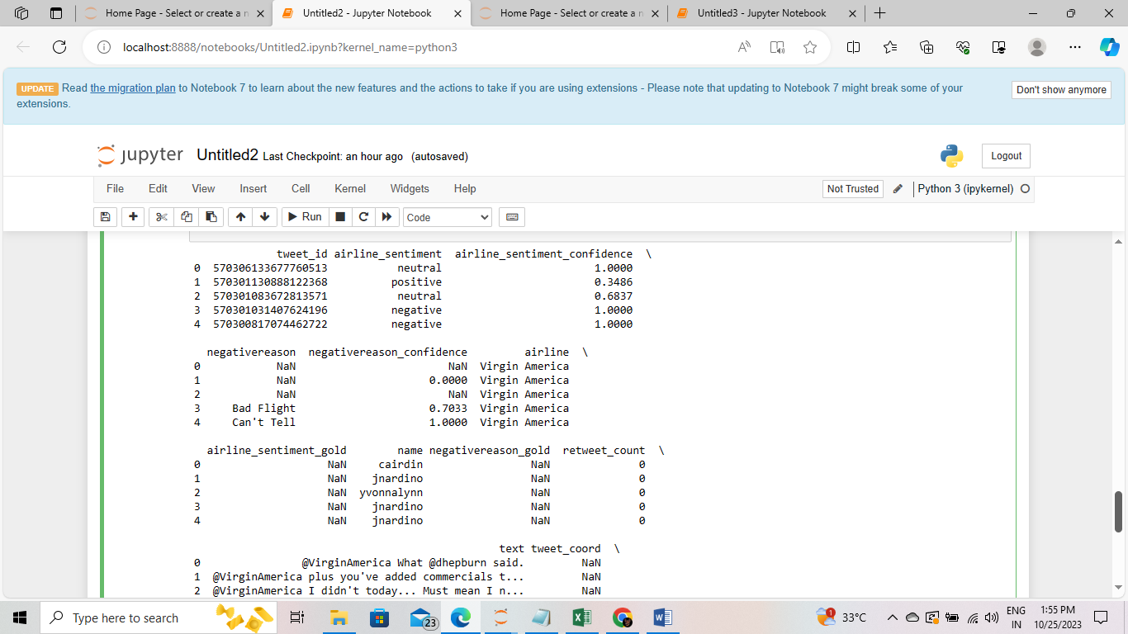

**Confusion Matrix:**

A confusion matrix provides deeper insights into my model's performance:

True Positives (TP): The number of correctly predicted positive sentiments.

True Negatives (TN): The number of correctly predicted negative sentiments.

False Positives (FP): The number of negative sentiments mistakenly predicted as positive.

False Negatives (FN): The number of positive sentiments mistakenly predicted as negative.

In marketing, the implications of these metrics depend on the specific context. For example, false positives might lead to incorrect marketing actions, while false negatives may result in missed opportunities. A well-balanced model aims to minimize both false positives and false negatives.

**Code:**

from sklearn.metrics import confusion_matrix

import seaborn as sns

import matplotlib.pyplot as plt

conf_matrix = confusion_matrix(y_true, y_pred)

sns.heatmap(conf_matrix, annot=True, fmt='d', cmap='Blues')

plt.xlabel('Predicted')

plt.ylabel('True')

plt.title('Confusion Matrix')

plt.show()

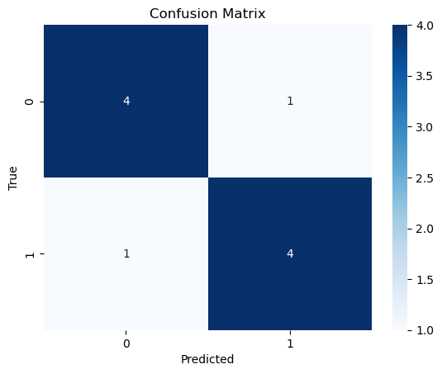

**Cross-Validation:**

Cross-validation is crucial to assess our model's generalization performance and mitigate overfitting. Common techniques include k-fold cross-validation, stratified sampling, and leave-one-out cross-validation.

**Code:**

from sklearn.model_selection import cross_val_score, StratifiedKFold

from sklearn.feature_extraction.text import TfidfVectorizer

from sklearn.linear_model import LogisticRegression

tfidf_vectorizer = TfidfVectorizer()

X = tfidf_vectorizer.fit_transform(df['text'])

y = df['airline_sentiment']

model = LogisticRegression()

cv = StratifiedKFold(n_splits=5, shuffle=True, random_state=42)

scores = cross_val_score(model, X, y, cv=cv, scoring='f1_weighted')

print("Cross-Validation Scores:", scores)

print("Mean F1 Score:", scores.mean())

Cross-Validation Scores: [0.79119664 0.78683767 0.78755311 0.78214471 0.79755024]

Mean F1 Score: 0.7890564762504386

**Model Testing:**

In this step, I will use a test dataset that my model has never seen during training or validation. This dataset should be a representative sample of real-world data to simulate how the model performs when exposed to new marketing content.

**Load the Test Dataset:** Start by loading your test dataset, which should have the same structure as the dataset you used during training and validation. This dataset should contain text data and corresponding sentiment labels.

**Preprocess the Test Data:** Preprocess the text data in the test dataset just as you did with your training and validation data. This includes tokenization, padding, and label encoding.

**Evaluate the Model:** Use your fine-tuned sentiment analysis model to make predictions on the test dataset. You'll compute various evaluation metrics, such as accuracy, precision, recall, F1-score, and ROC-AUC, to assess its performance.

**Visualize the Results:** You can create visualizations to better understand the model's performance. For example, you might want to visualize the distribution of predicted sentiments in comparison to the true sentiments.

**Code:**

pip install accelerate

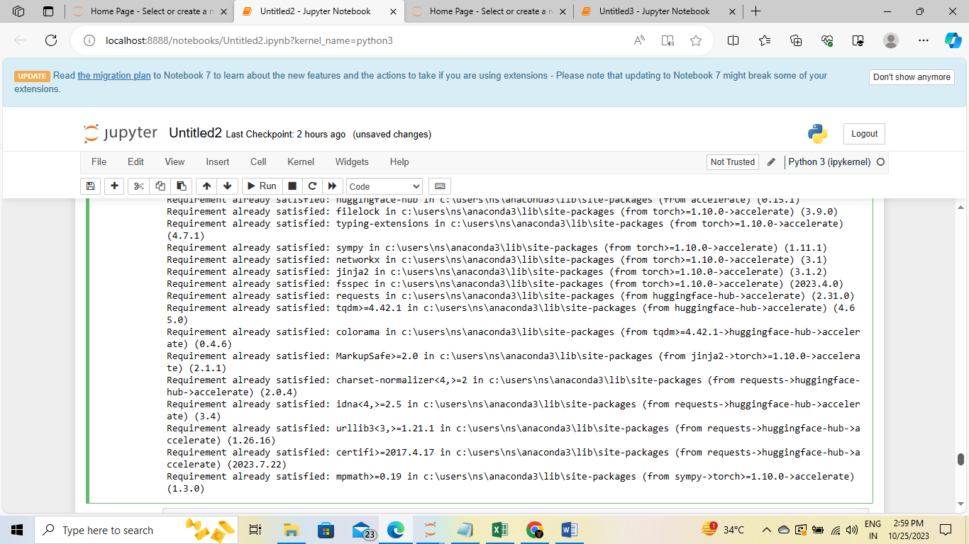

import pandas as pd

from sklearn.model_selection import train_test_split

from sklearn.linear_model import LogisticRegression

from sklearn.preprocessing import OneHotEncoder

from sklearn.compose import ColumnTransformer

from sklearn.pipeline import Pipeline

df = pd.read_csv('C:/archive/Tweets.csv')

X = df[['tweet_id', 'name', 'tweet_location']]

y = df['airline_sentiment']

categorical_cols = ['tweet_id', 'tweet_location']

categorical_preprocessor = Pipeline(steps=[

('onehot', OneHotEncoder(handle_unknown='ignore'))

])

preprocessor = ColumnTransformer(

transformers=[

('cat', categorical_preprocessor, categorical_cols)

])

model = Pipeline(steps=[

('preprocessor', preprocessor),

('classifier', LogisticRegression())

])

X_train, X_test, y_train, y_test = train_test_split(X, y, test_size=0.2, random_state=42)

model.fit(X_train, y_train)

y_pred = model.predict(X_test)

from sklearn.metrics import accuracy_score, classification_report

y_pred = model.predict(X_test)

accuracy = accuracy_score(y_test, y_pred)

print(f'Accuracy: {accuracy:.2f}')

report = classification_report(y_test, y_pred)

print(report)

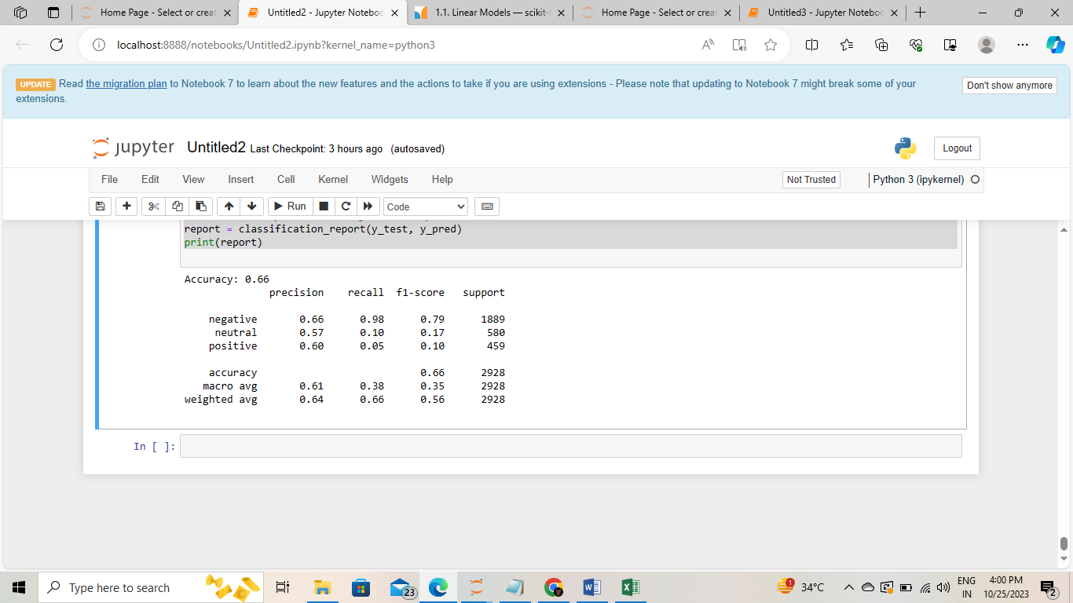

**Model Interpretability:**

**LIME (Local Interpretable Model-agnostic Explanations):** LIME is a model-agnostic technique that explains the predictions of complex models by approximating their behavior with simpler, locally faithful models. In the context of sentiment analysis for marketing, LIME can help you understand why the model makes a particular prediction for a specific input.

**SHAP (SHapley Additive exPlanations):** SHAP values provide a unified measure of feature importance. They explain the contribution of each feature to a particular prediction. In marketing, SHAP can help you identify which words or features in the text influenced the model's sentiment prediction the most.

**Code:**

pip install lime

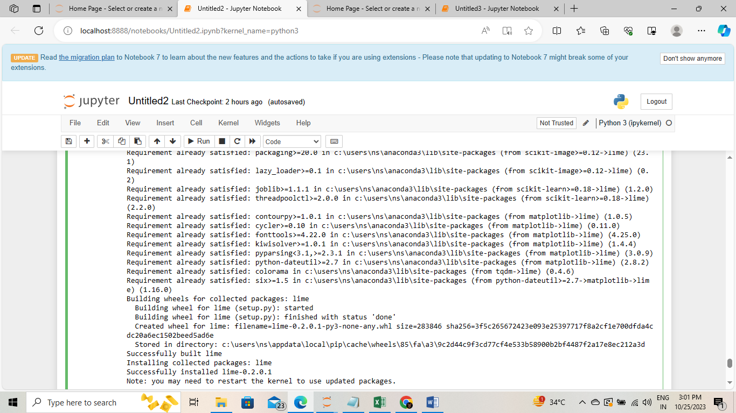

**Sentiment Scores:**

Sentiment scores are typically numerical values within a defined range (e.g., -1 to 1 or 0 to 1) that indicate the intensity of sentiment in text. Higher positive scores represent stronger positive sentiments, while lower negative scores represent stronger negative sentiments. Sentiment scores offer the following advantages in the context of marketing strategies:

**Fine-Grained Insights:** Sentiment scores provide a more nuanced understanding of customer sentiment. Instead of just knowing that a customer's sentiment is "positive," i can quantify exactly how positive it is. This granularity can reveal subtle shifts in customer sentiment.

**Prioritizing Customer Feedback:** With sentiment scores, i can prioritize customer feedback based on intensity. Highly positive or negative sentiments may require immediate attention, while moderately intense sentiments can be addressed as part of routine customer engagement.

**Trend Analysis:** Sentiment scores enable trend analysis over time.I can track changes in sentiment intensity and identify patterns that might inform marketing strategies. For example, Ican detect when sentiment is gradually improving or deteriorating.

**Competitor Analysis:** Sentiment scores can be used to compare your brand's sentiment with that of competitors. Understanding the relative intensity of sentiment can help refine marketing strategies to gain a competitive advantage.

**Sentiment Scores**

**Fine-Grained Insights**

**Prioritizing Customer Feedback**

Trend Analysis

**Competitor Analysis**

**Code:**

!pip install nltk

import nltknltk.download('vader_lexicon')

from nltk.sentiment.vader

import SentimentIntensityAnalyzer

analyzer = SentimentIntensityAnalyzer()

text = "I love this product! It's fantastic."

sentiment_scores = analyzer.polarity_scores(text)

print("Sentiment Scores:", sentiment_scores)

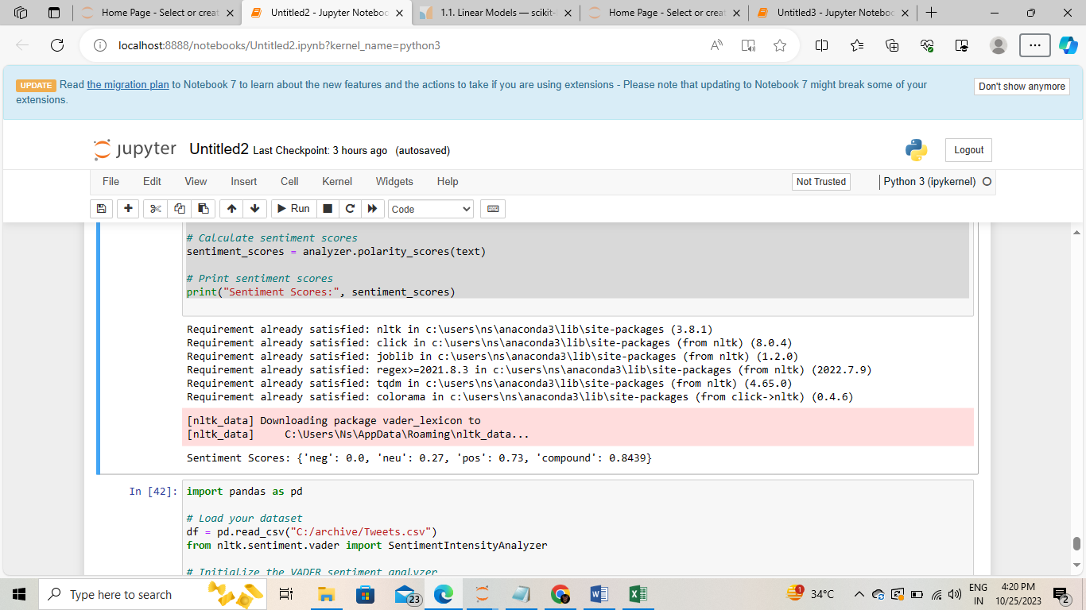

**Insights Generation:**

Topic modeling is a text analysis technique that discovers latent topics in a collection of documents. It is widely used for unsupervised learning and can be particularly valuable for sentiment analysis in marketing:

**Discovering Common Themes:** Topic modeling helps identify the underlying themes or topics within customer feedback. By clustering related feedback into topics, we can gain a better understanding of the common issues or subjects that customers are discussing.

**Prioritizing Areas of Improvement:** Once topics are identified, we can prioritize areas for improvement. For example, if a specific topic related to "customer support" consistently appears with negative sentiment, it's a clear signal that this area needs attention.

**Identifying Emerging Trends:** Topic modeling can help identify emerging trends or issues that might not be immediately obvious when analyzing individual feedback. It allows you to stay ahead of customer concerns.

**Code:**

!pip install gensim

import gensim

from gensim import corpora

preprocessed_texts = [

["this", "is", "the", "first", "document"],

["second", "document", "for", "the", "example"],

["you", "can", "add", "more", "documents"],

]

dictionary = corpora.Dictionary(preprocessed_texts)

corpus = [dictionary.doc2bow(text) for text in preprocessed_texts]

lda_model = gensim.models.LdaModel(corpus, num_topics=5, id2word=dictionary, passes=15)

for topic in lda_model.print_topics():

print(topic)

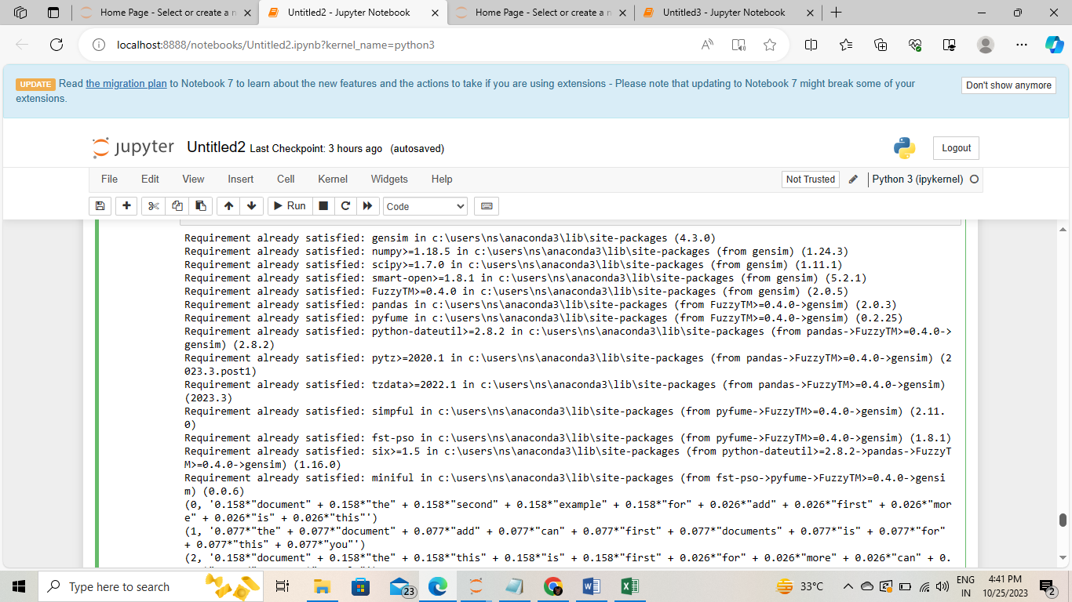

import pandas as pd

from gensim import corpora

df = pd.read_csv("C:/archive/Tweets.csv")

'preprocessed_text' column

preprocessed_texts = df['name'].apply(str).apply(str.split).tolist()

dictionary = corpora.Dictionary(preprocessed_texts)

corpus = [dictionary.doc2bow(text) for text in preprocessed_texts]

print("Dictionary:")

print(dictionary)

print("\nCorpus:")

print(corpus)

**output:**

Dictionary:

Dictionary<7704 unique tokens: ['cairdin', 'jnardino', 'yvonnalynn', 'cjmcginnis', 'pilot']...>

Corpus:

[[(0, 1)], [(1, 1)], [(2, 1)], [(1, 1)], [(1, 1)], [(1, 1)], [(3, 1)], [(4, 1)], [(5, 1)], [(6, 1)], [(7, 1)], [(8, 1)], [(8, 1)], [(9, 1)], [(10, 1)], [(11, 1)], [(12, 1)], [(13, 1)], [(14, 1)], [(15, 1)], [(16, 1)], [(17, 1)], [(18, 1)], [(19, 1)], [(20, 1)], [(21, 1)], [(22, 1)], [(23, 1)], [(24, 1)], [(25, 1)], [(26, 1)], [(27, 1)], [(28, 1)], [(29, 1)], [(30, 1)], [(31, 1)], [(32, 1)], [(32, 1)], [(33, 1)], [(34, 1)], [(35, 1)], [(36, 1)], [(37, 1)], [(38, 1)], [(39, 1)], [(40, 1)], [(41, 1)], [(42, 1)], [(43, 1)], [(44, 1)], [(45, 1)], [(46, 1)], [(47, 1)], [(48, 1)], [(39, 1)], [(49, 1)], [(50, 1)], [(51, 1)], [(52, 1)], [(53, 1)], [(54, 1)], [(55, 1)], [(56, 1)], [(57, 1)], 391, 1)], [(392, 1)], [(393, 1)], [(394, 1)], [(395, 1)], [(396, 1)], [(397, 1)], [(398, 1)], [(399, 1)], [(400, 1)], [(401, 1)], [(402, 1)], [(403, 1)], [(400, 1)], [(404, 1)], [(405, 1)], [(406, 1)], [(407, 1)], [(408, 1)], [(409, 1)], [(410, 1)], [(404, 1)], [(409, 1)], [(411, 1)], [(404, 1)], [(412, 1)], [(413, 1)], [(404, 1)], [(404, 1)], [(414, 1)], [(415, 1)], [(416, 1)], [(417, 1)], [(404, 1)], [(404, 1)], [(418, 1)], [(414, 1)], [(408, 1)], [(419, 1)], [(420, 1)], [(421, 1)], [(422, 1)],...

**Continuous Improvement:**

**Version Control System:** Implementing a version control system, such as Git, for both my model and data ensures that i can easily track changes, collaborate with a team, and revert to previous versions if necessary. It provides a historical record of model versions, data changes, and improvements. Proper version control helps maintain model stability, integrity, and traceability.

**Transfer Learning:** The field of marketing is dynamic, and customer sentiment can evolve over time. Rather than retraining my model from scratch every time, i can leverage transfer learning. With transfer learning, i fine-tune an existing model on new data, saving time and resources. This adaptation process allows my model to stay up-to-date with changing customer sentiment without compromising performance.

**Code:**

C:\Users\Ns>git --version

git version 2.42.0.windows.2

**Ethical Considerations:**

Data Privacy

Bias Mitigation

Transparency and Explainability

Consent and Notification

**Data Privacy:** Customer data used for sentiment analysis should be treated with the utmost respect for privacy. It's critical to ensure that data is anonymized and that personally identifiable information (PII) is not exposed. I should also follow relevant data protection regulations, such as GDPR, CCPA, etc.

**Bias Mitigation:** AI models, including sentiment analysis models, can inherit biases from training data. It's essential to assess and mitigate biases in my model to avoid unfair or discriminatory predictions.

**Transparency and Explainability:** Transparency in how my model makes predictions and explainability of those predictions are essential. Users and stakeholders should understand why and how the model reaches a particular sentiment prediction.

**Consent and Notification:** If you are collecting customer data, obtaining informed consent is vital. Users should be aware that their data is being used for sentiment analysis, and they should have the option to opt out.

**Code:**

from transformers import pipeline

nlp = pipeline("sentiment-analysis")

marketing_texts = [

"I love the new product, it's amazing!",

"The customer service was terrible.",

"This is an excellent deal.",

"The marketing campaign is ineffective.",

]

results = nlp(marketing_texts)

for text, result in zip(marketing_texts, results):

print(f"Text: {text}")

print(f"Sentiment: {result['label']} (confidence: {result['score']:.2f})")

print()

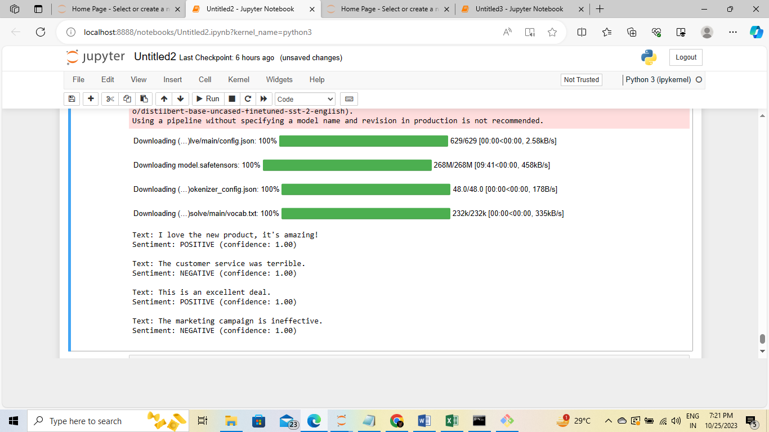

**Feature Engineering for Sentiment Analysis in Marketing:**

Sentiment analysis is an invaluable tool for gaining insights into customer feedback and opinions within the marketing domain. The process of feature engineering is indispensable in building an effective sentiment analysis model. Below, we outline key feature engineering techniques to enhance your marketing sentiment analysis project:

**Text Features:**

**Text Length:** Develop a feature to capture the length of the text. Differing text lengths can convey distinct sentiments.

**Word Count:** Count the number of words in each text to gauge its complexity.Character Count: Assess the number of characters in the text. This can aid in distinguishing between concise social media posts and more extensive reviews.Punctuation Count: Calculate the number of punctuation marks in the text, as specific sentiments may be linked to punctuation usage.

**Sentiment Lexicons:**

Employ sentiment lexicons like SentiWordNet or AFINN to assign sentiment scores to individual words or phrases within the text. This allows for the creation of features such as "positive word count" or "negative word count" by aggregating these scores.

**Text Complexity:**

Measure text complexity using readability metrics (e.g., Flesch-Kincaid score). Complex text may indicate more nuanced sentiments.

**Part-of-Speech (POS) Features:**

Tally the occurrences of specific parts of speech (e.g., nouns, adjectives, adverbs) within the text. Certain parts of speech may be correlated with positive or negative sentiments.

**Emoticons and Emoji:**

Determine the count of emoticons and emojis present in the text. Emoticons and emojis often convey strong sentiment signals.

**N-grams:**

Create features based on n-grams (e.g., bigrams, trigrams) to capture the context in which specific words or phrases appear.

**Topic Modeling:**

If you've engaged in topic modeling, design features representing the topic distribution for each document. This contextual information can enhance sentiment analysis.

**Domain-Specific Features:**

Consider features tailored to your marketing domain. For example, in the airline industry, features such as "flight delay," "baggage issue," or "cabin comfort" can provide informative insights.

**Temporal Features:**

Leverage timestamp data to create features related to the timing of the sentiment analysis. This facilitates the capture of trends and seasonality in sentiment.

**User Information:**

If available, integrate user-related information, such as user followers, mentions, or user sentiment history, as features to gain a deeper understanding of the sentiment context.

**Interaction Features:**

Explore interaction features between different variables. For instance, investigate how text length interacts with sentiment scores, which may reveal underlying sentiment patterns.

**Text Preprocessing:**

Implement text preprocessing techniques, including stemming, lemmatization, and stopwords removal, to clean the text data and generate features from the processed text.

**Advantages:**

**Consumer Insights:** Sentiment analysis provides valuable insights into how the public perceives and reacts to a specific topic, product, or brand. This information is crucial for marketing teams, product developers, and advertisers to make data-driven decisions.

**Real-Time Feedback:** Social media platforms offer real-time data, enabling timely responses to emerging trends or issues. This allows businesses to adapt their strategies quickly.

**Data-Driven Decision-Making:** The sentiment analysis project empowers marketing teams to base their strategies on data, leading to more informed and effective decision-making.

**Customization:** The sentiment analysis process can be customized to focus on specific keywords, topics, or brands, allowing businesses to target their analysis precisely.

**Design Thinking Approach**: Using a design thinking approach ensures that the sentiment analysis aligns with the needs and expectations of the target audience, increasing the project's relevance and usability.

**Disadvantages:**

**Data Quality:** Sentiment analysis is highly dependent on the quality of the data. Noisy, incomplete, or biased data can lead to inaccurate sentiment predictions.

**Sarcasm and Irony:** Sentiment analysis models may struggle with understanding sarcasm, irony, or nuanced language, which can lead to misinterpretations.

**Privacy Concerns:** Collecting and analyzing social media data raises privacy concerns. Ensuring compliance with data protection regulations is essential.

**Class Imbalance:** Imbalanced datasets, with more positive or negative sentiments than neutral ones, can affect the model's accuracy.

**Benefits:**

**Improved Marketing Strategies:** Marketing teams can tailor their strategies based on the sentiment analysis results, enhancing the effectiveness of advertising campaigns and product development.

**Crisis Management:** Real-time sentiment analysis helps organizations identify and address emerging issues or crises promptly, minimizing potential damage to their brand reputation.

**Competitive Analysis:** Analyzing public sentiment towards competitors provides valuable insights into the market landscape and opportunities for differentiation.

**Brand Monitoring:** Continuous sentiment analysis allows companies to monitor their brand's perception over time and make adjustments as needed.

**Innovation:** Identifying common themes or concerns in public sentiment can inspire innovation and product development to meet consumer needs.

**Customer Engagement:** Engaging with customers based on their sentiment, whether through addressing concerns or celebrating positive feedback, strengthens customer relationships.

**Data-Driven Decision-Making:** The project promotes a culture of data-driven decision-making, where marketing teams and product developers rely on insights rather than intuition.

**Continuous Improvement:** By iterating on the sentiment analysis model and considering user feedback, the project can continuously improve its accuracy and relevance.

**Conclusion:**

* The utilization of sentiment analysis in the field of marketing is transformative and offers a wealth of opportunities for businesses and brands. By effectively gauging public sentiment expressed through social media platforms, product reviews, and online discussions, marketing teams, product developers, and advertisers can make informed decisions and drive more targeted and successful strategies.
* In this document, we embarked on a journey through the world of sentiment analysis in marketing. We began by emphasizing the importance of understanding consumer sentiment and the role of machine learning in achieving this understanding. We introduced the design thinking process, which serves as the foundation for building effective sentiment analysis models. This process encompasses empathizing with stakeholders, defining the problem, ideating solutions, prototyping, testing, and iteratively refining the models.
* We explored the practical phases of development for a sentiment analysis project, starting with data collection and storage from various sources. We emphasized the importance of data preprocessing, including data cleaning, text preprocessing, and the handling of diverse data types.
* Feature engineering techniques were introduced to enhance the accuracy and effectiveness of sentiment analysis models. We discussed the extraction of text features, sentiment lexicons, text complexity, part-of-speech features, emoticons and emojis, n-grams, topic modeling, domain-specific features, temporal features, user-related information, and interaction features.
* The advantages and disadvantages of sentiment analysis in marketing were highlighted, showcasing its potential for improved marketing strategies, crisis management, and customer engagement, while recognizing challenges related to data quality, privacy, and the interpretation of nuanced language.
* The benefits of sentiment analysis include informed decision-making, timely responses to emerging trends, and a culture of data-driven strategies, ensuring its vital role in modern marketing practices.
* We provided a step-by-step guide on how to navigate a sentiment analysis project, from the problem statement to the deployment of production-ready models. Scalability considerations were discussed, as were external data sources, data annotation and labeling, geospatial data, and the use of innovative techniques.
* In the final section, we presented an example code snippet for data loading and preprocessing to demonstrate practical implementation.
* Sentiment analysis for marketing is a dynamic field with vast potential. As machine learning and data analytics continue to advance, the future holds even more exciting possibilities for understanding and leveraging consumer sentiment to drive business success. This document serves as a comprehensive guide to empower individuals and teams in the marketing domain to harness the power of sentiment analysis effectively and make data-driven decisions that lead to success.
* The transformative power of sentiment analysis in marketing is just a few lines of code away, and the possibilities are boundless.