|  |  |  |  |
| --- | --- | --- | --- |
| 2 | | 39,480.0 | |
| NUMERO DE FRONTERAS | | ENERGIA AGREGADA | |
|  | | | |
| NO | | 0 | |
| CONTRATO | | VENCIMIENTO CONTRATO | |
|  | | | |
| 61,890,822 | 31 | | 2,647,421 |
| INGRESO 2019 | DÍAS CERTIFICADOS 2019 | | ENERGIA RESPALDADA 2019 |
|  | | | |
| 42,371,977 | 80 | | 1,812,975 |
| INGRESO 2020 | DÍAS CERTIFICADOS 2020 | | ENERGIA RESPALDADA 2020 |
|  | | | |
| 107,225,463 | 155 | | 4,694,807 |
| INGRESO 2021 | DÍAS CERTIFICADOS 2021 | | ENERGIA RESPALDADA 2021 |

|  |
| --- |
| **ACESCO**  USUARIO |

|  |
| --- |
| **Edwin Torres**  Ejecutivo de cuenta |

|  |
| --- |
| **0**  PUNTO FOCAL |

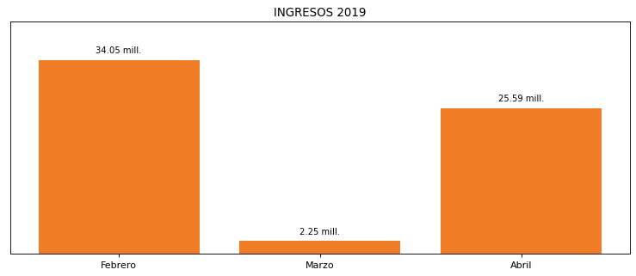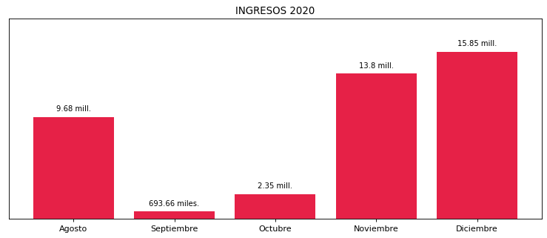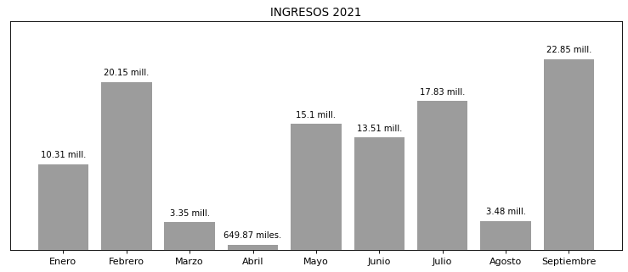

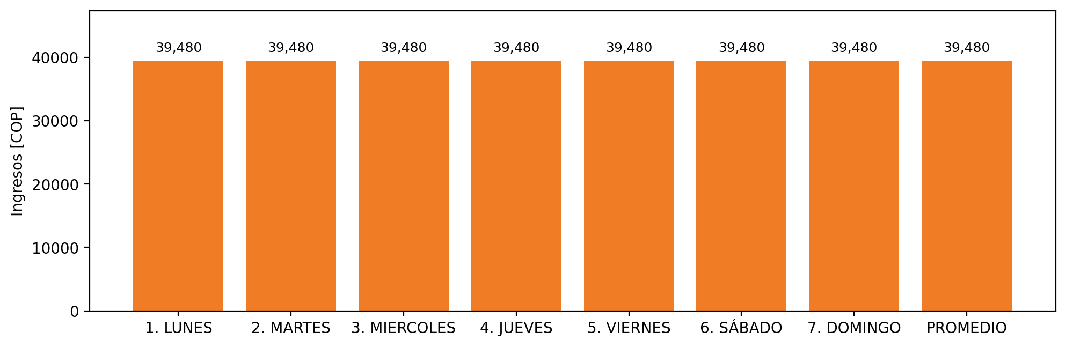

|  |  |  |  |  |  |  |  |  |  |  |
| --- | --- | --- | --- | --- | --- | --- | --- | --- | --- | --- |
| **FRONTERA** | **COD SIC** | **PREDIO** | **FRT DDV** | **TIPO DDV** | **PROMEDIO** | **PRÓXIMA ACTUALIZACIÓN** | **MARGEN DE ERROR** | **ÚLTIMA PRUEBA DDV** | **DÍAS PARTICIPACIÓN** | **FECHA REFERENCIA PRÓXIMA PRUEBA DDV** |
| ACERIAS DE COLOMBIA S.A. (34.5 KV) - 1 | Frt10274 | Prd01702 | Frt37001 | GPE | 26,400 | 2023-04-15 | NO APLICA | 2021-08-15 | 26.0 | 2022-01-05 |
| ACERIAS DE COLOMBIA S.A. (34.5 KV) - 2 | Frt10274 | Prd01702 | Frt42217 | GPE | 26,400 | 2026-04-15 | NO APLICA | 2021-08-15 | 26.0 | 2022-01-05 |