|  |  |  |  |
| --- | --- | --- | --- |
| 2 | | 39,480 | |
| **NUMERO DE FRONTERAS** | | **ENERGIA AGREGADA** | |
|  | | | |
| 61,890,822 | 31 | | 2,647,421 |
| INGRESO 2019 | DÍAS CERTIFICADOS 2019 | | ENERGIA RESPALDADA 2019 |
|  | | | |
| 42,371,977 | 80 | | 1,812,975 |
| INGRESO 2020 | DÍAS CERTIFICADOS 2020 | | ENERGIA RESPALDADA 2020 |
|  | | | |
| 121,099,052 | 173 | | 5,378,999 |
| INGRESO 2021 | DÍAS CERTIFICADOS 2021 | | ENERGIA RESPALDADA 2021 |

**HISTORICO REINTEGRO DDV**

|  |  |  |  |
| --- | --- | --- | --- |
|  | **2019** | **2020** | **2021** |
| **ENE** | - | - | 10.31 |
| **FEB** | 34.05 | - | 20.15 |
| **MAR** | 2.25 | - | 3.35 |
| **ABR** | 25.59 | - | 0.65 |
| **MAY** | - | - | 15.1 |
| **JUN** | - | - | 13.51 |
| **JUL** | - | - | 17.83 |
| **AGO** | - | 9.68 | 3.48 |
| **SEP** | - | 0.69 | 22.85 |
| **OCT** | - | 2.35 | 13.87 |
| **NOV** | - | 13.8 | - |
| **DIC** | - | 15.85 | - |

**Los valores de la tabla están en millones de COP**

**REINTEGRO MECANISMO DDV OCTUBRE 2021**

|  |  |  |  |  |  |
| --- | --- | --- | --- | --- | --- |
| FECHA | TIPO DIA | CANTIDADES RESPALDO | PRECIO PONDERADO USD | TRM | PNETO |
| 2021-10-01 | Viernes | 39,478 | 5.98 | 3,784.44 | 800,508 |
| 2021-10-06 | Miércoles | 39,478 | 5.98 | 3,784.44 | 800,508 |
| 2021-10-07 | Jueves | 39,478 | 5.98 | 3,784.44 | 800,508 |
| 2021-10-08 | Viernes | 39,478 | 5.98 | 3,784.44 | 800,508 |
| 2021-10-09 | Sábado | 39,478 | 5.98 | 3,784.44 | 800,508 |
| 2021-10-10 | Domingo - Festivo | 39,471 | 5.98 | 3,784.44 | 800,367 |
| 2021-10-11 | Lunes | 13,079 | 5.98 | 3,784.44 | 265,207 |
| 2021-10-18 | Domingo - Festivo | 39,477 | 5.98 | 3,784.44 | 800,488 |
| 2021-10-19 | Martes | 39,478 | 5.98 | 3,784.44 | 800,508 |
| 2021-10-20 | Miércoles | 39,477 | 5.98 | 3,784.44 | 800,488 |
| 2021-10-21 | Jueves | 39,478 | 5.98 | 3,784.44 | 800,508 |
| 2021-10-22 | Viernes | 39,478 | 5.98 | 3,784.44 | 800,508 |
| 2021-10-23 | Sábado | 39,477 | 5.98 | 3,784.44 | 800,488 |
| 2021-10-24 | Domingo - Festivo | 39,477 | 5.98 | 3,784.44 | 800,488 |
| 2021-10-25 | Lunes | 39,478 | 5.98 | 3,784.44 | 800,508 |
| 2021-10-26 | Martes | 39,478 | 5.98 | 3,784.44 | 800,508 |
| 2021-10-27 | Miércoles | 39,477 | 5.98 | 3,784.44 | 800,488 |
| 2021-10-28 | Jueves | 39,477 | 5.98 | 3,784.44 | 800,488 |

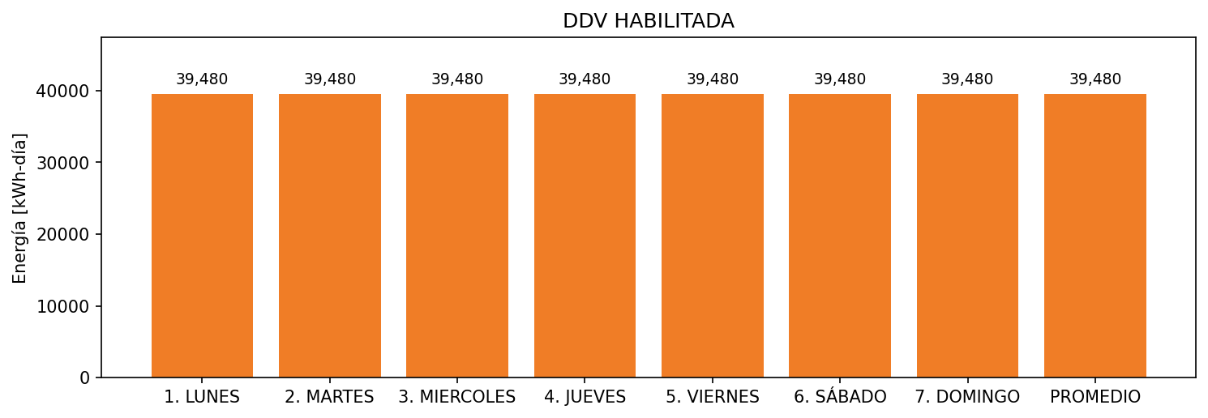

|  |  |  |  |  |  |  |  |  |  |
| --- | --- | --- | --- | --- | --- | --- | --- | --- | --- |
| **FRONTERA** | **COD SIC** | **FRT DDV** | **TIPO DDV** | **PROMEDIO** | **PRÓXIMA ACTUALIZACIÓN** | **MARGEN DE ERROR** | **ÚLTIMA PRUEBA DDV** | **DÍAS PARTICIPACIÓN** | **FECHA REFERENCIA PRÓXIMA PRUEBA DDV** |
| ACERIAS DE COLOMBIA S.A. (34.5 KV) - 1 | Frt10274 | Frt37001 | GPE | 26,400 | 2023-04-15 | NO APLICA | 2021-08-15 | 43.0 | 2022-01-20 |
| ACERIAS DE COLOMBIA S.A. (34.5 KV) - 2 | Frt10274 | Frt42217 | GPE | 13,080 | 2026-04-15 | NO APLICA | 2021-08-15 | 44.0 | 2022-01-20 |