|  |  |  |  |
| --- | --- | --- | --- |
| 3 | | 61,968.0 | |
| NUMERO DE FRONTERAS | | ENERGIA AGREGADA | |
|  | | | |
|  | |  | |
| CONTRATO | | VENCIMIENTO CONTRATO | |
|  | | | |
| 200,114,015 | 140 | | 8,601,644 |
| INGRESO 2021 | DÍAS CERTIFICADOS 2021 | | ENERGIA RESPALDADA 2021 |

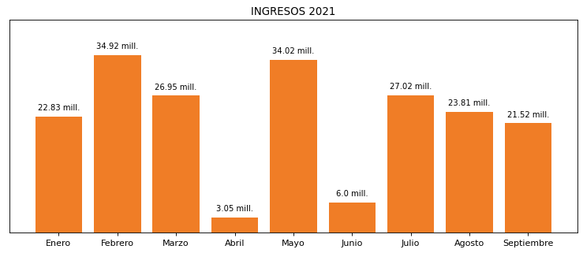

|  |
| --- |
| **ACONDESA**  USUARIO |

|  |
| --- |
| **Edwin Torres**  Ejecutivo de cuenta |

|  |
| --- |
| **0**  PUNTO FOCAL |

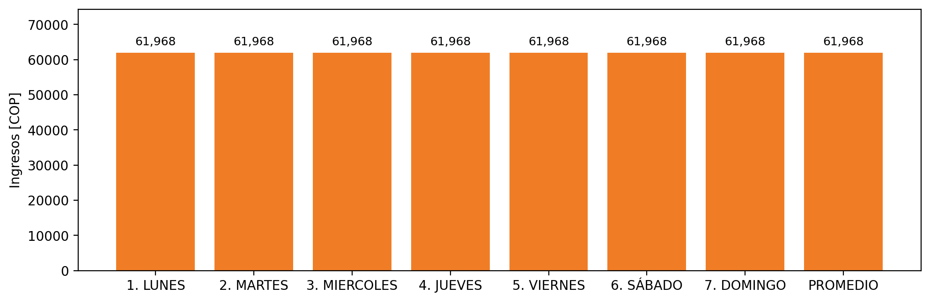

|  |  |  |  |  |  |  |  |  |  |  |
| --- | --- | --- | --- | --- | --- | --- | --- | --- | --- | --- |
| **FRONTERA** | **COD SIC** | **PREDIO** | **FRT DDV** | **TIPO DDV** | **PROMEDIO** | **PRÓXIMA ACTUALIZACIÓN** | **MARGEN DE ERROR** | **ÚLTIMA PRUEBA DDV** | **DÍAS PARTICIPACIÓN** | **FECHA REFERENCIA PRÓXIMA PRUEBA DDV** |
| ALIMENTOS CONCENTRADOS DEL CARIBE S.A ACONDESA S.A - 1 | Frt00904 | Prd02154 | Frt39897 | GPE | 40,344 | 2026-04-15 | NO APLICA | 2021-07-02 | 71.0 | 2021-12-06 |
| ALIMENTOS CONCENTRADOS DEL CARIBE S.A ACONDESA S.A - 2 | Frt00904 | Prd02154 | Frt40001 | GPE | 40,344 | 2026-04-15 | NO APLICA | 2021-07-02 | 31.0 | 2021-12-06 |
| ACONDESA S.A GRANJA CALUSE | Frt04775 | Prd02205 | Frt41582 | GPE | 40,344 | NO APLICA | NO APLICA | NO APLICA | 0.0 | 2022-03-04 |