|  |  |  |  |
| --- | --- | --- | --- |
| 3 | | 61,968 | |
| **NUMERO DE FRONTERAS** | | **ENERGIA AGREGADA** | |
|  | | | |
| 220,217,165 | 156 | | 9,593,054 |
| INGRESO 2021 | DÍAS CERTIFICADOS 2021 | | ENERGIA RESPALDADA 2021 |

**HISTORICO REINTEGRO DDV**

|  |  |
| --- | --- |
|  | **2021** |
| **ENE** | 22.83 |
| **FEB** | 34.92 |
| **MAR** | 26.95 |
| **ABR** | 3.05 |
| **MAY** | 34.02 |
| **JUN** | 6.0 |
| **JUL** | 27.02 |
| **AGO** | 23.81 |
| **SEP** | 21.52 |
| **OCT** | 20.1 |
| **NOV** | - |
| **DIC** | - |

**Los valores de la tabla están en millones de COP**

**REINTEGRO MECANISMO DDV OCTUBRE 2021**

|  |  |  |  |  |  |
| --- | --- | --- | --- | --- | --- |
| FECHA | TIPO DIA | CANTIDADES RESPALDO | PRECIO PONDERADO USD | TRM | PNETO |
| 2021-10-01 | Viernes | 61,965 | 5.98 | 3,784.44 | 1,256,485 |
| 2021-10-04 | Lunes | 61,963 | 5.98 | 3,784.44 | 1,256,444 |
| 2021-10-05 | Martes | 61,963 | 5.98 | 3,784.44 | 1,256,444 |
| 2021-10-06 | Miércoles | 61,963 | 5.98 | 3,784.44 | 1,256,444 |
| 2021-10-07 | Jueves | 61,965 | 5.98 | 3,784.44 | 1,256,485 |
| 2021-10-08 | Viernes | 61,965 | 5.98 | 3,784.44 | 1,256,485 |
| 2021-10-09 | Sábado | 61,965 | 5.98 | 3,784.44 | 1,256,485 |
| 2021-10-10 | Domingo - Festivo | 61,963 | 5.98 | 3,784.44 | 1,256,444 |
| 2021-10-11 | Lunes | 61,963 | 5.98 | 3,784.44 | 1,256,444 |
| 2021-10-18 | Domingo - Festivo | 61,963 | 5.98 | 3,784.44 | 1,256,444 |
| 2021-10-19 | Martes | 61,965 | 5.98 | 3,784.44 | 1,256,485 |
| 2021-10-20 | Miércoles | 61,953 | 5.98 | 3,784.44 | 1,256,242 |
| 2021-10-21 | Jueves | 61,963 | 5.98 | 3,784.44 | 1,256,444 |
| 2021-10-22 | Viernes | 61,963 | 5.98 | 3,784.44 | 1,256,444 |
| 2021-10-23 | Sábado | 61,965 | 5.98 | 3,784.44 | 1,256,485 |
| 2021-10-24 | Domingo - Festivo | 61,963 | 5.98 | 3,784.44 | 1,256,444 |

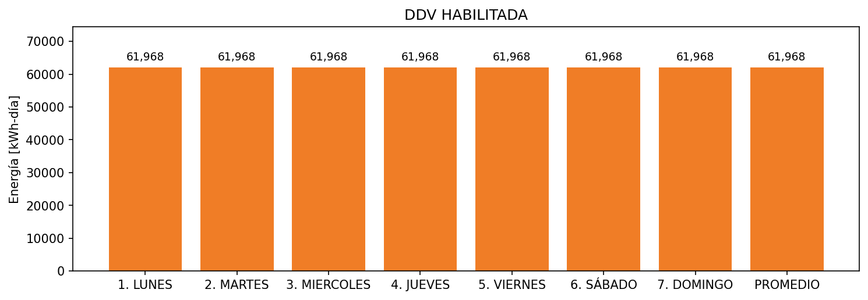

|  |  |  |  |  |  |  |  |  |  |
| --- | --- | --- | --- | --- | --- | --- | --- | --- | --- |
| **FRONTERA** | **COD SIC** | **FRT DDV** | **TIPO DDV** | **PROMEDIO** | **PRÓXIMA ACTUALIZACIÓN** | **MARGEN DE ERROR** | **ÚLTIMA PRUEBA DDV** | **DÍAS PARTICIPACIÓN** | **FECHA REFERENCIA PRÓXIMA PRUEBA DDV** |
| ALIMENTOS CONCENTRADOS DEL CARIBE S.A ACONDESA S.A - 1 | Frt00904 | Frt39897 | GPE | 40,344 | 2026-04-15 | NO APLICA | 2021-07-02 | 87.0 | 2021-12-20 |
| ALIMENTOS CONCENTRADOS DEL CARIBE S.A ACONDESA S.A - 2 | Frt00904 | Frt40001 | GPE | 21,624 | 2026-04-15 | NO APLICA | 2021-07-02 | 47.0 | 2021-12-20 |
| ACONDESA S.A GRANJA CALUSE | Frt04775 | Frt41582 | GPE | 0 | NO APLICA | NO APLICA | NO APLICA | 0.0 | 2022-03-17 |