|  |  |  |  |
| --- | --- | --- | --- |
| 4 | | 72,000.0 | |
| NUMERO DE FRONTERAS | | ENERGIA AGREGADA | |
|  | | | |
| SI | | 0 | |
| CONTRATO | | VENCIMIENTO CONTRATO | |
|  | | | |
| 20,445,761 | 45 | | 754,859 |
| INGRESO 2019 | DÍAS CERTIFICADOS 2019 | | ENERGIA RESPALDADA 2019 |
|  | | | |
| 321,835,431 | 229 | | 12,356,414 |
| INGRESO 2020 | DÍAS CERTIFICADOS 2020 | | ENERGIA RESPALDADA 2020 |
|  | | | |
| 278,835,386 | 167 | | 12,022,694 |
| INGRESO 2021 | DÍAS CERTIFICADOS 2021 | | ENERGIA RESPALDADA 2021 |

|  |
| --- |
| **ALBATEQ**  USUARIO |

|  |
| --- |
| **Mateo Porras**  Ejecutivo de cuenta |

|  |
| --- |
| **Carlos Arturo Delgado / Director de Operaciones / carlos.delgado@albateq.com**  PUNTO FOCAL |

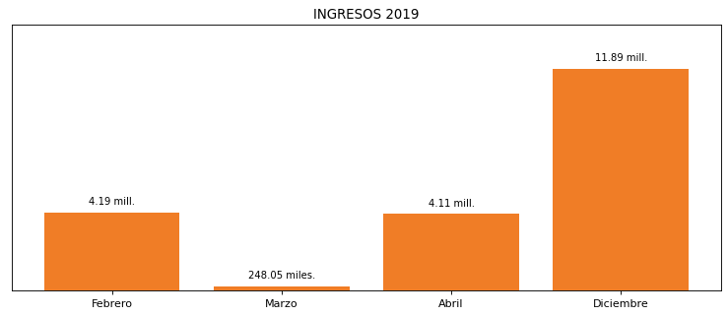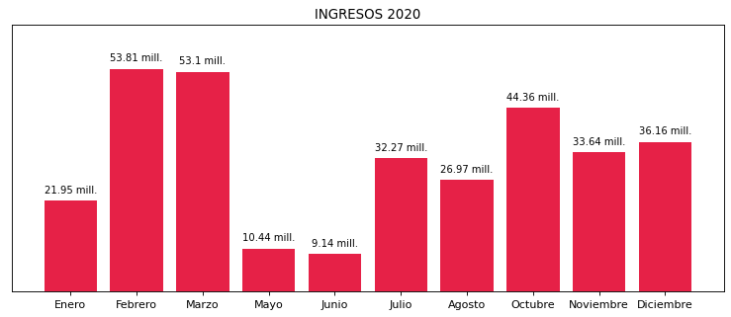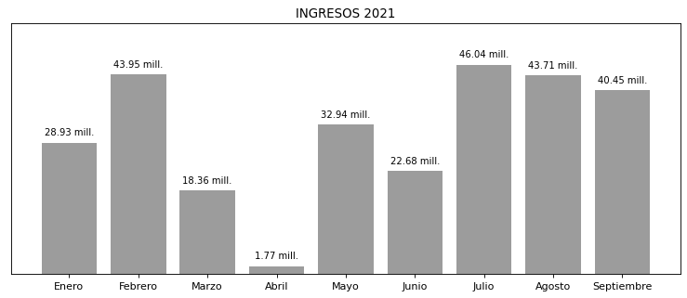

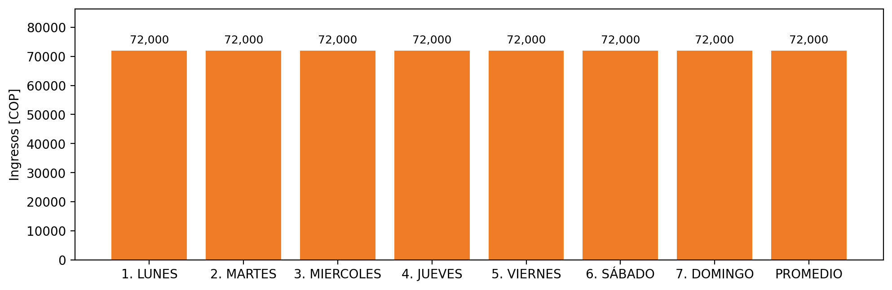

|  |  |  |  |  |  |  |  |  |  |  |
| --- | --- | --- | --- | --- | --- | --- | --- | --- | --- | --- |
| **FRONTERA** | **COD SIC** | **PREDIO** | **FRT DDV** | **TIPO DDV** | **PROMEDIO** | **PRÓXIMA ACTUALIZACIÓN** | **MARGEN DE ERROR** | **ÚLTIMA PRUEBA DDV** | **DÍAS PARTICIPACIÓN** | **FECHA REFERENCIA PRÓXIMA PRUEBA DDV** |
| ALBATEQ S.A. FUNZA - 1 | Frt01612 | Prd01506 | Frt35702 | GPE | 18,000 | 2023-04-15 | NO APLICA | 2021-10-11 | 0.0 | 2022-02-16 |
| ALBATEQ S.A. FUNZA - 2 | Frt01612 | Prd01506 | Frt38700 | GPE | 18,000 | 2023-04-15 | NO APLICA | 2021-10-11 | 0.0 | 2022-02-16 |
| ALBATEQ S.A. FUNZA - 3 | Frt01612 | Prd01506 | Frt38701 | GPE | 18,000 | 2023-04-15 | NO APLICA | 2021-10-11 | 0.0 | 2022-02-16 |
| ALBATEQ S.A. FUNZA - 4 | Frt01612 | Prd01506 | Frt38702 | GPE | 18,000 | 2023-04-15 | NO APLICA | 2021-10-11 | 0.0 | 2022-02-16 |