|  |  |  |  |
| --- | --- | --- | --- |
| 4 | | 72,000 | |
| **NUMERO DE FRONTERAS** | | **ENERGIA AGREGADA** | |
|  | | | |
| 20,445,761 | 45 | | 754,859 |
| INGRESO 2019 | DÍAS CERTIFICADOS 2019 | | ENERGIA RESPALDADA 2019 |
|  | | | |
| 321,835,431 | 229 | | 12,356,414 |
| INGRESO 2020 | DÍAS CERTIFICADOS 2020 | | ENERGIA RESPALDADA 2020 |
|  | | | |
| 306,881,087 | 186 | | 13,390,534 |
| INGRESO 2021 | DÍAS CERTIFICADOS 2021 | | ENERGIA RESPALDADA 2021 |

**HISTORICO REINTEGRO DDV**

|  |  |  |  |
| --- | --- | --- | --- |
|  | **2019** | **2020** | **2021** |
| **ENE** | - | 21.95 | 28.93 |
| **FEB** | 4.19 | 53.81 | 43.95 |
| **MAR** | 0.25 | 53.1 | 18.36 |
| **ABR** | 4.11 | - | 1.77 |
| **MAY** | - | 10.44 | 32.94 |
| **JUN** | - | 9.14 | 22.68 |
| **JUL** | - | 32.27 | 46.04 |
| **AGO** | - | 26.97 | 43.71 |
| **SEP** | - | - | 40.45 |
| **OCT** | - | 44.36 | 28.05 |
| **NOV** | - | 33.64 | - |
| **DIC** | 11.89 | 36.16 | - |

**Los valores de la tabla están en millones de COP**

**REINTEGRO MECANISMO DDV OCTUBRE 2021**

|  |  |  |  |  |  |
| --- | --- | --- | --- | --- | --- |
| FECHA | TIPO DIA | CANTIDADES RESPALDO | PRECIO PONDERADO USD | TRM | PNETO |
| 2021-10-04 | Lunes | 71,992 | 5.98 | 3,784.44 | 1,476,100 |
| 2021-10-05 | Martes | 71,992 | 5.98 | 3,784.44 | 1,476,100 |
| 2021-10-06 | Miércoles | 71,992 | 5.98 | 3,784.44 | 1,476,100 |
| 2021-10-07 | Jueves | 71,992 | 5.98 | 3,784.44 | 1,476,100 |
| 2021-10-08 | Viernes | 71,992 | 5.98 | 3,784.44 | 1,476,100 |
| 2021-10-09 | Sábado | 71,996 | 5.98 | 3,784.44 | 1,476,180 |
| 2021-10-10 | Domingo - Festivo | 71,992 | 5.98 | 3,784.44 | 1,476,100 |
| 2021-10-18 | Domingo - Festivo | 71,980 | 5.98 | 3,784.44 | 1,475,852 |
| 2021-10-19 | Martes | 71,992 | 5.98 | 3,784.44 | 1,476,100 |
| 2021-10-20 | Miércoles | 71,992 | 5.98 | 3,784.44 | 1,476,100 |
| 2021-10-21 | Jueves | 71,992 | 5.98 | 3,784.44 | 1,476,100 |
| 2021-10-22 | Viernes | 71,992 | 5.98 | 3,784.44 | 1,476,100 |
| 2021-10-23 | Sábado | 71,992 | 5.98 | 3,784.44 | 1,476,100 |
| 2021-10-24 | Domingo - Festivo | 71,992 | 5.98 | 3,784.44 | 1,476,100 |
| 2021-10-25 | Lunes | 71,992 | 5.98 | 3,784.44 | 1,476,100 |
| 2021-10-26 | Martes | 71,992 | 5.98 | 3,784.44 | 1,476,100 |
| 2021-10-27 | Miércoles | 71,992 | 5.98 | 3,784.44 | 1,476,100 |
| 2021-10-28 | Jueves | 71,992 | 5.98 | 3,784.44 | 1,476,100 |
| 2021-10-29 | Viernes | 71,992 | 5.98 | 3,784.44 | 1,476,100 |

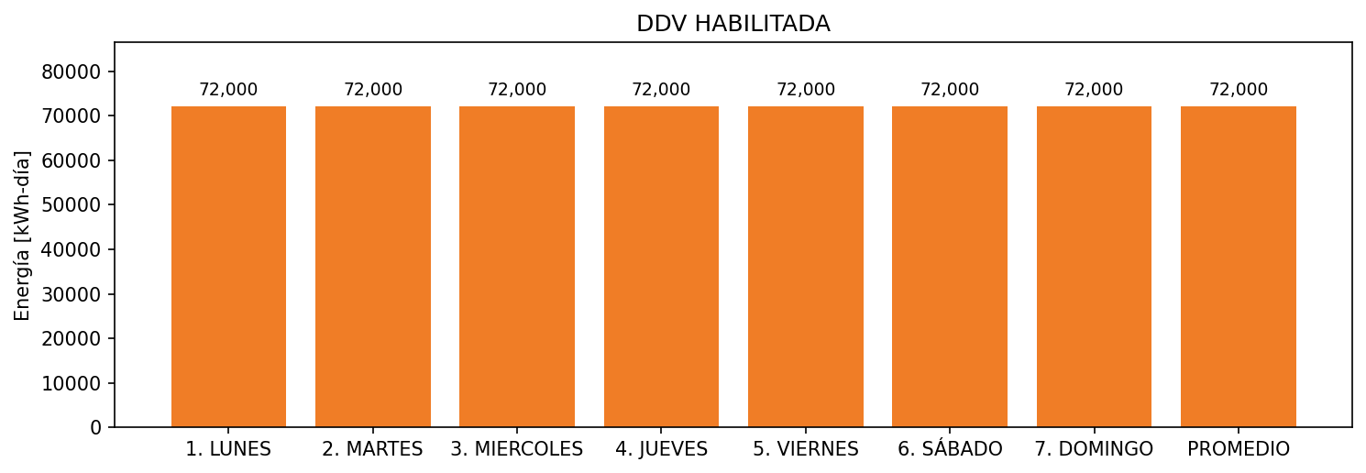

|  |  |  |  |  |  |  |  |  |  |
| --- | --- | --- | --- | --- | --- | --- | --- | --- | --- |
| **FRONTERA** | **COD SIC** | **FRT DDV** | **TIPO DDV** | **PROMEDIO** | **PRÓXIMA ACTUALIZACIÓN** | **MARGEN DE ERROR** | **ÚLTIMA PRUEBA DDV** | **DÍAS PARTICIPACIÓN** | **FECHA REFERENCIA PRÓXIMA PRUEBA DDV** |
| ALBATEQ S.A. FUNZA - 1 | Frt01612 | Frt35702 | GPE | 18,000 | 2023-04-15 | NO APLICA | 2021-10-11 | 12.0 | 2022-02-27 |
| ALBATEQ S.A. FUNZA - 2 | Frt01612 | Frt38700 | GPE | 18,000 | 2023-04-15 | NO APLICA | 2021-10-11 | 12.0 | 2022-02-27 |
| ALBATEQ S.A. FUNZA - 3 | Frt01612 | Frt38701 | GPE | 18,000 | 2023-04-15 | NO APLICA | 2021-10-11 | 12.0 | 2022-02-27 |
| ALBATEQ S.A. FUNZA - 4 | Frt01612 | Frt38702 | GPE | 18,000 | 2023-04-15 | NO APLICA | 2021-10-11 | 12.0 | 2022-02-27 |