|  |  |  |  |
| --- | --- | --- | --- |
| 3 | | 31,800 | |
| **NUMERO DE FRONTERAS** | | **ENERGIA AGREGADA** | |
|  | | | |
| 88,397,682 | 127 | | 3,964,524 |
| INGRESO 2021 | DÍAS CERTIFICADOS 2021 | | ENERGIA RESPALDADA 2021 |

**HISTORICO REINTEGRO DDV**

|  |  |
| --- | --- |
|  | **2021** |
| **ENE** | - |
| **FEB** | - |
| **MAR** | - |
| **ABR** | - |
| **MAY** | 12.39 |
| **JUN** | 17.9 |
| **JUL** | 20.88 |
| **AGO** | 13.97 |
| **SEP** | 11.0 |
| **OCT** | 12.25 |
| **NOV** | - |
| **DIC** | - |

**Los valores de la tabla están en millones de COP**

**REINTEGRO MECANISMO DDV OCTUBRE 2021**

|  |  |  |  |  |  |
| --- | --- | --- | --- | --- | --- |
| FECHA | TIPO DIA | CANTIDADES RESPALDO | PRECIO PONDERADO USD | TRM | PNETO |
| 2021-10-01 | Viernes | 31,795 | 5.98 | 3,784.44 | 644,718 |
| 2021-10-02 | Sábado | 31,795 | 5.98 | 3,784.44 | 644,718 |
| 2021-10-03 | Domingo - Festivo | 31,795 | 5.98 | 3,784.44 | 644,718 |
| 2021-10-04 | Lunes | 31,795 | 5.98 | 3,784.44 | 644,718 |
| 2021-10-05 | Martes | 31,795 | 5.98 | 3,784.44 | 644,718 |
| 2021-10-06 | Miércoles | 31,795 | 5.98 | 3,784.44 | 644,718 |
| 2021-10-07 | Jueves | 31,795 | 5.98 | 3,784.44 | 644,718 |
| 2021-10-08 | Viernes | 31,795 | 5.98 | 3,784.44 | 644,718 |
| 2021-10-09 | Sábado | 31,795 | 5.98 | 3,784.44 | 644,718 |
| 2021-10-10 | Domingo - Festivo | 31,795 | 5.98 | 3,784.44 | 644,718 |
| 2021-10-11 | Lunes | 31,795 | 5.98 | 3,784.44 | 644,718 |
| 2021-10-19 | Martes | 31,795 | 5.98 | 3,784.44 | 644,718 |
| 2021-10-20 | Miércoles | 31,795 | 5.98 | 3,784.44 | 644,718 |
| 2021-10-21 | Jueves | 31,795 | 5.98 | 3,784.44 | 644,718 |
| 2021-10-22 | Viernes | 31,795 | 5.98 | 3,784.44 | 644,718 |
| 2021-10-23 | Sábado | 31,795 | 5.98 | 3,784.44 | 644,718 |
| 2021-10-24 | Domingo - Festivo | 31,795 | 5.98 | 3,784.44 | 644,718 |
| 2021-10-25 | Lunes | 31,795 | 5.98 | 3,784.44 | 644,718 |
| 2021-10-26 | Martes | 31,795 | 5.98 | 3,784.44 | 644,718 |

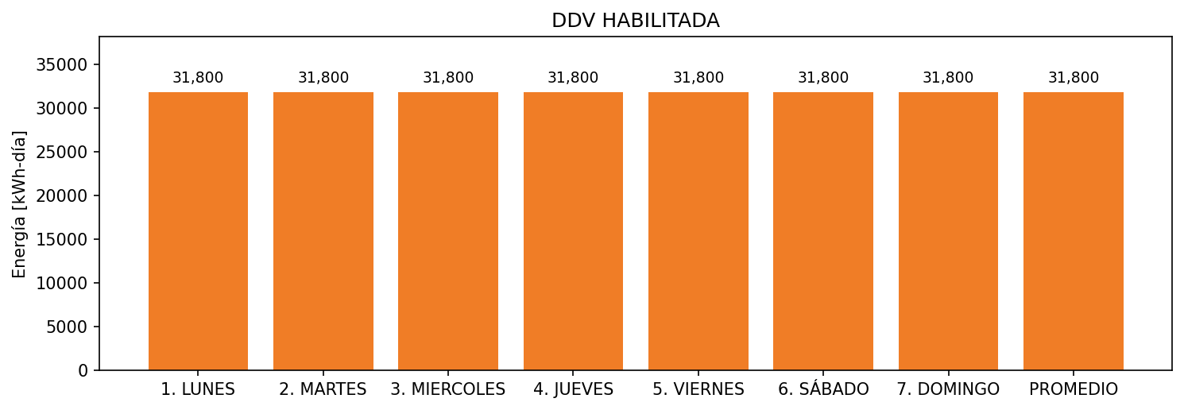

|  |  |  |  |  |  |  |  |  |  |
| --- | --- | --- | --- | --- | --- | --- | --- | --- | --- |
| **FRONTERA** | **COD SIC** | **FRT DDV** | **TIPO DDV** | **PROMEDIO** | **PRÓXIMA ACTUALIZACIÓN** | **MARGEN DE ERROR** | **ÚLTIMA PRUEBA DDV** | **DÍAS PARTICIPACIÓN** | **FECHA REFERENCIA PRÓXIMA PRUEBA DDV** |
| PRODUCTOS NATURALES DE CAJICA S.A LA ALQUERIA - 1 | Frt00875 | Frt39977 | GPE | 16,800 | 2026-04-15 | NO APLICA | 2021-09-06 | 32.0 | 2022-02-07 |
| PRODUCTOS NATURALES DE CAJICA S.A LA ALQUERIA - 2 | Frt00875 | Frt40002 | GPE | 10,200 | 2026-04-15 | NO APLICA | 2021-09-06 | 32.0 | 2022-02-07 |
| PRODUCTOS NATURALES DE CAJICA S.A LA ALQUERIA - 3 | Frt00875 | Frt40003 | GPE | 4,800 | 2026-04-15 | NO APLICA | 2021-09-06 | 32.0 | 2022-02-07 |