|  |  |  |  |
| --- | --- | --- | --- |
| 1 | | 25,272.0 | |
| NUMERO DE FRONTERAS | | ENERGIA AGREGADA | |
|  | | | |
| NO | | 0 | |
| CONTRATO | | VENCIMIENTO CONTRATO | |
|  | | | |
| 58,943,856 | 89 | | 2,087,512 |
| INGRESO 2019 | DÍAS CERTIFICADOS 2019 | | ENERGIA RESPALDADA 2019 |
|  | | | |
| 69,486,959 | 110 | | 2,598,101 |
| INGRESO 2020 | DÍAS CERTIFICADOS 2020 | | ENERGIA RESPALDADA 2020 |
|  | | | |
| 83,501,540 | 143 | | 3,612,422 |
| INGRESO 2021 | DÍAS CERTIFICADOS 2021 | | ENERGIA RESPALDADA 2021 |

|  |
| --- |
| **ALUICA**  USUARIO |

|  |
| --- |
| **Mateo Porras**  Ejecutivo de cuenta |

|  |
| --- |
| **0**  PUNTO FOCAL |

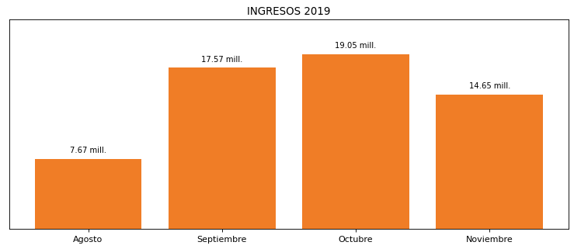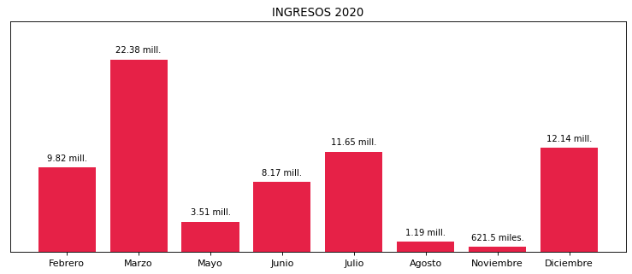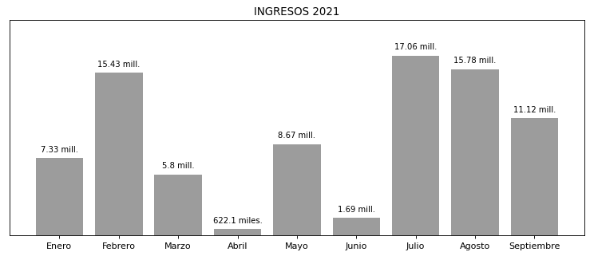

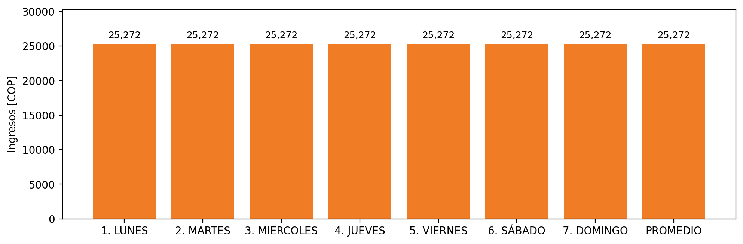

|  |  |  |  |  |  |  |  |  |  |  |
| --- | --- | --- | --- | --- | --- | --- | --- | --- | --- | --- |
| **FRONTERA** | **COD SIC** | **PREDIO** | **FRT DDV** | **TIPO DDV** | **PROMEDIO** | **PRÓXIMA ACTUALIZACIÓN** | **MARGEN DE ERROR** | **ÚLTIMA PRUEBA DDV** | **DÍAS PARTICIPACIÓN** | **FECHA REFERENCIA PRÓXIMA PRUEBA DDV** |
| ALUICA S.A.S. | Frt31204 | Prd01312 | Frt32984 | GPE | 25,272 | 2023-04-15 | NO APLICA | 2021-11-06 | 0.0 | 2022-03-02 |