|  |  |  |  |
| --- | --- | --- | --- |
| 1 | | 25,272 | |
| **NUMERO DE FRONTERAS** | | **ENERGIA AGREGADA** | |
|  | | | |
| 58,943,856 | 89 | | 2,087,512 |
| INGRESO 2019 | DÍAS CERTIFICADOS 2019 | | ENERGIA RESPALDADA 2019 |
|  | | | |
| 69,486,959 | 110 | | 2,598,101 |
| INGRESO 2020 | DÍAS CERTIFICADOS 2020 | | ENERGIA RESPALDADA 2020 |
|  | | | |
| 88,625,561 | 153 | | 3,865,119 |
| INGRESO 2021 | DÍAS CERTIFICADOS 2021 | | ENERGIA RESPALDADA 2021 |

**HISTORICO REINTEGRO DDV**

|  |  |  |  |
| --- | --- | --- | --- |
|  | **2019** | **2020** | **2021** |
| **ENE** | - | - | 7.33 |
| **FEB** | - | 9.82 | 15.43 |
| **MAR** | - | 22.38 | 5.8 |
| **ABR** | - | - | 0.62 |
| **MAY** | - | 3.51 | 8.67 |
| **JUN** | - | 8.17 | 1.69 |
| **JUL** | - | 11.65 | 17.06 |
| **AGO** | 7.67 | 1.19 | 15.78 |
| **SEP** | 17.57 | - | 11.12 |
| **OCT** | 19.05 | - | 5.12 |
| **NOV** | 14.65 | 0.62 | - |
| **DIC** | - | 12.14 | - |

**Los valores de la tabla están en millones de COP**

**REINTEGRO MECANISMO DDV OCTUBRE 2021**

|  |  |  |  |  |  |
| --- | --- | --- | --- | --- | --- |
| FECHA | TIPO DIA | CANTIDADES RESPALDO | PRECIO PONDERADO USD | TRM | PNETO |
| 2021-10-01 | Viernes | 25,271 | 5.98 | 3,784.44 | 512,428 |
| 2021-10-02 | Sábado | 25,270 | 5.98 | 3,784.44 | 512,408 |
| 2021-10-03 | Domingo - Festivo | 25,266 | 5.98 | 3,784.44 | 512,327 |
| 2021-10-04 | Lunes | 25,269 | 5.98 | 3,784.44 | 512,388 |
| 2021-10-05 | Martes | 25,270 | 5.98 | 3,784.44 | 512,408 |
| 2021-10-06 | Miércoles | 25,270 | 5.98 | 3,784.44 | 512,408 |
| 2021-10-07 | Jueves | 25,270 | 5.98 | 3,784.44 | 512,408 |
| 2021-10-08 | Viernes | 25,270 | 5.98 | 3,784.44 | 512,408 |
| 2021-10-09 | Sábado | 25,271 | 5.98 | 3,784.44 | 512,428 |
| 2021-10-28 | Jueves | 25,270 | 5.98 | 3,784.44 | 512,408 |

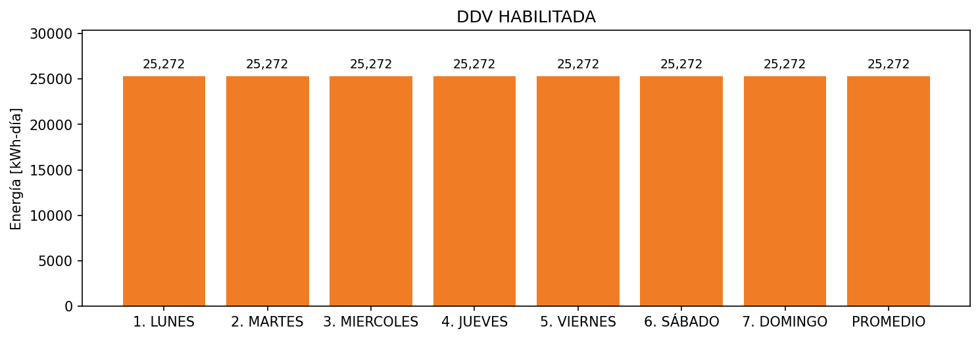

|  |  |  |  |  |  |  |  |  |  |
| --- | --- | --- | --- | --- | --- | --- | --- | --- | --- |
| **FRONTERA** | **COD SIC** | **FRT DDV** | **TIPO DDV** | **PROMEDIO** | **PRÓXIMA ACTUALIZACIÓN** | **MARGEN DE ERROR** | **ÚLTIMA PRUEBA DDV** | **DÍAS PARTICIPACIÓN** | **FECHA REFERENCIA PRÓXIMA PRUEBA DDV** |
| ALUICA S.A.S. | Frt31204 | Frt32984 | GPE | 25,272 | 2023-04-15 | NO APLICA | 2021-11-06 | 0.0 | 2022-03-13 |