|  |  |  |  |
| --- | --- | --- | --- |
| 2 | | 15,600 | |
| **NUMERO DE FRONTERAS** | | **ENERGIA AGREGADA** | |
|  | | | |
| 30,124,847 | 115 | | 1,334,141 |
| INGRESO 2021 | DÍAS CERTIFICADOS 2021 | | ENERGIA RESPALDADA 2021 |

**HISTORICO REINTEGRO DDV**

|  |  |
| --- | --- |
|  | **2021** |
| **ENE** | - |
| **FEB** | - |
| **MAR** | 1.36 |
| **ABR** | 0.66 |
| **MAY** | 5.97 |
| **JUN** | 10.07 |
| **JUL** | 8.59 |
| **AGO** | 2.4 |
| **SEP** | 1.08 |
| **OCT** | - |
| **NOV** | - |
| **DIC** | - |

**Los valores de la tabla están en millones de COP**



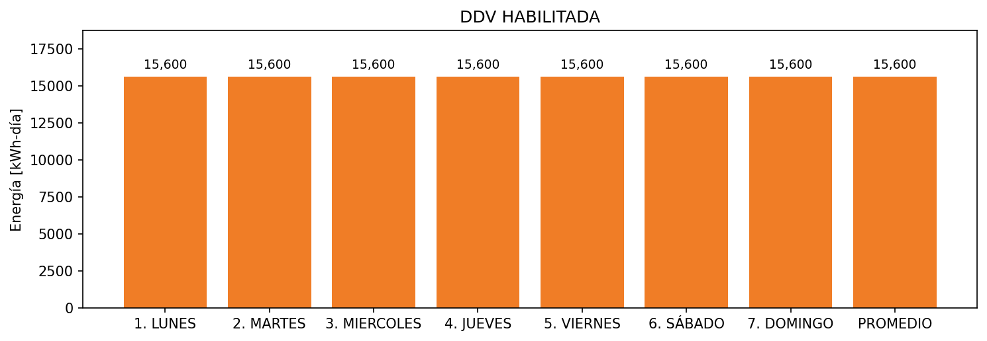

|  |  |  |  |  |  |  |  |  |  |
| --- | --- | --- | --- | --- | --- | --- | --- | --- | --- |
| **FRONTERA** | **COD SIC** | **FRT DDV** | **TIPO DDV** | **PROMEDIO** | **PRÓXIMA ACTUALIZACIÓN** | **MARGEN DE ERROR** | **ÚLTIMA PRUEBA DDV** | **DÍAS PARTICIPACIÓN** | **FECHA REFERENCIA PRÓXIMA PRUEBA DDV** |
| APROPPET REGENERADO | Frt06367 | Frt40365 | MI | 8,928 | 2026-04-15 | NO APLICA | 2021-10-30 | 0.0 | 2022-03-16 |
| APROPPET LAVADO | Frt06367 | Frt40123 | MI | 6,672 | 2026-04-15 | NO APLICA | 2021-04-30 | 82.0 | 2021-12-18 |