|  |  |  |  |
| --- | --- | --- | --- |
| 1 | | 30,000.0 | |
| NUMERO DE FRONTERAS | | ENERGIA AGREGADA | |
|  | | | |
| NO | | 0 | |
| CONTRATO | | VENCIMIENTO CONTRATO | |
|  | | | |
| 89,355,474 | 29 | | 3,744,900 |
| INGRESO 2019 | DÍAS CERTIFICADOS 2019 | | ENERGIA RESPALDADA 2019 |
|  | | | |
| 187,346,891 | 235 | | 7,064,974 |
| INGRESO 2020 | DÍAS CERTIFICADOS 2020 | | ENERGIA RESPALDADA 2020 |
|  | | | |
| 125,121,881 | 150 | | 4,490,256 |
| INGRESO 2021 | DÍAS CERTIFICADOS 2021 | | ENERGIA RESPALDADA 2021 |

|  |
| --- |
| **ARGOS**  USUARIO |

|  |
| --- |
| **Mateo Porras**  Ejecutivo de cuenta |

|  |
| --- |
| **Arbey Angrino Pereira / Jefe Autogeneracion / aangrino@argos.com.co**  PUNTO FOCAL |

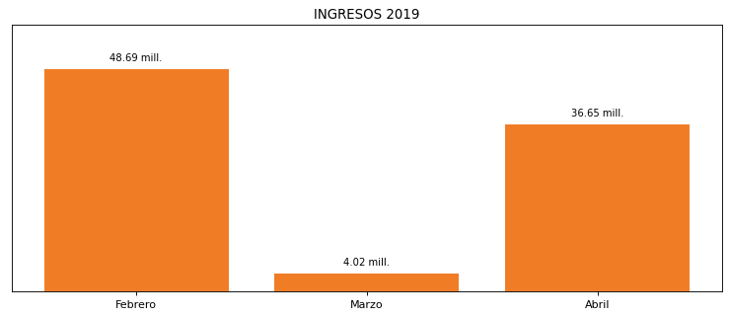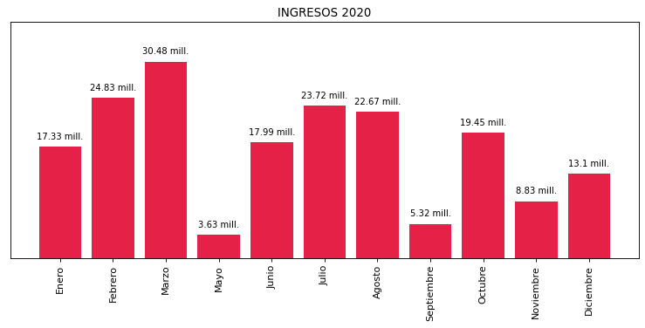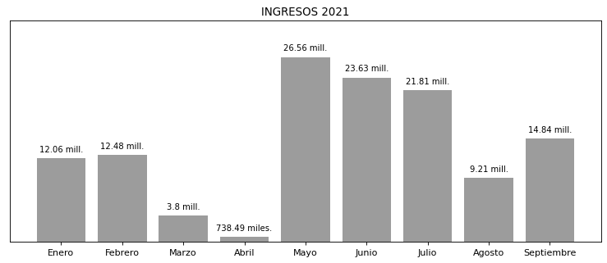

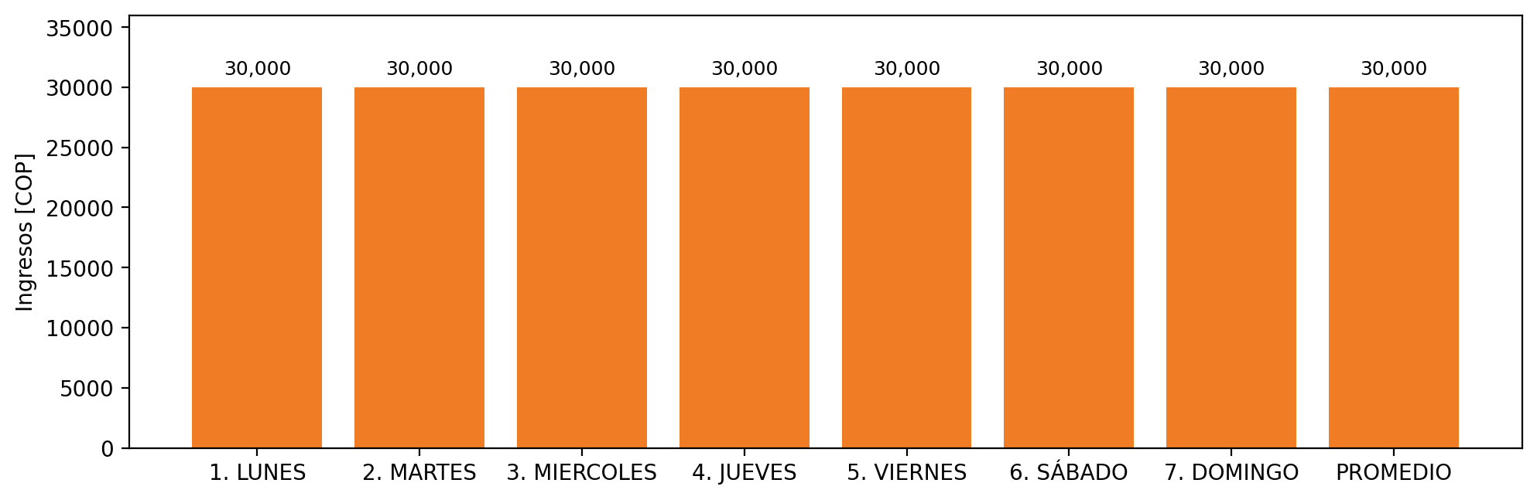

|  |  |  |  |  |  |  |  |  |  |  |
| --- | --- | --- | --- | --- | --- | --- | --- | --- | --- | --- |
| **FRONTERA** | **COD SIC** | **PREDIO** | **FRT DDV** | **TIPO DDV** | **PROMEDIO** | **PRÓXIMA ACTUALIZACIÓN** | **MARGEN DE ERROR** | **ÚLTIMA PRUEBA DDV** | **DÍAS PARTICIPACIÓN** | **FECHA REFERENCIA PRÓXIMA PRUEBA DDV** |
| CEMENTOS ARGOS S.A. (VIA PANORAMA 1) | Frt11133 | Prd01522 | Frt36078 | GPE | 30,000 | 2023-04-15 | NO APLICA | 2021-08-12 | 26.0 | 2022-01-08 |