|  |  |  |  |
| --- | --- | --- | --- |
| 1 | | 30,000 | |
| **NUMERO DE FRONTERAS** | | **ENERGIA AGREGADA** | |
|  | | | |
| 89,355,474 | 29 | | 3,744,900 |
| INGRESO 2019 | DÍAS CERTIFICADOS 2019 | | ENERGIA RESPALDADA 2019 |
|  | | | |
| 187,346,891 | 235 | | 7,064,974 |
| INGRESO 2020 | DÍAS CERTIFICADOS 2020 | | ENERGIA RESPALDADA 2020 |
|  | | | |
| 142,516,007 | 169 | | 5,060,224 |
| INGRESO 2021 | DÍAS CERTIFICADOS 2021 | | ENERGIA RESPALDADA 2021 |

**HISTORICO REINTEGRO DDV**

|  |  |  |  |
| --- | --- | --- | --- |
|  | **2019** | **2020** | **2021** |
| **ENE** | - | 17.33 | 12.06 |
| **FEB** | 48.69 | 24.83 | 12.48 |
| **MAR** | 4.02 | 30.48 | 3.8 |
| **ABR** | 36.65 | - | 0.74 |
| **MAY** | - | 3.63 | 26.56 |
| **JUN** | - | 17.99 | 23.63 |
| **JUL** | - | 23.72 | 21.81 |
| **AGO** | - | 22.67 | 9.21 |
| **SEP** | - | 5.32 | 14.84 |
| **OCT** | - | 19.45 | 17.39 |
| **NOV** | - | 8.83 | - |
| **DIC** | - | 13.1 | - |

**Los valores de la tabla están en millones de COP**

**REINTEGRO MECANISMO DDV OCTUBRE 2021**

|  |  |  |  |  |  |
| --- | --- | --- | --- | --- | --- |
| FECHA | TIPO DIA | CANTIDADES RESPALDO | PRECIO PONDERADO USD | TRM | PNETO |
| 2021-10-01 | Viernes | 29,999 | 9.0 | 3,784.44 | 915,501 |
| 2021-10-02 | Sábado | 29,999 | 9.0 | 3,784.44 | 915,501 |
| 2021-10-04 | Lunes | 29,999 | 9.0 | 3,784.44 | 915,501 |
| 2021-10-05 | Martes | 29,998 | 9.0 | 3,784.44 | 915,471 |
| 2021-10-06 | Miércoles | 29,999 | 9.0 | 3,784.44 | 915,501 |
| 2021-10-07 | Jueves | 29,999 | 9.0 | 3,784.44 | 915,501 |
| 2021-10-08 | Viernes | 29,999 | 9.0 | 3,784.44 | 915,501 |
| 2021-10-11 | Lunes | 29,995 | 9.0 | 3,784.44 | 915,379 |
| 2021-10-15 | Viernes | 29,998 | 9.0 | 3,784.44 | 915,471 |
| 2021-10-16 | Sábado | 29,998 | 9.0 | 3,784.44 | 915,471 |
| 2021-10-18 | Domingo - Festivo | 29,998 | 9.0 | 3,784.44 | 915,471 |
| 2021-10-19 | Martes | 29,999 | 9.0 | 3,784.44 | 915,501 |
| 2021-10-25 | Lunes | 29,999 | 9.0 | 3,784.44 | 915,501 |
| 2021-10-26 | Martes | 29,999 | 9.0 | 3,784.44 | 915,501 |
| 2021-10-27 | Miércoles | 29,998 | 9.0 | 3,784.44 | 915,471 |
| 2021-10-28 | Jueves | 29,998 | 9.0 | 3,784.44 | 915,471 |
| 2021-10-29 | Viernes | 29,998 | 9.0 | 3,784.44 | 915,471 |
| 2021-10-30 | Sábado | 29,998 | 9.0 | 3,784.44 | 915,471 |
| 2021-10-31 | Domingo - Festivo | 29,998 | 9.0 | 3,784.44 | 915,471 |

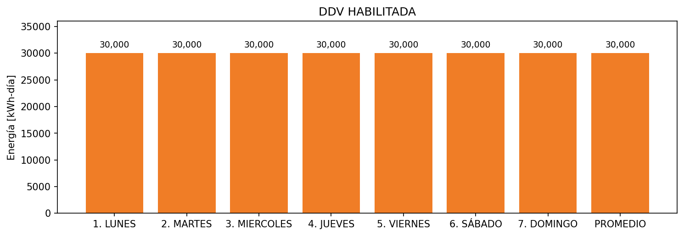

|  |  |  |  |  |  |  |  |  |  |
| --- | --- | --- | --- | --- | --- | --- | --- | --- | --- |
| **FRONTERA** | **COD SIC** | **FRT DDV** | **TIPO DDV** | **PROMEDIO** | **PRÓXIMA ACTUALIZACIÓN** | **MARGEN DE ERROR** | **ÚLTIMA PRUEBA DDV** | **DÍAS PARTICIPACIÓN** | **FECHA REFERENCIA PRÓXIMA PRUEBA DDV** |
| CEMENTOS ARGOS S.A. (VIA PANORAMA 1) | Frt11133 | Frt36078 | GPE | 30,000 | 2023-04-15 | NO APLICA | 2021-08-12 | 45.0 | 2022-01-23 |