|  |  |  |  |
| --- | --- | --- | --- |
| 1 | | 23,075 | |
| **NUMERO DE FRONTERAS** | | **ENERGIA AGREGADA** | |
|  | | | |
| 13,232,732 | 25 | | 606,000 |
| INGRESO 2020 | DÍAS CERTIFICADOS 2020 | | ENERGIA RESPALDADA 2020 |
|  | | | |
| 91,276,731 | 167 | | 3,995,195 |
| INGRESO 2021 | DÍAS CERTIFICADOS 2021 | | ENERGIA RESPALDADA 2021 |

**HISTORICO REINTEGRO DDV**

|  |  |  |
| --- | --- | --- |
|  | **2020** | **2021** |
| **ENE** | - | 12.46 |
| **FEB** | - | 11.39 |
| **MAR** | - | 11.74 |
| **ABR** | - | 1.19 |
| **MAY** | - | 6.76 |
| **JUN** | - | 10.89 |
| **JUL** | - | 9.2 |
| **AGO** | - | 8.98 |
| **SEP** | - | 12.08 |
| **OCT** | - | 6.58 |
| **NOV** | - | - |
| **DIC** | 13.23 | - |

**Los valores de la tabla están en millones de COP**

**REINTEGRO MECANISMO DDV OCTUBRE 2021**

|  |  |  |  |  |  |
| --- | --- | --- | --- | --- | --- |
| FECHA | TIPO DIA | CANTIDADES RESPALDO | PRECIO PONDERADO USD | TRM | PNETO |
| 2021-10-06 | Miércoles | 23,442 | 5.98 | 3,784.44 | 475,341 |
| 2021-10-07 | Jueves | 23,158 | 5.98 | 3,784.44 | 469,582 |
| 2021-10-08 | Viernes | 22,942 | 5.98 | 3,784.44 | 465,203 |
| 2021-10-11 | Lunes | 23,518 | 5.98 | 3,784.44 | 476,882 |
| 2021-10-12 | Martes | 23,226 | 5.98 | 3,784.44 | 470,961 |
| 2021-10-13 | Miércoles | 23,374 | 5.98 | 3,784.44 | 473,962 |
| 2021-10-19 | Martes | 23,230 | 5.98 | 3,784.44 | 471,042 |
| 2021-10-25 | Lunes | 23,158 | 5.98 | 3,784.44 | 469,582 |
| 2021-10-26 | Martes | 22,894 | 5.98 | 3,784.44 | 464,229 |
| 2021-10-27 | Miércoles | 22,942 | 5.98 | 3,784.44 | 465,203 |
| 2021-10-28 | Jueves | 23,182 | 5.98 | 3,784.44 | 470,069 |
| 2021-10-29 | Viernes | 23,110 | 5.98 | 3,784.44 | 468,609 |
| 2021-10-30 | Sábado | 23,134 | 5.98 | 3,784.44 | 469,096 |
| 2021-10-31 | Domingo - Festivo | 23,014 | 5.98 | 3,784.44 | 466,663 |

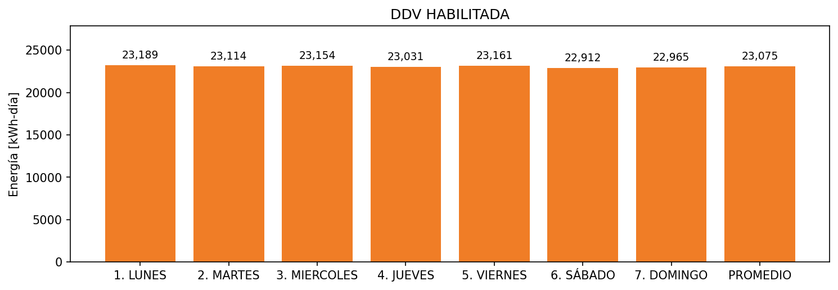

|  |  |  |  |  |  |  |  |  |  |
| --- | --- | --- | --- | --- | --- | --- | --- | --- | --- |
| **FRONTERA** | **COD SIC** | **FRT DDV** | **TIPO DDV** | **PROMEDIO** | **PRÓXIMA ACTUALIZACIÓN** | **MARGEN DE ERROR** | **ÚLTIMA PRUEBA DDV** | **DÍAS PARTICIPACIÓN** | **FECHA REFERENCIA PRÓXIMA PRUEBA DDV** |
| BANCOLOMBIA S.A. - BELLO NIVEL 3 | Frt11189 | Frt39834 | LBC | 23,075 | 2022-01-28 | 0,82 | 2021-09-27 | 14.0 | 2022-02-20 |