|  |  |  |  |
| --- | --- | --- | --- |
| 1 | | 67,632 | |
| **NUMERO DE FRONTERAS** | | **ENERGIA AGREGADA** | |







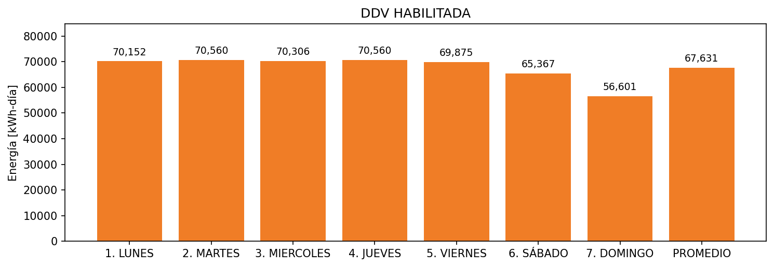

|  |  |  |  |  |  |  |  |  |  |
| --- | --- | --- | --- | --- | --- | --- | --- | --- | --- |
| **FRONTERA** | **COD SIC** | **FRT DDV** | **TIPO DDV** | **PROMEDIO** | **PRÓXIMA ACTUALIZACIÓN** | **MARGEN DE ERROR** | **ÚLTIMA PRUEBA DDV** | **DÍAS PARTICIPACIÓN** | **FECHA REFERENCIA PRÓXIMA PRUEBA DDV** |
| LABORATORIOS BAXTER S.A. | Frt11055 | Frt36456 | LBC | 67,631 | 2022-01-19 | 3,65 | 2021-11-18 | 0.0 | 2022-03-14 |