|  |  |  |  |
| --- | --- | --- | --- |
| 1 | | 44,447.0 | |
| NUMERO DE FRONTERAS | | ENERGIA AGREGADA | |
|  | | | |
| NO | | 0 | |
| CONTRATO | | VENCIMIENTO CONTRATO | |
|  | | | |
| 45,076,604 | 51 | | 1,950,965 |
| INGRESO 2020 | DÍAS CERTIFICADOS 2020 | | ENERGIA RESPALDADA 2020 |
|  | | | |
| 96,237,642 | 108 | | 4,123,118 |
| INGRESO 2021 | DÍAS CERTIFICADOS 2021 | | ENERGIA RESPALDADA 2021 |

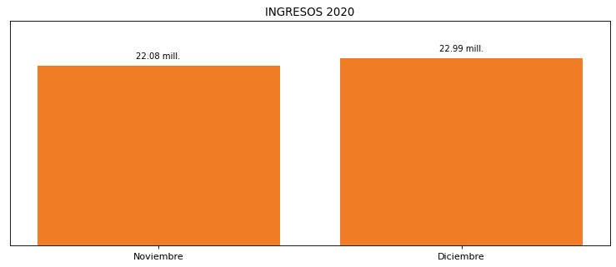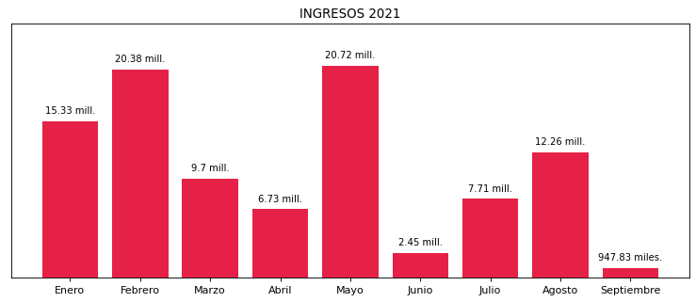

|  |
| --- |
| **CAMAGUEY**  USUARIO |

|  |
| --- |
| **Edwin Torres**  Ejecutivo de cuenta |

|  |
| --- |
| **0**  PUNTO FOCAL |

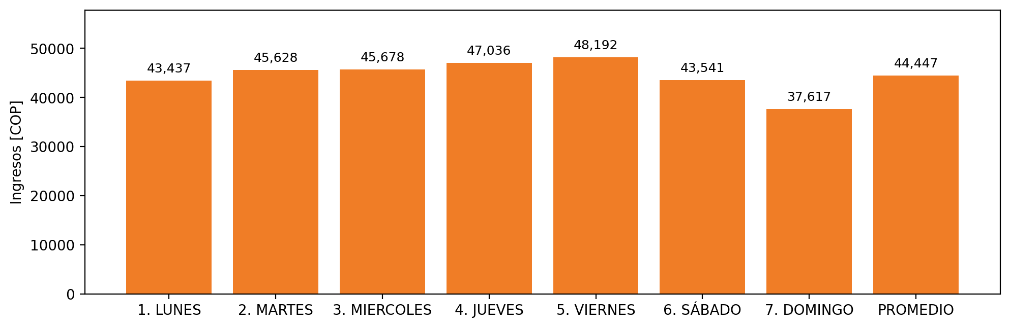

|  |  |  |  |  |  |  |  |  |  |  |
| --- | --- | --- | --- | --- | --- | --- | --- | --- | --- | --- |
| **FRONTERA** | **COD SIC** | **PREDIO** | **FRT DDV** | **TIPO DDV** | **PROMEDIO** | **PRÓXIMA ACTUALIZACIÓN** | **MARGEN DE ERROR** | **ÚLTIMA PRUEBA DDV** | **DÍAS PARTICIPACIÓN** | **FECHA REFERENCIA PRÓXIMA PRUEBA DDV** |
| CAMAGUEY | Frt00823 | Prd02127 | Frt39415 | LBC | 44,447 | 2021-12-09 | 4,66 | 2021-10-08 | 0.0 | 2022-02-09 |