|  |  |  |  |
| --- | --- | --- | --- |
| 1 | | 44,447 | |
| **NUMERO DE FRONTERAS** | | **ENERGIA AGREGADA** | |
|  | | | |
| 45,076,604 | 51 | | 1,950,965 |
| INGRESO 2020 | DÍAS CERTIFICADOS 2020 | | ENERGIA RESPALDADA 2020 |
|  | | | |
| 107,780,716 | 121 | | 4,692,378 |
| INGRESO 2021 | DÍAS CERTIFICADOS 2021 | | ENERGIA RESPALDADA 2021 |

**HISTORICO REINTEGRO DDV**

|  |  |  |
| --- | --- | --- |
|  | **2020** | **2021** |
| **ENE** | - | 15.33 |
| **FEB** | - | 20.38 |
| **MAR** | - | 9.7 |
| **ABR** | - | 6.73 |
| **MAY** | - | 20.72 |
| **JUN** | - | 2.45 |
| **JUL** | - | 7.71 |
| **AGO** | - | 12.26 |
| **SEP** | - | 0.95 |
| **OCT** | - | 11.54 |
| **NOV** | 22.08 | - |
| **DIC** | 22.99 | - |

**Los valores de la tabla están en millones de COP**

**REINTEGRO MECANISMO DDV OCTUBRE 2021**

|  |  |  |  |  |  |
| --- | --- | --- | --- | --- | --- |
| FECHA | TIPO DIA | CANTIDADES RESPALDO | PRECIO PONDERADO USD | TRM | PNETO |
| 2021-10-18 | Domingo - Festivo | 40,941 | 5.98 | 3,784.44 | 830,174 |
| 2021-10-19 | Martes | 40,941 | 5.98 | 3,784.44 | 830,174 |
| 2021-10-20 | Miércoles | 47,012 | 5.98 | 3,784.44 | 953,278 |
| 2021-10-21 | Jueves | 48,188 | 5.98 | 3,784.44 | 977,124 |
| 2021-10-22 | Viernes | 43,533 | 5.98 | 3,784.44 | 882,733 |
| 2021-10-23 | Sábado | 37,605 | 5.98 | 3,784.44 | 762,529 |
| 2021-10-24 | Domingo - Festivo | 43,413 | 5.98 | 3,784.44 | 880,300 |
| 2021-10-25 | Lunes | 45,620 | 5.98 | 3,784.44 | 925,052 |
| 2021-10-26 | Martes | 45,669 | 5.98 | 3,784.44 | 926,045 |
| 2021-10-27 | Miércoles | 47,012 | 5.98 | 3,784.44 | 953,278 |
| 2021-10-28 | Jueves | 48,188 | 5.98 | 3,784.44 | 977,124 |
| 2021-10-29 | Viernes | 43,533 | 5.98 | 3,784.44 | 882,733 |
| 2021-10-30 | Sábado | 37,605 | 5.98 | 3,784.44 | 762,529 |

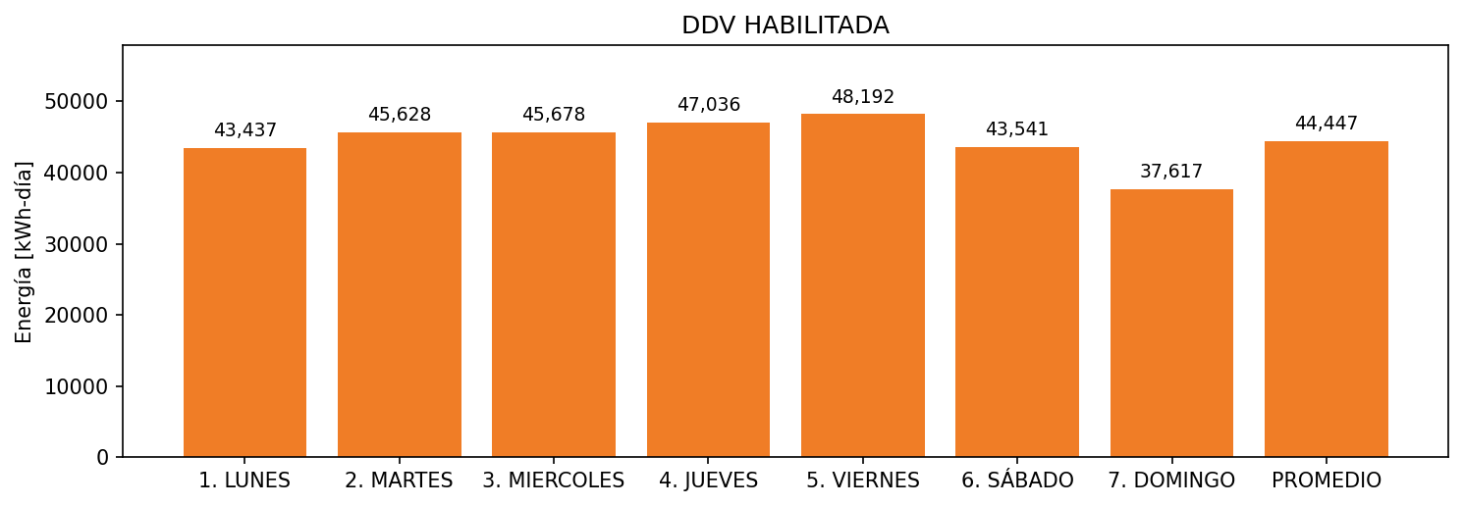

|  |  |  |  |  |  |  |  |  |  |
| --- | --- | --- | --- | --- | --- | --- | --- | --- | --- |
| **FRONTERA** | **COD SIC** | **FRT DDV** | **TIPO DDV** | **PROMEDIO** | **PRÓXIMA ACTUALIZACIÓN** | **MARGEN DE ERROR** | **ÚLTIMA PRUEBA DDV** | **DÍAS PARTICIPACIÓN** | **FECHA REFERENCIA PRÓXIMA PRUEBA DDV** |
| CAMAGUEY | Frt00823 | Frt39415 | LBC | 44,447 | 2021-12-09 | 4,66 | 2021-10-08 | 13.0 | 2022-02-21 |