|  |  |  |  |
| --- | --- | --- | --- |
| 1 | | 235,244 | |
| **NUMERO DE FRONTERAS** | | **ENERGIA AGREGADA** | |
|  | | | |
| 815,362,813 | 92 | | 32,503,487 |
| INGRESO 2019 | DÍAS CERTIFICADOS 2019 | | ENERGIA RESPALDADA 2019 |
|  | | | |
| 491,704,649 | 88 | | 20,190,048 |
| INGRESO 2020 | DÍAS CERTIFICADOS 2020 | | ENERGIA RESPALDADA 2020 |
|  | | | |
| 768,958,420 | 145 | | 33,987,625 |
| INGRESO 2021 | DÍAS CERTIFICADOS 2021 | | ENERGIA RESPALDADA 2021 |

**HISTORICO REINTEGRO DDV**

|  |  |  |  |
| --- | --- | --- | --- |
|  | **2019** | **2020** | **2021** |
| **ENE** | - | - | 44.13 |
| **FEB** | 162.2 | - | 104.25 |
| **MAR** | 10.76 | - | 32.65 |
| **ABR** | 142.56 | - | 5.29 |
| **MAY** | 161.32 | - | 81.49 |
| **JUN** | 147.79 | - | 63.28 |
| **JUL** | 190.73 | - | 125.99 |
| **AGO** | - | 41.11 | 71.47 |
| **SEP** | - | 44.67 | 152.39 |
| **OCT** | - | 171.32 | 88.01 |
| **NOV** | - | 104.68 | - |
| **DIC** | - | 129.92 | - |

**Los valores de la tabla están en millones de COP**

**REINTEGRO MECANISMO DDV OCTUBRE 2021**

|  |  |  |  |  |  |
| --- | --- | --- | --- | --- | --- |
| FECHA | TIPO DIA | CANTIDADES RESPALDO | PRECIO PONDERADO USD | TRM | PNETO |
| 2021-10-05 | Martes | 231,344 | 5.98 | 3,784.44 | 4,691,039 |
| 2021-10-06 | Miércoles | 231,307 | 5.98 | 3,784.44 | 4,690,289 |
| 2021-10-07 | Jueves | 231,345 | 5.98 | 3,784.44 | 4,691,059 |
| 2021-10-08 | Viernes | 231,345 | 5.98 | 3,784.44 | 4,691,059 |
| 2021-10-09 | Sábado | 199,529 | 5.98 | 3,784.44 | 4,045,916 |
| 2021-10-10 | Domingo - Festivo | 235,315 | 5.98 | 3,784.44 | 4,771,560 |
| 2021-10-11 | Lunes | 231,352 | 5.98 | 3,784.44 | 4,691,201 |
| 2021-10-12 | Martes | 235,352 | 5.98 | 3,784.44 | 4,772,311 |
| 2021-10-13 | Miércoles | 235,352 | 5.98 | 3,784.44 | 4,772,311 |
| 2021-10-14 | Jueves | 235,352 | 5.98 | 3,784.44 | 4,772,311 |
| 2021-10-19 | Martes | 235,352 | 5.98 | 3,784.44 | 4,772,311 |
| 2021-10-20 | Miércoles | 235,352 | 5.98 | 3,784.44 | 4,772,311 |
| 2021-10-21 | Jueves | 199,522 | 5.98 | 3,784.44 | 4,045,774 |
| 2021-10-22 | Viernes | 231,345 | 5.98 | 3,784.44 | 4,691,059 |
| 2021-10-23 | Sábado | 235,352 | 5.98 | 3,784.44 | 4,772,311 |
| 2021-10-24 | Domingo - Festivo | 199,523 | 5.98 | 3,784.44 | 4,045,794 |
| 2021-10-25 | Lunes | 235,352 | 5.98 | 3,784.44 | 4,772,311 |
| 2021-10-26 | Martes | 235,352 | 5.98 | 3,784.44 | 4,772,311 |
| 2021-10-27 | Miércoles | 235,352 | 5.98 | 3,784.44 | 4,772,311 |

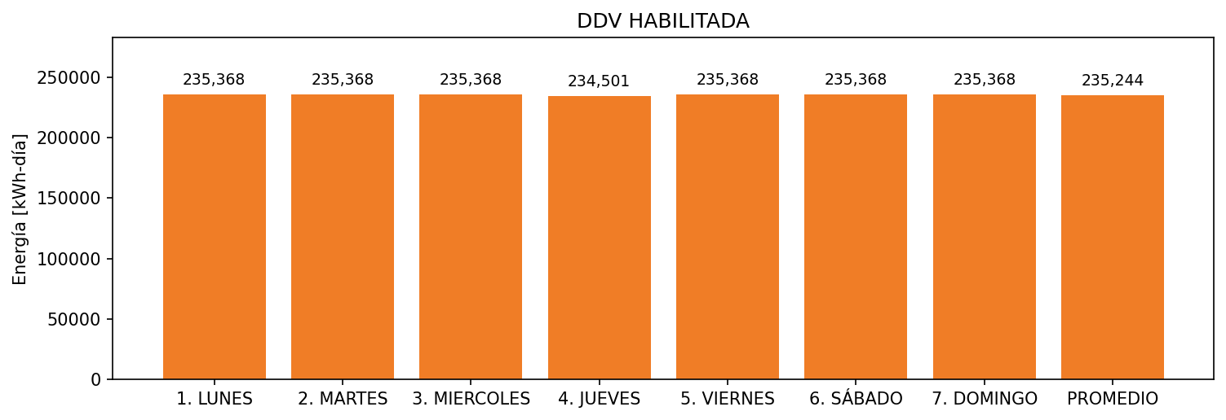

|  |  |  |  |  |  |  |  |  |  |
| --- | --- | --- | --- | --- | --- | --- | --- | --- | --- |
| **FRONTERA** | **COD SIC** | **FRT DDV** | **TIPO DDV** | **PROMEDIO** | **PRÓXIMA ACTUALIZACIÓN** | **MARGEN DE ERROR** | **ÚLTIMA PRUEBA DDV** | **DÍAS PARTICIPACIÓN** | **FECHA REFERENCIA PRÓXIMA PRUEBA DDV** |
| CARVAJAL PULPA Y PAPEL S.A. | Frt11025 | Frt30291 | LBC | 235,244 | 2022-02-25 | 2,59 | 2021-10-06 | 18.0 | 2022-02-20 |