|  |  |  |  |
| --- | --- | --- | --- |
| 1 | | 389,978.71428571426 | |
| NUMERO DE FRONTERAS | | ENERGIA AGREGADA | |
|  | | | |
| NO | | 0 | |
| CONTRATO | | VENCIMIENTO CONTRATO | |
|  | | | |
| 1,811,268,622 | 160 | | 66,762,034 |
| INGRESO 2019 | DÍAS CERTIFICADOS 2019 | | ENERGIA RESPALDADA 2019 |
|  | | | |
| 2,658,195,999 | 248 | | 98,157,011 |
| INGRESO 2020 | DÍAS CERTIFICADOS 2020 | | ENERGIA RESPALDADA 2020 |
|  | | | |
| 1,599,788,615 | 167 | | 68,029,774 |
| INGRESO 2021 | DÍAS CERTIFICADOS 2021 | | ENERGIA RESPALDADA 2021 |

|  |
| --- |
| **CEPSA**  USUARIO |

|  |
| --- |
| **Mateo Porras**  Ejecutivo de cuenta |

|  |
| --- |
| **Fernando Sandoval / Coordinador área Mantenimiento e Integridad / fernando.sandoval@cepsa.com**  PUNTO FOCAL |

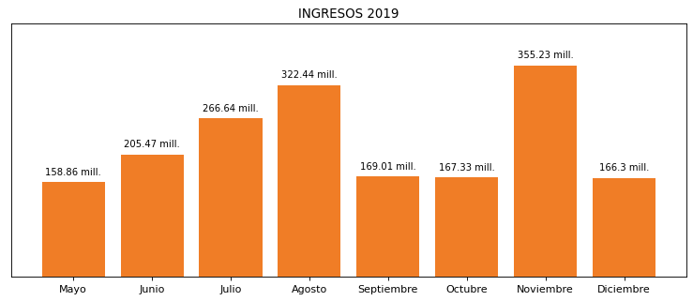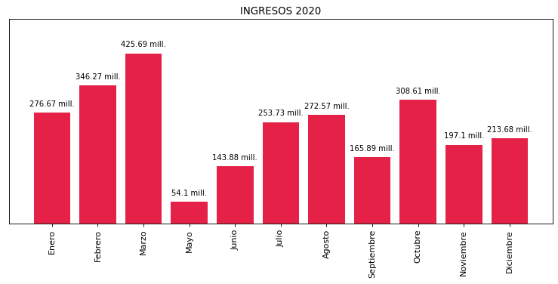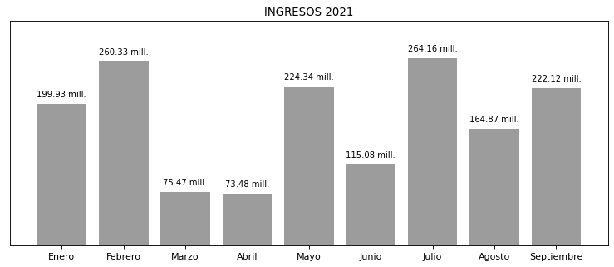

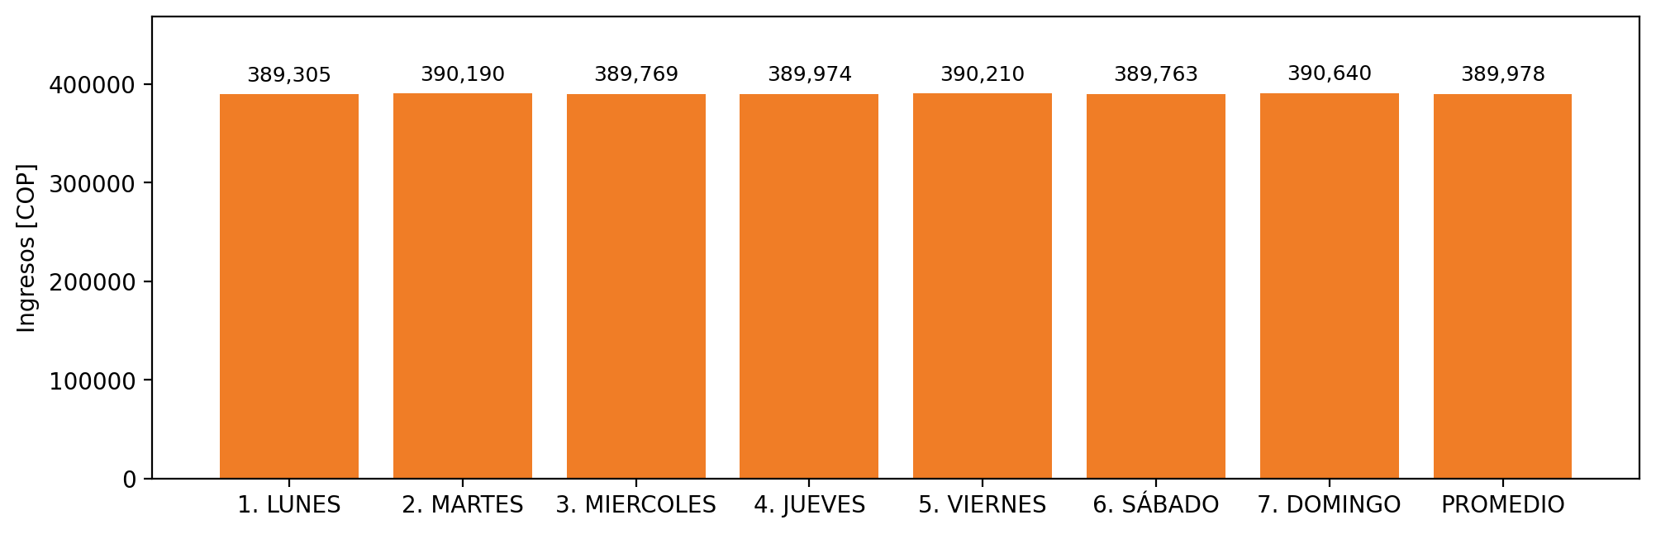

|  |  |  |  |  |  |  |  |  |  |  |
| --- | --- | --- | --- | --- | --- | --- | --- | --- | --- | --- |
| **FRONTERA** | **COD SIC** | **PREDIO** | **FRT DDV** | **TIPO DDV** | **PROMEDIO** | **PRÓXIMA ACTUALIZACIÓN** | **MARGEN DE ERROR** | **ÚLTIMA PRUEBA DDV** | **DÍAS PARTICIPACIÓN** | **FECHA REFERENCIA PRÓXIMA PRUEBA DDV** |
| CEPCOLSA | Frt11545 | Prd01278 | Frt32701 | LBC | 389,978 | 2022-01-22 | 1,36 | 2021-10-02 | 0.0 | 2022-02-10 |