|  |  |  |  |
| --- | --- | --- | --- |
| 1 | | 389,979 | |
| **NUMERO DE FRONTERAS** | | **ENERGIA AGREGADA** | |
|  | | | |
| 1,811,268,622 | 160 | | 66,762,034 |
| INGRESO 2019 | DÍAS CERTIFICADOS 2019 | | ENERGIA RESPALDADA 2019 |
|  | | | |
| 2,658,195,999 | 248 | | 98,157,011 |
| INGRESO 2020 | DÍAS CERTIFICADOS 2020 | | ENERGIA RESPALDADA 2020 |
|  | | | |
| 1,753,513,994 | 186 | | 75,445,391 |
| INGRESO 2021 | DÍAS CERTIFICADOS 2021 | | ENERGIA RESPALDADA 2021 |

**HISTORICO REINTEGRO DDV**

|  |  |  |  |
| --- | --- | --- | --- |
|  | **2019** | **2020** | **2021** |
| **ENE** | - | 276.67 | 199.93 |
| **FEB** | - | 346.27 | 260.33 |
| **MAR** | - | 425.69 | 75.47 |
| **ABR** | - | - | 73.48 |
| **MAY** | 158.86 | 54.1 | 224.34 |
| **JUN** | 205.47 | 143.88 | 115.08 |
| **JUL** | 266.64 | 253.73 | 264.16 |
| **AGO** | 322.44 | 272.57 | 164.87 |
| **SEP** | 169.01 | 165.89 | 222.12 |
| **OCT** | 167.33 | 308.61 | 153.73 |
| **NOV** | 355.23 | 197.1 | - |
| **DIC** | 166.3 | 213.68 | - |

**Los valores de la tabla están en millones de COP**

**REINTEGRO MECANISMO DDV OCTUBRE 2021**

|  |  |  |  |  |  |
| --- | --- | --- | --- | --- | --- |
| FECHA | TIPO DIA | CANTIDADES RESPALDO | PRECIO PONDERADO USD | TRM | PNETO |
| 2021-10-01 | Viernes | 396,515 | 5.98 | 3,784.44 | 8,219,737 |
| 2021-10-06 | Miércoles | 394,159 | 5.98 | 3,784.44 | 8,170,897 |
| 2021-10-07 | Jueves | 393,405 | 5.98 | 3,784.44 | 8,155,266 |
| 2021-10-08 | Viernes | 394,989 | 5.98 | 3,784.44 | 8,188,103 |
| 2021-10-09 | Sábado | 394,687 | 5.98 | 3,784.44 | 8,181,842 |
| 2021-10-10 | Domingo - Festivo | 371,988 | 5.98 | 3,784.44 | 7,711,293 |
| 2021-10-19 | Martes | 390,142 | 5.98 | 3,784.44 | 8,087,625 |
| 2021-10-20 | Miércoles | 390,598 | 5.98 | 3,784.44 | 8,097,078 |
| 2021-10-21 | Jueves | 389,926 | 5.98 | 3,784.44 | 8,083,147 |
| 2021-10-22 | Viernes | 390,166 | 5.98 | 3,784.44 | 8,088,122 |
| 2021-10-23 | Sábado | 389,732 | 5.98 | 3,784.44 | 8,079,125 |
| 2021-10-24 | Domingo - Festivo | 390,596 | 5.98 | 3,784.44 | 8,097,036 |
| 2021-10-25 | Lunes | 389,278 | 5.98 | 3,784.44 | 8,069,714 |
| 2021-10-26 | Martes | 390,142 | 5.98 | 3,784.44 | 8,087,625 |
| 2021-10-27 | Miércoles | 389,734 | 5.98 | 3,784.44 | 8,079,167 |
| 2021-10-28 | Jueves | 389,926 | 5.98 | 3,784.44 | 8,083,147 |
| 2021-10-29 | Viernes | 390,166 | 5.98 | 3,784.44 | 8,088,122 |
| 2021-10-30 | Sábado | 389,734 | 5.98 | 3,784.44 | 8,079,167 |
| 2021-10-31 | Domingo - Festivo | 389,734 | 5.98 | 3,784.44 | 8,079,167 |

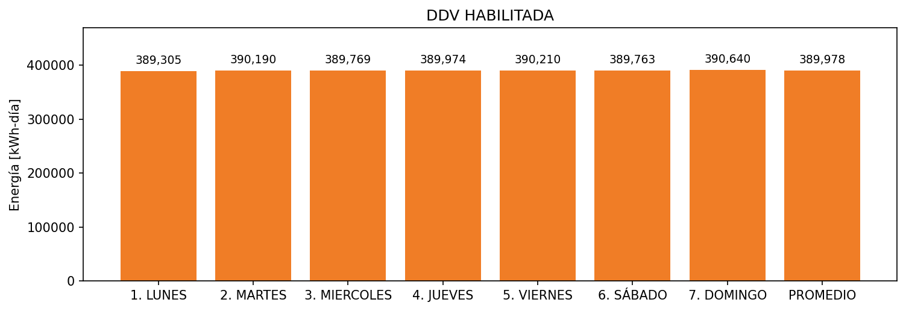

|  |  |  |  |  |  |  |  |  |  |
| --- | --- | --- | --- | --- | --- | --- | --- | --- | --- |
| **FRONTERA** | **COD SIC** | **FRT DDV** | **TIPO DDV** | **PROMEDIO** | **PRÓXIMA ACTUALIZACIÓN** | **MARGEN DE ERROR** | **ÚLTIMA PRUEBA DDV** | **DÍAS PARTICIPACIÓN** | **FECHA REFERENCIA PRÓXIMA PRUEBA DDV** |
| CEPCOLSA | Frt11545 | Frt32701 | LBC | 389,978 | 2022-01-22 | 1,36 | 2021-10-02 | 18.0 | 2022-02-20 |