|  |  |  |  |
| --- | --- | --- | --- |
| 1 | | 96,925.71428571429 | |
| NUMERO DE FRONTERAS | | ENERGIA AGREGADA | |
|  | | | |
| SI | | 04/09/2020 | |
| CONTRATO | | VENCIMIENTO CONTRATO | |
|  | | | |
| 286,225,123 | 132 | | 12,456,131 |
| INGRESO 2021 | DÍAS CERTIFICADOS 2021 | | ENERGIA RESPALDADA 2021 |

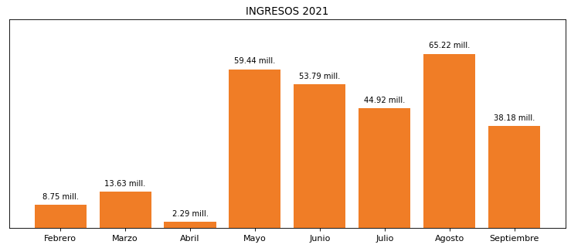

|  |
| --- |
| **CRYOGAS**  USUARIO |

|  |
| --- |
| **Camilo Bermudez**  Ejecutivo de cuenta |

|  |
| --- |
| **0**  PUNTO FOCAL |

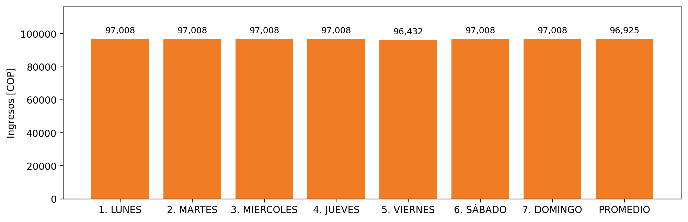

|  |  |  |  |  |  |  |  |  |  |  |
| --- | --- | --- | --- | --- | --- | --- | --- | --- | --- | --- |
| **FRONTERA** | **COD SIC** | **PREDIO** | **FRT DDV** | **TIPO DDV** | **PROMEDIO** | **PRÓXIMA ACTUALIZACIÓN** | **MARGEN DE ERROR** | **ÚLTIMA PRUEBA DDV** | **DÍAS PARTICIPACIÓN** | **FECHA REFERENCIA PRÓXIMA PRUEBA DDV** |
| GASES INDUSTRIALES DE COLOMBIA S.A. - CRYOGAS | Frt00688 | Prd01446 | Frt34406 | LBC | 96,925 | 2022-02-09 | 2,6 | 2021-07-21 | 50.0 | 2021-12-08 |