|  |  |  |  |
| --- | --- | --- | --- |
| 1 | | 97,873 | |
| **NUMERO DE FRONTERAS** | | **ENERGIA AGREGADA** | |
|  | | | |
| 321,625,229 | 150 | | 14,201,928 |
| INGRESO 2021 | DÍAS CERTIFICADOS 2021 | | ENERGIA RESPALDADA 2021 |

**HISTORICO REINTEGRO DDV**

|  |  |
| --- | --- |
|  | **2021** |
| **ENE** | - |
| **FEB** | 8.75 |
| **MAR** | 13.63 |
| **ABR** | 2.29 |
| **MAY** | 59.44 |
| **JUN** | 53.79 |
| **JUL** | 44.92 |
| **AGO** | 65.22 |
| **SEP** | 38.18 |
| **OCT** | 35.4 |
| **NOV** | - |
| **DIC** | - |

**Los valores de la tabla están en millones de COP**

**REINTEGRO MECANISMO DDV OCTUBRE 2021**

|  |  |  |  |  |  |
| --- | --- | --- | --- | --- | --- |
| FECHA | TIPO DIA | CANTIDADES RESPALDO | PRECIO PONDERADO USD | TRM | PNETO |
| 2021-10-01 | Viernes | 97,004 | 5.98 | 3,784.44 | 1,966,982 |
| 2021-10-02 | Sábado | 97,002 | 5.98 | 3,784.44 | 1,966,942 |
| 2021-10-03 | Domingo - Festivo | 97,002 | 5.98 | 3,784.44 | 1,966,942 |
| 2021-10-04 | Lunes | 97,002 | 5.98 | 3,784.44 | 1,966,942 |
| 2021-10-05 | Martes | 97,002 | 5.98 | 3,784.44 | 1,966,942 |
| 2021-10-06 | Miércoles | 97,002 | 5.98 | 3,784.44 | 1,966,942 |
| 2021-10-07 | Jueves | 97,002 | 5.98 | 3,784.44 | 1,966,942 |
| 2021-10-08 | Viernes | 97,002 | 5.98 | 3,784.44 | 1,966,942 |
| 2021-10-09 | Sábado | 97,004 | 5.98 | 3,784.44 | 1,966,982 |
| 2021-10-11 | Lunes | 97,001 | 5.98 | 3,784.44 | 1,966,922 |
| 2021-10-12 | Martes | 97,001 | 5.98 | 3,784.44 | 1,966,922 |
| 2021-10-13 | Miércoles | 97,001 | 5.98 | 3,784.44 | 1,966,922 |
| 2021-10-14 | Jueves | 97,001 | 5.98 | 3,784.44 | 1,966,922 |
| 2021-10-15 | Viernes | 96,881 | 5.98 | 3,784.44 | 1,964,488 |
| 2021-10-19 | Martes | 96,884 | 5.98 | 3,784.44 | 1,964,549 |
| 2021-10-20 | Miércoles | 97,004 | 5.98 | 3,784.44 | 1,966,982 |
| 2021-10-21 | Jueves | 97,001 | 5.98 | 3,784.44 | 1,966,922 |
| 2021-10-25 | Lunes | 97,001 | 5.98 | 3,784.44 | 1,966,922 |

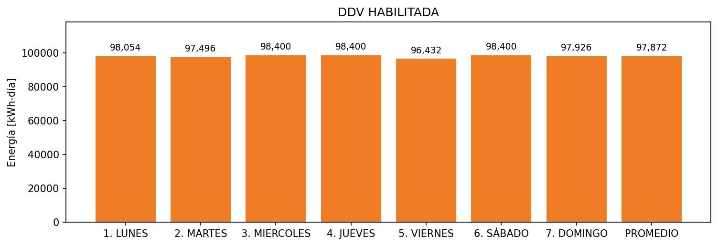

|  |  |  |  |  |  |  |  |  |  |
| --- | --- | --- | --- | --- | --- | --- | --- | --- | --- |
| **FRONTERA** | **COD SIC** | **FRT DDV** | **TIPO DDV** | **PROMEDIO** | **PRÓXIMA ACTUALIZACIÓN** | **MARGEN DE ERROR** | **ÚLTIMA PRUEBA DDV** | **DÍAS PARTICIPACIÓN** | **FECHA REFERENCIA PRÓXIMA PRUEBA DDV** |
| GASES INDUSTRIALES DE COLOMBIA S.A. - CRYOGAS | Frt00688 | Frt34406 | LBC | 97,872 | 2022-02-09 | 2,6 | 2021-11-25 | 0.0 | 2022-03-14 |