|  |  |  |  |
| --- | --- | --- | --- |
| 1 | | 68,457 | |
| **NUMERO DE FRONTERAS** | | **ENERGIA AGREGADA** | |
|  | | | |
| 207,656,253 | 137 | | 9,101,293 |
| INGRESO 2021 | DÍAS CERTIFICADOS 2021 | | ENERGIA RESPALDADA 2021 |

**HISTORICO REINTEGRO DDV**

|  |  |
| --- | --- |
|  | **2021** |
| **ENE** | - |
| **FEB** | - |
| **MAR** | - |
| **ABR** | 19.74 |
| **MAY** | 42.92 |
| **JUN** | 45.0 |
| **JUL** | 26.34 |
| **AGO** | 19.45 |
| **SEP** | 28.09 |
| **OCT** | 26.13 |
| **NOV** | - |
| **DIC** | - |

**Los valores de la tabla están en millones de COP**

**REINTEGRO MECANISMO DDV OCTUBRE 2021**

|  |  |  |  |  |  |
| --- | --- | --- | --- | --- | --- |
| FECHA | TIPO DIA | CANTIDADES RESPALDO | PRECIO PONDERADO USD | TRM | PNETO |
| 2021-10-01 | Viernes | 68,709 | 5.98 | 3,784.44 | 1,393,235 |
| 2021-10-02 | Sábado | 67,555 | 5.98 | 3,784.44 | 1,369,835 |
| 2021-10-03 | Domingo - Festivo | 65,684 | 5.98 | 3,784.44 | 1,331,896 |
| 2021-10-04 | Lunes | 66,595 | 5.98 | 3,784.44 | 1,350,369 |
| 2021-10-05 | Martes | 66,475 | 5.98 | 3,784.44 | 1,347,936 |
| 2021-10-06 | Miércoles | 68,707 | 5.98 | 3,784.44 | 1,393,195 |
| 2021-10-07 | Jueves | 68,707 | 5.98 | 3,784.44 | 1,393,195 |
| 2021-10-08 | Viernes | 67,555 | 5.98 | 3,784.44 | 1,369,835 |
| 2021-10-09 | Sábado | 68,707 | 5.98 | 3,784.44 | 1,393,195 |
| 2021-10-10 | Domingo - Festivo | 65,684 | 5.98 | 3,784.44 | 1,331,896 |
| 2021-10-11 | Lunes | 66,595 | 5.98 | 3,784.44 | 1,350,369 |
| 2021-10-12 | Martes | 68,707 | 5.98 | 3,784.44 | 1,393,195 |
| 2021-10-19 | Martes | 68,707 | 5.98 | 3,784.44 | 1,393,195 |
| 2021-10-25 | Lunes | 68,707 | 5.98 | 3,784.44 | 1,393,195 |
| 2021-10-26 | Martes | 68,491 | 5.98 | 3,784.44 | 1,388,815 |
| 2021-10-27 | Miércoles | 67,171 | 5.98 | 3,784.44 | 1,362,049 |
| 2021-10-28 | Jueves | 68,707 | 5.98 | 3,784.44 | 1,393,195 |
| 2021-10-29 | Viernes | 68,707 | 5.98 | 3,784.44 | 1,393,195 |
| 2021-10-30 | Sábado | 68,635 | 5.98 | 3,784.44 | 1,391,735 |

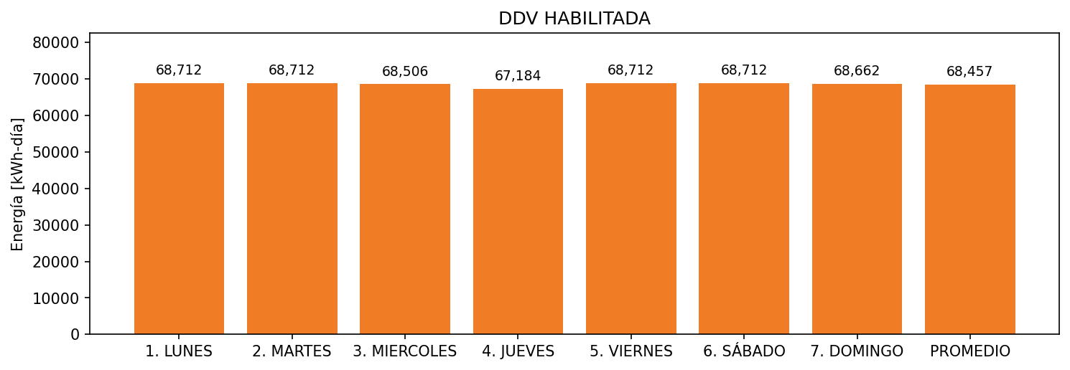

|  |  |  |  |  |  |  |  |  |  |
| --- | --- | --- | --- | --- | --- | --- | --- | --- | --- |
| **FRONTERA** | **COD SIC** | **FRT DDV** | **TIPO DDV** | **PROMEDIO** | **PRÓXIMA ACTUALIZACIÓN** | **MARGEN DE ERROR** | **ÚLTIMA PRUEBA DDV** | **DÍAS PARTICIPACIÓN** | **FECHA REFERENCIA PRÓXIMA PRUEBA DDV** |
| EUROCERAMICA S.A | Frt00717 | Frt29409 | LBC | 68,457 | 2022-01-28 | 2,26 | 2021-08-05 | 49.0 | 2022-01-15 |