|  |  |  |  |
| --- | --- | --- | --- |
| 10 | | 24,237.285714285717 | |
| NUMERO DE FRONTERAS | | ENERGIA AGREGADA | |
|  | | | |
|  | |  | |
| CONTRATO | | VENCIMIENTO CONTRATO | |
|  | | | |
| 22,302,093 | 54 | | 957,711 |
| INGRESO 2020 | DÍAS CERTIFICADOS 2020 | | ENERGIA RESPALDADA 2020 |
|  | | | |
| 68,599,897 | 160 | | 2,999,986 |
| INGRESO 2021 | DÍAS CERTIFICADOS 2021 | | ENERGIA RESPALDADA 2021 |

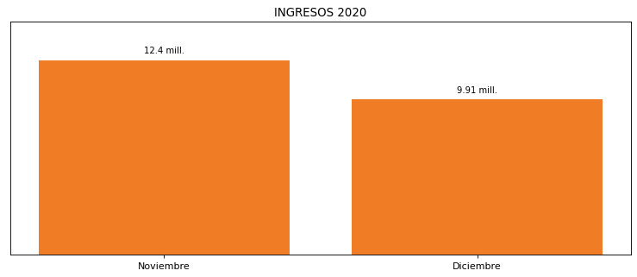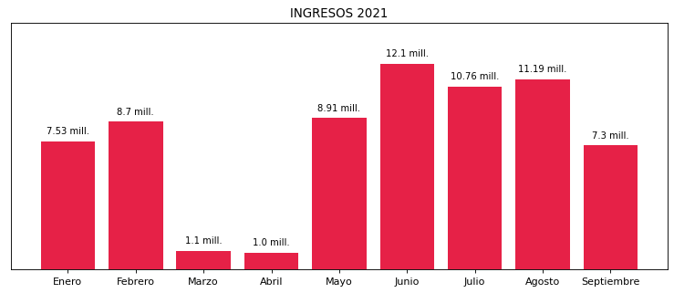

|  |
| --- |
| **EURO**  USUARIO |

|  |
| --- |
| **Camilo Bermudez**  Ejecutivo de cuenta |

|  |
| --- |
| **0**  PUNTO FOCAL |

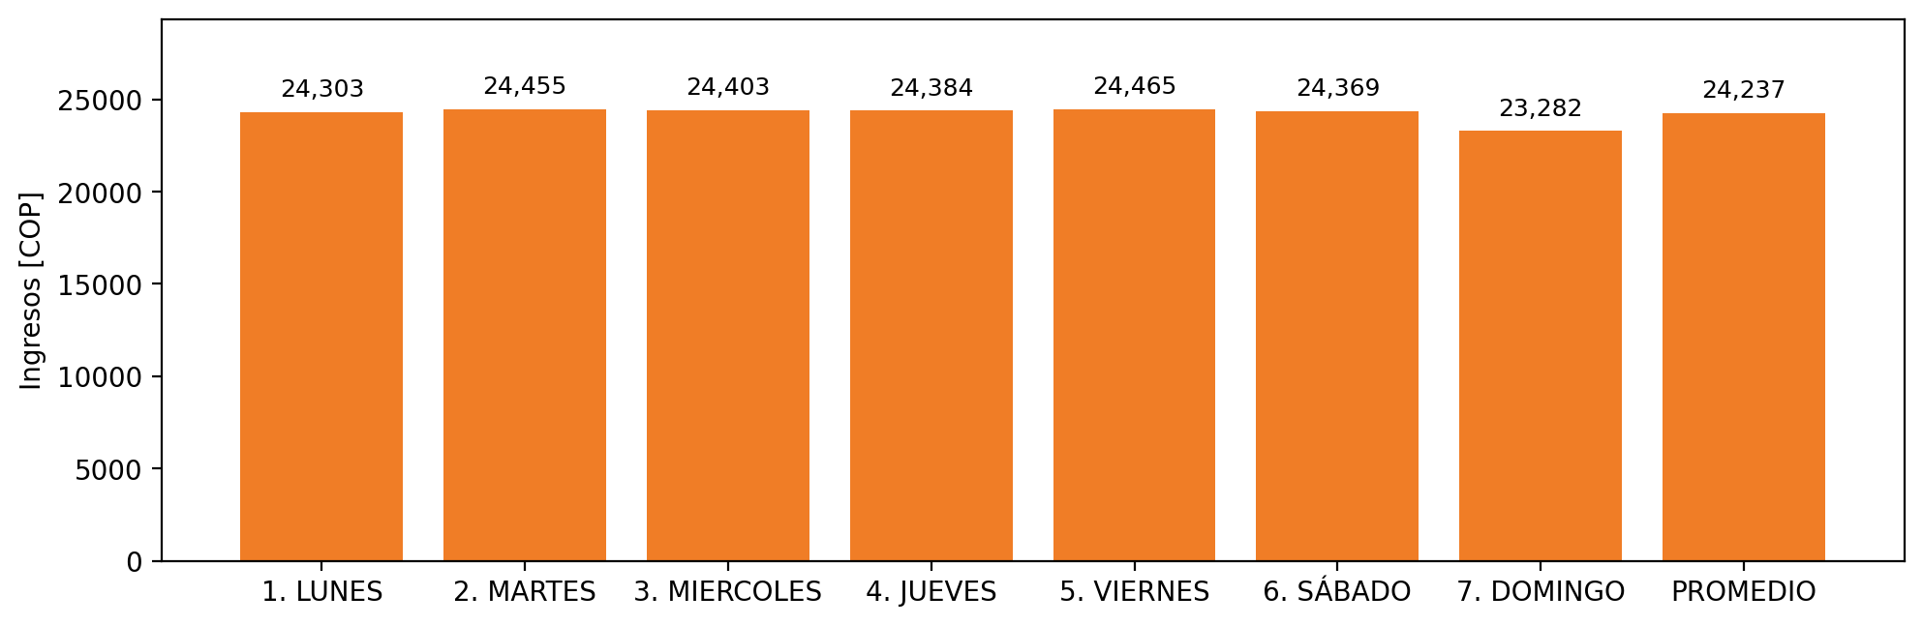

|  |  |  |  |  |  |  |  |  |  |  |
| --- | --- | --- | --- | --- | --- | --- | --- | --- | --- | --- |
| **FRONTERA** | **COD SIC** | **PREDIO** | **FRT DDV** | **TIPO DDV** | **PROMEDIO** | **PRÓXIMA ACTUALIZACIÓN** | **MARGEN DE ERROR** | **ÚLTIMA PRUEBA DDV** | **DÍAS PARTICIPACIÓN** | **FECHA REFERENCIA PRÓXIMA PRUEBA DDV** |
| INVERSIONES EURO FRONTERA | Frt29126 | Prd02110 | Frt39082 | LBC | 4,343 | 2022-03-02 | 2,03 | 2021-09-16 | 2.0 | 2022-02-07 |
| INVERSIONES EURO SA FLORIDA | Frt29733 | Prd02114 | Frt39086 | LBC | 4,343 | 2022-03-02 | 2,36 | 2021-09-09 | 11.0 | 2022-01-27 |
| INVERSIONES EURO MAYORISTA ITAGUI | Frt29127 | Prd02112 | Frt39084 | LBC | 4,343 | 2022-03-02 | 2,34 | 2021-09-14 | 6.0 | 2022-02-01 |
| INVERSIONES EURO SA - PALMA GRANDE | Frt29378 | Prd02117 | Frt39089 | LBC | 4,343 | 2022-03-02 | 1,75 | 2021-09-15 | 6.0 | 2022-02-02 |
| INVERSIONES EURO SA SABANETA | Frt30453 | Prd02118 | Frt39090 | LBC | 4,343 | 2022-03-02 | 1,84 | 2021-09-13 | 6.0 | 2022-02-01 |
| EURO SUPERMERCADO - INVERSIONES EURO SA - MONTERÍA | Frt28526 | Prd02116 | Frt39088 | LBC | 4,343 | 2022-03-02 | 3,55 | 2021-09-08 | 9.0 | 2022-01-30 |
| INVERSIONES EURO SA - LOMA DE LOS BERNAL | Frt29462 | Prd02115 | Frt39087 | LBC | 4,343 | 2022-03-02 | 0,8 | 2021-09-17 | 1.0 | 2022-02-05 |
| INVERSIONES EURO SA LO NUESTRO MONTERIA | Frt29125 | Prd02113 | Frt39085 | LBC | 4,343 | 2022-03-02 | 3,29 | 2021-09-06 | 11.0 | 2022-01-27 |
| INVERSIONES EURO SA LAURELES | Frt29080 | Prd02111 | Frt39083 | LBC | 4,343 | 2022-03-02 | 2,44 | 2021-09-10 | 8.0 | 2022-02-04 |
| INVERSIONES EURO (GUADALCANAL) | Frt14451 | Prd02109 | Frt39081 | LBC | 4,343 | 2022-03-02 | 2,06 | 2021-09-20 | 0.0 | 2022-02-12 |