|  |  |  |  |
| --- | --- | --- | --- |
| 10 | | 24,237 | |
| **NUMERO DE FRONTERAS** | | **ENERGIA AGREGADA** | |
|  | | | |
| 22,302,093 | 54 | | 957,711 |
| INGRESO 2020 | DÍAS CERTIFICADOS 2020 | | ENERGIA RESPALDADA 2020 |
|  | | | |
| 78,032,324 | 184 | | 3,465,157 |
| INGRESO 2021 | DÍAS CERTIFICADOS 2021 | | ENERGIA RESPALDADA 2021 |

**HISTORICO REINTEGRO DDV**

|  |  |  |
| --- | --- | --- |
|  | **2020** | **2021** |
| **ENE** | - | 7.53 |
| **FEB** | - | 8.7 |
| **MAR** | - | 1.1 |
| **ABR** | - | 1.0 |
| **MAY** | - | 8.91 |
| **JUN** | - | 12.1 |
| **JUL** | - | 10.76 |
| **AGO** | - | 11.19 |
| **SEP** | - | 7.3 |
| **OCT** | - | 9.43 |
| **NOV** | 12.4 | - |
| **DIC** | 9.91 | - |

**Los valores de la tabla están en millones de COP**

**REINTEGRO MECANISMO DDV OCTUBRE 2021**

|  |  |  |  |  |  |
| --- | --- | --- | --- | --- | --- |
| FECHA | TIPO DIA | CANTIDADES RESPALDO | PRECIO PONDERADO USD | TRM | PNETO |
| 2021-10-01 | Viernes | 21,351 | 5.98 | 3,784.44 | 432,942 |
| 2021-10-02 | Sábado | 24,662 | 5.98 | 3,784.44 | 500,080 |
| 2021-10-03 | Domingo - Festivo | 23,390 | 5.98 | 3,784.44 | 474,286 |
| 2021-10-04 | Lunes | 24,422 | 5.98 | 3,784.44 | 495,213 |
| 2021-10-05 | Martes | 24,614 | 5.98 | 3,784.44 | 499,107 |
| 2021-10-06 | Miércoles | 24,758 | 5.98 | 3,784.44 | 502,026 |
| 2021-10-07 | Jueves | 24,902 | 5.98 | 3,784.44 | 504,946 |
| 2021-10-08 | Viernes | 24,854 | 5.98 | 3,784.44 | 503,973 |
| 2021-10-09 | Sábado | 21,160 | 5.98 | 3,784.44 | 429,069 |
| 2021-10-10 | Domingo - Festivo | 15,689 | 5.98 | 3,784.44 | 318,131 |
| 2021-10-11 | Lunes | 24,422 | 5.98 | 3,784.44 | 495,213 |
| 2021-10-18 | Domingo - Festivo | 6,358 | 5.98 | 3,784.44 | 128,923 |
| 2021-10-19 | Martes | 24,614 | 5.98 | 3,784.44 | 499,107 |
| 2021-10-20 | Miércoles | 11,396 | 5.98 | 3,784.44 | 231,080 |
| 2021-10-21 | Jueves | 2,183 | 5.98 | 3,784.44 | 44,265 |
| 2021-10-22 | Viernes | 22,719 | 5.98 | 3,784.44 | 460,681 |
| 2021-10-23 | Sábado | 17,849 | 5.98 | 3,784.44 | 361,929 |
| 2021-10-25 | Lunes | 24,422 | 5.98 | 3,784.44 | 495,213 |
| 2021-10-26 | Martes | 24,614 | 5.98 | 3,784.44 | 499,107 |
| 2021-10-27 | Miércoles | 8,037 | 5.98 | 3,784.44 | 162,970 |
| 2021-10-28 | Jueves | 18,520 | 5.98 | 3,784.44 | 375,536 |
| 2021-10-29 | Viernes | 17,105 | 5.98 | 3,784.44 | 346,844 |
| 2021-10-30 | Sábado | 17,009 | 5.98 | 3,784.44 | 344,898 |
| 2021-10-31 | Domingo - Festivo | 16,121 | 5.98 | 3,784.44 | 326,891 |

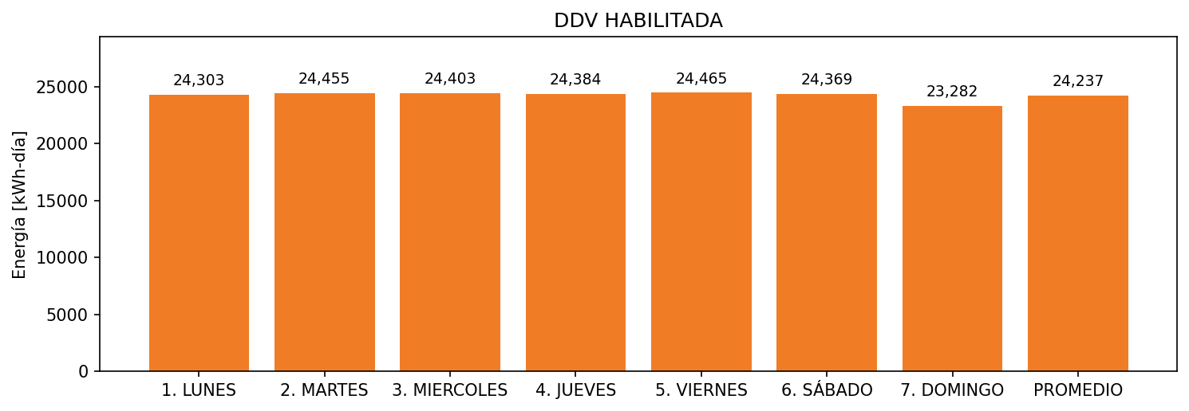

|  |  |  |  |  |  |  |  |  |  |
| --- | --- | --- | --- | --- | --- | --- | --- | --- | --- |
| **FRONTERA** | **COD SIC** | **FRT DDV** | **TIPO DDV** | **PROMEDIO** | **PRÓXIMA ACTUALIZACIÓN** | **MARGEN DE ERROR** | **ÚLTIMA PRUEBA DDV** | **DÍAS PARTICIPACIÓN** | **FECHA REFERENCIA PRÓXIMA PRUEBA DDV** |
| INVERSIONES EURO FRONTERA | Frt29126 | Frt39082 | LBC | 4,343 | 2022-03-02 | 2,03 | 2021-09-16 | 20.0 | 2022-02-18 |
| INVERSIONES EURO SA FLORIDA | Frt29733 | Frt39086 | LBC | 2,999 | 2022-03-02 | 2,36 | 2021-09-09 | 31.0 | 2022-02-06 |
| INVERSIONES EURO MAYORISTA ITAGUI | Frt29127 | Frt39084 | LBC | 2,619 | 2022-03-02 | 2,34 | 2021-09-14 | 26.0 | 2022-02-12 |
| INVERSIONES EURO SA - PALMA GRANDE | Frt29378 | Frt39089 | LBC | 2,640 | 2022-03-02 | 1,75 | 2021-09-15 | 26.0 | 2022-02-12 |
| INVERSIONES EURO SA SABANETA | Frt30453 | Frt39090 | LBC | 2,333 | 2022-03-02 | 1,84 | 2021-09-13 | 26.0 | 2022-02-11 |
| EURO SUPERMERCADO - INVERSIONES EURO SA - MONTERÍA | Frt28526 | Frt39088 | LBC | 2,164 | 2022-03-02 | 3,55 | 2021-09-08 | 29.0 | 2022-02-09 |
| INVERSIONES EURO SA - LOMA DE LOS BERNAL | Frt29462 | Frt39087 | LBC | 2,120 | 2022-03-02 | 0,8 | 2021-09-17 | 21.0 | 2022-02-15 |
| INVERSIONES EURO SA LO NUESTRO MONTERIA | Frt29125 | Frt39085 | LBC | 1,970 | 2022-03-02 | 3,29 | 2021-09-06 | 31.0 | 2022-02-06 |
| INVERSIONES EURO SA LAURELES | Frt29080 | Frt39083 | LBC | 1,800 | 2022-03-02 | 2,44 | 2021-09-10 | 23.0 | 2022-02-14 |
| INVERSIONES EURO (GUADALCANAL) | Frt14451 | Frt39081 | LBC | 1,247 | 2022-03-02 | 2,06 | 2021-09-20 | 15.0 | 2022-02-22 |