|  |  |  |  |
| --- | --- | --- | --- |
| 1 | | 23,246.14285714286 | |
| NUMERO DE FRONTERAS | | ENERGIA AGREGADA | |
|  | | | |
| NO | | 0 | |
| CONTRATO | | VENCIMIENTO CONTRATO | |
|  | | | |
| 10,388,611 | 19 | | 448,655 |
| INGRESO 2021 | DÍAS CERTIFICADOS 2021 | | ENERGIA RESPALDADA 2021 |

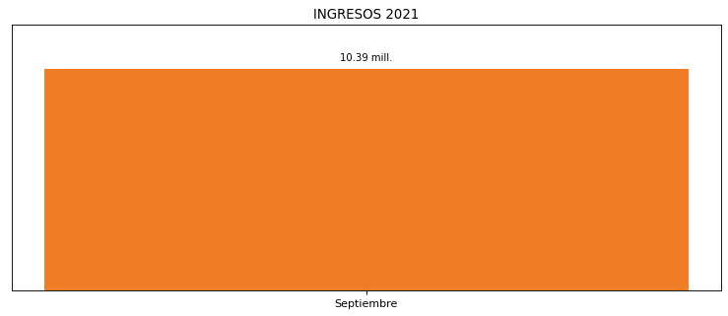

|  |
| --- |
| **FAREVA**  USUARIO |

|  |
| --- |
| **Mateo Porras**  Ejecutivo de cuenta |

|  |
| --- |
| **Evelio Castaño Arango / Gerente Ingenieria / ecastano.villarica@fareva.co**  PUNTO FOCAL |

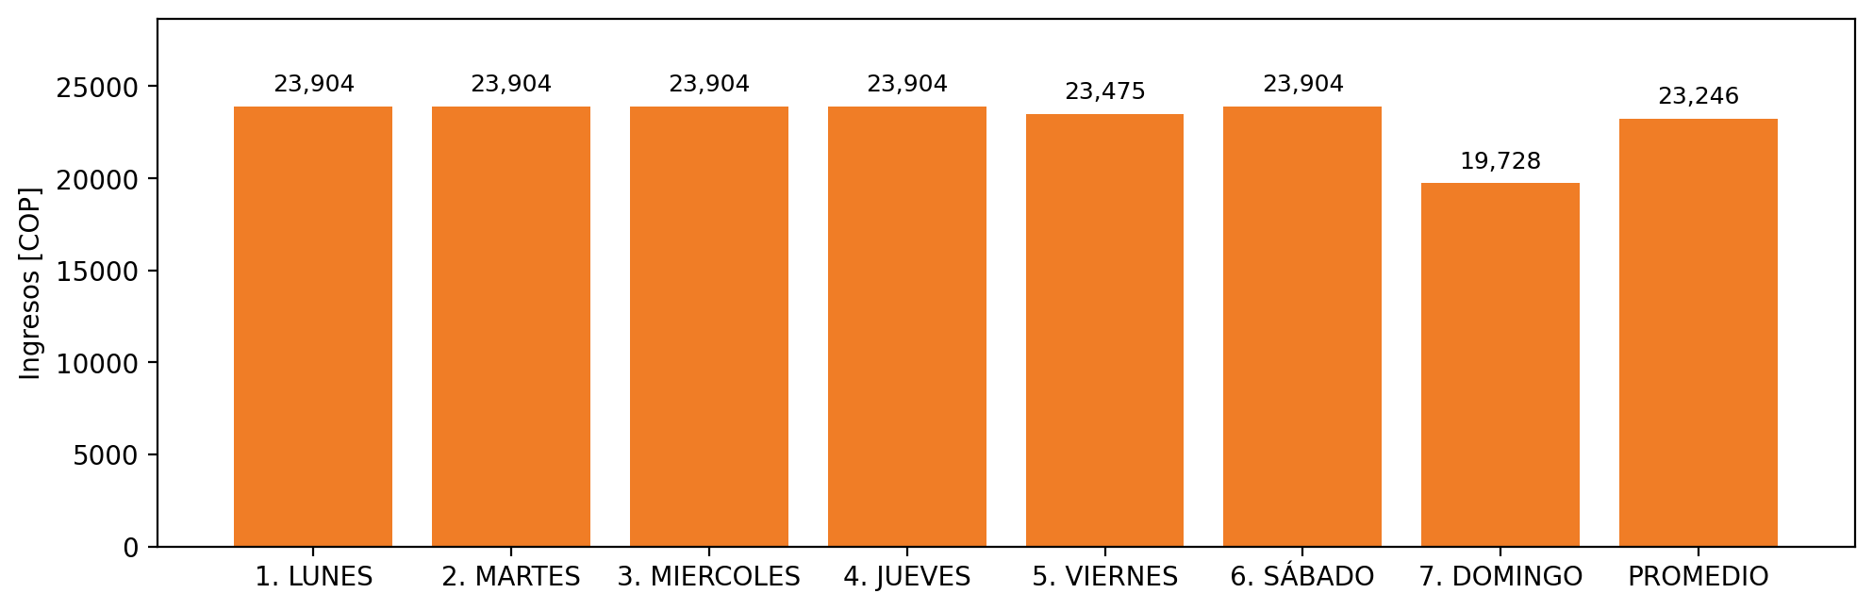

|  |  |  |  |  |  |  |  |  |  |  |
| --- | --- | --- | --- | --- | --- | --- | --- | --- | --- | --- |
| **FRONTERA** | **COD SIC** | **PREDIO** | **FRT DDV** | **TIPO DDV** | **PROMEDIO** | **PRÓXIMA ACTUALIZACIÓN** | **MARGEN DE ERROR** | **ÚLTIMA PRUEBA DDV** | **DÍAS PARTICIPACIÓN** | **FECHA REFERENCIA PRÓXIMA PRUEBA DDV** |
| FAREVA | Frt02678 | Prd00475 | Frt29842 | LBC | 23,246 | 2021-11-25 | 4,08 | 2021-07-23 | 37.0 | 2021-12-29 |