|  |  |  |  |
| --- | --- | --- | --- |
| 1 | | 17,241 | |
| **NUMERO DE FRONTERAS** | | **ENERGIA AGREGADA** | |
|  | | | |
| 123,500,168 | 193 | | 4,550,329 |
| INGRESO 2020 | DÍAS CERTIFICADOS 2020 | | ENERGIA RESPALDADA 2020 |
|  | | | |
| 19,810,473 | 39 | | 913,305 |
| INGRESO 2021 | DÍAS CERTIFICADOS 2021 | | ENERGIA RESPALDADA 2021 |

**HISTORICO REINTEGRO DDV**

|  |  |  |
| --- | --- | --- |
|  | **2020** | **2021** |
| **ENE** | 15.41 | - |
| **FEB** | 20.36 | - |
| **MAR** | 25.71 | - |
| **ABR** | 0.47 | - |
| **MAY** | 1.37 | - |
| **JUN** | 7.65 | - |
| **JUL** | 11.33 | - |
| **AGO** | 6.91 | - |
| **SEP** | 2.61 | 10.39 |
| **OCT** | 15.76 | 9.42 |
| **NOV** | 6.16 | - |
| **DIC** | 9.77 | - |

**Los valores de la tabla están en millones de COP**

**REINTEGRO MECANISMO DDV OCTUBRE 2021**

|  |  |  |  |  |  |
| --- | --- | --- | --- | --- | --- |
| FECHA | TIPO DIA | CANTIDADES RESPALDO | PRECIO PONDERADO USD | TRM | PNETO |
| 2021-10-06 | Miércoles | 23,471 | 5.98 | 3,784.44 | 475,929 |
| 2021-10-07 | Jueves | 23,898 | 5.98 | 3,784.44 | 484,588 |
| 2021-10-08 | Viernes | 23,903 | 5.98 | 3,784.44 | 484,689 |
| 2021-10-09 | Sábado | 23,903 | 5.98 | 3,784.44 | 484,689 |
| 2021-10-10 | Domingo - Festivo | 23,903 | 5.98 | 3,784.44 | 484,689 |
| 2021-10-11 | Lunes | 23,903 | 5.98 | 3,784.44 | 484,689 |
| 2021-10-18 | Domingo - Festivo | 23,471 | 5.98 | 3,784.44 | 475,929 |
| 2021-10-19 | Martes | 23,898 | 5.98 | 3,784.44 | 484,588 |
| 2021-10-20 | Miércoles | 23,902 | 5.98 | 3,784.44 | 484,669 |
| 2021-10-21 | Jueves | 23,902 | 5.98 | 3,784.44 | 484,669 |
| 2021-10-22 | Viernes | 23,902 | 5.98 | 3,784.44 | 484,669 |
| 2021-10-23 | Sábado | 19,726 | 5.98 | 3,784.44 | 399,991 |
| 2021-10-24 | Domingo - Festivo | 19,727 | 5.98 | 3,784.44 | 400,011 |
| 2021-10-25 | Lunes | 23,903 | 5.98 | 3,784.44 | 484,689 |
| 2021-10-26 | Martes | 23,902 | 5.98 | 3,784.44 | 484,669 |
| 2021-10-27 | Miércoles | 23,902 | 5.98 | 3,784.44 | 484,669 |
| 2021-10-28 | Jueves | 23,903 | 5.98 | 3,784.44 | 484,689 |
| 2021-10-29 | Viernes | 23,903 | 5.98 | 3,784.44 | 484,689 |
| 2021-10-30 | Sábado | 23,902 | 5.98 | 3,784.44 | 484,669 |
| 2021-10-31 | Domingo - Festivo | 19,726 | 5.98 | 3,784.44 | 399,991 |

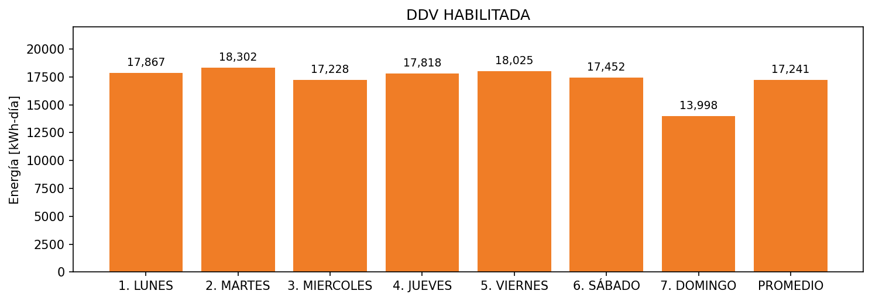

|  |  |  |  |  |  |  |  |  |  |
| --- | --- | --- | --- | --- | --- | --- | --- | --- | --- |
| **FRONTERA** | **COD SIC** | **FRT DDV** | **TIPO DDV** | **PROMEDIO** | **PRÓXIMA ACTUALIZACIÓN** | **MARGEN DE ERROR** | **ÚLTIMA PRUEBA DDV** | **DÍAS PARTICIPACIÓN** | **FECHA REFERENCIA PRÓXIMA PRUEBA DDV** |
| FAREVA | Frt02678 | Frt29842 | LBC | 17,241 | 2022-03-11 | 4,08 | 2021-07-23 | 57.0 | 2022-01-11 |