|  |  |  |  |
| --- | --- | --- | --- |
| 1 | | 19,680 | |
| **NUMERO DE FRONTERAS** | | **ENERGIA AGREGADA** | |
|  | | | |
| 18,472,467 | 33 | | 811,800 |
| INGRESO 2020 | DÍAS CERTIFICADOS 2020 | | ENERGIA RESPALDADA 2020 |
|  | | | |
| 69,950,270 | 141 | | 3,054,186 |
| INGRESO 2021 | DÍAS CERTIFICADOS 2021 | | ENERGIA RESPALDADA 2021 |

**HISTORICO REINTEGRO DDV**

|  |  |  |
| --- | --- | --- |
|  | **2020** | **2021** |
| **ENE** | - | 10.43 |
| **FEB** | - | 15.02 |
| **MAR** | - | 4.4 |
| **ABR** | - | 0.61 |
| **MAY** | - | 4.05 |
| **JUN** | - | 10.07 |
| **JUL** | - | 13.28 |
| **AGO** | - | 6.62 |
| **SEP** | - | 5.47 |
| **OCT** | - | - |
| **NOV** | 6.65 | - |
| **DIC** | 11.82 | - |

**Los valores de la tabla están en millones de COP**



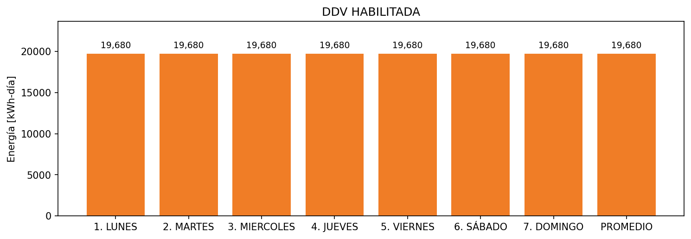

|  |  |  |  |  |  |  |  |  |  |
| --- | --- | --- | --- | --- | --- | --- | --- | --- | --- |
| **FRONTERA** | **COD SIC** | **FRT DDV** | **TIPO DDV** | **PROMEDIO** | **PRÓXIMA ACTUALIZACIÓN** | **MARGEN DE ERROR** | **ÚLTIMA PRUEBA DDV** | **DÍAS PARTICIPACIÓN** | **FECHA REFERENCIA PRÓXIMA PRUEBA DDV** |
| FIBERGLASS COLOMBIA S.A. | Frt00694 | Frt38981 | GPE | 19,680 | 2026-04-15 | NO APLICA | 2021-05-12 | 89.0 | 2021-12-18 |