|  |  |  |  |
| --- | --- | --- | --- |
| 1 | | 23,157 | |
| **NUMERO DE FRONTERAS** | | **ENERGIA AGREGADA** | |
|  | | | |
| 32,207,994 | 83 | | 1,419,252 |
| INGRESO 2020 | DÍAS CERTIFICADOS 2020 | | ENERGIA RESPALDADA 2020 |
|  | | | |
| 46,239,351 | 89 | | 2,026,039 |
| INGRESO 2021 | DÍAS CERTIFICADOS 2021 | | ENERGIA RESPALDADA 2021 |

**HISTORICO REINTEGRO DDV**

|  |  |  |
| --- | --- | --- |
|  | **2020** | **2021** |
| **ENE** | - | 9.93 |
| **FEB** | - | 14.42 |
| **MAR** | - | 2.34 |
| **ABR** | - | - |
| **MAY** | 4.78 | 7.91 |
| **JUN** | - | 6.38 |
| **JUL** | 8.82 | 5.27 |
| **AGO** | 11.96 | - |
| **SEP** | 3.37 | - |
| **OCT** | 2.18 | - |
| **NOV** | 0.2 | - |
| **DIC** | 0.9 | - |

**Los valores de la tabla están en millones de COP**



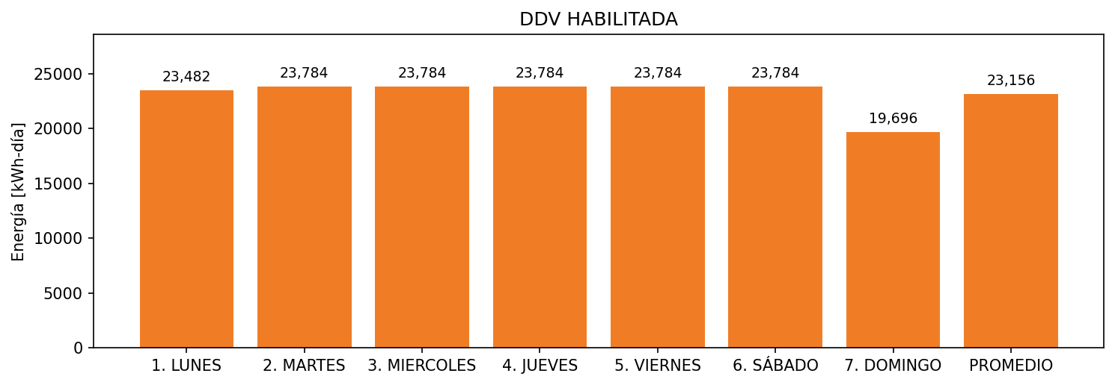

|  |  |  |  |  |  |  |  |  |  |
| --- | --- | --- | --- | --- | --- | --- | --- | --- | --- |
| **FRONTERA** | **COD SIC** | **FRT DDV** | **TIPO DDV** | **PROMEDIO** | **PRÓXIMA ACTUALIZACIÓN** | **MARGEN DE ERROR** | **ÚLTIMA PRUEBA DDV** | **DÍAS PARTICIPACIÓN** | **FECHA REFERENCIA PRÓXIMA PRUEBA DDV** |
| COLOMBIANA FLEXOGRAFICA DE PLASTICOS S.A.S. | Frt02089 | Frt37569 | LBC | 23,156 | 2022-03-02 | 2,97 | 2020-12-24 | 89.0 | 2021-12-17 |