|  |  |  |  |
| --- | --- | --- | --- |
| 1 | | 13,200.0 | |
| NUMERO DE FRONTERAS | | ENERGIA AGREGADA | |
|  | | | |
| NO | | 0 | |
| CONTRATO | | VENCIMIENTO CONTRATO | |
|  | | | |
| 22,139,145 | 58 | | 952,059 |
| INGRESO 2020 | DÍAS CERTIFICADOS 2020 | | ENERGIA RESPALDADA 2020 |
|  | | | |
| 39,115,985 | 123 | | 1,716,755 |
| INGRESO 2021 | DÍAS CERTIFICADOS 2021 | | ENERGIA RESPALDADA 2021 |

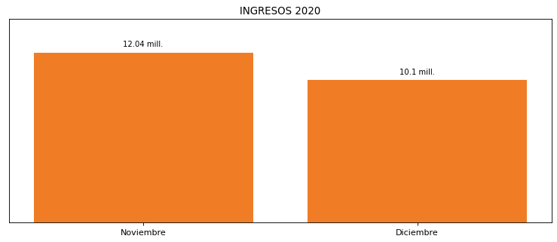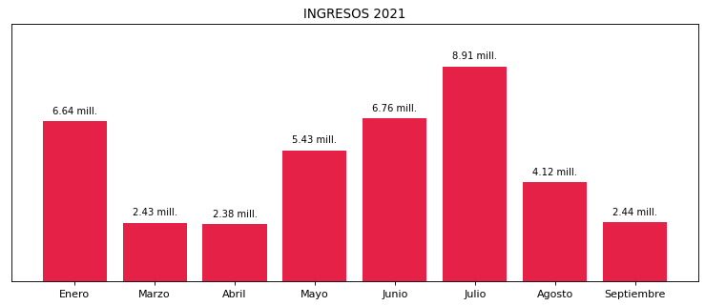

|  |
| --- |
| **FRIOGAN**  USUARIO |

|  |
| --- |
| **Camilo Bermudez**  Ejecutivo de cuenta |

|  |
| --- |
| **Diney Soriano / Coordinadora Administrativa / Diney.Soriano@friogan.com**  PUNTO FOCAL |

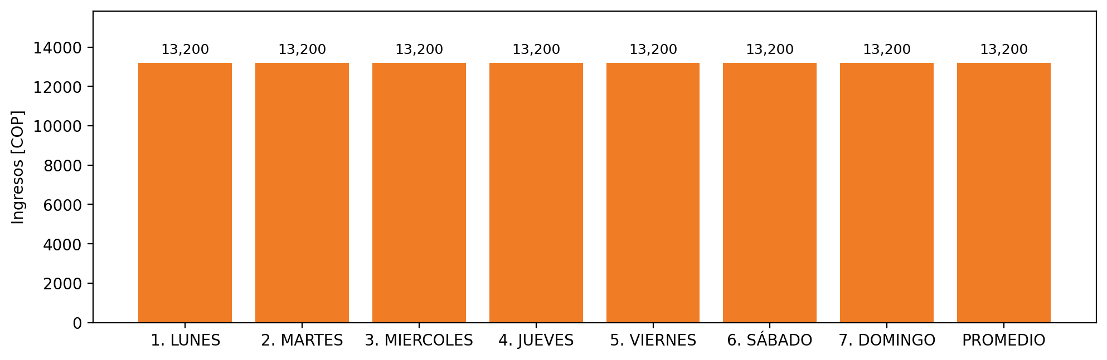

|  |  |  |  |  |  |  |  |  |  |  |
| --- | --- | --- | --- | --- | --- | --- | --- | --- | --- | --- |
| **FRONTERA** | **COD SIC** | **PREDIO** | **FRT DDV** | **TIPO DDV** | **PROMEDIO** | **PRÓXIMA ACTUALIZACIÓN** | **MARGEN DE ERROR** | **ÚLTIMA PRUEBA DDV** | **DÍAS PARTICIPACIÓN** | **FECHA REFERENCIA PRÓXIMA PRUEBA DDV** |
| FRIGORIFICOS GANADEROS DE COLOMBIA SA EN REORGANIZACION | Frt02450 | Prd02125 | Frt39205 | GPE | 13,200 | 2026-04-15 | NO APLICA | 2021-09-12 | 7.0 | 2022-02-07 |