|  |  |  |  |
| --- | --- | --- | --- |
| 1 | | 13,200 | |
| **NUMERO DE FRONTERAS** | | **ENERGIA AGREGADA** | |
|  | | | |
| 22,139,145 | 58 | | 952,059 |
| INGRESO 2020 | DÍAS CERTIFICADOS 2020 | | ENERGIA RESPALDADA 2020 |
|  | | | |
| 43,398,233 | 139 | | 1,927,939 |
| INGRESO 2021 | DÍAS CERTIFICADOS 2021 | | ENERGIA RESPALDADA 2021 |

**HISTORICO REINTEGRO DDV**

|  |  |  |
| --- | --- | --- |
|  | **2020** | **2021** |
| **ENE** | - | 6.64 |
| **FEB** | - | - |
| **MAR** | - | 2.43 |
| **ABR** | - | 2.38 |
| **MAY** | - | 5.43 |
| **JUN** | - | 6.76 |
| **JUL** | - | 8.91 |
| **AGO** | - | 4.12 |
| **SEP** | - | 2.44 |
| **OCT** | - | 4.28 |
| **NOV** | 12.04 | - |
| **DIC** | 10.1 | - |

**Los valores de la tabla están en millones de COP**

**REINTEGRO MECANISMO DDV OCTUBRE 2021**

|  |  |  |  |  |  |
| --- | --- | --- | --- | --- | --- |
| FECHA | TIPO DIA | CANTIDADES RESPALDO | PRECIO PONDERADO USD | TRM | PNETO |
| 2021-10-01 | Viernes | 13,199 | 5.98 | 3,784.44 | 267,641 |
| 2021-10-02 | Sábado | 13,199 | 5.98 | 3,784.44 | 267,641 |
| 2021-10-03 | Domingo - Festivo | 13,199 | 5.98 | 3,784.44 | 267,641 |
| 2021-10-04 | Lunes | 13,199 | 5.98 | 3,784.44 | 267,641 |
| 2021-10-05 | Martes | 13,199 | 5.98 | 3,784.44 | 267,641 |
| 2021-10-06 | Miércoles | 13,199 | 5.98 | 3,784.44 | 267,641 |
| 2021-10-07 | Jueves | 13,199 | 5.98 | 3,784.44 | 267,641 |
| 2021-10-08 | Viernes | 13,199 | 5.98 | 3,784.44 | 267,641 |
| 2021-10-09 | Sábado | 13,199 | 5.98 | 3,784.44 | 267,641 |
| 2021-10-10 | Domingo - Festivo | 13,199 | 5.98 | 3,784.44 | 267,641 |
| 2021-10-11 | Lunes | 13,199 | 5.98 | 3,784.44 | 267,641 |
| 2021-10-19 | Martes | 13,199 | 5.98 | 3,784.44 | 267,641 |
| 2021-10-20 | Miércoles | 13,199 | 5.98 | 3,784.44 | 267,641 |
| 2021-10-21 | Jueves | 13,199 | 5.98 | 3,784.44 | 267,641 |
| 2021-10-22 | Viernes | 13,199 | 5.98 | 3,784.44 | 267,641 |
| 2021-10-23 | Sábado | 13,199 | 5.98 | 3,784.44 | 267,641 |

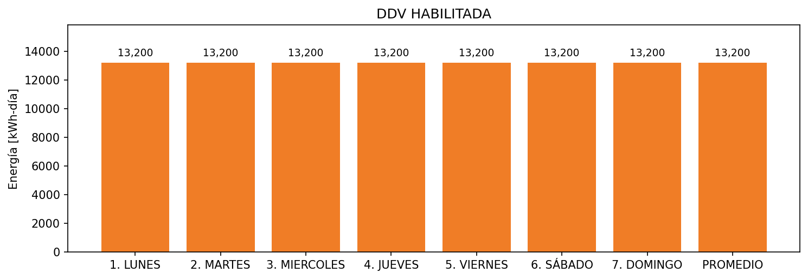

|  |  |  |  |  |  |  |  |  |  |
| --- | --- | --- | --- | --- | --- | --- | --- | --- | --- |
| **FRONTERA** | **COD SIC** | **FRT DDV** | **TIPO DDV** | **PROMEDIO** | **PRÓXIMA ACTUALIZACIÓN** | **MARGEN DE ERROR** | **ÚLTIMA PRUEBA DDV** | **DÍAS PARTICIPACIÓN** | **FECHA REFERENCIA PRÓXIMA PRUEBA DDV** |
| FRIGORIFICOS GANADEROS DE COLOMBIA SA EN REORGANIZACION | Frt02450 | Frt39205 | GPE | 13,200 | 2026-04-15 | NO APLICA | 2021-09-12 | 23.0 | 2022-02-19 |