|  |  |  |  |
| --- | --- | --- | --- |
| 1 | | 21,235.0 | |
| NUMERO DE FRONTERAS | | ENERGIA AGREGADA | |
|  | | | |
| NO | | 0 | |
| CONTRATO | | VENCIMIENTO CONTRATO | |
|  | | | |
| 59,283,375 | 80 | | 2,171,220 |
| INGRESO 2019 | DÍAS CERTIFICADOS 2019 | | ENERGIA RESPALDADA 2019 |
|  | | | |
| 81,380,048 | 114 | | 3,213,373 |
| INGRESO 2020 | DÍAS CERTIFICADOS 2020 | | ENERGIA RESPALDADA 2020 |
|  | | | |
| 78,528,026 | 126 | | 3,437,520 |
| INGRESO 2021 | DÍAS CERTIFICADOS 2021 | | ENERGIA RESPALDADA 2021 |

|  |
| --- |
| **GELCO**  USUARIO |

|  |
| --- |
| **Edwin Torres**  Ejecutivo de cuenta |

|  |
| --- |
| **Alejandro Harris / Jefe de Mantenimiento Eléctrico y Locativo / alejandro.harris@gelcointernational.com**  PUNTO FOCAL |

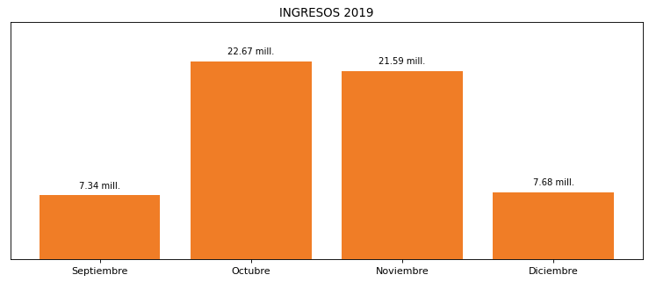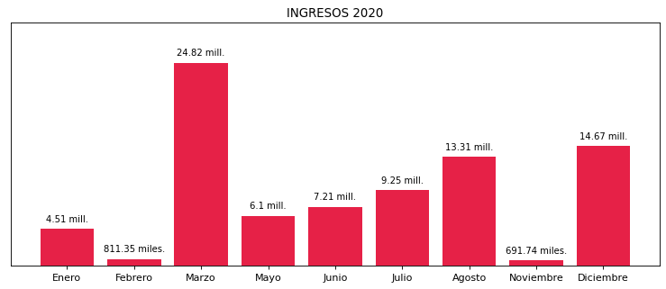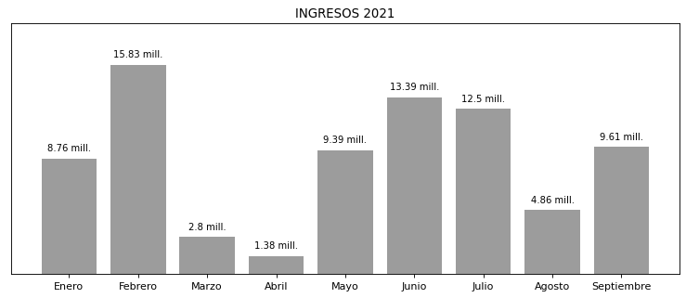

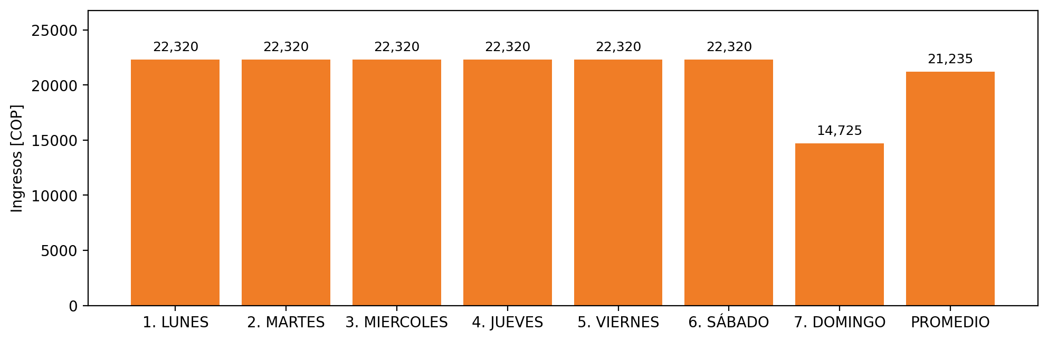

|  |  |  |  |  |  |  |  |  |  |  |
| --- | --- | --- | --- | --- | --- | --- | --- | --- | --- | --- |
| **FRONTERA** | **COD SIC** | **PREDIO** | **FRT DDV** | **TIPO DDV** | **PROMEDIO** | **PRÓXIMA ACTUALIZACIÓN** | **MARGEN DE ERROR** | **ÚLTIMA PRUEBA DDV** | **DÍAS PARTICIPACIÓN** | **FECHA REFERENCIA PRÓXIMA PRUEBA DDV** |
| GELCO S.A.S. | Frt00467 | Prd01356 | Frt33302 | LBC | 21,235 | 2022-03-05 | 29,2 | 2021-10-19 | 0.0 | 2022-02-17 |