|  |  |  |  |
| --- | --- | --- | --- |
| 1 | | 21,235 | |
| **NUMERO DE FRONTERAS** | | **ENERGIA AGREGADA** | |
|  | | | |
| 59,283,375 | 80 | | 2,171,220 |
| INGRESO 2019 | DÍAS CERTIFICADOS 2019 | | ENERGIA RESPALDADA 2019 |
|  | | | |
| 81,380,048 | 114 | | 3,213,373 |
| INGRESO 2020 | DÍAS CERTIFICADOS 2020 | | ENERGIA RESPALDADA 2020 |
|  | | | |
| 82,658,721 | 135 | | 3,641,230 |
| INGRESO 2021 | DÍAS CERTIFICADOS 2021 | | ENERGIA RESPALDADA 2021 |

**HISTORICO REINTEGRO DDV**

|  |  |  |  |
| --- | --- | --- | --- |
|  | **2019** | **2020** | **2021** |
| **ENE** | - | 4.51 | 8.76 |
| **FEB** | - | 0.81 | 15.83 |
| **MAR** | - | 24.82 | 2.8 |
| **ABR** | - | - | 1.38 |
| **MAY** | - | 6.1 | 9.39 |
| **JUN** | - | 7.21 | 13.39 |
| **JUL** | - | 9.25 | 12.5 |
| **AGO** | - | 13.31 | 4.86 |
| **SEP** | 7.34 | - | 9.61 |
| **OCT** | 22.67 | - | 4.13 |
| **NOV** | 21.59 | 0.69 | - |
| **DIC** | 7.68 | 14.67 | - |

**Los valores de la tabla están en millones de COP**

**REINTEGRO MECANISMO DDV OCTUBRE 2021**

|  |  |  |  |  |  |
| --- | --- | --- | --- | --- | --- |
| FECHA | TIPO DIA | CANTIDADES RESPALDO | PRECIO PONDERADO USD | TRM | PNETO |
| 2021-10-06 | Miércoles | 24,070 | 5.98 | 3,784.44 | 488,075 |
| 2021-10-07 | Jueves | 27,857 | 5.98 | 3,784.44 | 564,866 |
| 2021-10-08 | Viernes | 29,057 | 5.98 | 3,784.44 | 589,198 |
| 2021-10-09 | Sábado | 28,078 | 5.98 | 3,784.44 | 569,347 |
| 2021-10-10 | Domingo - Festivo | 13,847 | 5.98 | 3,784.44 | 280,780 |
| 2021-10-28 | Jueves | 22,318 | 5.98 | 3,784.44 | 452,550 |
| 2021-10-29 | Viernes | 22,318 | 5.98 | 3,784.44 | 452,550 |
| 2021-10-30 | Sábado | 22,318 | 5.98 | 3,784.44 | 452,550 |
| 2021-10-31 | Domingo - Festivo | 13,847 | 5.98 | 3,784.44 | 280,780 |

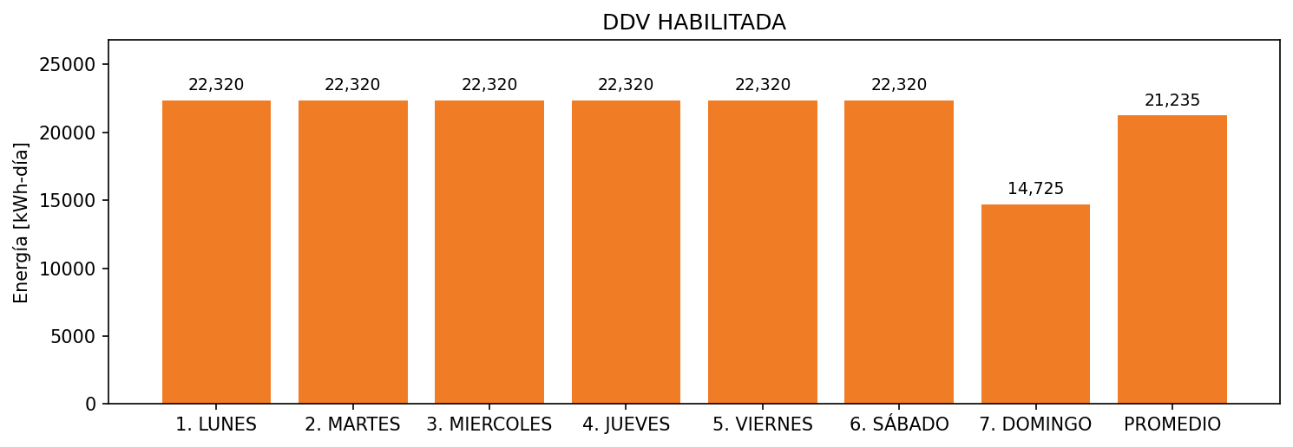

|  |  |  |  |  |  |  |  |  |  |
| --- | --- | --- | --- | --- | --- | --- | --- | --- | --- |
| **FRONTERA** | **COD SIC** | **FRT DDV** | **TIPO DDV** | **PROMEDIO** | **PRÓXIMA ACTUALIZACIÓN** | **MARGEN DE ERROR** | **ÚLTIMA PRUEBA DDV** | **DÍAS PARTICIPACIÓN** | **FECHA REFERENCIA PRÓXIMA PRUEBA DDV** |
| GELCO S.A.S. | Frt00467 | Frt33302 | LBC | 21,235 | 2022-03-05 | 29,2 | 2021-10-19 | 4.0 | 2022-02-27 |