|  |  |  |  |
| --- | --- | --- | --- |
| 1 | | 10,584 | |
| **NUMERO DE FRONTERAS** | | **ENERGIA AGREGADA** | |
|  | | | |
| 26,665,282 | 64 | | 974,129 |
| INGRESO 2019 | DÍAS CERTIFICADOS 2019 | | ENERGIA RESPALDADA 2019 |
|  | | | |
| 13,031,652 | 86 | | 529,675 |
| INGRESO 2020 | DÍAS CERTIFICADOS 2020 | | ENERGIA RESPALDADA 2020 |
|  | | | |
| 19,331,342 | 89 | | 834,651 |
| INGRESO 2021 | DÍAS CERTIFICADOS 2021 | | ENERGIA RESPALDADA 2021 |

**HISTORICO REINTEGRO DDV**

|  |  |  |  |
| --- | --- | --- | --- |
|  | **2019** | **2020** | **2021** |
| **ENE** | - | 0.83 | 4.07 |
| **FEB** | - | - | 5.04 |
| **MAR** | - | - | 1.27 |
| **ABR** | - | 0.28 | 1.75 |
| **MAY** | - | - | 5.81 |
| **JUN** | - | - | 1.4 |
| **JUL** | - | 3.24 | - |
| **AGO** | - | 2.33 | - |
| **SEP** | - | 1.43 | - |
| **OCT** | 3.01 | 2.83 | - |
| **NOV** | 11.8 | 1.33 | - |
| **DIC** | 11.86 | 0.76 | - |

**Los valores de la tabla están en millones de COP**



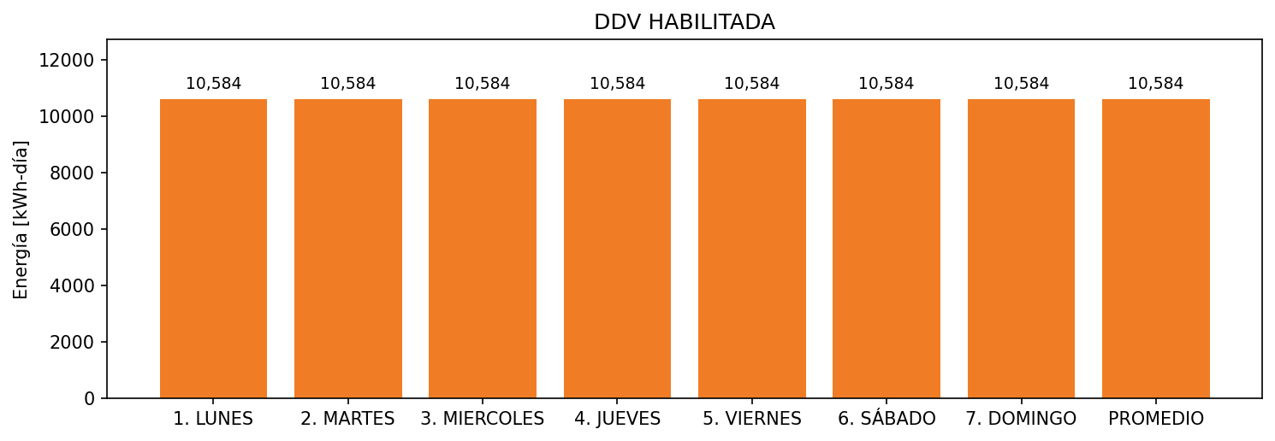

|  |  |  |  |  |  |  |  |  |  |
| --- | --- | --- | --- | --- | --- | --- | --- | --- | --- |
| **FRONTERA** | **COD SIC** | **FRT DDV** | **TIPO DDV** | **PROMEDIO** | **PRÓXIMA ACTUALIZACIÓN** | **MARGEN DE ERROR** | **ÚLTIMA PRUEBA DDV** | **DÍAS PARTICIPACIÓN** | **FECHA REFERENCIA PRÓXIMA PRUEBA DDV** |
| INDUSTRIA GRAFICA LATINOAMERICA S.A. - INDUGRAL S.A. | Frt26185 | Frt33220 | LBC | 10,584 | 2022-03-11 | 5,92 | 2020-12-24 | 89.0 | 2021-12-18 |