|  |  |  |  |
| --- | --- | --- | --- |
| 1 | | 24,504.0 | |
| NUMERO DE FRONTERAS | | ENERGIA AGREGADA | |
|  | | | |
| SI | | 16-04-2022 | |
| CONTRATO | | VENCIMIENTO CONTRATO | |
|  | | | |
| 104,908,178 | 164 | | 3,756,815 |
| INGRESO 2020 | DÍAS CERTIFICADOS 2020 | | ENERGIA RESPALDADA 2020 |
|  | | | |
| 88,273,228 | 156 | | 3,798,052 |
| INGRESO 2021 | DÍAS CERTIFICADOS 2021 | | ENERGIA RESPALDADA 2021 |

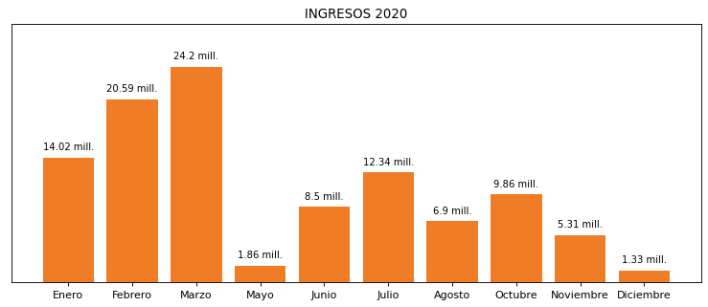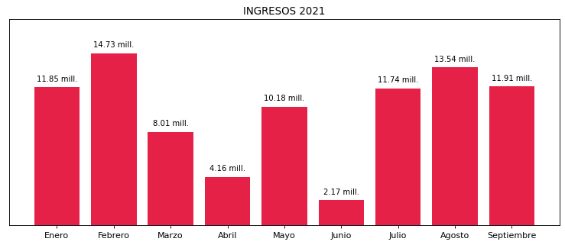

|  |
| --- |
| **MALTIBIT**  USUARIO |

|  |
| --- |
| **Mateo Porras**  Ejecutivo de cuenta |

|  |
| --- |
| **0**  PUNTO FOCAL |

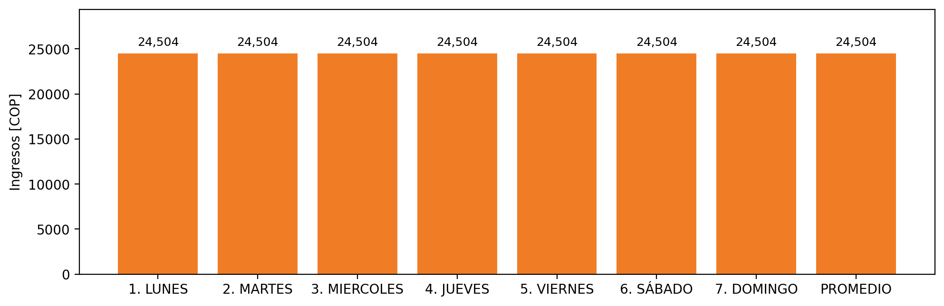

|  |  |  |  |  |  |  |  |  |  |  |
| --- | --- | --- | --- | --- | --- | --- | --- | --- | --- | --- |
| **FRONTERA** | **COD SIC** | **PREDIO** | **FRT DDV** | **TIPO DDV** | **PROMEDIO** | **PRÓXIMA ACTUALIZACIÓN** | **MARGEN DE ERROR** | **ÚLTIMA PRUEBA DDV** | **DÍAS PARTICIPACIÓN** | **FECHA REFERENCIA PRÓXIMA PRUEBA DDV** |
| BAVARIA S.A. (MALTIBIT) | Frt00641 | Prd01331 | Frt33221 | LBC | 24,504 | 2022-01-18 | 3,41 | 2021-06-04 | 70.0 | 2021-12-05 |